**DSA 01(OOPS C++)**

**AADITYA PARTIBAN**

**192211037**

QUESTION 1

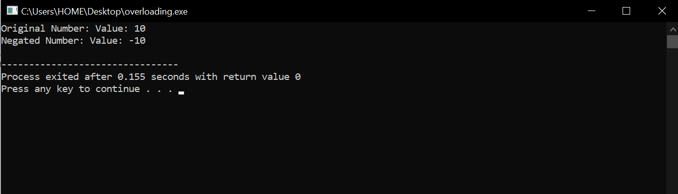

QUESTION 2

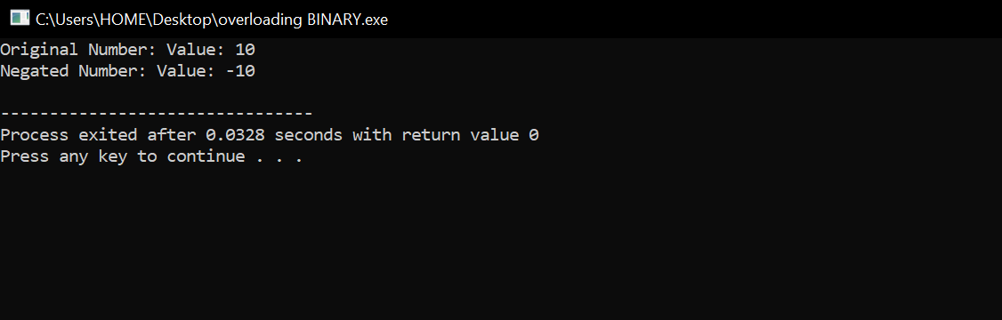

QUESTION 3

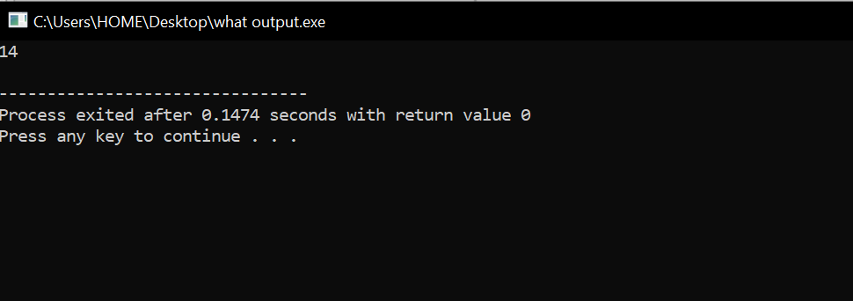

QUESTION 4

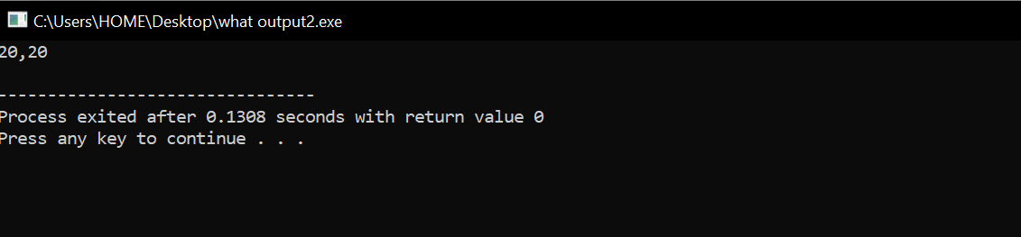

QUESTION 5

