**Compiler Design Lab**

**Name –** N Aditya Sai

**Register No –** RA1911030010075

**Experiment –** 1

**Aim:** To study and code a lexical analyser in C++.

**Algorithm:**

• Start • Get the input program from the file program.txt. • Read the program line by line and check if each word in a line is a keyword, identifier, constant or an operator. • If the word read is an identifier, assign a number to the identifier and make an entry into the symbol table stored in sybol.txt. • For each lexeme read, generate a token as follows: a. If the lexeme is an identifier, then the token generated is of the form b. If the lexeme is an operator, then the token generated is . c. If the lexeme is a constant, then the token generated is . d. If the lexeme is a keyword, then the token is the keyword itself. • The stream of tokens generated are displayed in the console output. • Stop.

**Code:**

#include<bits/stdc++.h>

#include<stdlib.h>

#include<string.h>

#include<ctype.h>

using namespace std;

int isKeyword(char buffer[]){

char keywords[32][10] =

{"auto","break","case","char","const","continue","default",

"do","double","else","enum","extern","float","for","goto",

"if","int","long","register","return","short","signed",

"sizeof","static","struct","switch","typedef","union",

"unsigned","void","volatile","while"};

int i, flag = 0;

for(i = 0; i < 32; ++i){

if(strcmp(keywords[i], buffer) == 0){

flag = 1;

break;

}

}

return flag;

}

int main(){

char ch, buffer[15],b[30], logical_op[] = "><",math_op[]="+-*/=",numer[]=".0123456789",other[]=",;\(){}[]'':";

ifstream fin("Program.txt");

int mark[1000]={0};

int i,j=0,kc=0,ic=0,lc=0,mc=0,nc=0,oc=0,aaa=0;

vector < string > k;

vector<char >id;

vector<char>lo;

vector<char>ma;

vector<string>nu;

vector<char>ot;

if(!fin.is_open()){

cout<<"error while opening the file\n";

exit(0);

}

while(!fin.eof()){

ch = fin.get();

for(i = 0; i < 12; ++i){

if(ch == other[i]){

int aa=ch;

if(mark[aa]!=1){

ot.push_back(ch);

mark[aa]=1;

++oc;

}

}

}

for(i = 0; i < 5; ++i){

if(ch == math_op[i]){

int aa=ch;

if(mark[aa]!=1){

ma.push_back(ch);

mark[aa]=1;

++mc;

}

}

}

for(i = 0; i < 2; ++i){

if(ch == logical_op[i]){

int aa=ch;

if(mark[aa]!=1){

lo.push_back(ch);

mark[aa]=1;

++lc;

}

}

}

if(ch=='0' || ch=='1' || ch=='2' || ch=='3' || ch=='4' || ch=='5' || ch=='6' || ch=='7' || ch=='8' || ch=='9' || ch=='.' ||ch == ' ' || ch == '\n' || ch == ';'){

if(ch=='0' || ch=='1' || ch=='2' || ch=='3' || ch=='4' || ch=='5' || ch=='6' || ch=='7' || ch=='8' || ch=='9' || ch=='.')b[aaa++]=ch;

if((ch == ' ' || ch == '\n' || ch == ';') && (aaa != 0)){

b[aaa] = '\0';

aaa = 0;

char arr[30];

strcpy(arr,b);

nu.push_back(arr);

++nc;

}

}

if(isalnum(ch)){

buffer[j++] = ch;

}

else if((ch == ' ' || ch == '\n') && (j != 0)){

buffer[j] = '\0';

j = 0;

if(isKeyword(buffer) == 1){

k.push_back(buffer);

++kc;

}

else{

if(buffer[0]>=97 && buffer[0]<=122) {

if(mark[buffer[0]-'a']!=1){

id.push_back(buffer[0]);

++ic;

mark[buffer[0]-'a']=1;

}

}

}

}

}

fin.close();

printf("Keywords: ");

for(int f=0;f<kc;++f){

if(f==kc-1){

cout<<k[f]<<"\n";

}

else {

cout<<k[f]<<", ";

}

}

printf("\nIdentifiers: ");

for(int f=0;f<ic;++f){

if(f==ic-1){

cout<<id[f]<<"\n";

}

else {

cout<<id[f]<<", ";

}

}

printf("\nMath Operators: ");

for(int f=0;f<mc;++f){

if(f==mc-1){

cout<<ma[f]<<"\n";

}

else {

cout<<ma[f]<<", ";

}

}

printf("\nLogical Operators: ");

for(int f=0;f<lc;++f){

if(f==lc-1){

cout<<lo[f]<<"\n";

}

else {

cout<<lo[f]<<", ";

}

}

printf("\nNumerical Values: ");

for(int f=0;f<nc;++f){

if(f==nc-1){

cout<<nu[f]<<"\n";

}

else {

cout<<nu[f]<<", ";

}

}

printf("\nOthers: ");

for(int f=0;f<oc;++f){

if(f==oc-1){

cout<<ot[f]<<"\n";

}

else {

cout<<ot[f]<<" ";

}

}

return 0;

}

**Screenshots:**

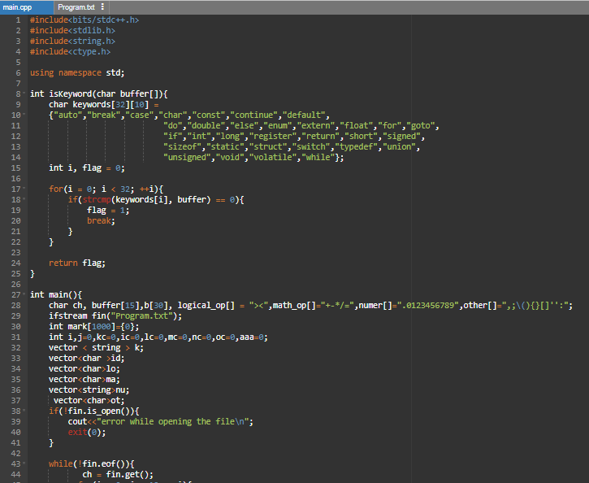

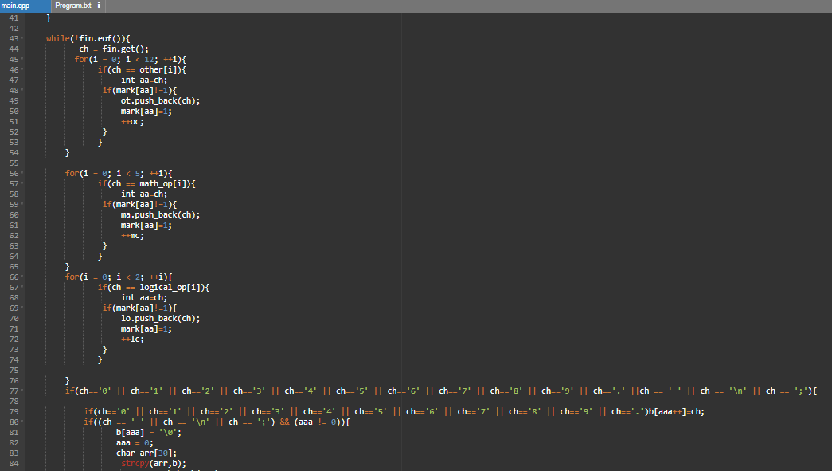

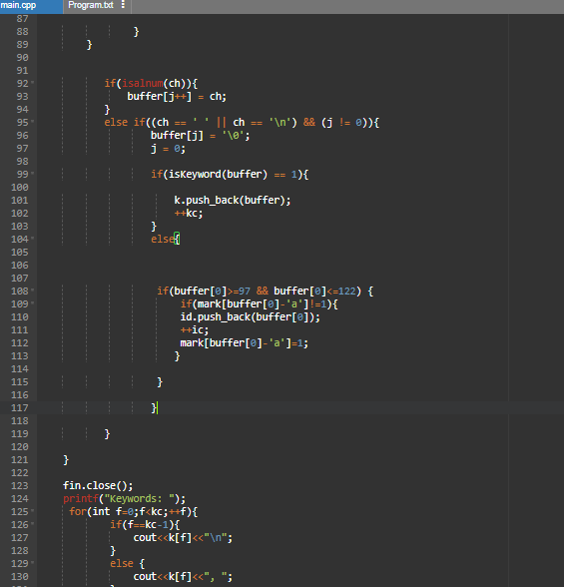

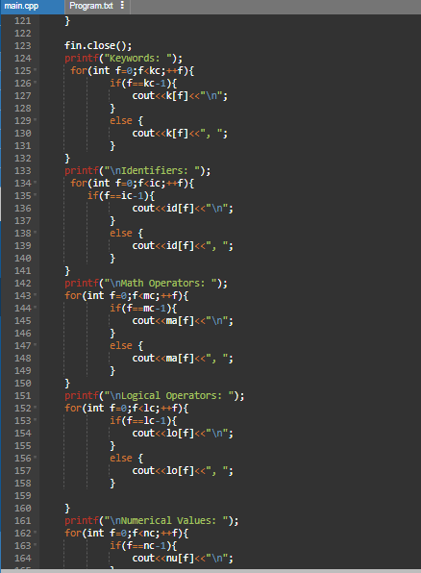

**Output**:

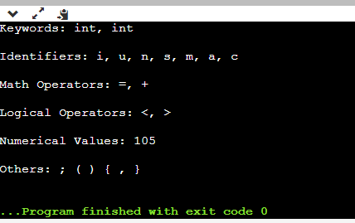

**Result:** Lexical Analyser was studied and executed successfully in C++.