**Compiler Design Lab**

**Name –** Sai Dhatri Byrisetti

**Register No –** RA1911030010087

**Experiment –** 5

**Aim:** To compute first and follow of a given set of productions.

**Algorithm**:

For computing the first:

1. If X is a terminal then FIRST(X) ={X} Example: F->I|id. We can write it as FIRST(F)->{(,id}
2. If X is a non terminal like E->T the to get FIRST substitute T with other productions until you get a terminal as the first symbol.
3. If X-> ε then add ε. To FIRST(X)

For computing the follow:

1. Always check the right side of the productions for a non-terminal, whose FOLLOW set is being found.
2. If that non terminal (S,A,B..) is followed by any terminal (alb…,*,+,

(,)…) then add that terminal into the FOLLOW set.

If that non-terminal is followed by any other non-terminal then add

FIRST of other non terminal into the FOLLOW set.

**Code:**

import sys

sys.setrecursionlimit(60)

def first(string):

#print("first({})".format(string)) first_ = set() #convert any of the iterable to sequence of iterable elements with distinct elements if string in non_terminals: alternatives = productions_dict[string]

for alternative in alternatives: first_2 = first(alternative) first_ = first_ |first_2

elif string in terminals: first_ = {string}

elif string=='' or string=='@': first_ = {'@'}

else: first_2 = first(string[0]) if '@' in first_2: i = 1 while '@' in first_2: #print("inside while")

first_ = first_ | (first_2 - {'@'}) #print('string[i:]=', string[i:]) if string[i:] in terminals:

first_ = first_ | {string[i:]}

break elif string[i:] == '':

first_ = first_ | {'@'}

break

first_2 = first(string[i:]) first_ = first_ | first_2 - {'@'}

i += 1 else: first_ = first_ | first_2

#print("returning for first({})".format(string),first_) return first_

def follow(nT):

#print("inside follow({})".format(nT))

follow_ = set()

#print("FOLLOW", FOLLOW) prods = productions_dict.items() if nT==starting_symbol:

follow_ = follow_ | {'$'} for nt,rhs in prods: #print("nt to rhs", nt,rhs) for alt in rhs: for char in alt: if char==nT: following_str = alt[alt.index(char) +

1:] if following_str=='': if nt==nT: continue else: follow_ = follow_ | follow(nt) else: follow_2 = first(following_str) if '@' in follow_2: follow_ = follow_ | follow_2-

{'@'}

follow_ = follow_ | follow(nt) else: follow_ = follow_ | follow_2 #print("returning for follow({})".format(nT),follow_) return follow_

no_of_terminals=int(input("Enter no. of terminals: ")) terminals = []

print("Enter the terminals :") for _ in range(no_of_terminals): terminals.append(input())

no_of_non_terminals=int(input("Enter no. of non terminals: ")) non_terminals = []

print("Enter the non terminals :") for _ in range(no_of_non_terminals): non_terminals.append(input()) starting_symbol = input("Enter the starting symbol: ")

no_of_productions = int(input("Enter no of productions:

")) productions = []

print("Enter the productions:") for _ in range(no_of_productions): productions.append(input())

#print("terminals", terminals)

#print("non terminals", non_terminals) #print("productions",productions)

productions_dict = {}

for nT in non_terminals: productions_dict[nT] = []

#print("productions_dict",productions_dict)

for production in productions: nonterm_to_prod = production.split("->") alternatives = nonterm_to_prod[1].split("/") for alternative in alternatives:

productions_dict[nonterm_to_prod[0]].append(alternative) #print("productions_dict",productions_dict)

#print("nonterm_to_prod",nonterm_to_prod)

#print("alternatives",alternatives)

FIRST = {}

FOLLOW = {}

for non_terminal in non_terminals: FIRST[non_terminal] = set()

for non_terminal in non_terminals: FOLLOW[non_terminal] = set() #print("FIRST",FIRST)

for non_terminal in non_terminals:

FIRST[non_terminal] = FIRST[non_terminal] | first(non_terminal) #print("FIRST",FIRST)

FOLLOW[starting_symbol] = FOLLOW[starting_symbol] | {'$'} for non_terminal in non_terminals:

FOLLOW[non_terminal] = FOLLOW[non_terminal] | follow(non_terminal) #print("FOLLOW", FOLLOW)

print("{: ^20}{: ^20}{: ^20}".format('Non Terminals','First','Follow')) for non_terminal in non_terminals: print("{: ^20}{: ^20}{:

^20}”.format(non_terminal,str(FIRST[non_terminal]),str(FO LLOW[non_terminal])))

**Output:**

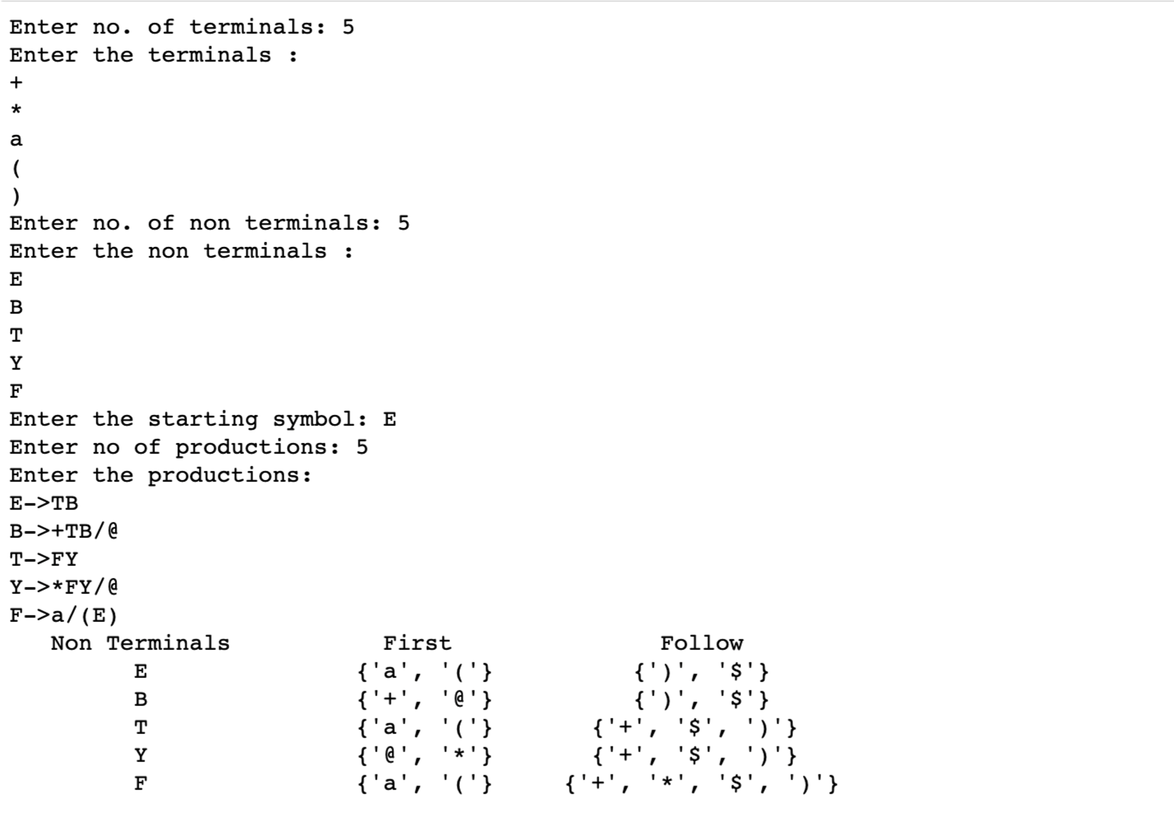

**Result:** Computation of first and follow of a given set of productions is done successfully.