**Compiler Design Lab**

**Name –** N Aditya Sai

**Register No –** RA1911030010075

**Experiment –** 9

**Aim:** A program to implement LR(0) items.

**Algorithm**:

* Start.
* Create structure for production with LHS and RHS.
* Open file and read input from file.
* Build state 0 from extra grammar Law S' -> S $ that is all start symbol of grammar and one
* Dot ( . ) before S symbol.
* If Dot symbol is before a non-terminal, add grammar laws that this non-terminal is in Left
* Hand Side of that Law and set Dot in before of first part of Right Hand Side.
* If state exists (a state with this Laws and same Dot position), use that instead.
* Now find set of terminals and non-terminals in which Dot exist in before.
* If step 7 Set is non-empty go to 9, else go to 10.
* For each terminal/non-terminal in set step 7 create new state by using all grammar law that
* Dot position is before of that terminal/non-terminal in reference state by increasing Dot point
* to next part in Right Hand Side of that laws.
* Go to step 5.
* End of state building.
* Display the output.
* End.

**Code:**

#include<iostream.h>

#include<conio.h>

#include<string.h>

using namespace std;

char prod[20][20],listofvar[26]="ABCDEFGHIJKLMNOPQR";

int novar=1,i=0,j=0,k=0,n=0,m=0,arr[30];

int noitem=0;

struct Grammar

{

char lhs;

char rhs[8];

}g[20],item[20],clos[20][10];

int isvariable(char variable)

{

for(int i=0;i<novar;i++)

if(g[i].lhs==variable)

return i+1;

return 0;

}

void findclosure(int z, char a)

{

int n=0,i=0,j=0,k=0,l=0;

for(i=0;i<arr[z];i++)

{

for(j=0;j<strlen(clos[z][i].rhs);j++)

{

if(clos[z][i].rhs[j]=='.' && clos[z][i].rhs[j+1]==a)

{

clos[noitem][n].lhs=clos[z][i].lhs;

strcpy(clos[noitem][n].rhs,clos[z][i].rhs);

char temp=clos[noitem][n].rhs[j];

clos[noitem][n].rhs[j]=clos[noitem][n].rhs[j+1];

clos[noitem][n].rhs[j+1]=temp;

n=n+1;

}

}

}

for(i=0;i<n;i++)

{

for(j=0;j<strlen(clos[noitem][i].rhs);j++)

{

if(clos[noitem][i].rhs[j]=='.' && isvariable(clos[noitem][i].rhs[j+1])>0)

{

for(k=0;k<novar;k++)

{

if(clos[noitem][i].rhs[j+1]==clos[0][k].lhs)

{

for(l=0;l<n;l++)

if(clos[noitem][l].lhs==clos[0][k].lhs &&

strcmp(clos[noitem][l].rhs,clos[0][k].rhs)==0)

break;

if(l==n)

{

clos[noitem][n].lhs=clos[0][k].lhs;

strcpy(clos[noitem][n].rhs,clos[0][k].rhs);

n=n+1;

}

}

}

}

}

}

arr[noitem]=n;

int flag=0;

for(i=0;i<noitem;i++)

{

if(arr[i]==n)

{

for(j=0;j<arr[i];j++)

{

int c=0;

for(k=0;k<arr[i];k++)

if(clos[noitem][k].lhs==clos[i][k].lhs &&

strcmp(clos[noitem][k].rhs,clos[i][k].rhs)==0)

c=c+1;

if(c==arr[i])

{

flag=1;

goto exit;

}

}

}

}

exit:;

if(flag==0)

arr[noitem++]=n;

}

int main()

{

cout<<"ENTER THE PRODUCTIONS OF THE GRAMMAR(0 TO END) :\n";

do

{

cin>>prod[i++];

}while(strcmp(prod[i-1],"0")!=0);

for(n=0;n<i-1;n++)

{

m=0;

j=novar;

g[novar++].lhs=prod[n][0];

for(k=3;k<strlen(prod[n]);k++)

{

if(prod[n][k] != '|')

g[j].rhs[m++]=prod[n][k];

if(prod[n][k]=='|')

{

g[j].rhs[m]='\0';

m=0;

j=novar;

g[novar++].lhs=prod[n][0];

}

}

}

for(i=0;i<26;i++)

if(!isvariable(listofvar[i]))

break;

g[0].lhs=listofvar[i];

char temp[2]={g[1].lhs,'\0'};

strcat(g[0].rhs,temp);

cout<<"\n\n augumented grammar \n";

for(i=0;i<novar;i++)

cout<<endl<<g[i].lhs<<"->"<<g[i].rhs<<" ";

getch();

for(i=0;i<novar;i++)

{

clos[noitem][i].lhs=g[i].lhs;

strcpy(clos[noitem][i].rhs,g[i].rhs);

if(strcmp(clos[noitem][i].rhs,"ε")==0)

strcpy(clos[noitem][i].rhs,".");

else

{

for(int j=strlen(clos[noitem][i].rhs)+1;j>=0;j--)

clos[noitem][i].rhs[j]=clos[noitem][i].rhs[j-1];

clos[noitem][i].rhs[0]='.';

}

}

arr[noitem++]=novar;

for(int z=0;z<noitem;z++)

{

char list[10];

int l=0;

for(j=0;j<arr[z];j++)

{

for(k=0;k<strlen(clos[z][j].rhs)-1;k++)

{

if(clos[z][j].rhs[k]=='.')

{

for(m=0;m<l;m++)

if(list[m]==clos[z][j].rhs[k+1])

break;

if(m==l)

list[l++]=clos[z][j].rhs[k+1];

}

}

}

for(int x=0;x<l;x++)

findclosure(z,list[x]);

}

cout<<"\n THE SET OF ITEMS ARE \n\n";

for(z=0;z<noitem;z++)

{

cout<<"\n I"<<z<<"\n\n";

for(j=0;j<arr[z];j++)

cout<<clos[z][j].lhs<<"->"<<clos[z][j].rhs<<"\n";

getch();

}

getch();

return 0;

}

**Screenshots:**

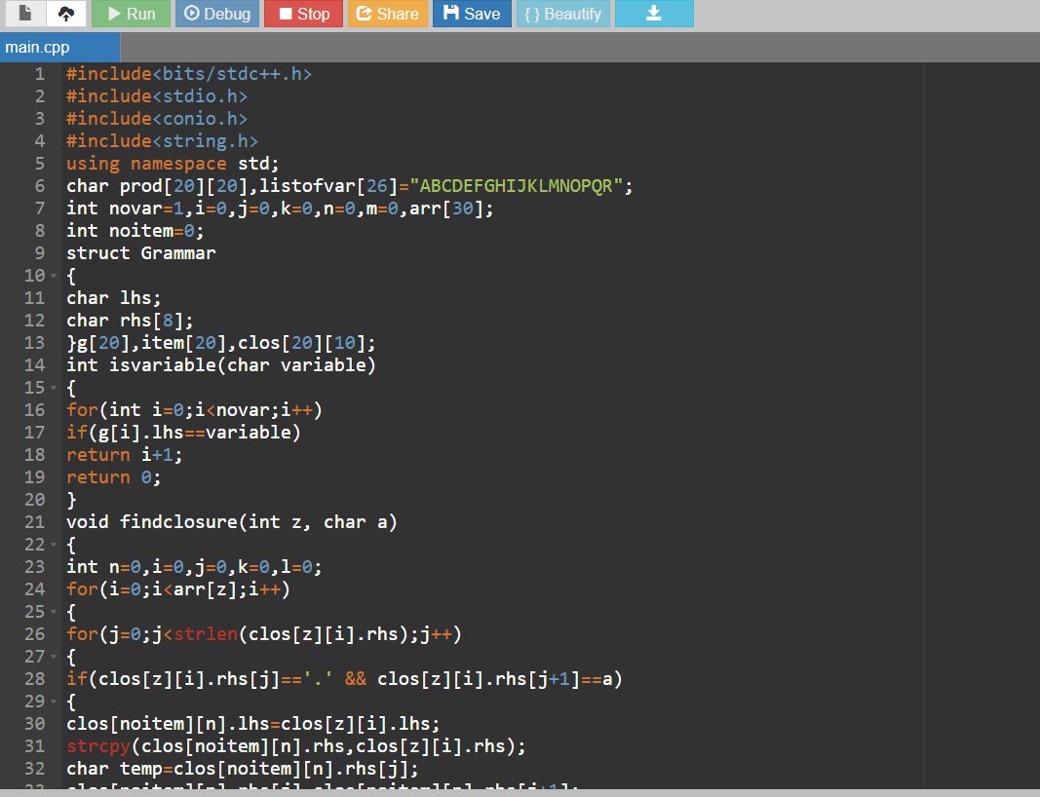

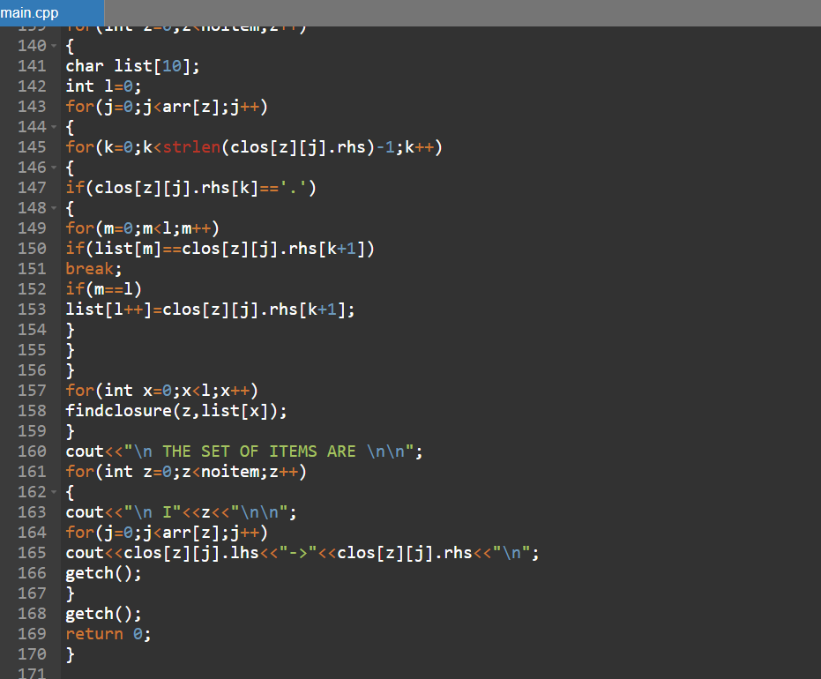

**Output:**

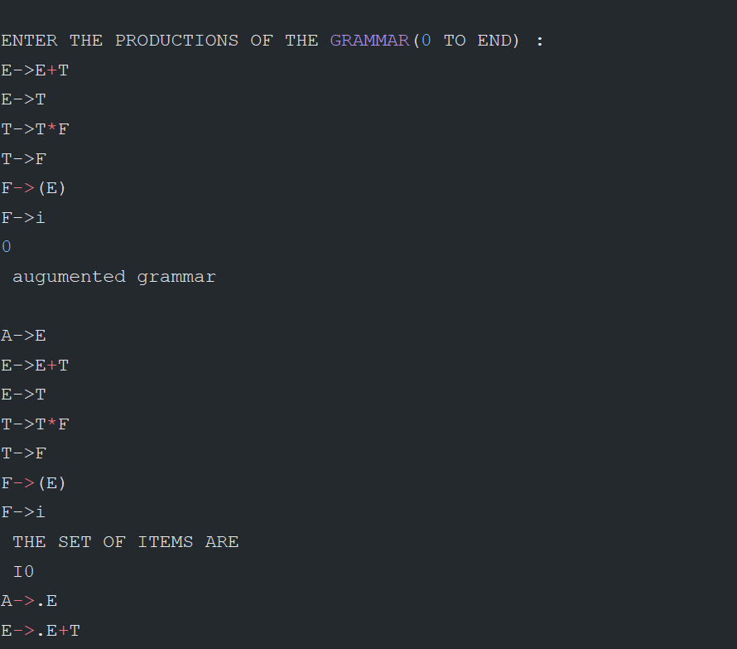

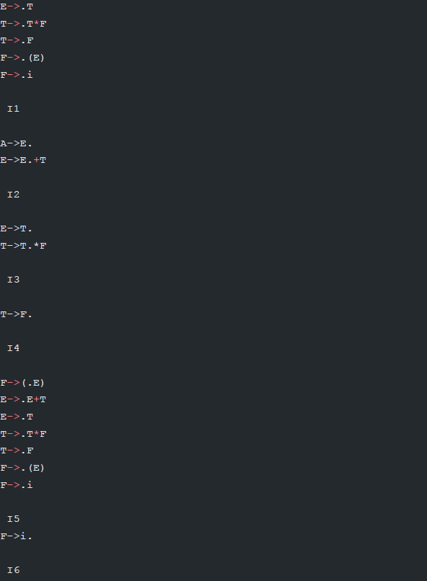

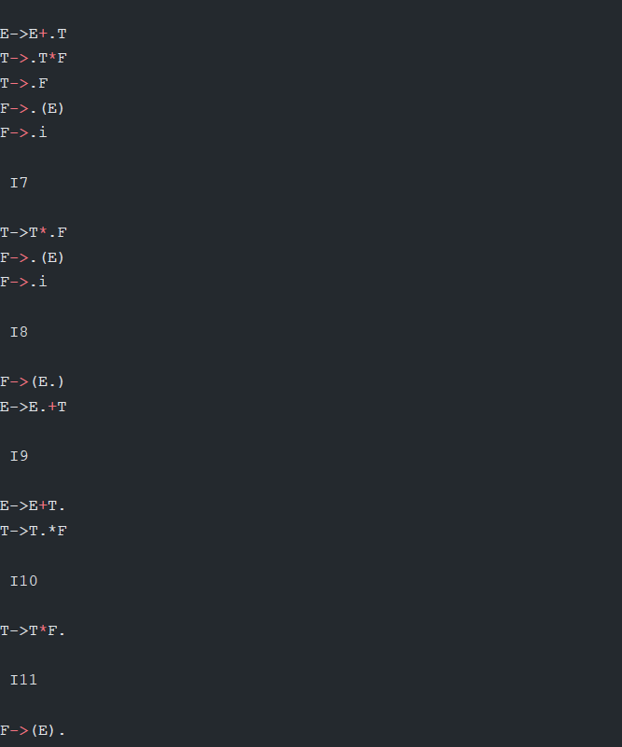

**Result:** The program was successfully compiled and run.