**Database Management System Lab**

**Name** – N Aditya Sai

**Register Number**- RA1911030010075

**Section** - O2

**Date** – 24.01.2022

**Experiment** - 1

**Aim:** To write SQL Queries to execute basic SQL commands

1. Create Table

CREATE TABLE "AGENTS"

(

"AGENT_CODE" CHAR(6) NOT NULL PRIMARY KEY,

"AGENT_NAME" CHAR(40),

"WORKING_AREA" CHAR(35),

"COMMISSION" NUMBER(10,2),

"PHONE_NO" CHAR(15),

"COUNTRY" VARCHAR2(25)

);

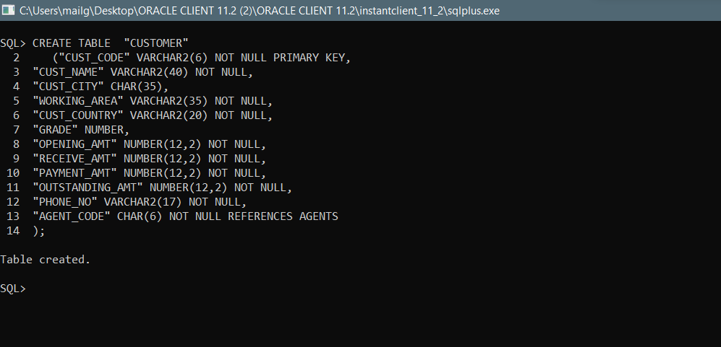

1. Insert Values

INSERT INTO AGENTS VALUES ('A007', 'Ramasundar', 'Bangalore', '0.15', '077-25814763', '');

INSERT INTO AGENTS VALUES ('A003', 'Alex ', 'London', '0.13', '075-12458969', '');

INSERT INTO AGENTS VALUES ('A008', 'Alford', 'New York', '0.12', '044-25874365', '');

INSERT INTO AGENTS VALUES ('A011', 'Ravi Kumar', 'Bangalore', '0.15', '077-45625874', '');

INSERT INTO AGENTS VALUES ('A010', 'Santakumar', 'Chennai', '0.14', '007-22388644', '');

INSERT INTO AGENTS VALUES ('A012', 'Lucida', 'San Jose', '0.12', '044-52981425', '');

INSERT INTO AGENTS VALUES ('A005', 'Anderson', 'Brisban', '0.13', '045-21447739', '');

INSERT INTO AGENTS VALUES ('A001', 'Subbarao', 'Bangalore', '0.14', '077-12346674', '');

INSERT INTO AGENTS VALUES ('A002', 'Mukesh', 'Mumbai', '0.11', '029-12358964', '');

INSERT INTO AGENTS VALUES ('A006', 'McDen', 'London', '0.15', '078-22255588', '');

INSERT INTO AGENTS VALUES ('A004', 'Ivan', 'Torento', '0.15', '008-22544166', '');

INSERT INTO AGENTS VALUES ('A009', 'Benjamin', 'Hampshair', '0.11', '008-22536178', '');

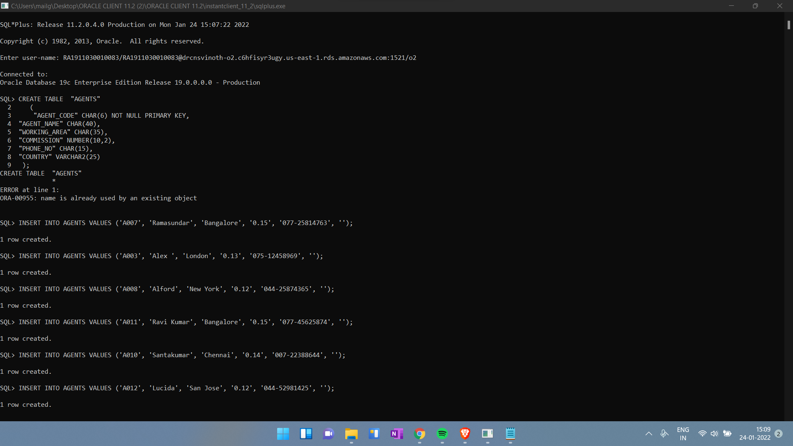

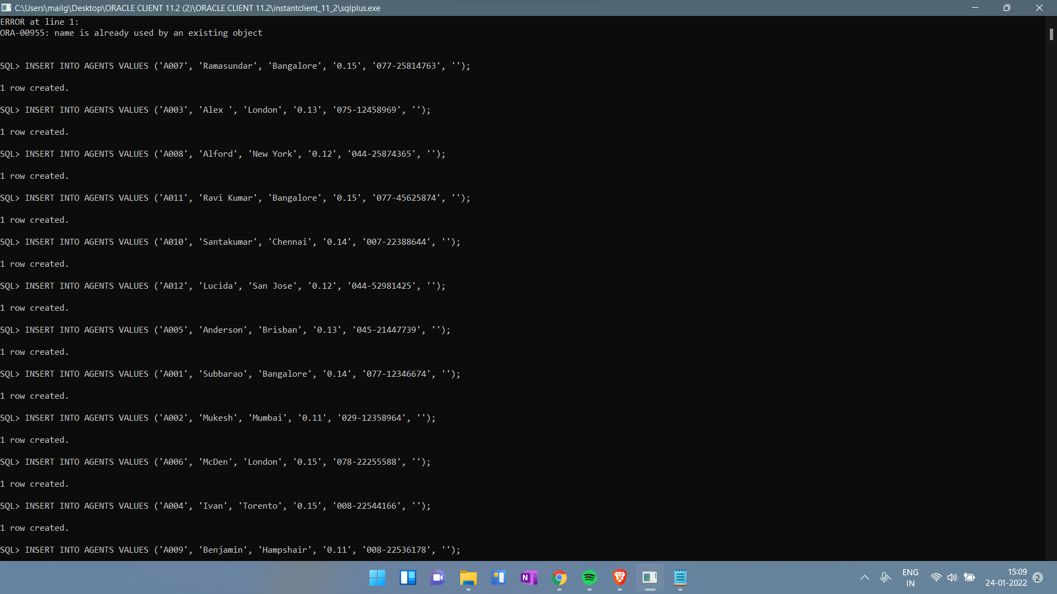

1. Display Values

SELECT * FROM AGENTS;

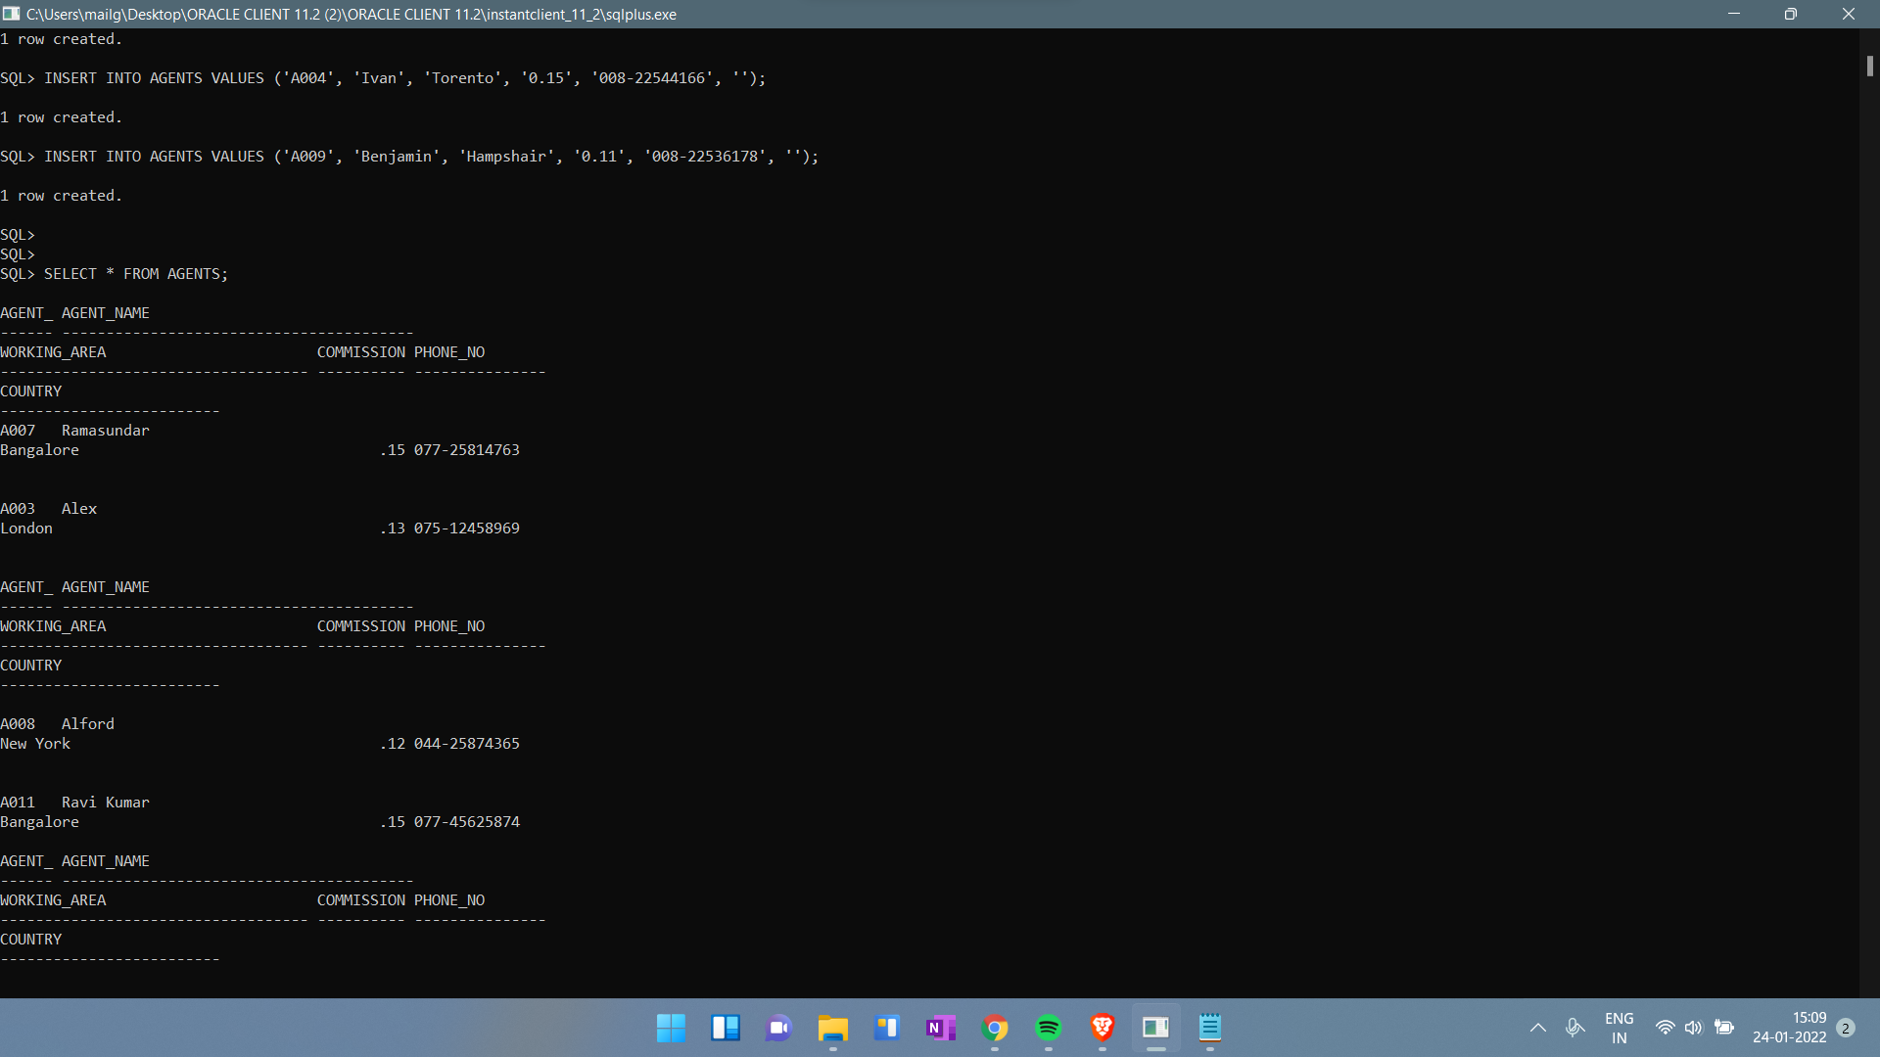

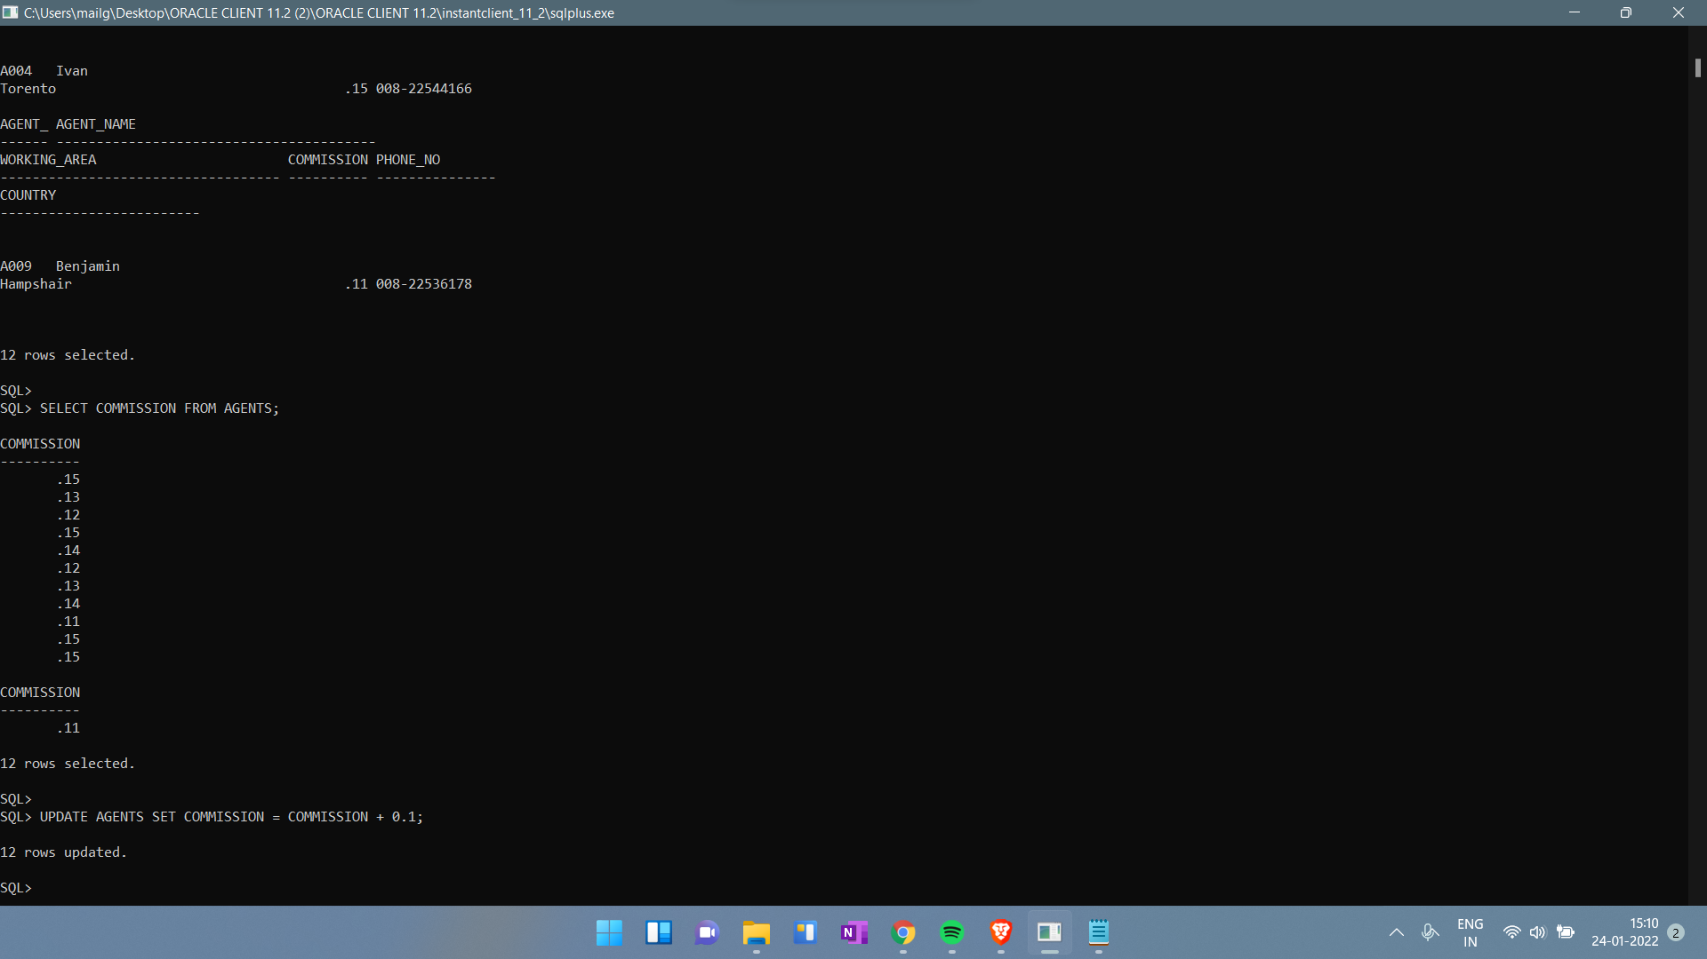

1. Modify Values

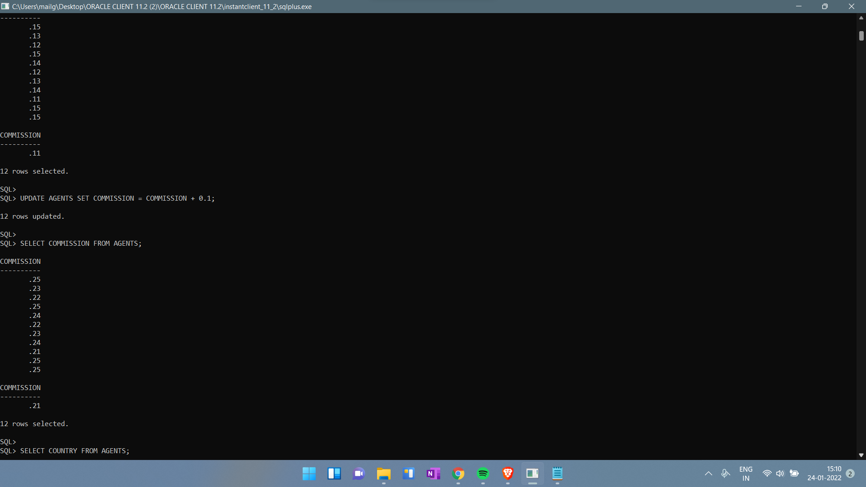

1. Delete Values

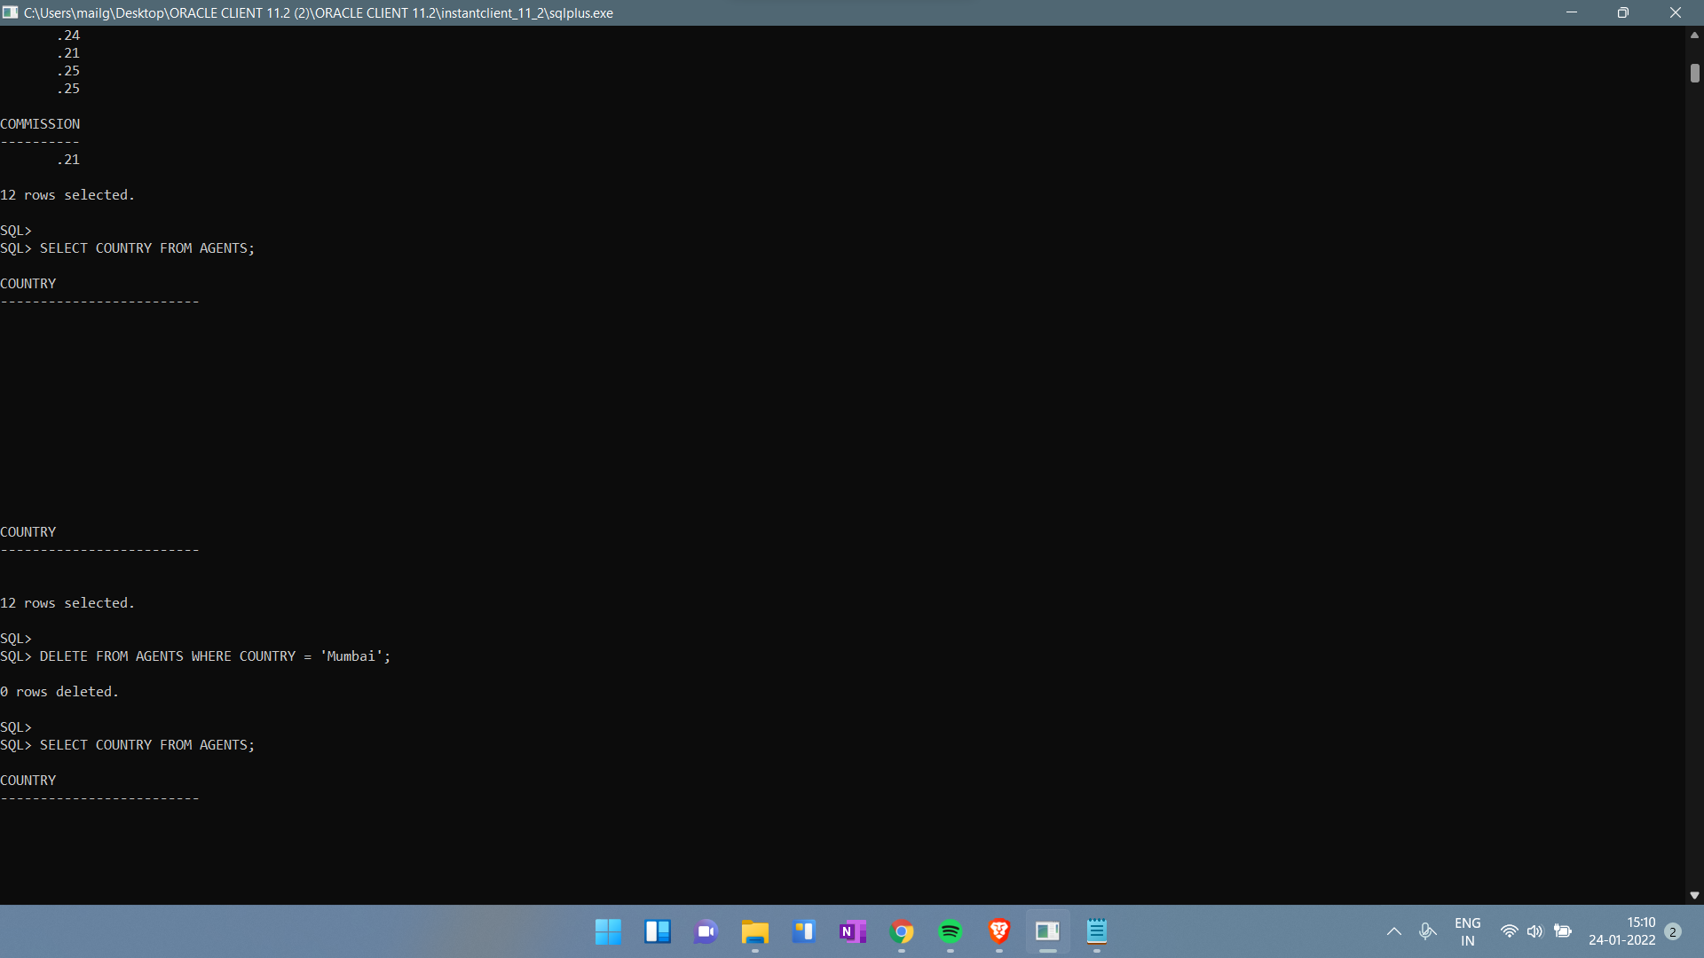

**RESULT**:

Thus the basic SQL queries were successfully executed and verified.