**Database Management System Lab**

**Name** – N Aditya Sai

**Register Number**- RA1911030010075

**Section** - O2

**Experiment** - 2

**Aim**: To write SQL Queries to execute different DML commands

1. Database created for this exercise is

CREATE TABLE "AGENTS"

(

"AGENT_CODE" CHAR(6) NOT NULL PRIMARY KEY,

"AGENT_NAME" CHAR(40),

"WORKING_AREA" CHAR(35),

"COMMISSION" NUMBER(10,2),

"PHONE_NO" CHAR(15),

"COUNTRY" VARCHAR2(25)

);

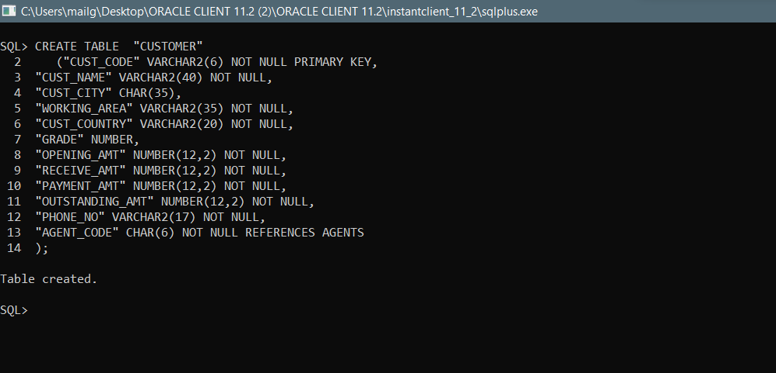

1. **SELECT:**
2. Used to query or fetch selected fields or columns from a database table

Syntax,

SELECT column_name1, column_name2, …

FROM table_name

WHERE condition_ expression;

Example:

Select customer_id, sale_date, order_id, store_state from customers;

Select * from customers;

SELECT * FROM AGENTS;

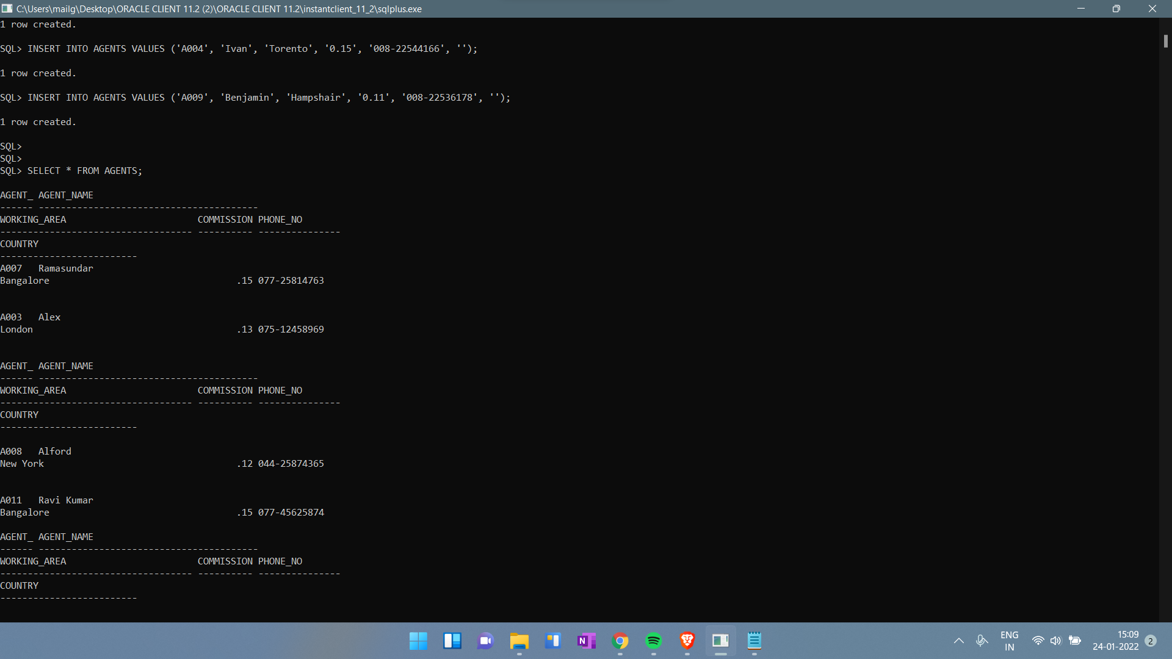

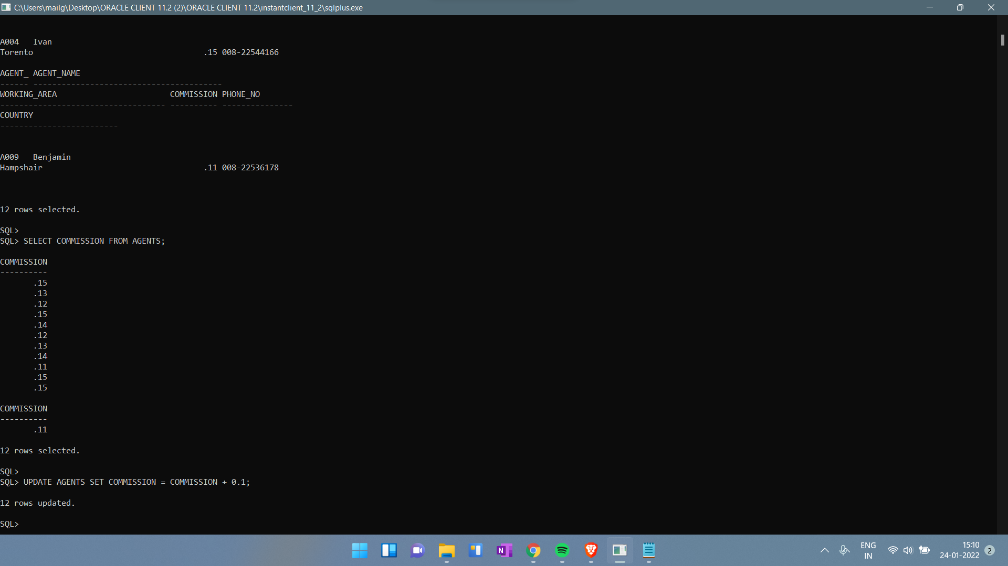

1. **INSERT**

* Used to insert new data records or rows in the database table

Syntax,

INSERT INTO table_name (column_name_1, column_name_2, column_name_3, ...)

VALUES (value1, value2, value3, ...)

Example:

INSERT INTO sales(

customer_id, sale_date, sale_amount, salesperson, store_state, order_id)

VALUES (1005,TO_DATE('2019-12-12','YYYY-MM-DD),4200,'R K Rakesh','MH','1007');

(or)

INSERT INTO customers

VALUES ('1006','2020-03-04',3200,'DL', '1008');

INSERT INTO AGENTS VALUES ('A007', 'Ramasundar', 'Bangalore', '0.15', '077-25814763', '');

INSERT INTO AGENTS VALUES ('A003', 'Alex ', 'London', '0.13', '075-12458969', '');

INSERT INTO AGENTS VALUES ('A008', 'Alford', 'New York', '0.12', '044-25874365', '');

INSERT INTO AGENTS VALUES ('A011', 'Ravi Kumar', 'Bangalore', '0.15', '077-45625874', '');

INSERT INTO AGENTS VALUES ('A010', 'Santakumar', 'Chennai', '0.14', '007-22388644', '');

INSERT INTO AGENTS VALUES ('A012', 'Lucida', 'San Jose', '0.12', '044-52981425', '');

INSERT INTO AGENTS VALUES ('A005', 'Anderson', 'Brisban', '0.13', '045-21447739', '');

INSERT INTO AGENTS VALUES ('A001', 'Subbarao', 'Bangalore', '0.14', '077-12346674', '');

INSERT INTO AGENTS VALUES ('A002', 'Mukesh', 'Mumbai', '0.11', '029-12358964', '');

INSERT INTO AGENTS VALUES ('A006', 'McDen', 'London', '0.15', '078-22255588', '');

INSERT INTO AGENTS VALUES ('A004', 'Ivan', 'Torento', '0.15', '008-22544166', '');

INSERT INTO AGENTS VALUES ('A009', 'Benjamin', 'Hampshair', '0.11', '008-22536178', '');

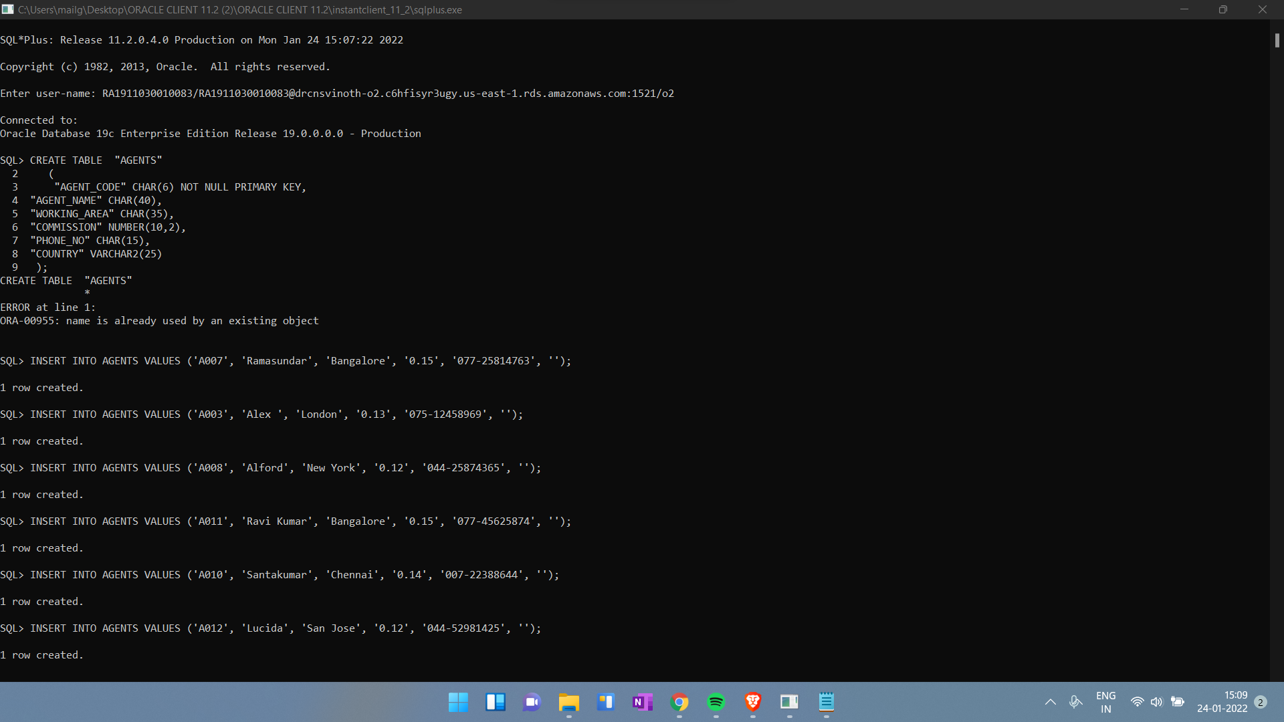

1. **UPDATE:**

Used to set the value of a field or column for a particular record to a new value

**Syntax,**

**UPDATE table_name**

**SET column_name_1 = value1, column_name_2 = value2, ...**

**WHERE condition;**

Example,

UPDATE customers

SET store_state = 'DL'

WHERE store_state = 'NY';

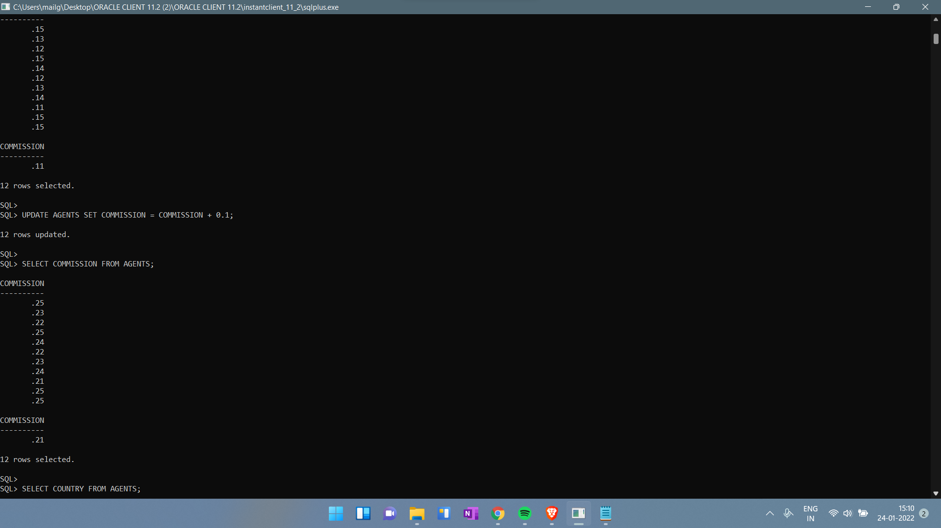

1. **DELETE**

* Used to remove one or more rows from the database table

**Syntax,**

**DELETE FROM table_name WHERE condition;**

Example,

DELETE FROM customers

WHERE store_state = 'MH'

AND customer_id = '1001';

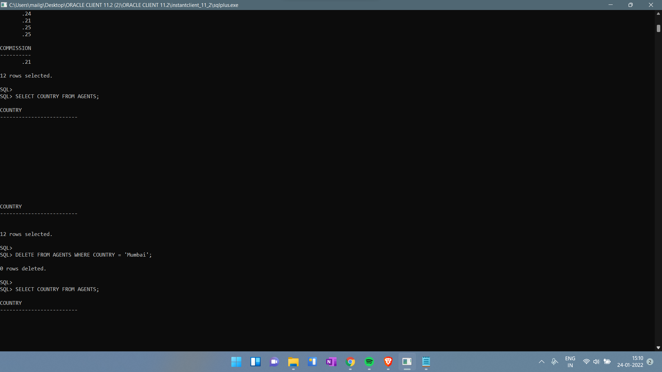

**Result:**

Thus, the DML commands are used to modify or manipulate data records present in the customer database tables.