**EXPERIMENT**

**To design automatic led Diwali lights (consisting of 6 led’s) such that it only works during night and can generate two patterns which can be toggled with switch. a. Pattern 1 – led blinks with a freq. of 500 msec. b. Pattern 2 – led blinks with a freq. of 1 sec.**

**APPARATUS REQUIRED**

Arduino board, LED, resistance, LDR, switch, connecting wires.

**CIRCUIT DIAGRAM:**

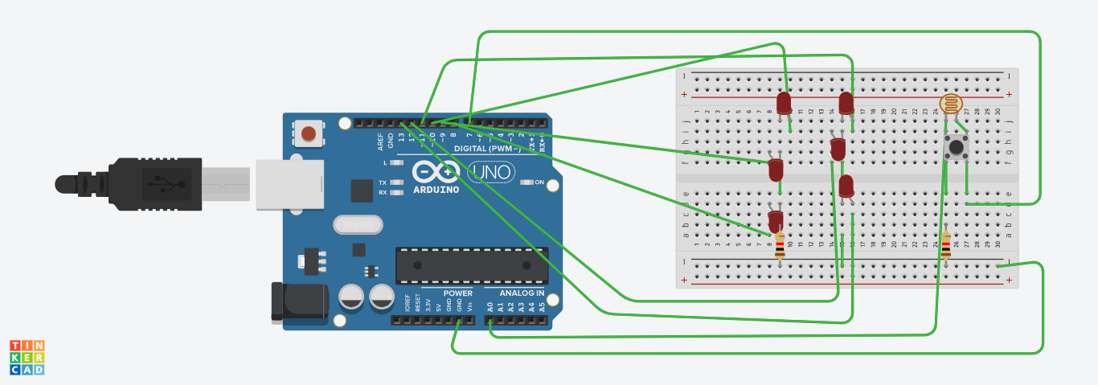

**CONCEPTS:**

1. The arduino board can supply a power of 5V as digital output signal through the 14 pins.
2. The GND pin of the arduino board act as a ground.

**PROBLEMS AND TROUBLESHOOTING:**

1. If LED is not turning ON, check the problem in positive and negative terminals or in the cathode and anode which is in the LED.
2. Check whether the arduino board is working or not.

**LEARNING OUTCOMES:**

1. Learnt about the working and applications of arduino.
2. Demonstration on how Diwali lights work on arduino.