**Miniproject: Brief Report**

**(ECE 4039- Motion and Geometry Based Methods in Computer Vision)**

Name(s): Debang, Riya, Aditya, Srikar

Registration Numbers: Debang-140907484 ,riya-140907618, Aditya-140907676, Srikar-140907638

**Title**: Histograms of Oriented Gradients for Human Detection

**Objective**: Our objective is to analyze any given image and classify if the image is of a person or not. The method is based on evaluating well-normalized local histograms of image gradient orientations in a dense grid.

**Expected Output:**

The algorithm will be able to detect pedestrians from pictures with various backgrounds, brightness levels and pose variations.

**Dataset:**

A standard dataset is being used for this project.

**Dataset Name: INRIA Person Dataset**

**Source:**  [**http://pascal.inrialpes.fr/data/human/**](http://pascal.inrialpes.fr/data/human/)

The data set contains images from several different sources:

* Images from [GRAZ 01](http://www.emt.tugraz.at/~pinz/data/GRAZ_01/) dataset, though annotation files are completely new.

Images from personal digital image collections taken over a long time period. Usually the original positive images were of very high resolution (approx. 2592x1944 pixels), so they have cropped these images to highlight persons. Many people are bystanders taken from the backgrounds of these input photos, so ideally there is no particular bias in their pose

**Output**: The results after testing the images are as follows:

For positive images, precision= 92%

For negative images, precision = 93%

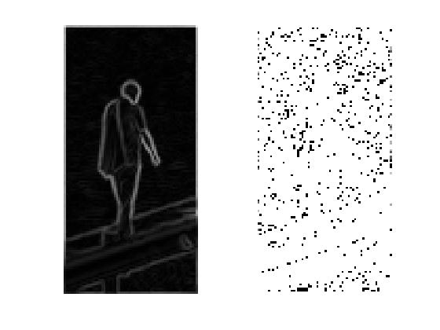 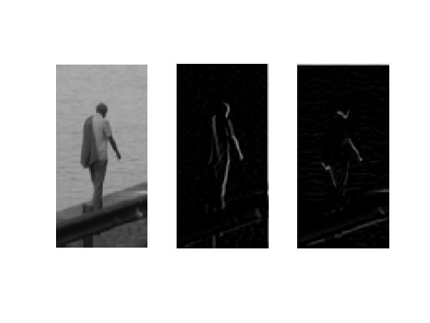 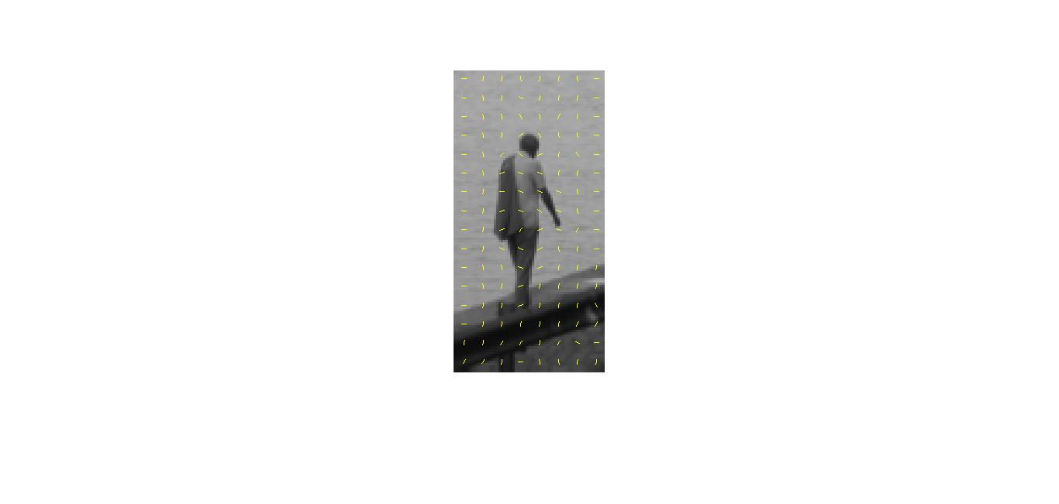

**Observations:** We observed that this algorithm does not give good results in the case of occlusion.

**Approach**:

The input image is taken and the colour and gamma values are normalized. The gradients of this image are computed and are weight voted into spatial and orientation cells. The contrast of the overlapping spatial blocks are normalized.

The HOG’s are collected over detection window and linear SVM is applied which is used to classify the image as a person/ non-person.

**Flowchart of the working procedure:**

References:

[1] “Histograms of Oriented Gradients for Human Detection”, Navneet Dalal and Bill Triggs.