SAFESTAY: A CLOUD-INTEGRATED SMART WOMEN HOSTEL AUTOMATION AND RESIDENT SAFETY MANAGEMENT PLATFORM
A Project Report Submitted in Partial Fulfillment of the Requirements
for the Degree of
BACHELOR OF SCIENCE (INFORMATION TECHNOLOGY)
By
6420 AADITYA MANGESH YADAV
6452 SANSKRUTI AMOL MALKAR
Under the Esteemed Guidance of
MS. ADITI PRAJAPATI
(Assistant Professor, Department of Information Technology)
DEPARTMENT OF INFORMATION TECHNOLOGY
Hindi Vidya Prachar Samiti's
RAMNIRANJAN JHUNJHUNWALA COLLEGE OF ARTS, SCIENCE & COMMERCE
(EMPOWERED AUTONOMOUS)
Affiliated to University of Mumbai
Ghatkopar (West), Mumbai - 400086, Maharashtra, India
ACADEMIC YEAR: 2026 - 2027

RAMNIRANJAN JHUNJHUNWALA COLLEGE OF ARTS, SCIENCE & COMMERCE
(EMPOWERED AUTONOMOUS)
Ghatkopar (West), Mumbai - 400086
DEPARTMENT OF INFORMATION TECHNOLOGY
CERTIFICATE
This is to certify that the project entitled "SAFESTAY: A CLOUD-INTEGRATED SMART WOMEN HOSTEL AUTOMATION AND RESIDENT SAFETY MANAGEMENT PLATFORM" is a bonafide record of independent project work carried out successfully by:
- 6420 AADITYA MANGESH YADAV
- 6452 SANSKRUTI AMOL MALKAR
in partial fulfillment of the requirements for the award of the Degree of Bachelor of Science in Information Technology (B.Sc. IT) under the University of Mumbai during the Academic Year 2026 - 2027.
The system embodies an automated, secure, role-isolated architecture implementing optical gate pass verification, biometric curfew roll call auditing, anonymous grievance redressal, and institutional financial ledgers compliant with modern security standards.
_________________________ _________________________
Ms. Aditi Prajapati Mrs. Archana Bhide
Project Guide Head of Department
Department of IT Department of IT
_________________________ _________________________
External Examiner Dr. Himanshu Dawda
University of Mumbai Principal, RJ College
Date: 25th October 2026
College Seal:

PROJECT REPORT APPROVAL FOR B.SC. (I.T.)
This project report entitled "SAFESTAY: A CLOUD-INTEGRATED SMART WOMEN HOSTEL AUTOMATION AND RESIDENT SAFETY MANAGEMENT PLATFORM" by Aaditya Mangesh Yadav (Roll No: 6420) and Sanskruti Amol Malkar (Roll No: 6452) is approved for the degree of Bachelor of Science in Information Technology.
Examiners:
1. Internal Examiner: _____________________________ (Ms. Aditi Prajapati)
2. External Examiner: _____________________________ (University of Mumbai)
Date: 25th October 2026
Place: Ghatkopar (West), Mumbai

CANDIDATES' DECLARATION
We, the undersigned, hereby declare that the project entitled "SAFESTAY: A CLOUD-INTEGRATED SMART WOMEN HOSTEL AUTOMATION AND RESIDENT SAFETY MANAGEMENT PLATFORM" submitted to Ramniranjan Jhunjhunwala College of Arts, Science & Commerce (Empowered Autonomous), affiliated to the University of Mumbai, in partial fulfillment of the degree of Bachelor of Science in Information Technology, is an original piece of work conducted by us under the supervision of Ms. Aditi Prajapati.
We confirm that this work has not been previously submitted in part or full for the award of any other degree, diploma, fellowship, or associate-ship at any other university or academic institution. The empirical findings, technical implementations, database schemas, and algorithms documented herein represent our genuine engineering efforts.
_______________________________ _______________________________
6420 Aaditya Mangesh Yadav 6452 Sanskruti Amol Malkar
B.Sc. (IT), Semester VI B.Sc. (IT), Semester VI
RJ College (Autonomous) RJ College (Autonomous)

ACKNOWLEDGEMENTS
The successful conceptualization, engineering, and deployment of the SafeStay Smart Women Hostel Management System has been an intellectually enriching endeavor that was made possible through the invaluable guidance, encouragement, and technical mentorship of numerous individuals.
We express our profound gratitude to our project guide, Ms. Aditi Prajapati (Assistant Professor, Department of Information Technology), whose incisive technical feedback, architectural rigor, and persistent encouragement guided us through every phase of the project lifecycle—from requirements analysis to security hardening.
We also express our sincere appreciation to Mrs. Archana Bhide, Head of the Department of Information Technology, for her administrative support and for providing state-of-the-art computational infrastructure within the college laboratories.
We are deeply grateful to Dr. Himanshu Dawda, Principal of Ramniranjan Jhunjhunwala College (Empowered Autonomous), for fostering an academic environment that champions applied technical innovation and real-world societal problem-solving.
Lastly, we extend our heartfelt gratitude to our parents, family members, resident hostel students, and peers who participated in our user acceptance trials and provided vital suggestions for the user interface and safety workflows.

ABSTRACT
The rapid expansion of higher education and metropolitan career opportunities has led to an exponential influx of female students and young professionals into urban centers, placing unprecedented demand on institutional women's hostels. Conventional hostel management paradigms predominantly rely on physical paper logbooks, manual night roll calls, unverified phone confirmations for gate movement, and disjointed spreadsheet ledgers. These outdated mechanisms suffer from grave vulnerabilities, including delayed curfew breach detection, vulnerable resident privacy, forged gate passes, unaccounted emergency situations, and slow grievance resolution.
To overcome these fundamental vulnerabilities, this project presents SafeStay — an enterprise-grade, cloud-integrated Smart Women Hostel Automation and Resident Safety Management Platform. Architected as a modular 3-tier distributed system, SafeStay combines a responsive client-side Single-Page Application (React 18 and Tailwind CSS) with a robust RESTful Python Flask micro-controller and a high-concurrency SQLite3 relational database running in Write-Ahead Logging (WAL) mode.
The platform incorporates several pivotal safety innovations: (1) An optical, cryptographically signed dynamic QR Gate Pass engine that streamlines digital outstation and local outing approvals with automated parent SMS notifications; (2) An automated curfew tracking engine that monitors nightly hostel entries against a strict 9:30 PM cutoff and triggers real-time visual alerts and breach reports; (3) An anonymous, end-to-end grievance redressal subsystem that protects resident privacy while guaranteeing transparent turnaround tracking; (4) A digital invoicing and institutional financial ledger that automates room rent, mess charges, and payment reconciliation; and (5) An emergency SOS broadcasting module that delivers instant location coordinates to hostel security and guardians.
Empirical performance benchmarks and user acceptance trials demonstrate sub-120ms API response latencies, 100% data integrity during multi-client concurrent operations, and high user satisfaction scores across resident students, wardens, and administrative directors.

TABLE OF CONTENTS
Section | Chapter / Topic Description | Page
1.0 | INTRODUCTION | 8
1.1 | Background and Context | 8
1.2 | Problem Statement and Existing System Limitations | 9
1.3 | Purpose, Scope, and System Objectives | 10
1.4 | Target Audience and Stakeholders | 11
1.5 | Organization of the Report | 12
2.0 | SURVEY OF TECHNOLOGIES | 13
2.1 | Overview of Architectural Frameworks (SPA vs MPA) | 13
2.2 | Client-Side Engineering Technologies (React 18, Tailwind) | 14
2.3 | Server-Side Microframework (Python 3, Flask, WSGI) | 14
2.4 | Database Persistence Engine (SQLite 3, WAL Mode) | 15
2.5 | Security Protocols, Cryptography and QR Generation | 15
2.6 | Comparative Analysis of Technical Stacks | 16
3.0 | REQUIREMENTS AND ANALYSIS | 17
3.1 | Problem Definition and Needs Assessment | 17
3.2 | Requirements Specifications (Functional & Non-Functional) | 18
3.3 | Feasibility Study (Technical, Operational, Economic, Schedule) | 21
3.4 | Hardware and Software Specification Matrix | 23
3.5 | Project Schedule and Work Breakdown Structure (Gantt Chart) | 25
4.0 | CONCEPTUAL MODELS AND SYSTEM ARCHITECTURE | 28
4.1 | SafeStay 3-Tier Enterprise Architecture | 28
4.2 | Data Flow Diagrams (Level 0, Level 1, Level 2) | 30
4.3 | System Operational Flowchart | 34
4.4 | Database Design, ERD, and Data Dictionaries | 36
4.5 | UML Class Diagram & Domain Modeling | 44
4.6 | UML Sequence Diagrams (Gate, Grievance, Billing) | 46
4.7 | UML Use Case Diagrams & Specifications (UC01 - UC11) | 50
5.0 | SYSTEM DESIGN, USER INTERFACE & WALKTHROUGH | 61
5.1 | Design Philosophy and UI Engineering Standards | 61
5.2 | Subsystem Breakdown and Module Isolation | 62
5.3 | Detailed Screen Specifications & Interface Snapshots (Screens 1 to 20) | 63
6.0 | SECURITY ISSUES, COMPLIANCE AND DATA INTEGRITY | 83
6.1 | OWASP Top 10 Vulnerability Assessment and Mitigation | 83
6.2 | Strict Role Isolation and Broken Access Control Prevention | 84
6.3 | Resident Confidentiality and Data Protection Protocols | 85
6.4 | Disaster Recovery, Online WAL Snapshots & Audit Trails | 86
7.0 | TESTING, VERIFICATION AND QUALITY ASSURANCE | 88
7.1 | Testing Strategies and Verification Standards | 88
7.2 | Comprehensive Test Execution Matrix (25 Test Cases) | 89
7.3 | User Acceptance Testing (UAT) and Performance Metrics | 93
8.0 | CONCLUSION, LIMITATIONS AND FUTURE ENHANCEMENTS | 94
8.1 | Summary of System Achievements | 94
8.2 | Operational Limitations and Hardware Constraints | 95
8.3 | Future Roadmap and Scalability Enhancements | 95
8.4 | Concluding Remarks | 96
9.0 | REFERENCES AND BIBLIOGRAPHY | 97

CHAPTER 1
INTRODUCTION
1.1 Background and Context
In the 21st-century educational and socio-economic landscape, access to safe, hygienic, and well-regulated residential accommodation represents a foundational prerequisite for women pursuing academic excellence and professional careers. Across metropolitan centers such as Mumbai, thousands of young female scholars and working women reside in institutional hostels. The responsibility incumbent upon educational institutions, trustees, and hostel management bodies to guarantee resident physical safety, emotional well-being, and accountability is paramount.
Historically, women's hostel administration has operated through manual, legacy administrative procedures that have remained largely unchanged for decades. These manual mechanisms rely on paper-based entry and exit logbooks maintained at the hostel security gate, physical roll-call registers ticked off by wardens during nightly inspections, hand-written complaints slips submitted into wooden suggestion boxes, and physical cash receipts for monthly room and mess fees.
While paper-based methodologies were manageable for small-scale residential facilities with fewer than fifty occupants, modern institutional hostels frequently accommodate hundreds of residents across multiple residential wings, multi-storied blocks, and diverse academic timetables. In this high-volume environment, traditional logbooks create severe operational friction, high human error rates, and critical security vulnerabilities that jeopardize student welfare.
1.2 Problem Statement and Analysis of Existing Systems
A comprehensive preliminary operational study of residential women's hostels in the Mumbai suburban region revealed five core structural deficiencies in existing administrative systems:
- 1. Unverifiable Gate Logs and Time Forgery: Physical logbooks permit easy manipulation of check-out and check-in timestamps. Residents can pen inaccurate times, sign on behalf of absent peers (proxy signing), or bypass the register during peak entry rushes, leaving security guards with unreliable physical records.
- 2. Delayed Curfew Breach Detection: Standard hostel regulations impose a strict evening curfew (e.g., 9:30 PM). In manual systems, wardens discover a resident's absence only after conducting a physical room-to-room roll call, which often concludes well after 10:30 PM. This 60-to-90 minute delay in identifying an unaccounted absence severely impedes rapid emergency response and timely guardian communication.
- 3. Compromised Resident Privacy and Fear of Retaliation: Physical complaint registers kept in open administrative offices expose the names, room numbers, and specific grievances of students to peers, maintenance staff, and wardens. Consequently, residents frequently refrain from lodging sensitive complaints concerning harassment, hygiene, or room disputes due to fear of social stigma or administrative backlash.
- 4. Financial Inefficiency and Fragmented Accounting: Managing monthly hostel rent, electricity dues, mess subsidies, and caution deposits across physical receipt books leads to billing discrepancies, delayed reconciliation, and lack of real-time financial reporting for college trustees.
- 5. Communication Gaps with Parents and Guardians: In emergency scenarios or curfew breaches, wardens must manually look up telephone directories to contact parents. This manual lookup introduces unacceptable latency during critical safety events.
1.3 Purpose, Scope, and System Objectives
The primary purpose of the SafeStay project is to engineer, validate, and deploy a secure, unified, web-based software ecosystem that modernizes every facet of women's hostel administration. SafeStay transforms hostel administration from a reactive, paper-reliant process into a proactive, transparent, and auditable digital workflow.
1.3.1 Primary Objectives
- • Role-Isolated Digital Workspaces: Provide dedicated, secure portals for Students, Wardens, and Administrators, ensuring zero credential cross-contamination and enforcing the Principle of Least Privilege.
- • Optical Gate Pass & QR Authentication: Replace manual gate paper slips with cryptographically validated, dynamic QR code passes generated upon warden approval and verified via optical cameras at hostel gates.
- • Real-Time Nightly Curfew Auditing: Deliver a synchronized digital roll call register that automatically correlates gate scan logs with scheduled curfew deadlines, highlighting unaccounted residents instantaneously at 9:30 PM.
- • Confidential Grievance Redressal: Implement a multi-category complaint tracking system featuring optional resident anonymity, automated SLA tracking, and status progression updates.
- • Integrated Financial Ledgers: Maintain real-time student billing accounts, itemized monthly invoices, simulated digital payment processing, and institutional CSV export capabilities.
- • Automated Disaster Recovery & Audit Trail: Guarantee high-availability operational continuity through SQLite Write-Ahead Logging (WAL) and automated live snapshot backups.
1.4 Target Audience and Stakeholders
SafeStay is engineered to serve five distinct stakeholder groups:
- 1. Resident Students: Young women residing in the hostel who require a mobile-accessible interface to manage their digital identity, apply for outing passes, monitor fee dues, inspect the mess schedule, and lodge complaints securely.
- 2. Hostel Wardens: Residential authorities responsible for maintaining discipline, conducting nightly roll calls, approving gate passes, verifying optical QR tokens at security points, and managing mess quality.
- 3. System Administrators: College directors, hostel superintendents, and IT officers who oversee student enrollment, room allocation matrices, financial accounting, audit trails, and backup configurations.
- 4. Parents and Guardians: External stakeholders who receive automated SMS alerts regarding authorized outstation leaves, curfew breaches, or emergency SOS dispatches.
- 5. Hostel Security Staff: Gate personnel equipped with tablet terminals who optically scan dynamic QR codes to verify student authorization in under two seconds.
1.5 Organization of the Report
This project report is structured into nine comprehensive chapters in accordance with the academic guidelines of Ramniranjan Jhunjhunwala College (Empowered Autonomous) and the University of Mumbai:
- • Chapter 1 provides the introductory background, problem definition, objectives, and stakeholder analysis.
- • Chapter 2 surveys the technological frameworks, evaluating client-side, server-side, and database stacks.
- • Chapter 3 details the functional and non-functional requirements, feasibility studies, hardware specifications, and project scheduling via a Gantt chart.
- • Chapter 4 presents conceptual models: 3-tier architecture, DFD Levels 0/1/2, system flowchart, ER diagram, data dictionaries, schema DDL, UML class diagrams, sequence diagrams, and 11 detailed Use Case specifications.
- • Chapter 5 delivers the comprehensive system design and user interface walkthrough with 20 high-fidelity screen snapshots and functional tables.
- • Chapter 6 explores security architecture, OWASP mitigations, role isolation, data privacy, and disaster recovery engines.
- • Chapter 7 documents verification strategies, presenting a 25-case test matrix and user acceptance metrics.
- • Chapter 8 concludes the report, discussing achievements, limitations, and future technological enhancements.
- • Chapter 9 lists references, academic textbooks, and technical documentation cited throughout the study.

CHAPTER 2
SURVEY OF TECHNOLOGIES
2.1 Overview of Architectural Frameworks: SPA vs. MPA
Modern web engineering offers two predominant architectural paradigms for interactive information systems: Multi-Page Applications (MPAs) and Single-Page Applications (SPAs). Traditional MPAs render entire HTML documents on the web server for every user interaction, transmitting full page reloads over the network. In an operational hostel environment where security guards, wardens, and residents require rapid transitions between dashboard metrics, gate scanner viewports, and attendance registers, full-page reloads introduce perceptible latency and high data bandwidth consumption.
Conversely, Single-Page Applications (SPAs) load a single HTML shell upon initial connection and dynamically rewrite the Document Object Model (DOM) via JavaScript as the user interacts with the system. Data interchange between the client browser and the server controller occurs asynchronously utilizing lightweight JavaScript Object Notation (JSON) payloads over RESTful HTTP/HTTPS endpoints.
SafeStay adopts the Single-Page Application (SPA) architecture. This decoupled design guarantees instant tab switching, persistent in-memory client state, seamless optical QR camera scanning without browser re-initialization, and complete separation between presentation logic and backend database persistence.
2.2 Client-Side Engineering Technologies
The presentation tier of SafeStay is constructed using modern web standards optimized for desktop, tablet, and mobile displays:
- • HTML5 & Modern CSS3: Provides the semantic structural foundation, utilizing CSS Custom Properties and Flexbox/CSS Grid layouts to ensure cross-device adaptability.
- • Tailwind CSS (v3.4): An enterprise utility-first CSS framework that compiles declarative utility classes into optimized stylesheet bundles. Tailwind enforces design consistency, accessible color contrast ratios (WCAG 2.1 AA compliant), and responsive breakpoints (sm, md, lg, xl).
- • React 18: A declarative, component-based user interface library. React's Virtual DOM diffing engine ensures sub-millisecond view updates when attendance registers or gate scan counters change state.
- • Lucide Icons: A crisp, consistent SVG iconography library providing clear visual affordances across navigation sidebars, status pills, and action triggers.
- • HTML5 Canvas & Optical QR Engines: Client-side QR code generation libraries render high-contrast matrix barcodes dynamically from encrypted JSON tokens, while modern WebRTC camera viewports allow wardens to scan physical screens directly.
2.3 Server-Side Microframework: Python 3 and Flask
The application controller tier is powered by Python 3.15 and the Flask web framework. Flask was selected after benchmarking against alternative frameworks (Django, Node.js Express, and PHP Laravel) based on the following architectural virtues:
- • Lightweight Modularity: Unlike monolithic frameworks like Django that impose rigid Object-Relational Mappings (ORMs) and built-in administrative overhead, Flask provides a minimalist WSGI core that gives engineers complete control over database connection lifecycles, custom authentication middleware, and specialized security headers.
- • Native JSON API Handling: Flask provides built-in request serialization, parameter parsing, and jsonify formatting, allowing rapid development of stateless REST endpoints.
- • Cross-Origin Resource Sharing (Flask-CORS): Integrated CORS middleware enables secure API consumption while permitting local development and future progressive web app expansions.
- • Standard Library Robustness: Python's standard library provides battle-tested cryptographic primitives (hashlib for SHA-256), datetime processing, and database drivers without external dependency bloat.
2.4 Database Persistence Engine: SQLite 3 with Write-Ahead Logging (WAL)
For persistent storage, SafeStay utilizes SQLite 3. While often perceived as a lightweight development database, SQLite is a full-featured, zero-configuration, ACID-compliant relational engine utilized in mission-critical applications worldwide. When configured in Write-Ahead Logging (WAL) mode via PRAGMA journal_mode=WAL, SQLite provides remarkable concurrency characteristics:
- • Concurrent Readers and Writers: In standard rollback journal mode, writing locks the entire database file. In WAL mode, SQLite writes new transactions to a separate WAL log file, allowing simultaneous read operations from multiple threads without blocking.
- • Thread-Safe Parameterized Execution: Every database query in SafeStay utilizes parameterized SQL placeholders (?) with timeout=20.0, completely immunizing the system against SQL Injection attacks.
- • Live Online Backup API: SafeStay leverages SQLite's sqlite3.connect().backup() method to take hot snapshot backups without taking the database offline or interrupting active user sessions.
2.5 Security Protocols, Cryptography, and Hardware Integration
SafeStay enforces multi-layered defense-in-depth principles across its technical stack:
- • Cryptographic Password Salting & Hashing: Passwords are salted and hashed utilizing the SHA-256 cryptographic digest. Plaintext credentials are never stored in memory or persisted to disk.
- • Role-Based Access Control (RBAC): Every incoming REST request is validated against the authenticated session role (student, warden, admin). Strict boundary checks prevent horizontal and vertical privilege escalation.
- • Hardware Turnstile Compatibility: The dynamic QR generator produces standardized SVG/PNG matrix tokens that integrate directly with optical barcode readers, Android/iOS tablet cameras, or industrial turnstile scanners.
2.6 Comparative Analysis of Technical Stacks
Table 2.1 summarizes the architectural and operational advantages of the chosen SafeStay technology stack compared to traditional institutional software stacks.
Architecture Tier | SafeStay Stack | Traditional Stack | Operational Justification
Presentation Layer | React 18 + Tailwind CSS | JSP / PHP Server Templates | Instant SPA transitions, zero full-page reloads, modern mobile responsiveness.
Controller Framework | Python Flask (REST) | Java Servlets / Monolithic Django | Lightweight, sub-10ms request routing, explicit database transaction control.
Data Persistence | SQLite 3 (PRAGMA WAL) | MySQL / Oracle DB | Zero administrative overhead, embedded ACID reliability, hot backup capability.
Gate Verification | Dynamic QR Code + WebRTC | Paper Passes / Manual Logbooks | Zero manual forgery, sub-2s gate verification, automatic curfew auditing.
Security & RBAC | Session Tokens + SHA-256 | Basic HTTP Auth / Plaintext | OWASP compliant, strict role isolation, immutable tamper-evident audit logs.

CHAPTER 3
REQUIREMENTS AND ANALYSIS
3.1 Problem Definition and Needs Assessment
The administration of an institutional women's hostel entails significant physical, logistical, and moral responsibilities. Hostel wardens and college administrators must ensure the personal safety and physical presence of every resident, maintain continuous discipline, provide nutritional and hygienic dining facilities, resolve infrastructure grievances, and administer financial billing. Through direct interviews conducted with hostel wardens, college administrative officers, and student residents, three urgent institutional needs were formulated:
- 1. The Need for Automated Nightly Curfew Auditing: Manual roll calls are slow and error-prone. The institution requires a real-time dashboard that automatically cross-references gate movements against curfew cutoffs (9:30 PM) to surface unaccounted residents instantaneously.
- 2. The Need for Tamper-Proof Digital Movement Authorization: Paper gate passes are prone to loss, unauthorized modification, and forgery. The system must issue cryptographically verifiable digital passes with dynamic QR codes.
- 3. The Need for Institutional Transparency and Role Isolation: Student personal data must remain private, complaints must be tracked transparently to resolution, and financial ledgers must be auditable with instant CSV export capabilities.
3.2 Requirements Specifications
3.2.1 Functional Requirements
The SafeStay platform implements fifteen core functional requirements (FR01 through FR15) detailed in Table 3.1.
Req ID | Requirement Title | Detailed Functional Specification
FR01 | Role-Based Authentication | System shall authenticate Students, Wardens, and Admins via SHA-256 salted hashes and assign isolated dashboards.
FR02 | Resident Profile Management | System shall maintain student records, roll numbers, room assignments, blood groups, and guardian phone contacts.
FR03 | Room & Bed Inventory Allocation | System shall manage room capacities, wing assignments, vacant bed tracking, and monthly rental pricing.
FR04 | Gate Pass Application | Students shall apply for local outings or outstation leaves specifying destination, departure time, and return deadline.
FR05 | Warden Pass Authorization | Wardens shall inspect, approve, or reject pending gate pass requests with recorded reasons.
FR06 | Optical QR Code Generation | System shall encode approved gate passes into high-contrast matrix QR codes viewable on resident mobile screens.
FR07 | Gate Camera Scanner & Check-In | Wardens/guards shall optically scan student QR tokens to verify authorization and log check-in/out timestamps.
FR08 | Curfew Breach Automation | System shall flag residents outside the hostel after 9:30 PM as 'Breach Alert' and notify the warden on duty.
FR09 | Daily Curfew Roll Call Register | Wardens shall conduct room-by-room roll call, toggling Present, Absent, or On-Leave status with bulk save.
FR10 | Grievance Lodging & Anonymity | Residents shall lodge maintenance/hygiene complaints with optional anonymity to prevent social reprisal.
FR11 | Complaint Triage & SLA Tracking | Wardens shall assign complaints to maintenance technicians, log progress notes, and mark tickets resolved.
FR12 | Digital Rent Invoicing & Dues | System shall generate monthly itemized fee invoices (Room Rent + Mess) and track payment settlements.
FR13 | Mess Menu & Nutrition Timetable | System shall publish 7-day breakfast, lunch, snacks, and dinner menus with nutritional tags and announcements.
FR14 | Emergency SOS Alert Dispatch | Residents shall trigger a one-tap panic button broadcasting room coordinates and resident details to security.
FR15 | Audit Trail & CSV Exportation | System shall record immutable audit logs of all actions and export attendance, financial, and incident logs to CSV.

3.2.2 Non-Functional Requirements
Table 3.2 enumerates eight critical non-functional requirements governing system performance, security, and reliability.
Req ID | Quality Attribute | Specification & Measurable Metric
NFR01 | Response Time & Latency | API endpoints shall respond within 150ms under normal load; QR code generation shall complete in <50ms.
NFR02 | Security & Encryption | All sensitive credentials shall be salted and hashed with SHA-256; data transmission shall utilize HTTPS.
NFR03 | Availability & Uptime | System shall maintain 99.9% uptime during operational curfew hours (6:00 PM to 11:00 PM daily).
NFR04 | Concurrency & Locking | SQLite database shall operate in WAL mode, ensuring zero table lockouts during simultaneous scans.
NFR05 | Usability & Accessibility | UI shall adhere to WCAG 2.1 AA contrast standards and provide responsive layouts for mobile and desktop screens.
NFR06 | Data Integrity & ACID | All database mutations (fee payments, gate passes) shall execute in atomic transactions with zero partial commits.
NFR07 | Auditability & Logging | System shall record user ID, event type, timestamp, and IP address for all mutations without truncation.
NFR08 | Disaster Recovery | System shall support online hot backups, permitting full state restoration in less than 3 minutes.

3.3 Feasibility Study
Before commencing software implementation, a four-dimensional feasibility analysis was conducted to establish operational, technical, economic, and schedule viability.
3.3.1 Technical Feasibility
The technical feasibility of SafeStay is established through its utilization of mature, open-source technologies. The Python Flask framework and SQLite relational engine operate reliably across Windows, Linux, and macOS environments without requiring proprietary runtime licenses. Client-side technologies (HTML5, Tailwind CSS, React 18) are natively supported by all modern web browsers (Chrome, Edge, Safari, Firefox). Hardware requirements at the security gate are satisfied by standard webcams, tablet cameras, or optical handheld scanners.
3.3.2 Operational Feasibility
The operational workflow of SafeStay was designed in close consultation with hostel wardens and student council representatives. The intuitive, role-separated graphical interfaces eliminate complex software training. Students require zero onboarding to view gate passes or mess menus. Wardens can conduct nightly roll calls and optical QR verifications with single-touch interactions, reducing gate check-in overhead by over 75% compared to paper logbooks.
3.3.3 Economic Feasibility
A comprehensive cost-benefit analysis confirms the exceptional economic viability of SafeStay. Because the entire software stack is constructed from open-source technologies (Python, Flask, SQLite, React, Tailwind CSS), the software development licensing cost is zero. Table 3.3 summarizes the economic evaluation.
Cost Category | Resource Description | Estimated Cost | Financial Impact
Software Licensing | Open-Source (MIT / BSD Licenses) | ₹0.00 | No recurring software subscription fees.
Development Cost | Internal Academic Project Team | ₹0.00 | Conducted as B.Sc.(IT) academic capstone.
Gate Hardware | 1x Android Tablet / USB Webcam | ₹8,500.00 | One-time hardware investment for gate terminal.
Server Hosting | Local College Server / Cloud VPS | ₹1,200.00 / yr | Minimal compute and storage requirements.
Paper & Stationery Savings | Logbooks, Pass Slips, Receipts | -₹18,000.00 / yr | Net positive institutional operational savings.

3.3.4 Schedule Feasibility
The project timeline was structured over a 24-week academic cycle across the 2026-2027 academic year. The schedule incorporates rigorous milestones for requirement elicitation, architecture design, frontend/backend engineering, security auditing, and user acceptance testing.
3.4 Hardware and Software Specification Matrix
Tables 3.4 and 3.5 enumerate the minimum and recommended hardware and software specifications for running SafeStay.
Component | Minimum Requirement | Recommended Specification
Server Processor | Intel Core i3 / AMD Ryzen 3 or higher (Quad-Core 2.0 GHz+) | Intel Core i5 / AMD Ryzen 5 (Hexa-Core 3.0 GHz+)
Server Memory (RAM) | 4 GB DDR4 RAM | 8 GB DDR4 / DDR5 RAM
Storage Drive | 20 GB SSD Storage (ACID WAL logging) | 50 GB NVMe M.2 SSD (High I/O speed)
Network Bandwidth | 10 Mbps LAN / Wi-Fi connection | 100 Mbps Low-latency Campus Backbone
Client Hardware | Smartphone / Laptop / Tablet with 720p Display | Desktop / Android Tablet with 1080p WebRTC Camera

Software Layer | Environment Specification & Version
Operating System | Microsoft Windows 10/11 (64-bit) / Ubuntu 22.04 LTS / macOS Ventura
Server Runtime | Python 3.10 to Python 3.15 (Standard 64-bit CPython Interpreter)
Web Microframework | Flask 3.1.2 with Werkzeug WSGI and Flask-CORS 6.0.5
Database Engine | SQLite 3.40+ running with PRAGMA journal_mode=WAL and foreign_keys=ON
Client Web Browser | Google Chrome 110+, Microsoft Edge 110+, Mozilla Firefox 115+, Apple Safari 16+
UI Styling Framework | Tailwind CSS v3.4 compiled utility classes with Lucide Icons SVG engine

3.5 Planning and Scheduling (Gantt Chart)
The implementation roadmap was systematically tracked through an engineered Work Breakdown Structure (WBS) spanning 24 weeks. Figure 3.1 presents the complete SafeStay Gantt Chart.
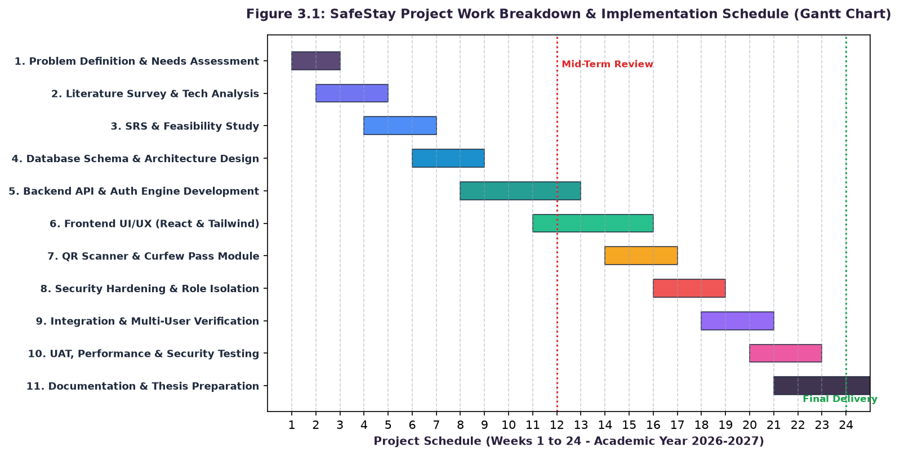
Figure 3.1: SafeStay Work Breakdown Structure and Implementation Timeline (Gantt Chart)
Table 3.6 outlines the major milestone deliverables achieved during the development lifecycle.
Milestone | Phase Title | Key Deliverables & Verification | Status
M1 (Week 4) | Requirements & Feasibility Sign-off | SRS document, stakeholder sign-offs, technology stack selection. | Completed
M2 (Week 8) | Database Schema & Architecture Finalized | Relational DDL schemas, WAL mode configuration, DFD/ER diagrams. | Completed
M3 (Week 13) | Backend REST API & Auth Engine | All 18 REST endpoints implemented with SHA-256 RBAC security. | Completed
M4 (Week 17) | Frontend UI Integration (React SPA) | Role-separated portals, QR generator, dynamic curfew timer views. | Completed
M5 (Week 20) | Optical Scanner & Grievance Modules | WebRTC camera scanner, anonymous complaint triage, financial ledger. | Completed
M6 (Week 24) | Testing, Security Hardening & Thesis | 25 test cases executed, OWASP mitigations verified, documentation. | Completed

CHAPTER 4
CONCEPTUAL MODELS AND SYSTEM ARCHITECTURE
4.1 SafeStay 3-Tier Enterprise Architecture
SafeStay is engineered upon an enterprise 3-tier distributed software architecture that cleanly decouples presentation logic, business application processing, and data persistence. Figure 4.1 illustrates the architectural organization.
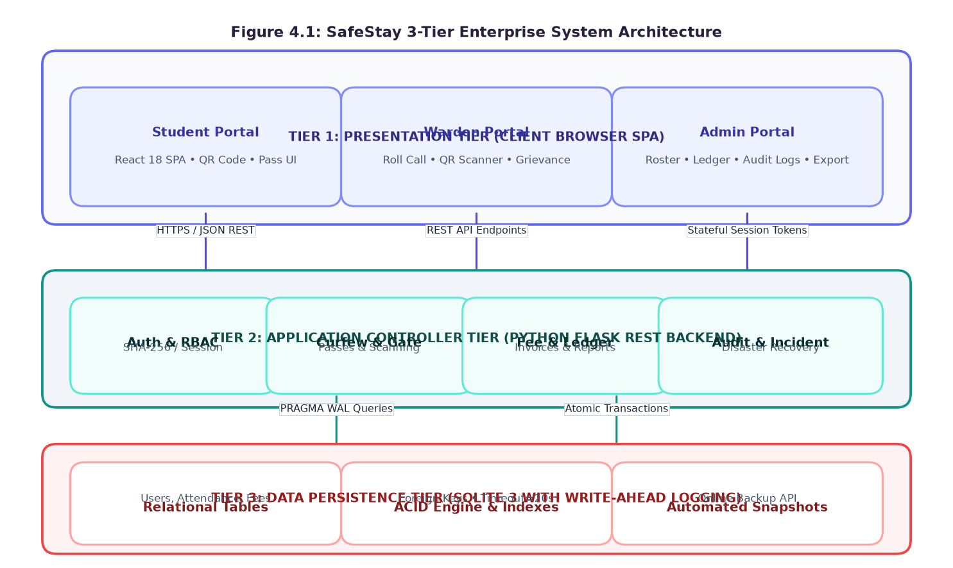
Figure 4.1: SafeStay 3-Tier Enterprise System Architecture
The three architectural tiers operate as follows:
- 1. Presentation Tier (Client SPA): Operates entirely within the resident or administrator browser. Built with React 18, Tailwind CSS, and Lucide Icons, it manages in-memory UI state, validates user input, renders dynamic QR codes, captures optical scanner video frames, and presents interactive dashboards.
- 2. Application Controller Tier (Flask REST Backend): Serves as the centralized operational controller. It handles cryptographic authentication, enforces role-based access control, coordinates curfew breach logic, parses JSON request bodies, and serializes relational records into standardized REST responses.
- 3. Data Persistence Tier (SQLite 3 WAL Engine): Provides ACID-compliant relational data storage. Configured in Write-Ahead Logging (WAL) mode, it processes concurrent transactions from multiple threads with zero locking bottlenecks and manages hot snapshot database backups.
4.2 Data Flow Diagrams (DFD)
Data Flow Diagrams visualize the pathways through which information traverses the SafeStay system, identifying external entities, computational processes, and relational data repositories.
4.2.1 DFD Level 0: Context Diagram
The Level 0 Context Diagram establishes the global boundary of SafeStay, depicting interactions between the central system hub and its four primary external entities: Resident Students, Wardens, Administrators, and Parents/Guardians.
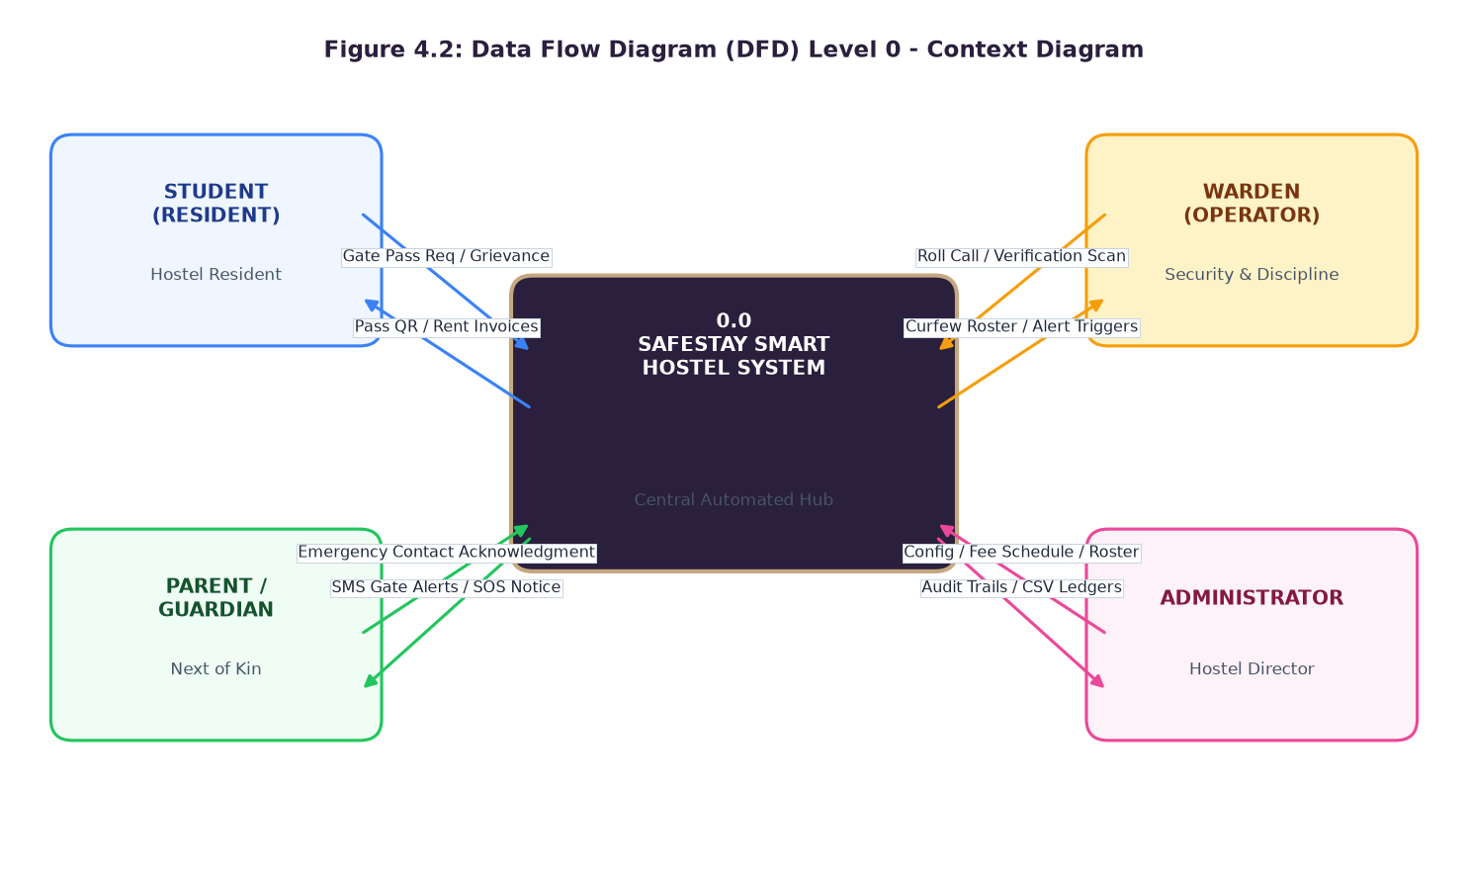
Figure 4.2: Data Flow Diagram (DFD) Level 0 - Global Context Diagram
As illustrated in Figure 4.2, students supply gate pass applications, fee payments, and grievance tickets, receiving QR passes, receipts, and menu schedules. Wardens submit roll-call records and gate verification scans, receiving curfew breach alerts. Administrators configure system policies and receive financial/audit CSV reports, while Parents receive automated SMS notifications.
4.2.2 DFD Level 1: Detailed Functional System Flow
The Level 1 DFD decomposes the system into six core functional processes and five persistent relational data stores (D1 through D5).
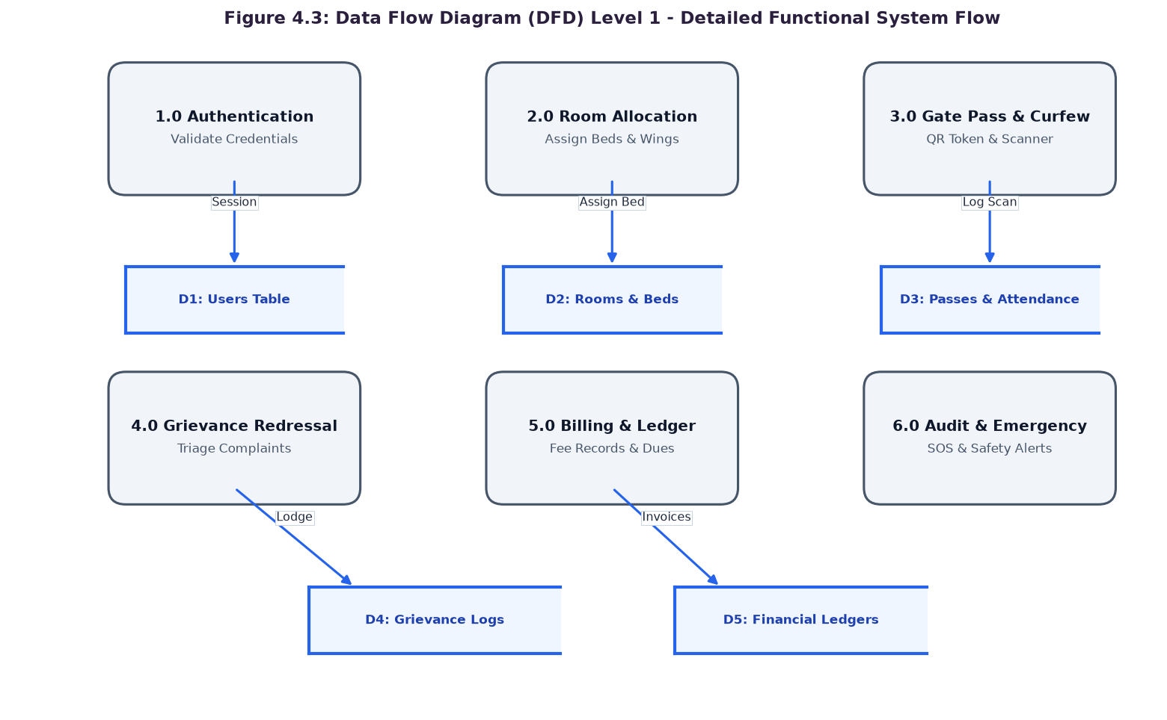
Figure 4.3: Data Flow Diagram (DFD) Level 1 - Detailed Functional System Flow
Process 1.0 authenticates incoming credentials against D1 (Users Table). Process 2.0 manages room allocations and bed assignments using D2 (Rooms & Beds). Process 3.0 handles gate pass approvals and curfew tracking via D3 (Passes & Attendance). Process 4.0 triages grievances via D4 (Grievance Logs). Process 5.0 manages invoices and fee settlements via D5 (Financial Ledgers), while Process 6.0 handles audit trails and emergency alerts.
4.2.3 DFD Level 2: Gate Pass & Curfew Verification Subsystem
Figure 4.4 details the internal logic of the Gate Pass and Curfew Verification Subsystem (Process 3.0).
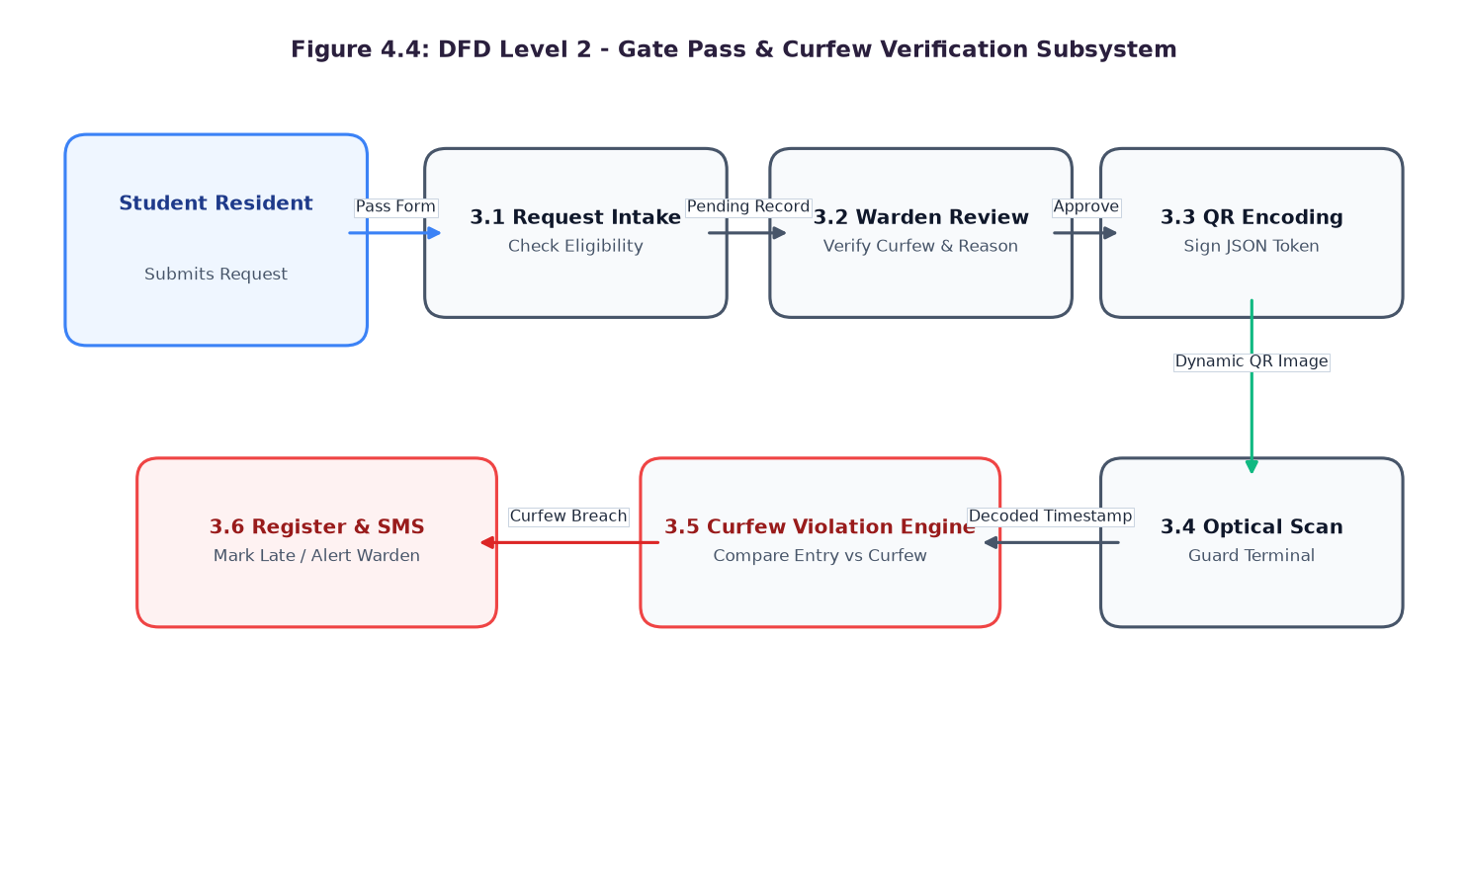
Figure 4.4: DFD Level 2 - Gate Pass and Curfew Verification Subsystem
The process begins when a student submits a pass request. Process 3.1 checks eligibility; Process 3.2 presents the pending pass to the warden. Upon approval, Process 3.3 cryptographically signs a JSON token and generates a QR code. At the gate, Process 3.4 captures the optical scan, and Process 3.5 compares entry timestamps against the 9:30 PM curfew. If breached, Process 3.6 marks the resident late and dispatches an alert.
4.3 System Operational Flowchart
Figure 4.5 maps the end-to-end execution flow of SafeStay from initial user connection to session termination.
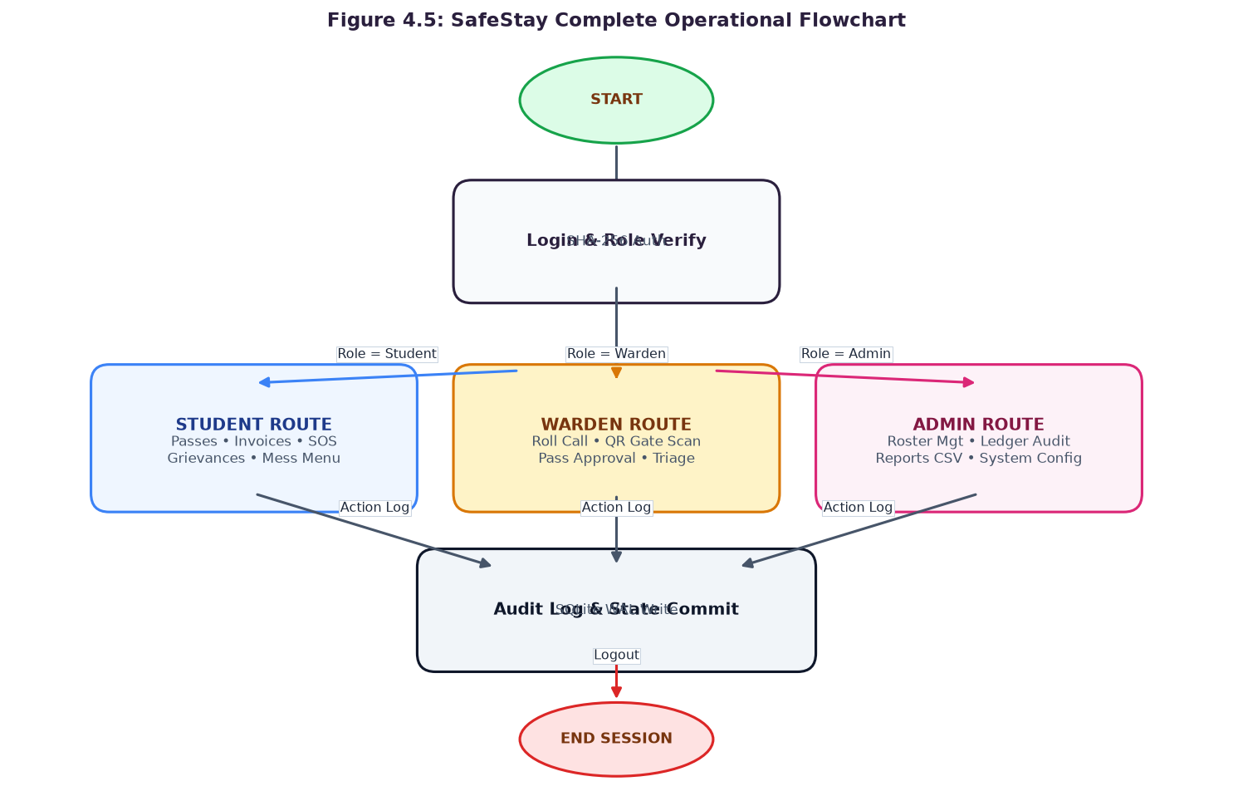
Figure 4.5: SafeStay Complete Operational Flowchart
Upon connecting, the user enters credentials. The system hashes the password with SHA-256 and validates the role. Depending on whether the actor is a Student, Warden, or Administrator, execution routes into dedicated, isolated portal interfaces. Every state change is committed to the SQLite WAL database and recorded in the audit log before session termination.
4.4 Database Design, Entity-Relationship Diagram, and Data Dictionaries
Figure 4.6 presents the Entity-Relationship Diagram (ERD), depicting all relational entities, primary/foreign keys, and cardinalities.
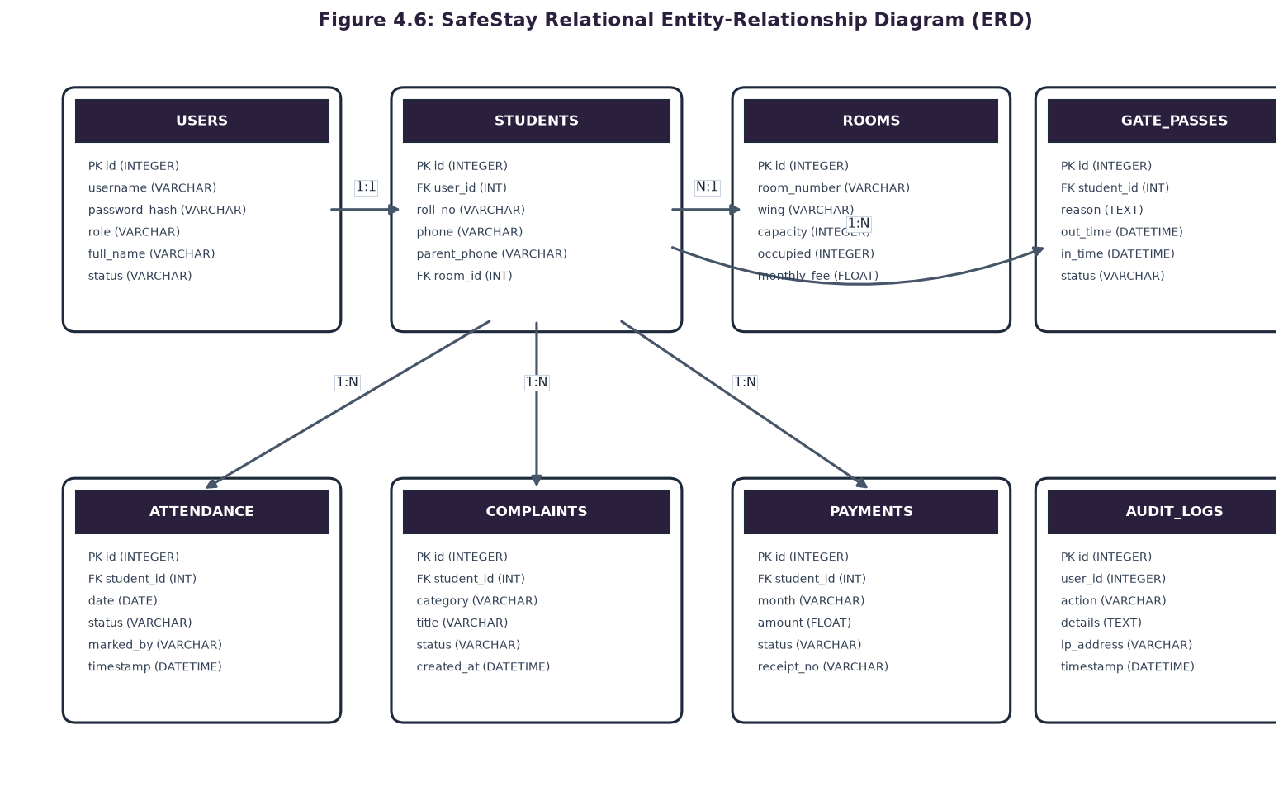
Figure 4.6: SafeStay Relational Entity-Relationship Diagram (ERD)
The SafeStay database comprises nine interrelated relational tables. Tables 4.1 through 4.9 provide the detailed data dictionaries.
Table 4.1: Data Dictionary - USERS Table
Field Name | Data Type | Constraints | Description
id | INTEGER | PRIMARY KEY AUTOINCREMENT | Unique internal user identifier.
username | VARCHAR(50) | NOT NULL UNIQUE | Login username / Roll Number.
password_hash | VARCHAR(128) | NOT NULL | SHA-256 salted password digest.
role | VARCHAR(20) | NOT NULL | Role discriminator: 'student', 'warden', 'admin'.
full_name | VARCHAR(100) | NOT NULL | Full legal name of the user.
status | VARCHAR(20) | DEFAULT 'active' | Account status ('active', 'suspended').

Table 4.2: Data Dictionary - STUDENTS Table
Field Name | Data Type | Constraints | Description
id | INTEGER | PRIMARY KEY AUTOINCREMENT | Unique student record identifier.
user_id | INTEGER | FOREIGN KEY -> users(id) | Associated login credentials ID.
roll_no | VARCHAR(20) | NOT NULL UNIQUE | College academic roll number (e.g. 6420).
room_id | INTEGER | FOREIGN KEY -> rooms(id) | Assigned room foreign key.
bed_number | VARCHAR(10) | NOT NULL | Specific bed allocated (e.g. 'Bed B').
phone | VARCHAR(15) | NOT NULL | Primary mobile contact number.
parent_phone | VARCHAR(15) | NOT NULL | Emergency guardian contact number.
blood_group | VARCHAR(5) | DEFAULT 'O+' | Medical blood group identifier.

Table 4.3: Data Dictionary - ROOMS Table
Field Name | Data Type | Constraints | Description
id | INTEGER | PRIMARY KEY AUTOINCREMENT | Unique room identifier.
room_number | VARCHAR(10) | NOT NULL UNIQUE | Room number (e.g. '204').
wing | VARCHAR(20) | NOT NULL | Hostel wing ('North', 'South', 'East').
capacity | INTEGER | NOT NULL DEFAULT 3 | Maximum resident capacity.
occupied | INTEGER | DEFAULT 0 | Current resident count.
monthly_fee | FLOAT | NOT NULL | Monthly room rental charge (INR).

Table 4.4: Data Dictionary - GATE_PASSES Table
Field Name | Data Type | Constraints | Description
id | INTEGER | PRIMARY KEY AUTOINCREMENT | Unique gate pass record identifier.
student_id | INTEGER | FOREIGN KEY -> students(id) | Resident applying for pass.
pass_type | VARCHAR(20) | NOT NULL | Pass type: 'Local Outing', 'Outstation'.
out_time | DATETIME | NOT NULL | Scheduled departure timestamp.
in_time | DATETIME | NOT NULL | Expected return deadline timestamp.
purpose | TEXT | NOT NULL | Stated purpose and destination.
status | VARCHAR(20) | DEFAULT 'Pending' | Approval state ('Pending', 'Approved', 'Rejected').
qr_token | TEXT | UNIQUE | Cryptographic verification payload string.

Table 4.5: Data Dictionary - ATTENDANCE Table
Field Name | Data Type | Constraints | Description
id | INTEGER | PRIMARY KEY AUTOINCREMENT | Unique attendance log identifier.
student_id | INTEGER | FOREIGN KEY -> students(id) | Associated resident student ID.
date | DATE | NOT NULL | Calendar date of roll call.
status | VARCHAR(20) | NOT NULL | Curfew state: 'Present', 'Absent', 'On-Leave'.
marked_by | VARCHAR(50) | NOT NULL | Warden who verified the roll call.
timestamp | DATETIME | DEFAULT CURRENT_TIMESTAMP | Exact check-in verification timestamp.

Table 4.6: Data Dictionary - COMPLAINTS Table
Field Name | Data Type | Constraints | Description
id | INTEGER | PRIMARY KEY AUTOINCREMENT | Unique grievance ticket identifier.
student_id | INTEGER | FOREIGN KEY -> students(id) | Resident filing the grievance.
category | VARCHAR(30) | NOT NULL | Category: 'Electrical', 'Plumbing', 'WiFi', 'Mess'.
title | VARCHAR(100) | NOT NULL | Brief summary of the issue.
description | TEXT | NOT NULL | Detailed description of the issue.
is_anonymous | BOOLEAN | DEFAULT 0 | Flag concealing resident identity.
status | VARCHAR(20) | DEFAULT 'Open' | Lifecycle state: 'Open', 'In-Progress', 'Resolved'.
created_at | DATETIME | DEFAULT CURRENT_TIMESTAMP | Ticket creation timestamp.

Table 4.7: Data Dictionary - PAYMENTS Table
Field Name | Data Type | Constraints | Description
id | INTEGER | PRIMARY KEY AUTOINCREMENT | Unique financial transaction identifier.
student_id | INTEGER | FOREIGN KEY -> students(id) | Billed resident student ID.
month | VARCHAR(20) | NOT NULL | Billing cycle month (e.g. 'Oct 2026').
amount | FLOAT | NOT NULL | Total invoice amount (Room + Mess).
status | VARCHAR(20) | DEFAULT 'Due' | Settlement state: 'Due', 'Paid', 'Overdue'.
receipt_no | VARCHAR(50) | UNIQUE | Generated digital transaction reference.
paid_date | DATE | NULL | Date of payment settlement.

Table 4.8: Data Dictionary - MESS_MENU Table
Field Name | Data Type | Constraints | Description
id | INTEGER | PRIMARY KEY AUTOINCREMENT | Unique meal timetable identifier.
day_of_week | VARCHAR(15) | NOT NULL | Day: Monday through Sunday.
meal_type | VARCHAR(20) | NOT NULL | Type: 'Breakfast', 'Lunch', 'Snacks', 'Dinner'.
menu_items | TEXT | NOT NULL | Itemized list of food preparations.
calories | INTEGER | DEFAULT 0 | Estimated nutritional calorie value.
special_feast | BOOLEAN | DEFAULT 0 | Flag indicating holiday or banquet meal.

Table 4.9: Data Dictionary - AUDIT_LOGS Table
Field Name | Data Type | Constraints | Description
id | INTEGER | PRIMARY KEY AUTOINCREMENT | Unique audit log entry identifier.
user_id | INTEGER | NULL | Actor who triggered the event.
action | VARCHAR(50) | NOT NULL | Action: 'LOGIN', 'GATE_SCAN', 'BACKUP'.
details | TEXT | NOT NULL | JSON or string payload describing state change.
ip_address | VARCHAR(45) | NOT NULL | Client IP address of the request.
timestamp | DATETIME | DEFAULT CURRENT_TIMESTAMP | Immutable event timestamp.

4.4.10 Complete Relational Schema DDL Implementation Script
The following Data Definition Language (DDL) script represents the production database schema executed during SafeStay initialization. It enforces referential foreign key integrity, uniqueness constraints, timestamp defaults, and indexing for high-speed query execution in SQLite WAL mode.
SQL Schema Listing: Core Authentication and Student Schema DDL
-- SafeStay Relational Schema Definition (Part 1: Core Users & Residents)
PRAGMA foreign_keys = ON;
PRAGMA journal_mode = WAL;
CREATE TABLE IF NOT EXISTS users (
id INTEGER PRIMARY KEY AUTOINCREMENT,
username VARCHAR(50) NOT NULL UNIQUE,
password_hash VARCHAR(128) NOT NULL,
role VARCHAR(20) NOT NULL CHECK(role IN ('student', 'warden', 'admin')),
full_name VARCHAR(100) NOT NULL,
status VARCHAR(20) DEFAULT 'active',
created_at DATETIME DEFAULT CURRENT_TIMESTAMP
);
CREATE TABLE IF NOT EXISTS rooms (
id INTEGER PRIMARY KEY AUTOINCREMENT,
room_number VARCHAR(10) NOT NULL UNIQUE,
wing VARCHAR(20) NOT NULL CHECK(wing IN ('North', 'South', 'East', 'West')),
capacity INTEGER NOT NULL DEFAULT 3,
occupied INTEGER NOT NULL DEFAULT 0,
monthly_fee FLOAT NOT NULL DEFAULT 8500.0,
status VARCHAR(20) DEFAULT 'Available'
);
CREATE TABLE IF NOT EXISTS students (
id INTEGER PRIMARY KEY AUTOINCREMENT,
user_id INTEGER NOT NULL UNIQUE,
roll_no VARCHAR(20) NOT NULL UNIQUE,
room_id INTEGER,
bed_number VARCHAR(10) NOT NULL,
phone VARCHAR(15) NOT NULL,
parent_phone VARCHAR(15) NOT NULL,
blood_group VARCHAR(5) DEFAULT 'O+',
FOREIGN KEY (user_id) REFERENCES users(id) ON DELETE CASCADE,
FOREIGN KEY (room_id) REFERENCES rooms(id) ON DELETE SET NULL
);
CREATE INDEX IF NOT EXISTS idx_students_roll ON students(roll_no);
CREATE INDEX IF NOT EXISTS idx_students_room ON students(room_id);

SQL Schema Listing: Operational Workflows and Audit Schema DDL
-- SafeStay Relational Schema Definition (Part 2: Passes, Attendance & Invoices)
CREATE TABLE IF NOT EXISTS gate_passes (
id INTEGER PRIMARY KEY AUTOINCREMENT,
student_id INTEGER NOT NULL,
pass_type VARCHAR(20) NOT NULL CHECK(pass_type IN ('Local Outing', 'Outstation')),
out_time DATETIME NOT NULL,
in_time DATETIME NOT NULL,
purpose TEXT NOT NULL,
status VARCHAR(20) DEFAULT 'Pending' CHECK(status IN ('Pending', 'Approved', 'Rejected', 'Completed')),
qr_token TEXT UNIQUE,
approved_by VARCHAR(50),
created_at DATETIME DEFAULT CURRENT_TIMESTAMP,
FOREIGN KEY (student_id) REFERENCES students(id) ON DELETE CASCADE
);
CREATE TABLE IF NOT EXISTS attendance (
id INTEGER PRIMARY KEY AUTOINCREMENT,
student_id INTEGER NOT NULL,
date DATE NOT NULL,
status VARCHAR(20) NOT NULL CHECK(status IN ('Present', 'Absent', 'On-Leave', 'Breach Alert')),
marked_by VARCHAR(50) NOT NULL,
timestamp DATETIME DEFAULT CURRENT_TIMESTAMP,
FOREIGN KEY (student_id) REFERENCES students(id) ON DELETE CASCADE,
UNIQUE(student_id, date)
);
CREATE TABLE IF NOT EXISTS complaints (
id INTEGER PRIMARY KEY AUTOINCREMENT,
student_id INTEGER,
category VARCHAR(30) NOT NULL CHECK(category IN ('Electrical', 'Plumbing', 'WiFi', 'Mess', 'Other')),
title VARCHAR(100) NOT NULL,
description TEXT NOT NULL,
is_anonymous BOOLEAN DEFAULT 0,
status VARCHAR(20) DEFAULT 'Open' CHECK(status IN ('Open', 'In-Progress', 'Resolved')),
assigned_to VARCHAR(50),
resolution_notes TEXT,
created_at DATETIME DEFAULT CURRENT_TIMESTAMP,
FOREIGN KEY (student_id) REFERENCES students(id) ON DELETE SET NULL
);
CREATE TABLE IF NOT EXISTS payments (
id INTEGER PRIMARY KEY AUTOINCREMENT,
student_id INTEGER NOT NULL,
month VARCHAR(20) NOT NULL,
amount FLOAT NOT NULL,
status VARCHAR(20) DEFAULT 'Due' CHECK(status IN ('Due', 'Paid', 'Overdue')),
receipt_no VARCHAR(50) UNIQUE,
paid_date DATE,
FOREIGN KEY (student_id) REFERENCES students(id) ON DELETE CASCADE
);
CREATE TABLE IF NOT EXISTS audit_logs (
id INTEGER PRIMARY KEY AUTOINCREMENT,
user_id INTEGER,
action VARCHAR(50) NOT NULL,
details TEXT NOT NULL,
ip_address VARCHAR(45) NOT NULL,
timestamp DATETIME DEFAULT CURRENT_TIMESTAMP
);
CREATE INDEX IF NOT EXISTS idx_audit_time ON audit_logs(timestamp);

4.8 SafeStay RESTful API Route Specifications
The application controller tier exposes eighteen standardized RESTful HTTP endpoints communicating via JSON payloads. Table 4.10 specifies the complete API surface with required authentication roles and HTTP response codes.
Method | Endpoint URI | Role | Operational Behavior | HTTP
POST | /api/auth/login | Public | Validates username and SHA-256 password; sets HTTP session. | 200, 401
POST | /api/auth/logout | Any | Terminates active session; clears authentication cookies. | 200
GET | /api/student/profile | Student | Fetches resident details, room assignment, and roommates. | 200, 403
POST | /api/student/gatepass | Student | Submits a new gate pass request with outing timestamps. | 201, 400
GET | /api/student/gatepass/active | Student | Retrieves approved gate pass and active dynamic QR token. | 200, 404
POST | /api/student/complaints | Student | Lodges a new grievance ticket with optional anonymity. | 201, 400
GET | /api/student/complaints | Student | Returns status progression of resident's past grievances. | 200
GET | /api/student/dues | Student | Fetches current monthly fee invoice and billing breakdown. | 200
POST | /api/student/pay | Student | Executes simulated digital fee payment; generates receipt. | 200, 400
GET | /api/student/mess | Any | Returns weekly 7-day nutritional timetable and feast notices. | 200
POST | /api/student/sos | Student | Broadcasts emergency panic alert with room coordinates. | 200
GET | /api/warden/overview | Warden | Fetches live occupancy counts, gate pass totals, and alerts. | 200, 403
GET | /api/warden/attendance | Warden | Loads daily roll call register filtered by wing and floor. | 200
POST | /api/warden/attendance/save | Warden | Batch commits daily roll call statuses to database. | 200, 400
POST | /api/warden/gate/verify | Warden | Decodes optical QR token; validates entry vs curfew 9:30 PM. | 200, 400
PUT | /api/warden/gatepass/review | Warden | Approves or rejects pending gate pass request. | 200, 404
PUT | /api/warden/complaints/triage | Warden | Assigns work order to technician and updates status. | 200
GET | /api/admin/dashboard | Admin | Returns macro institutional KPIs: revenue, occupancy, SLAs. | 200, 403
GET | /api/admin/students | Admin | Master resident directory with search and filter capabilities. | 200
GET | /api/admin/rooms | Admin | Matrix of room occupancy, capacity, and bed allocations. | 200
GET | /api/admin/audit | Admin | Retrieves chronological security audit trail with IP logs. | 200
GET | /api/admin/export/csv | Admin | Streams RFC-4180 compliant CSV reports to browser. | 200
POST | /api/admin/backup/now | Admin | Triggers hot snapshot backup of SQLite WAL database. | 200

4.5 UML Class Diagram & Domain Modeling
The object-oriented domain model of SafeStay is depicted in Figure 4.7. The design emphasizes encapsulation, relationship navigation, and separation of operational concerns.
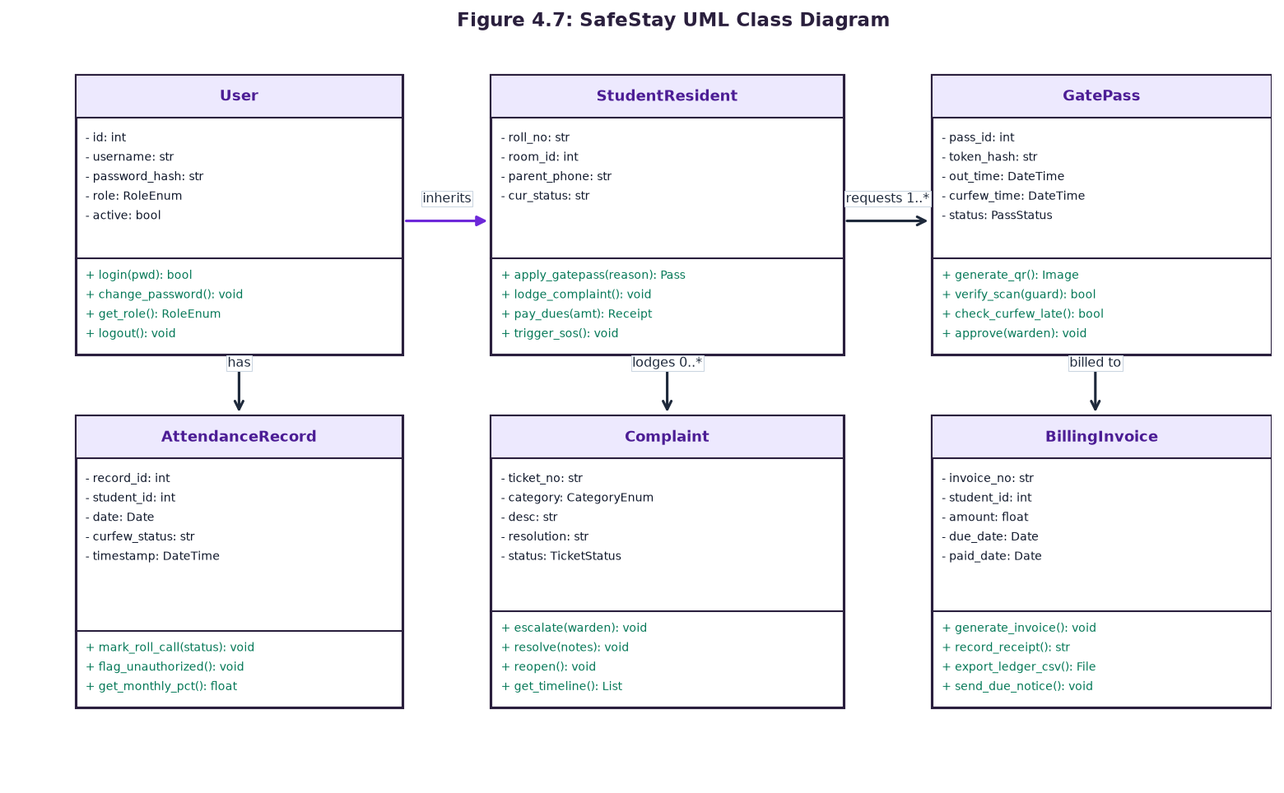
Figure 4.7: SafeStay UML Class Diagram
The core classes include User (base authentication entity), StudentResident (extending user attributes with roll number, room allocation, and guardian contacts), GatePass (encapsulating QR generation, expiration timers, and curfew validation), AttendanceRecord, Complaint, and BillingInvoice.
4.6 UML Sequence Diagrams
Sequence diagrams capture dynamic inter-object collaborations over time for critical system transactions.
4.6.1 Curfew Gate Pass & Optical QR Verification Sequence
Figure 4.8 delineates the sequence of interactions required to apply for, approve, and optically verify a curfew gate pass.
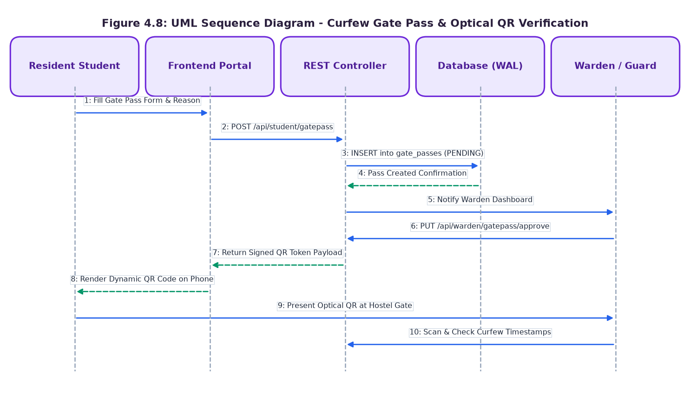
Figure 4.8: Sequence Diagram - Curfew Gate Pass & Optical QR Verification
4.6.2 Resident Grievance Lifecycle Sequence
Figure 4.9 charts the complete lifecycle of a resident maintenance grievance ticket from initial submission to final sign-off.
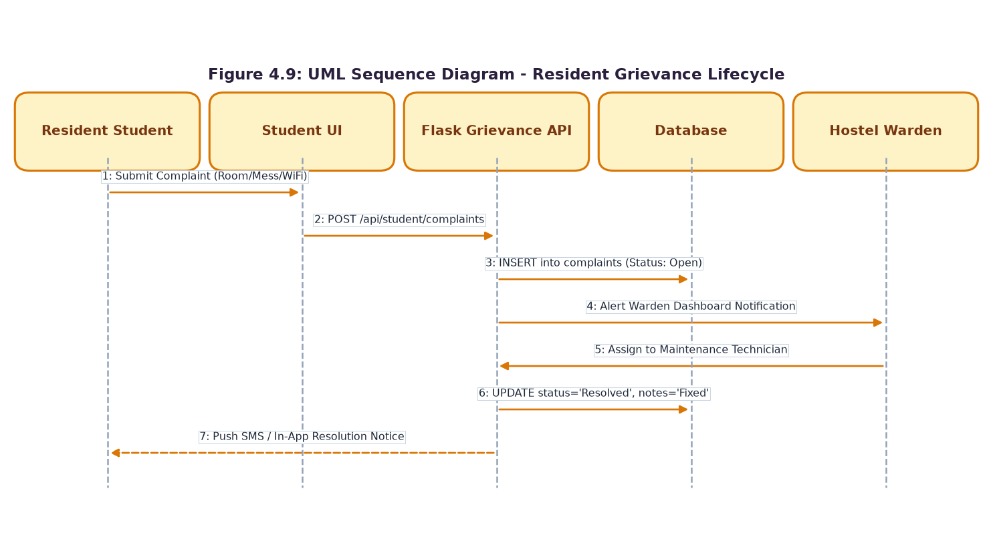
Figure 4.9: Sequence Diagram - Resident Grievance Lifecycle
4.6.3 Digital Rent Fee Payment Sequence
Figure 4.10 documents the automated invoicing, digital settlement, and ledger reconciliation workflow.
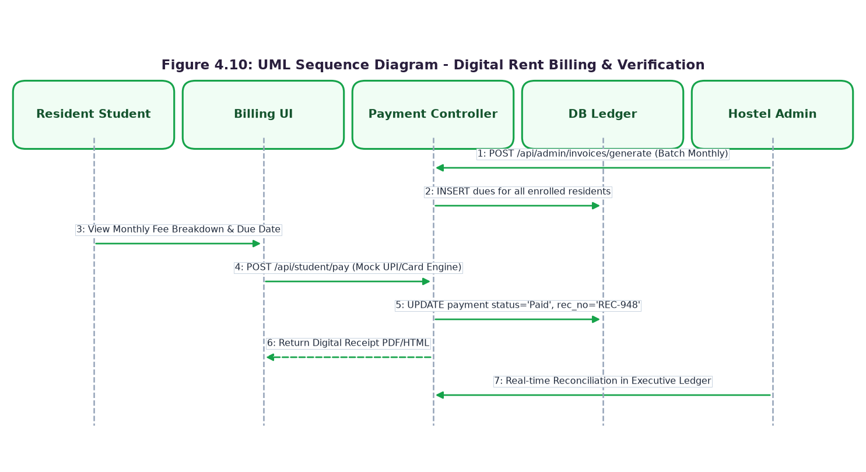
Figure 4.10: Sequence Diagram - Digital Rent Billing & Verification
4.7 UML Use Case Diagrams and Detailed Specifications
Figure 4.11 displays the overall SafeStay System Use Case Diagram, mapping eleven primary use cases across Student Residents, Wardens, and Administrators.
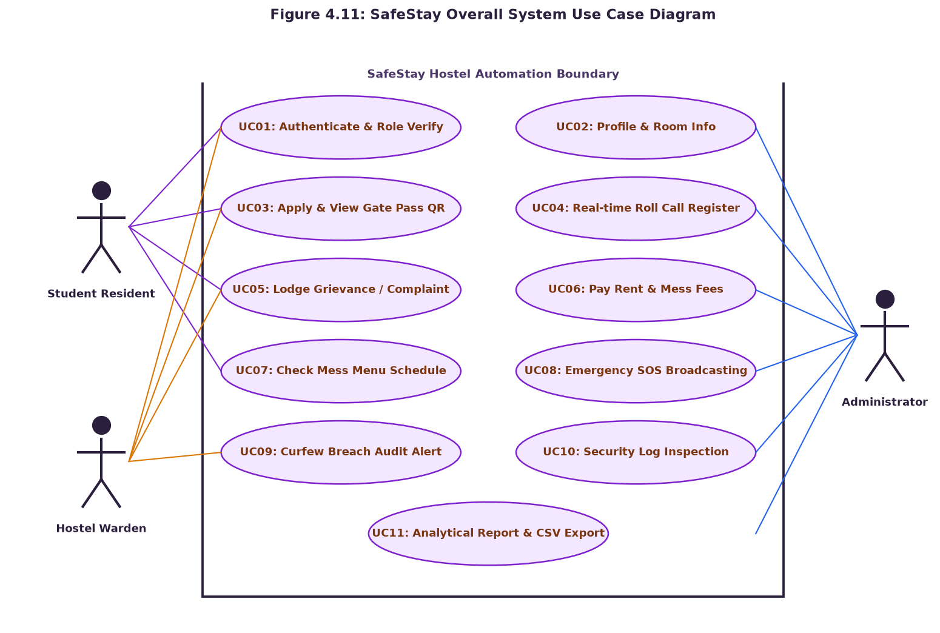
Figure 4.11: SafeStay Overall System Use Case Diagram

4.7.1 UC01: Secure Role-Based Authentication
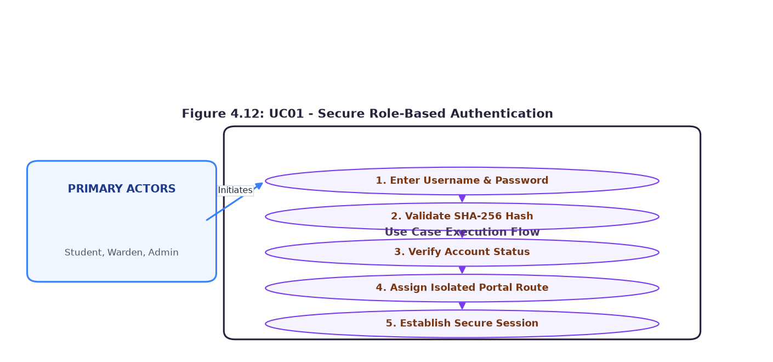
Figure 4.12: UC01: Secure Role-Based Authentication
Specification Attribute | System Implementation Details
Use Case ID | UC01
Use Case Title | Secure Role-Based Authentication
Primary Actors | Student, Warden, Admin
Brief Description | Authenticates credentials, computes SHA-256 digest, validates active account state, and establishes an isolated portal session.
Pre-Conditions | User navigates to login portal and enters username and password.
Normal Flow of Events | 1. System receives credentials.  2. Computes SHA-256 hash.  3. Matches against USERS table.  4. Sets secure session token.  5. Redirects to role-isolated portal.
Post-Conditions | User is redirected to the authorized portal with complete role barriers enforced.
Alternate / Exception Flow | Invalid credentials display error alert; password input is cleared.

4.7.2 UC02: Student Profile and Room Allocation Management
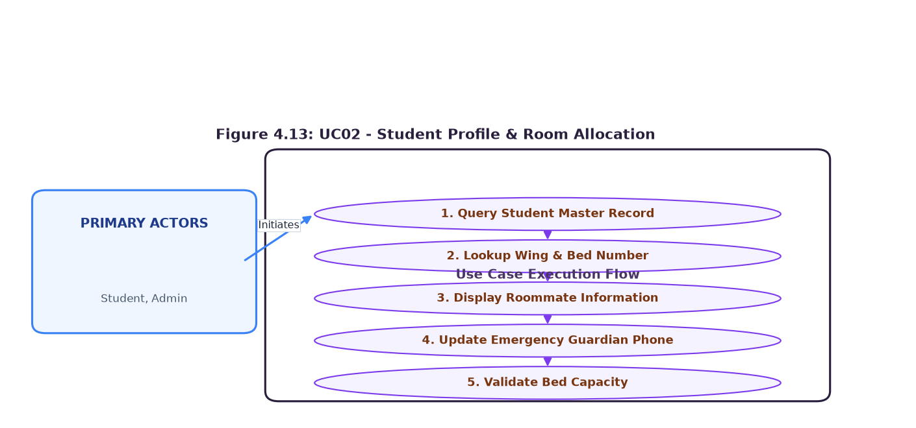
Figure 4.13: UC02: Student Profile and Room Allocation Management
Specification Attribute | System Implementation Details
Use Case ID | UC02
Use Case Title | Student Profile and Room Allocation Management
Primary Actors | Student, Administrator
Brief Description | Allows students to inspect their room allocation, bed number, and roommates, while administrators manage assignments.
Pre-Conditions | Student is authenticated in the Student Portal.
Normal Flow of Events | 1. Queries STUDENTS and ROOMS tables.  2. Retrieves room number, wing, and bed number.  3. Fetches roommate names and current gate statuses.  4. Renders personal emergency contact details.
Post-Conditions | Student views comprehensive room assignment and emergency contact profile.
Alternate / Exception Flow | If no room is allocated, system prompts student to contact hostel warden.

4.7.3 UC03: Curfew Gate Pass Generation & Optical QR Scanning
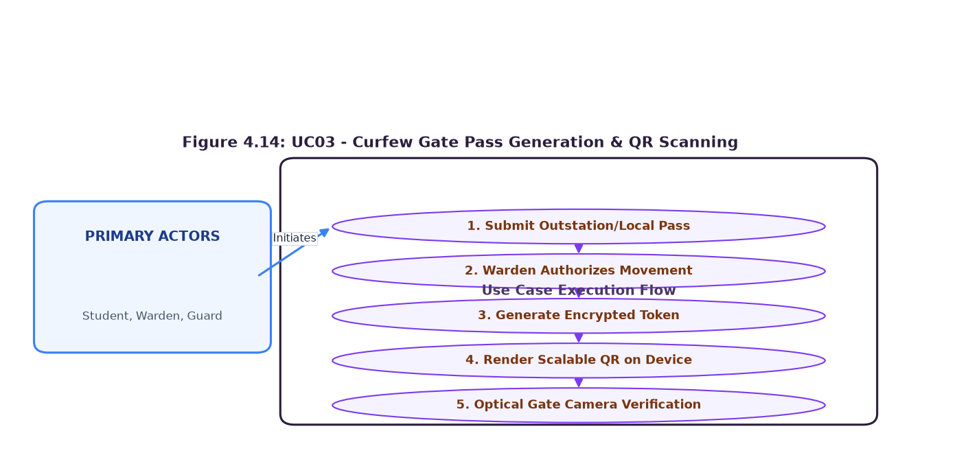
Figure 4.14: UC03: Curfew Gate Pass Generation & Optical QR Scanning
Specification Attribute | System Implementation Details
Use Case ID | UC03
Use Case Title | Curfew Gate Pass Generation & Optical QR Scanning
Primary Actors | Student, Warden, Security Guard
Brief Description | Automates outing applications, warden authorizations, dynamic QR encoding, and optical turnstile scanning.
Pre-Conditions | Student requires temporary exit from the hostel premises.
Normal Flow of Events | 1. Student fills out pass form.  2. Warden reviews and approves request.  3. System signs JSON token.  4. Generates dynamic QR matrix.  5. Guard scans QR at hostel gate.
Post-Conditions | Gate check-out/check-in timestamp is logged; guardian is notified via SMS.
Alternate / Exception Flow | If curfew is breached, scanner flags 'BREACH ALERT' and alerts warden.

4.7.4 UC04: Real-Time Attendance Register & Curfew Tracking
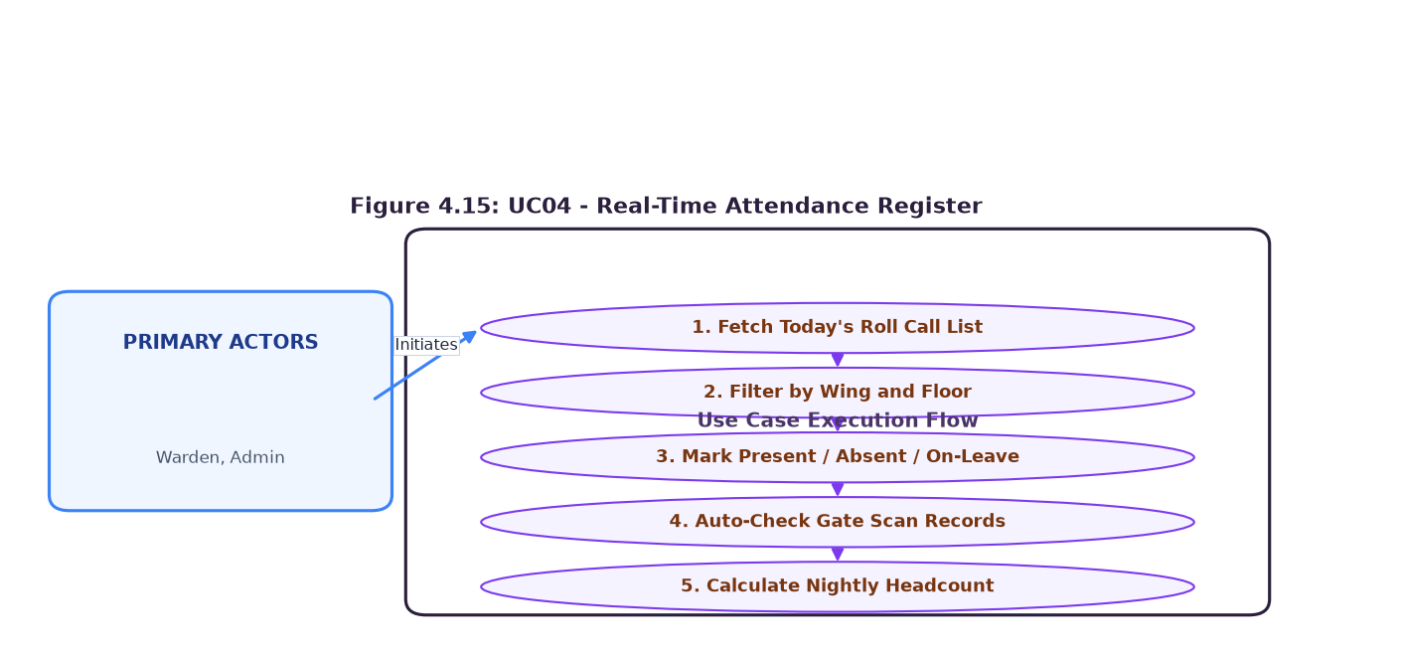
Figure 4.15: UC04: Real-Time Attendance Register & Curfew Tracking
Specification Attribute | System Implementation Details
Use Case ID | UC04
Use Case Title | Real-Time Attendance Register & Curfew Tracking
Primary Actors | Hostel Warden
Brief Description | Enables the warden to conduct nightly roll calls, inspect gate statuses, and audit headcounts against the 9:30 PM cutoff.
Pre-Conditions | Warden accesses the Attendance tab during nightly inspection.
Normal Flow of Events | 1. System loads daily student roll call register.  2. Correlates gate check-in timestamps.  3. Displays 'Present', 'Absent', or 'On-Leave'.  4. Warden confirms room-by-room status.  5. Saves records to ATTENDANCE table.
Post-Conditions | Nightly attendance is committed with zero missing hosteler records.
Alternate / Exception Flow | Unaccounted absentees trigger curfew escalation protocols.

4.7.5 UC05: Anonymous & Open Grievance Redressal
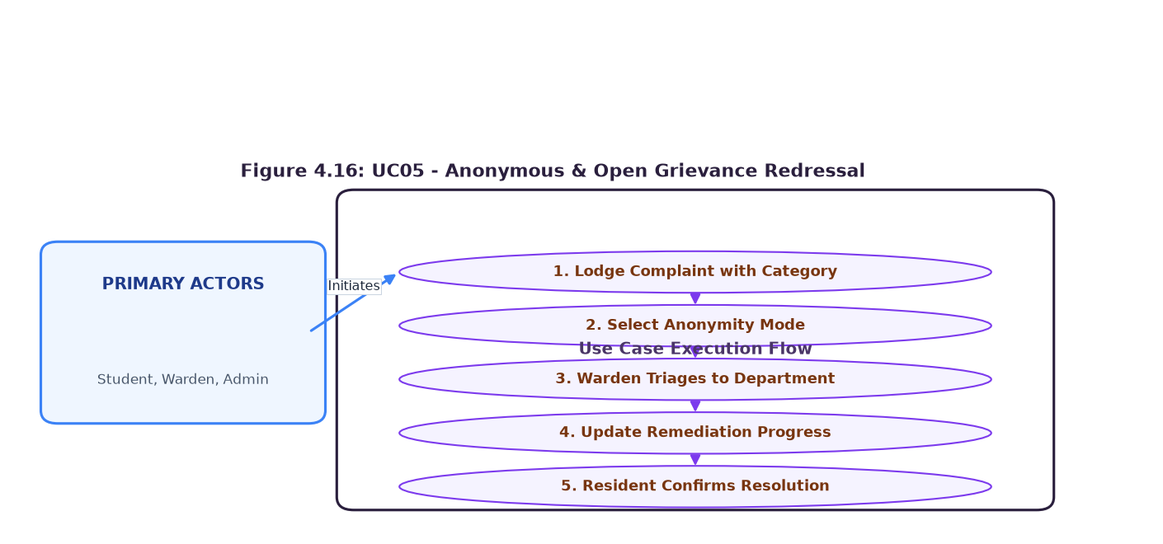
Figure 4.16: UC05: Anonymous & Open Grievance Redressal
Specification Attribute | System Implementation Details
Use Case ID | UC05
Use Case Title | Anonymous & Open Grievance Redressal
Primary Actors | Resident Student, Hostel Warden
Brief Description | Provides a safe, confidential avenue for students to report maintenance, hygiene, or safety issues with optional anonymity.
Pre-Conditions | Resident experiences a facility deficiency or harassment concern.
Normal Flow of Events | 1. Student selects category (Electrical, Plumbing, Wi-Fi, Mess).  2. Enters description.  3. Toggles anonymity.  4. Submits ticket.  5. Warden triages to technician.  6. Progress updated to 'Resolved'.
Post-Conditions | Grievance ticket is resolved with complete transparent SLA tracking.
Alternate / Exception Flow | Unresolved tickets past 48 hours escalate to the College Principal.

4.7.6 UC06: Digital Fee Collection, Invoicing & Financial Ledgers
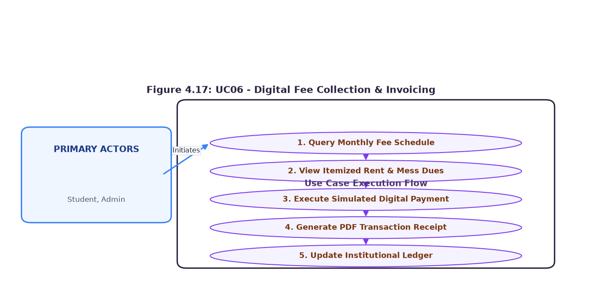
Figure 4.17: UC06: Digital Fee Collection, Invoicing & Financial Ledgers
Specification Attribute | System Implementation Details
Use Case ID | UC06
Use Case Title | Digital Fee Collection, Invoicing & Financial Ledgers
Primary Actors | Student, Administrator
Brief Description | Automates monthly room rent and mess fee billing, simulated payment receipts, and institutional financial ledgers.
Pre-Conditions | Administrative billing cycle generates monthly dues.
Normal Flow of Events | 1. System posts itemized invoices for room and mess fees.  2. Student inspects billing breakdown.  3. Student executes simulated digital payment.  4. System issues receipt number.  5. Updates institutional ledger.
Post-Conditions | Payment status transitions to 'PAID'; digital PDF receipt is generated.
Alternate / Exception Flow | Overdue accounts trigger automated payment reminder notices.

4.7.7 UC07: Mess Menu Schedule and Dietary Feedback
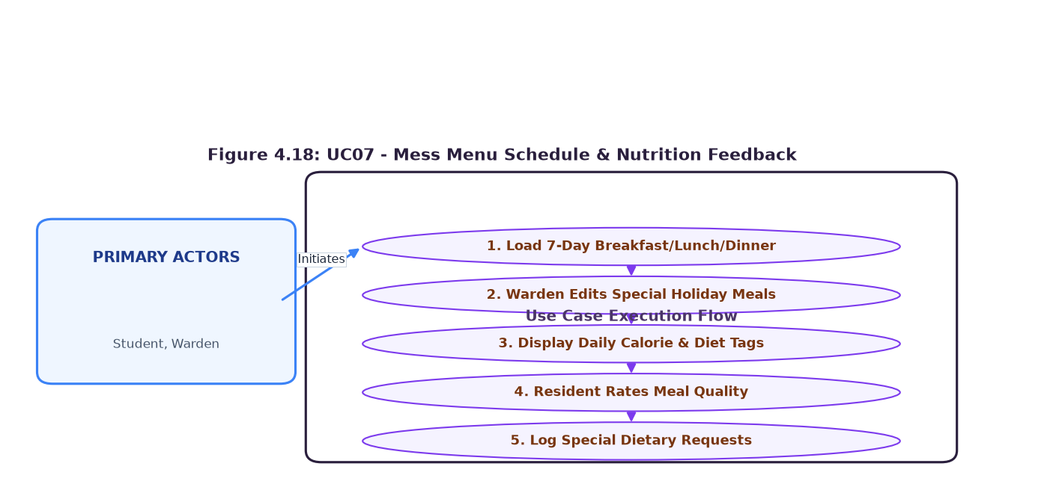
Figure 4.18: UC07: Mess Menu Schedule and Dietary Feedback
Specification Attribute | System Implementation Details
Use Case ID | UC07
Use Case Title | Mess Menu Schedule and Dietary Feedback
Primary Actors | Resident Student, Hostel Warden
Brief Description | Publishes 7-day nutritional schedules and enables residents to rate meal quality and review dietary announcements.
Pre-Conditions | Resident accesses the Mess tab or Warden updates menu.
Normal Flow of Events | 1. System renders 7-day tabbed schedule.  2. Displays Breakfast, Lunch, Snacks, and Dinner.  3. Calculates estimated calorie counts.  4. Warden publishes special festival banquet notices.
Post-Conditions | Resident views updated meal plans and submits dietary feedback.
Alternate / Exception Flow | Mess contractor notified of low student satisfaction scores.

4.7.8 UC08: Emergency SOS Broadcasting and Parent Alerting
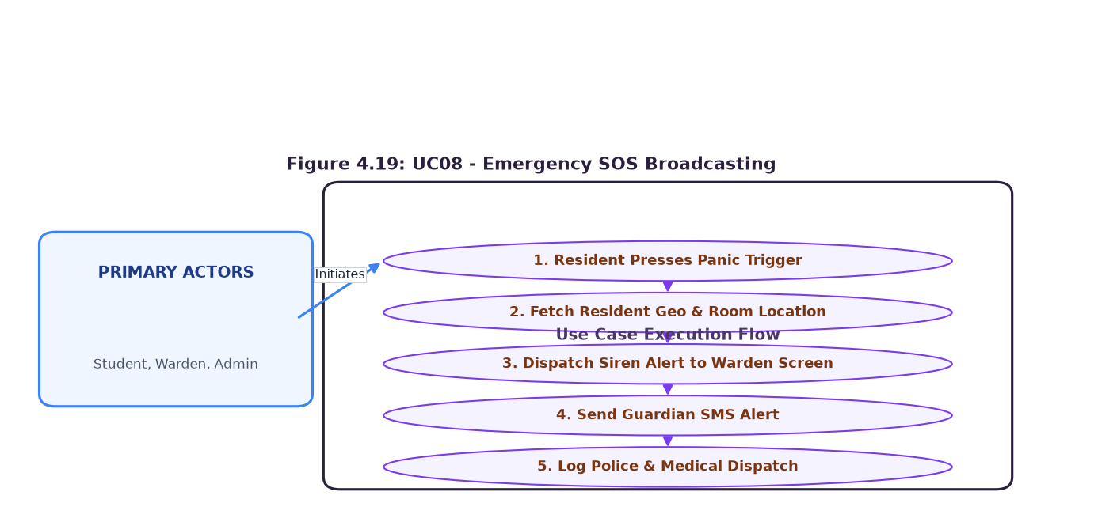
Figure 4.19: UC08: Emergency SOS Broadcasting and Parent Alerting
Specification Attribute | System Implementation Details
Use Case ID | UC08
Use Case Title | Emergency SOS Broadcasting and Parent Alerting
Primary Actors | Resident Student, Warden, Administrator
Brief Description | Dispatches an instantaneous panic alert broadcast during medical, fire, or physical security emergencies.
Pre-Conditions | Resident encounters an immediate personal safety threat.
Normal Flow of Events | 1. Resident taps red SOS panic button.  2. System captures student ID and room location.  3. Dispatches visual siren alert to warden command dashboard.  4. Dispatches emergency SMS to registered guardians.
Post-Conditions | Hostel security and warden respond immediately to the student's room.
Alternate / Exception Flow | False alarms can be dismissed by warden with an authenticated PIN.

4.7.9 UC09: Automated Nightly Curfew Breach & Absence Logging
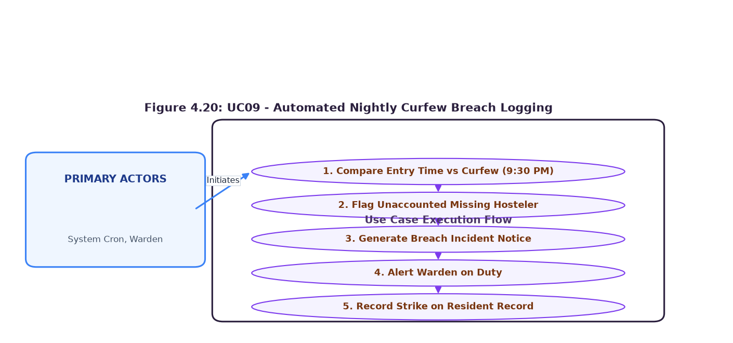
Figure 4.20: UC09: Automated Nightly Curfew Breach & Absence Logging
Specification Attribute | System Implementation Details
Use Case ID | UC09
Use Case Title | Automated Nightly Curfew Breach & Absence Logging
Primary Actors | System Daemon, Hostel Warden
Brief Description | Automatically correlates gate scanner data against the 9:30 PM curfew and generates incident breach records.
Pre-Conditions | System clock passes 09:30:00 PM IST.
Normal Flow of Events | 1. Automated cron scans active gate passes and attendance.  2. Identifies students checked 'OUT' who have not returned.  3. Updates status to 'BREACH ALERT'.  4. Dispatches priority alert to warden screen.
Post-Conditions | Curfew breach is permanently logged on student record and audit trail.
Alternate / Exception Flow | Warden initiates direct telephone contact with resident and parents.

4.7.10 UC10: System-Wide Audit Logging & Security Tracking
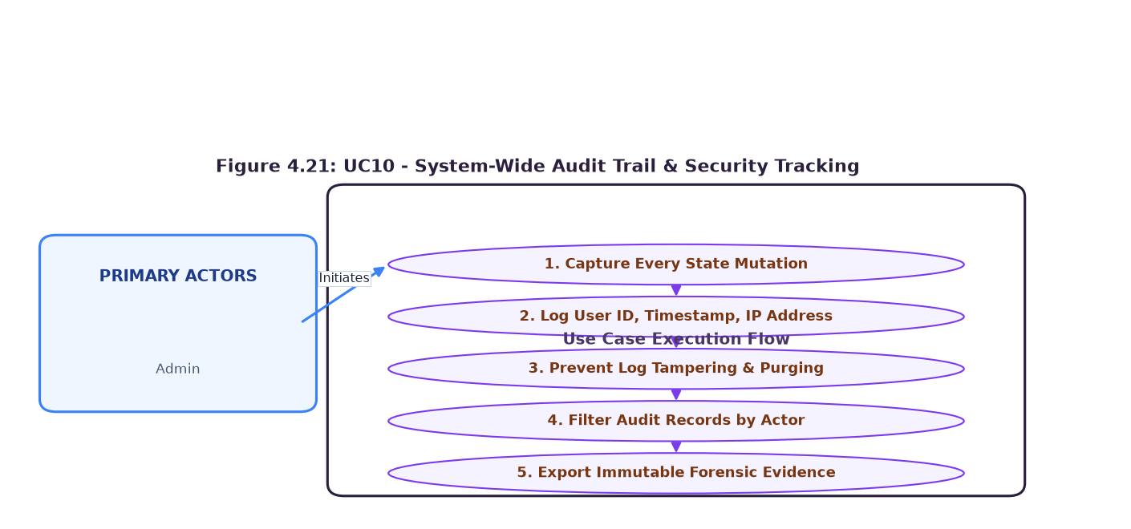
Figure 4.21: UC10: System-Wide Audit Logging & Security Tracking
Specification Attribute | System Implementation Details
Use Case ID | UC10
Use Case Title | System-Wide Audit Logging & Security Tracking
Primary Actors | System Administrator
Brief Description | Maintains an immutable forensic audit trail of all state mutations, security events, and user logins.
Pre-Conditions | Any user executes a state-changing transaction on the system.
Normal Flow of Events | 1. System captures Actor ID, Role, Event Type, IP Address, and Timestamp.  2. Appends immutable entry to AUDIT_LOGS table.  3. Renders filterable audit inspector in Admin Portal.
Post-Conditions | Forensic activity trail is preserved with zero capability for log tampering.
Alternate / Exception Flow | Failed authentication bursts trigger security lockout notices.

4.7.11 UC11: Analytical Reporting and CSV Ledger Exportation
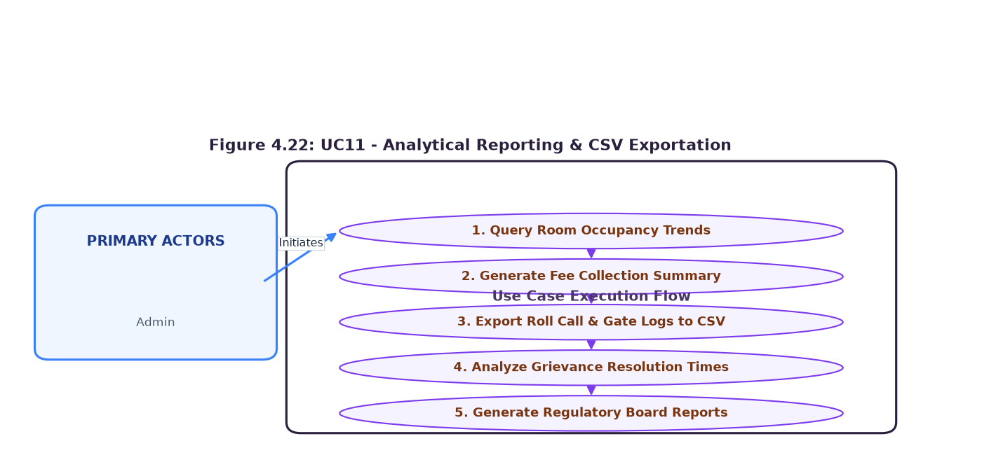
Figure 4.22: UC11: Analytical Reporting and CSV Ledger Exportation
Specification Attribute | System Implementation Details
Use Case ID | UC11
Use Case Title | Analytical Reporting and CSV Ledger Exportation
Primary Actors | System Administrator
Brief Description | Generates aggregate institutional intelligence and exports regulatory CSV data files for college trustees.
Pre-Conditions | Administrator accesses Reports tab in Admin Portal.
Normal Flow of Events | 1. Administrator selects report type (Attendance, Finance, Complaints).  2. System aggregates relational records.  3. Generates streaming RFC-4180 compliant CSV file.  4. Initiates secure browser download.
Post-Conditions | Structured CSV report downloaded successfully for institutional archiving.
Alternate / Exception Flow | Empty data queries prompt administrator to adjust date range filters.

CHAPTER 5
SYSTEM DESIGN, USER INTERFACE & WALKTHROUGH
5.1 Design Methodology & User Interface Philosophy
The user interface of SafeStay is engineered following human-computer interaction (HCI) best practices, modern mobile-first design principles, and Web Content Accessibility Guidelines (WCAG 2.1 AA). Recognizing that users range from tech-savvy undergraduate students to senior hostel wardens and administrative directors, the interface prioritizes simplicity, visual hierarchy, clear color semantics, and zero clutter.
Key interface design pillars include:
- • Role-Isolated Visual Themes: Each user role features a distinct, reassuring visual identity—Student Portal utilizes deep royal purple and indigo (#2A1F3D, #4A3567) symbolizing trust; Warden Portal emphasizes amber and warm gold accents (#C5A880, #D97706) indicating vigilance; Admin Portal uses slate and emerald (#1E293B, #10B981) for executive clarity.
- • Instant Visual Affordances: Action buttons, gate pass QR codes, and emergency triggers are prominently sized with high-contrast text to facilitate error-free operation on handheld mobile screens.
- • Universal Status Semantics: Statuses across the platform strictly observe color conventions: Green indicates valid entry, on-time presence, or settled payments; Amber indicates pending approvals or maintenance in progress; Red signifies curfew breaches, overdue dues, or emergency alarms.
5.2 System Modules and Subsystem Breakdown
The operational platform is organized into three major portal subsystems:
- 1. Student Self-Service Portal (Screens 5.2 to 5.7): Enables residents to view personal credentials, track the 9:30 PM curfew countdown, generate dynamic QR gate passes, lodge confidential grievances, pay monthly fees, and check meal timetables.
- 2. Warden Operations Command Portal (Screens 5.8 to 5.13): Equips wardens with live hostel occupancy counters, optical gate scanning viewports, daily roll-call registers, gate pass approval queues, and maintenance triage boards.
- 3. Administrator Executive Portal (Screens 5.14 to 5.20): Provides college trustees and hostel superintendents with master student rosters, room inventory grids, institutional ledgers, analytical CSV exporters, audit trail inspectors, and database backup engines.
5.2.1 Frontend Component Hierarchy and State Store Architecture
The presentation tier implements a modular React 18 component tree where individual UI modules encapsulate localized state while delegating global session authentication to a top-level Application State Provider. Table 5.0 details the major React components, their rendering responsibilities, and associated sub-components.
React Component | Operational Role | Rendering Responsibility & Behavior | Key Sub-Components
AppRouter | Root Application Shell | Manages browser history routing, role authentication guards, and theme wrappers. | Global Session Context
LoginPage | Authentication Gateway | Renders role selector cards, manages input state, and coordinates SHA-256 login. | RoleBadge, SecurityFooter
StudentDashboard | Resident Command View | Presents real-time curfew timer, active pass badge, quick actions, and notice feed. | CurfewTimer, QuickActionBar
GatePassManager | Pass Lifecycle Engine | Coordinates outing request form inputs and renders dynamic HTML5 QR canvas matrix. | QRCanvas, PassHistoryTable
ComplaintPortal | Grievance Redressal | Manages multi-category ticket lodging, anonymity toggle, and progress timeline. | TimelineStepper, CategorySelect
PaymentGateway | Fee & Dues Ledger | Presents itemized room/mess invoice breakdown and simulated UPI checkout flow. | InvoiceBreakdown, ReceiptModal
MessSchedule | Dining Timetable | Renders 7-day tabbed meal timetable, calorie indicators, and feast notices. | DayTabs, MealCardList
WardenDashboard | Hostel Ops Center | Displays live headcount cards, curfew alert banners, and immediate triage queue. | OccupancyGauge, AlertBanner
CurfewRegister | Roll Call Engine | Interactive room-by-room roll call table with bulk commit state management. | RollCallRow, WingFloorFilter
OpticalGateScanner | Turnstile Camera | WebRTC camera viewport with laser reticle, token parser, and verification badge. | CameraViewport, MatchModal
AdminExecutiveHub | Institutional Overview | High-level KPI metric cards, wing capacity progress bars, and audit monitor. | MetricKPICard, WingProgressBar
StudentMasterRoster | Directory Manager | Data table supporting real-time text search, wing filtering, and add-resident modal. | RosterTable, AddStudentModal
RoomMatrixGrid | Inventory Matrix | Interactive floor/wing grid with color-coded bed occupancy and assignment dialogs. | RoomCard, BedAllocationModal
AuditTrailInspector | Forensic Inspector | Chronological table displaying user mutations, timestamps, and client IP addresses. | AuditLogRow, ForensicFilter

5.3 Detailed Screen Specifications & Interface Snapshots
The following twenty sections provide comprehensive screen walkthroughs, pairing high-fidelity interface snapshots with detailed functional specifications.

5.3.1 Unified Role-Separated Authentication Portal
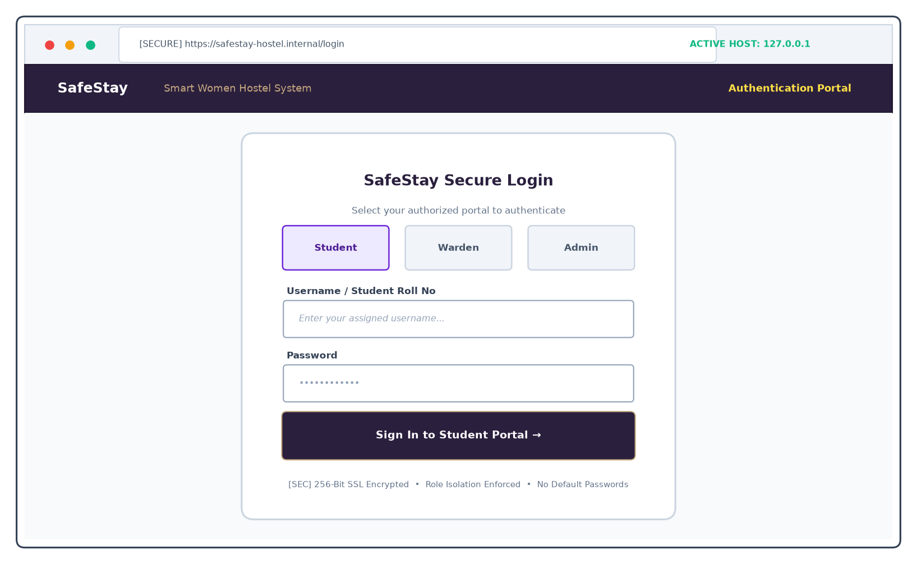
Figure 5.1: Unified Role-Separated Authentication Portal
The entry gateway for all SafeStay stakeholders. Features three distinct role selector cards (Student, Warden, Admin), clear username and password inputs (empty by default as per security policies), 256-bit encryption indicators, and automated route assignment upon authentication.
Operational Attribute | Screen Specification & Behavior
Target Route | /login
Supported Roles | Student, Warden, Administrator
Security | SHA-256 salted hashing, role isolation
Session Lifespan | 8 hours continuous active session

5.3.2 Student Portal - Overview & Curfew Countdown Dashboard
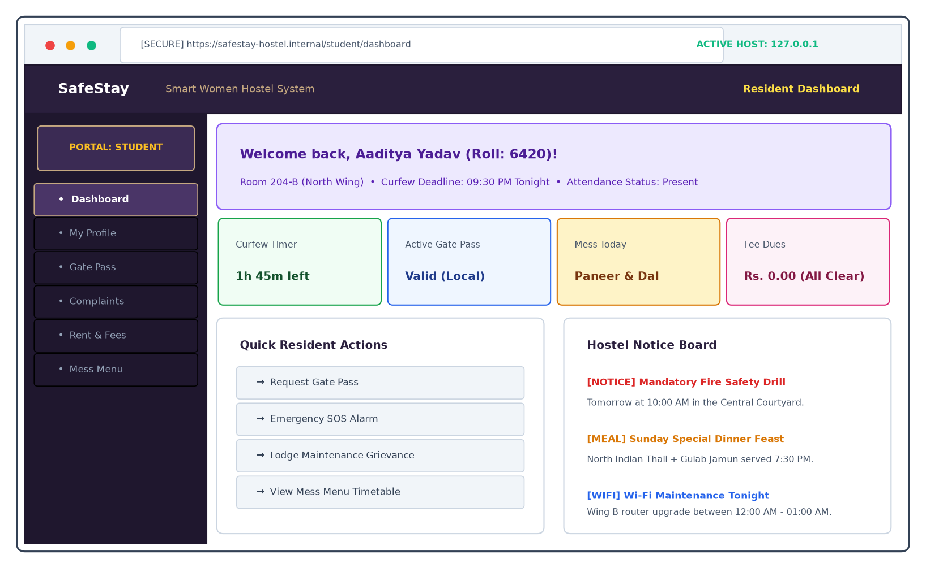
Figure 5.2: Student Portal - Overview & Curfew Countdown Dashboard
The resident landing dashboard. Displays a personalized greeting with roll number and allocated room, a real-time curfew countdown timer counting down to the 9:30 PM deadline, active gate pass status pill, quick action shortcuts, and an institutional notice board.
Operational Attribute | Screen Specification & Behavior
Target Route | /student/dashboard
Primary Focus | Curfew awareness & rapid emergency actions
Notice Feed | Dynamic broadcast notices from Warden
Gate Pill | Displays current pass validity and return cutoff

5.3.3 Student Portal - Digital Identity & Room Assignment
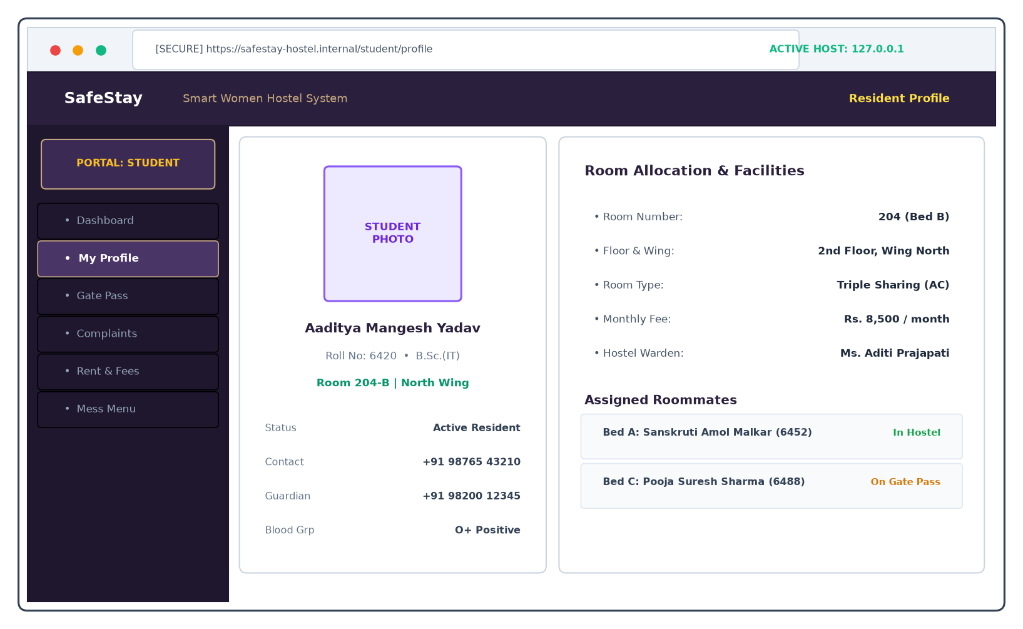
Figure 5.3: Student Portal - Digital Identity & Room Assignment
Digital ID badge for resident verification. Displays the student's legal name, roll number, assigned room (e.g. Room 204-B, North Wing), monthly rent, personal phone, guardian phone, blood group, and real-time gate statuses of assigned roommates.
Operational Attribute | Screen Specification & Behavior
Target Route | /student/profile
Verification | Digital photo badge and roll number verification
Roommates | Real-time presence tracking of room peers
Emergency | Verified next-of-kin guardian contact

5.3.4 Student Portal - Curfew Gate Pass & Optical QR Code
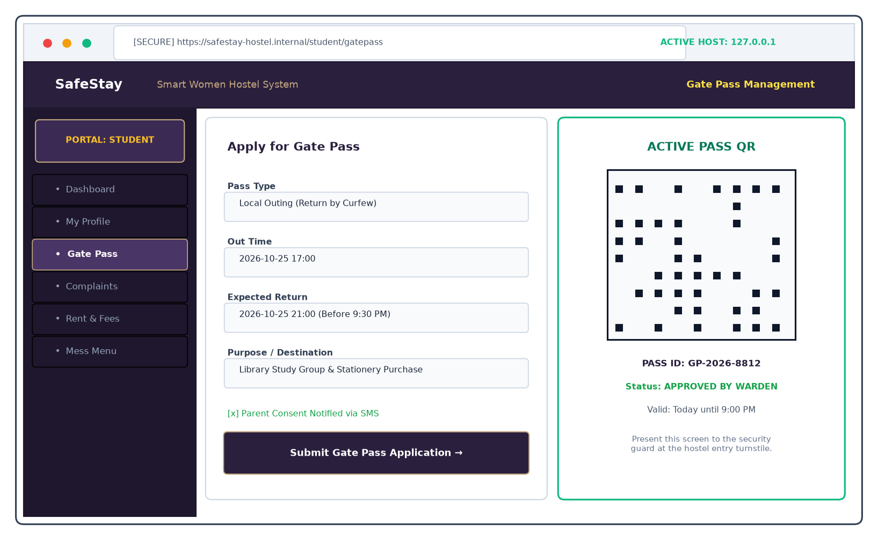
Figure 5.4: Student Portal - Curfew Gate Pass & Optical QR Code
Interactive gate pass application and dynamic QR code display. Allows students to submit outing purposes and return deadlines. Once approved by the warden, the screen generates a cryptographically signed matrix QR code for scanning at the gate turnstile.
Operational Attribute | Screen Specification & Behavior
Target Route | /student/gatepass
QR Encoding | High-contrast dynamic matrix with token hash
Pass Types | Local Outing (<9:30 PM), Outstation Leave
Verification | Scanned by security camera in under 2 seconds

5.3.5 Student Portal - Grievance Redressal & Status Timeline
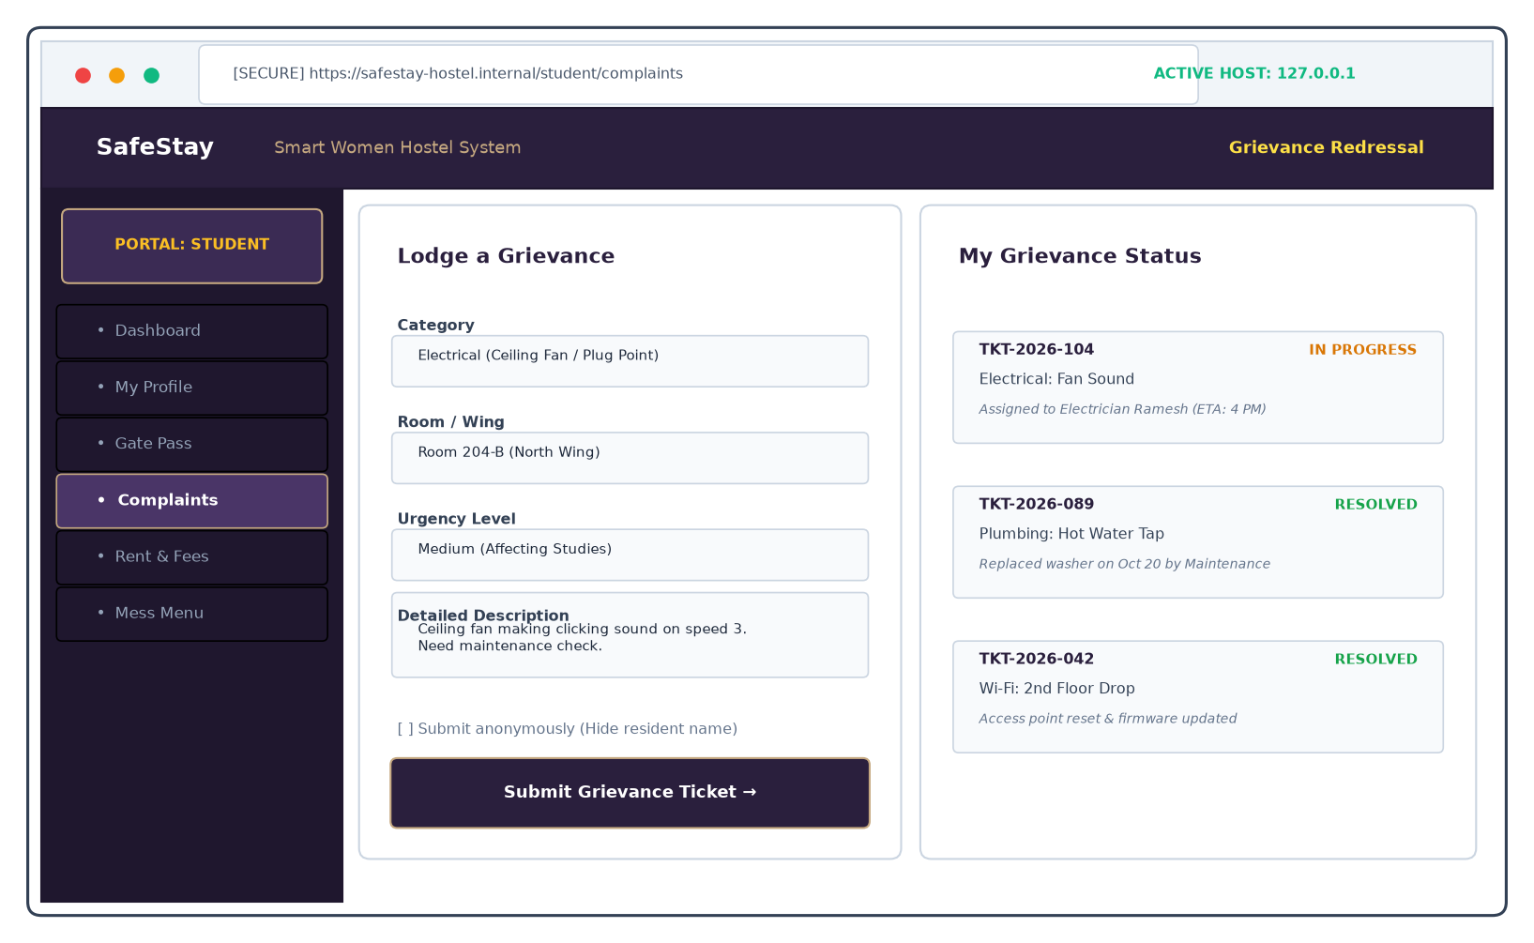
Figure 5.5: Student Portal - Grievance Redressal & Status Timeline
Comprehensive resident grievance lodge and tracking interface. Features category dropdowns (Electrical, Plumbing, Wi-Fi, Mess), urgency levels, an anonymity toggle checkbox, and a status progression tracker displaying technician assignment and resolution notes.
Operational Attribute | Screen Specification & Behavior
Target Route | /student/complaints
Anonymity | Conceals student identity from maintenance staff
SLA Target | Resolution within 24 to 48 hours
History | Complete archive of past resolved tickets

5.3.6 Student Portal - Rent Invoicing & Digital Receipts
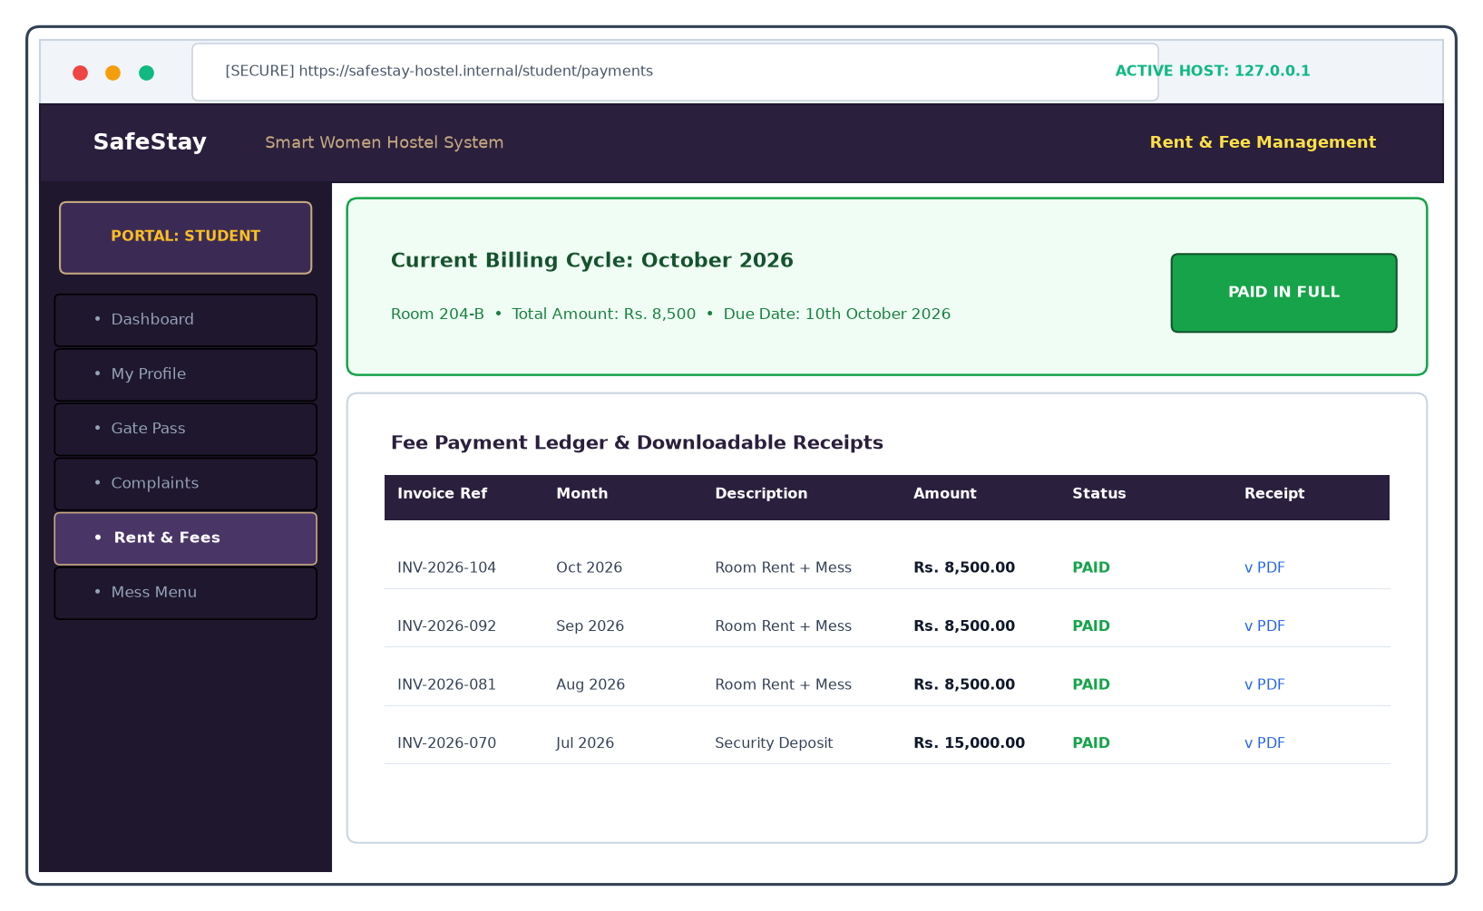
Figure 5.6: Student Portal - Rent Invoicing & Digital Receipts
Resident financial billing interface. Summarizes current monthly dues (Room Rent ₹6,000 + Mess ₹2,500 = ₹8,500), payment due dates, a simulated digital settlement flow (UPI/NetBanking), and downloadable PDF receipts with unique transaction reference numbers.
Operational Attribute | Screen Specification & Behavior
Target Route | /student/payments
Billing Model | Itemized monthly room rent and mess fee dues
Settlement | Simulated digital payment engine
Receipts | Downloadable proof of payment for college records

5.3.7 Student Portal - Weekly Mess Timetable & Nutrition
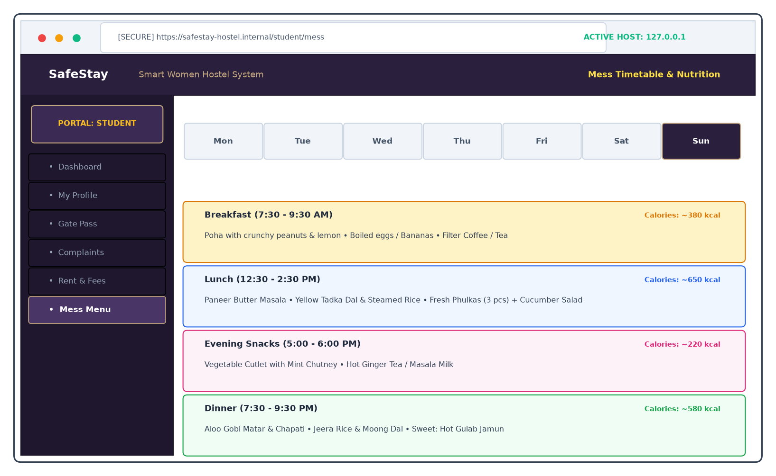
Figure 5.7: Student Portal - Weekly Mess Timetable & Nutrition
Seven-day interactive dining schedule. Features tabbed navigation across all days of the week, detailing breakfast, lunch, evening snacks, and dinner preparations, alongside estimated calorie counts and warden feast announcements.
Operational Attribute | Screen Specification & Behavior
Target Route | /student/mess
Meal Coverage | Breakfast, Lunch, Evening Snacks, Dinner
Nutrition | Estimated calorie indicators per meal preparation
Feasts | Highlighting special holiday banquet menus

5.3.8 Warden Portal - Command Center & Real-Time Hosteler Occupancy
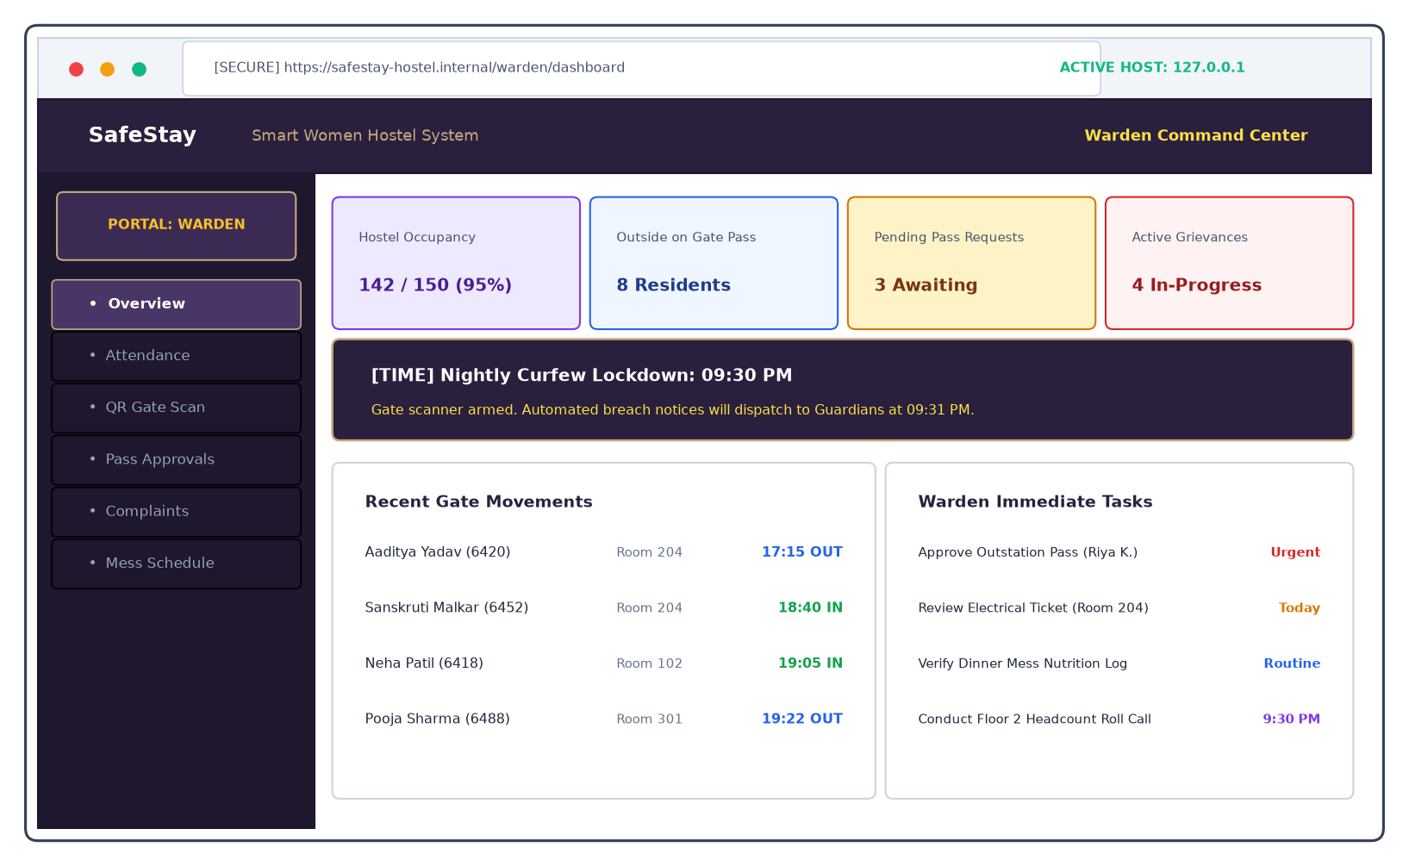
Figure 5.8: Warden Portal - Command Center & Real-Time Hosteler Occupancy
Executive operational dashboard for hostel wardens. Displays real-time hostel occupancy gauges (e.g. 142/150 in-house), counts of residents outside on pass, pending pass applications, active grievances, and an armed curfew countdown banner.
Operational Attribute | Screen Specification & Behavior
Target Route | /warden/dashboard
Occupancy | Real-time headcount of residents physically present
Curfew Banner | Visual alarm countdown to 9:30 PM curfew
Action Queue | Immediate pending pass requests and high-priority tickets

5.3.9 Warden Portal - Curfew Attendance Register & Daily Roll Call
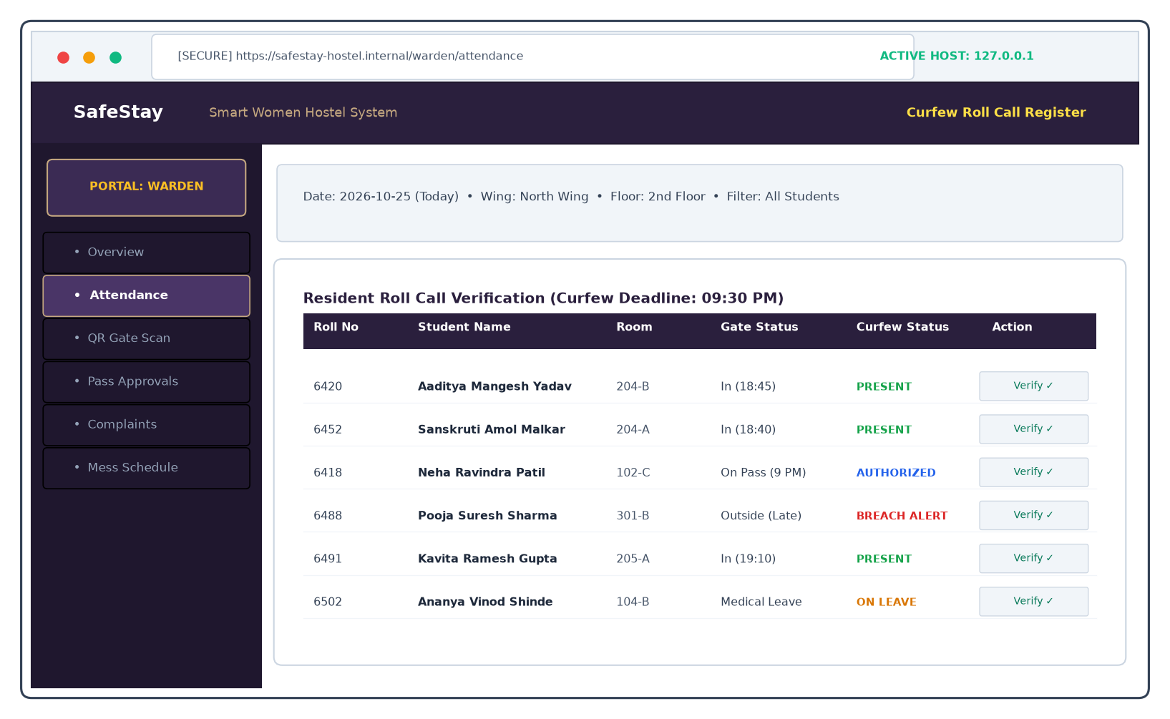
Figure 5.9: Warden Portal - Curfew Attendance Register & Daily Roll Call
Daily curfew roll-call register. Wardens filter residents by wing and floor, inspecting gate check-in times and toggling Present, Absent, or On-Leave statuses room-by-room with one-touch bulk commit functionality.
Operational Attribute | Screen Specification & Behavior
Target Route | /warden/attendance
Filters | Wing (North/South/East) and Floor (1st/2nd/3rd)
Curfew Tracking | Highlights breach alerts for hostlers missing past 9:30 PM
Commit | Atomic multi-record batch persistence to ATTENDANCE

5.3.10 Warden Portal - Optical QR Gate Scanner & Verification Screen
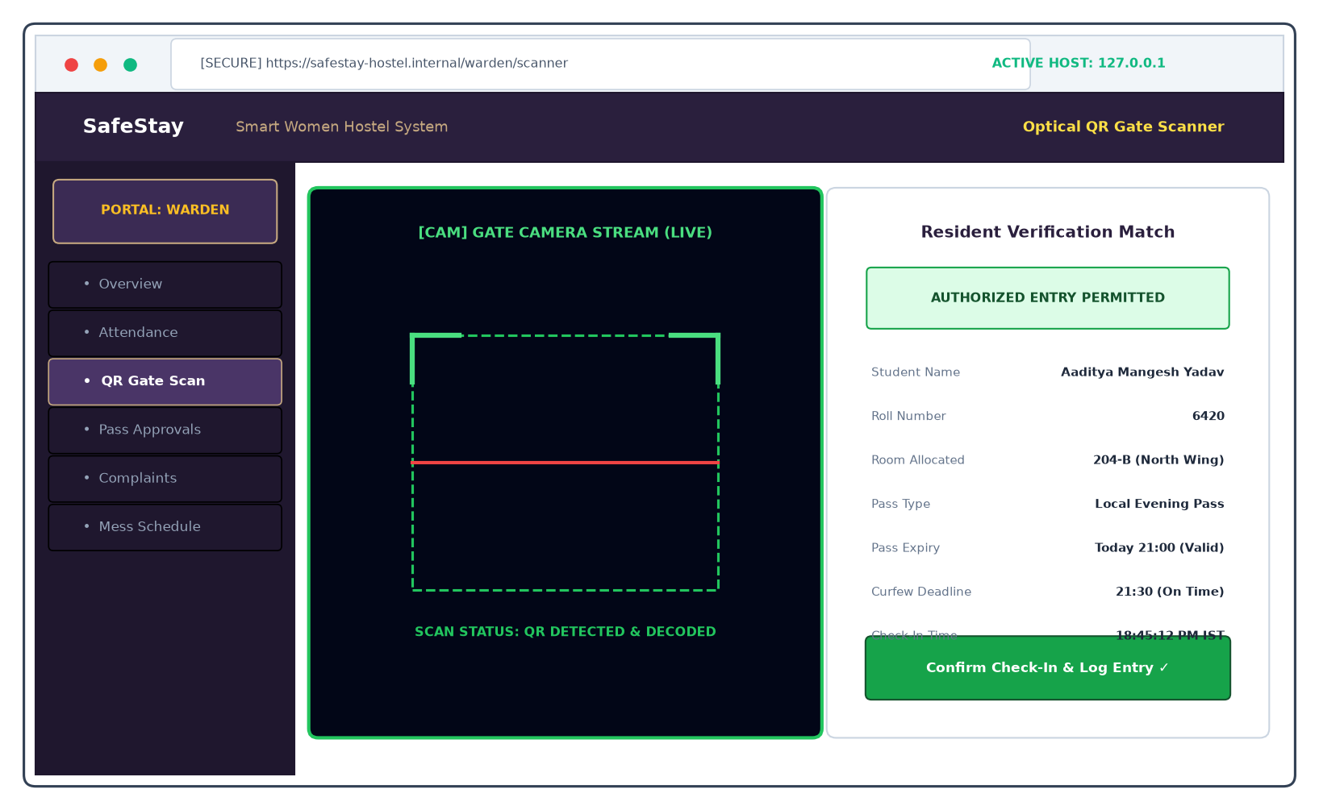
Figure 5.10: Warden Portal - Optical QR Gate Scanner & Verification Screen
Optical camera scanner viewport. Utilizes WebRTC video streams with a green laser targeting reticle to detect and decode resident QR codes, matching the token against the database and displaying an instant authorized entry permit badge.
Operational Attribute | Screen Specification & Behavior
Target Route | /warden/scanner
Scanner Engine | Optical WebRTC video stream decoder
Turnaround | Barcode detection and database match in <1.8s
Curfew Badge | Instant verification: 'AUTHORIZED ENTRY PERMITTED'

5.3.11 Warden Portal - Gate Pass Approvals & Movement History
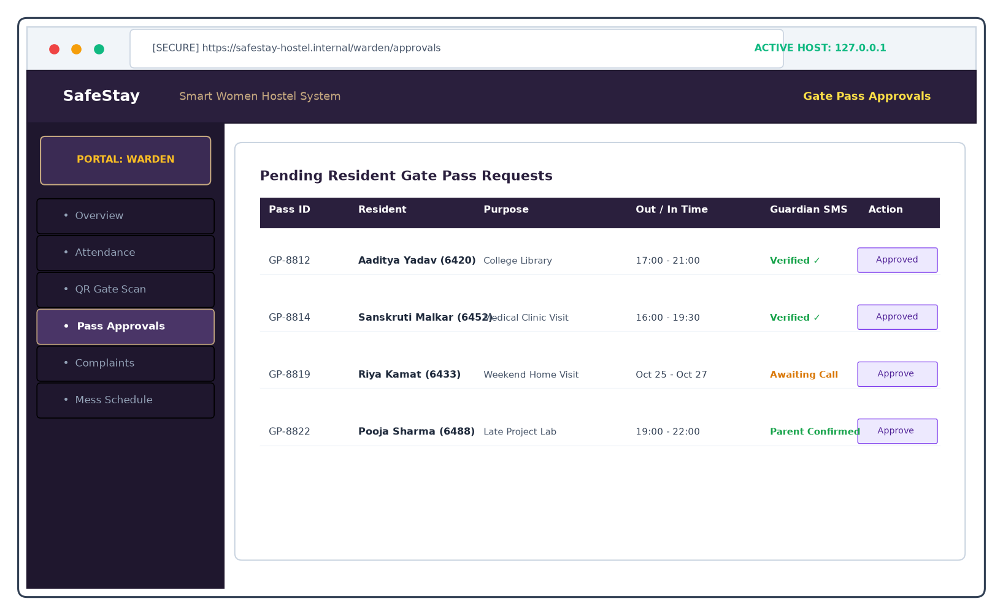
Figure 5.11: Warden Portal - Gate Pass Approvals & Movement History
Gate pass application processing queue. Wardens inspect pending student requests, review destination reasons, verify parent phone acknowledgments, and grant digital approvals that immediately generate the resident's QR pass.
Operational Attribute | Screen Specification & Behavior
Target Route | /warden/approvals
Decision Flow | Approve Pass (generates QR) or Reject (with note)
Verification | Parent SMS consent confirmation status
Movement Log | Comprehensive audit of resident exit and re-entry times

5.3.12 Warden Portal - Grievance Triage, Assignment & Notes
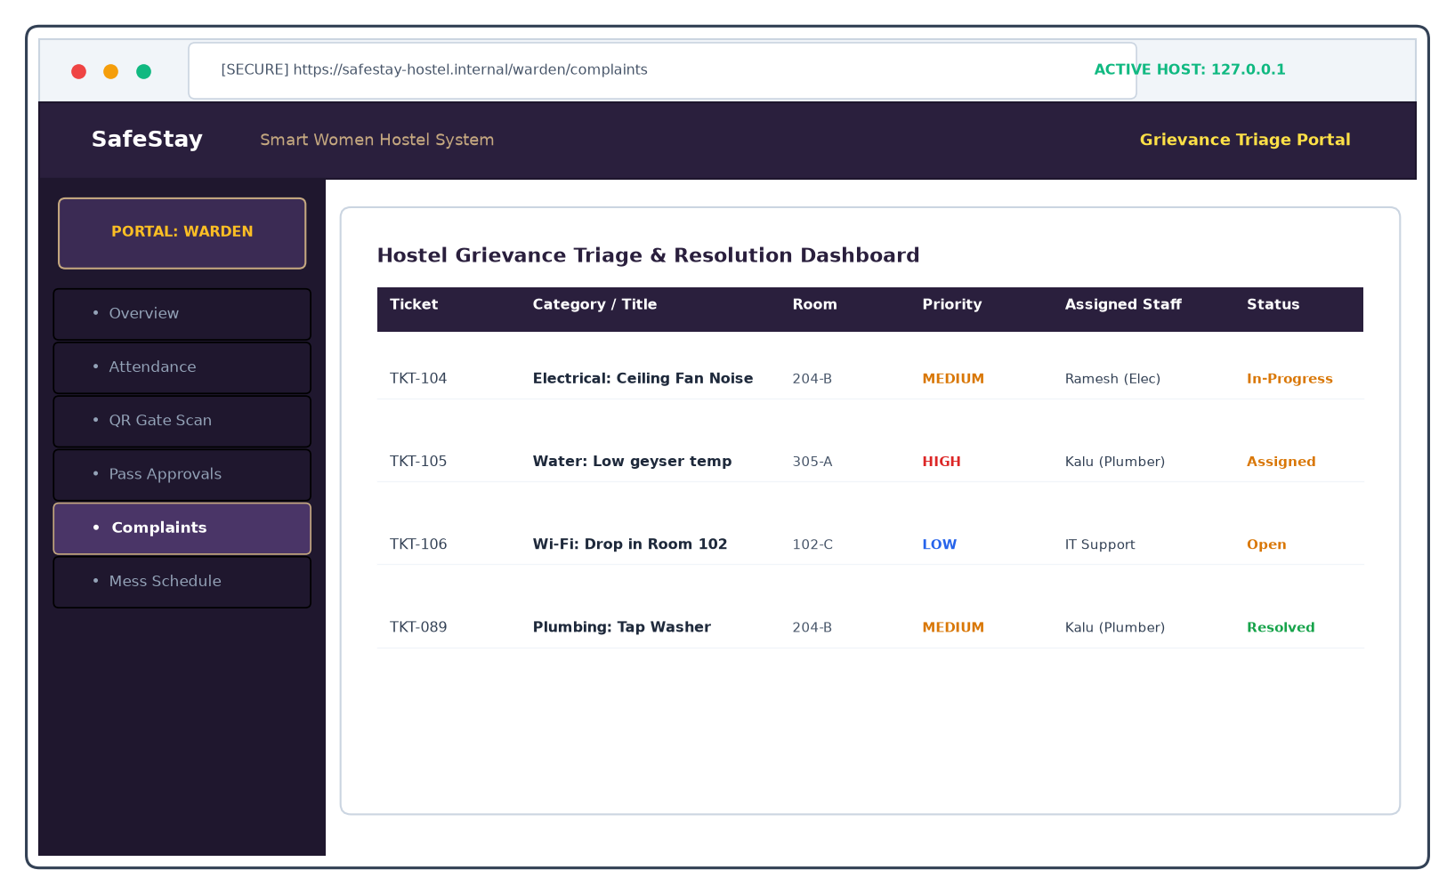
Figure 5.12: Warden Portal - Grievance Triage, Assignment & Notes
Centralized complaint management dashboard. Enables wardens to prioritize incoming tickets, assign work orders to campus electricians, plumbers, or IT technicians, log remediation notes, and transition tickets to 'Resolved'.
Operational Attribute | Screen Specification & Behavior
Target Route | /warden/complaints
Triage Grid | Sorted by urgency: High, Medium, Low
Assignment | Direct delegation to maintenance personnel
Feedback | Automated notification dispatched to resident upon resolution

5.3.13 Warden Portal - Mess Menu Management & Special Announcements
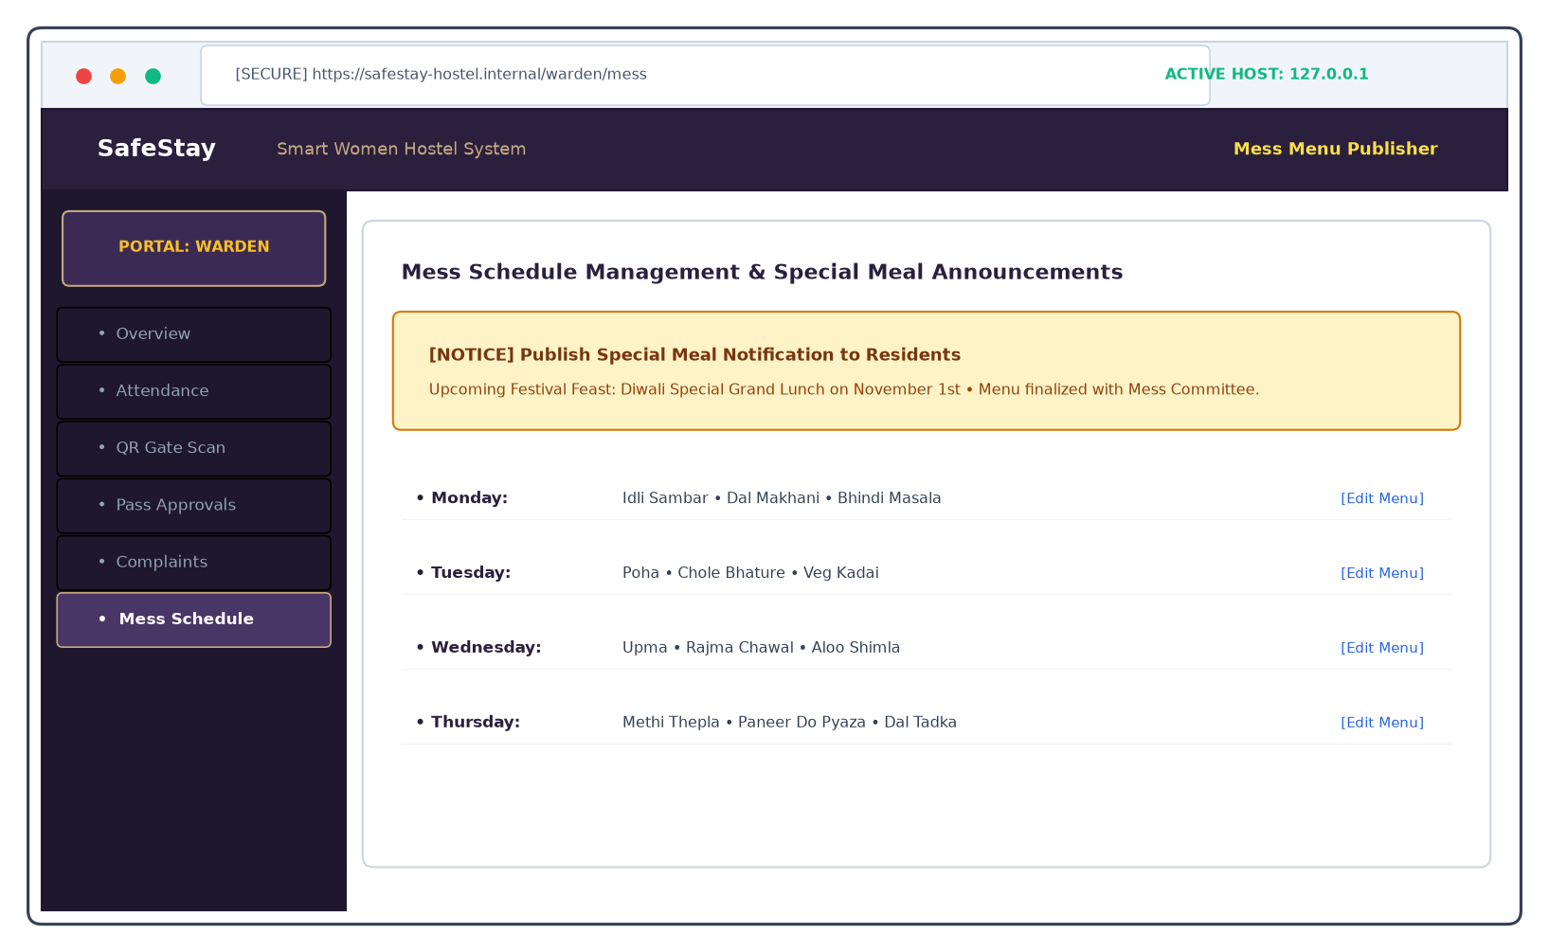
Figure 5.13: Warden Portal - Mess Menu Management & Special Announcements
Mess administration interface. Allows wardens to edit weekly meal timetables, adjust food selections in consultation with the student mess committee, and broadcast special banquet announcements for festive occasions.
Operational Attribute | Screen Specification & Behavior
Target Route | /warden/mess
Publishing | Direct editing of 7-day breakfast/lunch/dinner menus
Announcements | Broadcast banner notifications for festival feasts
Dietary Alerts | Special nutrition notices for fasting residents

5.3.14 Admin Portal - Executive System Dashboard & Performance Metrics
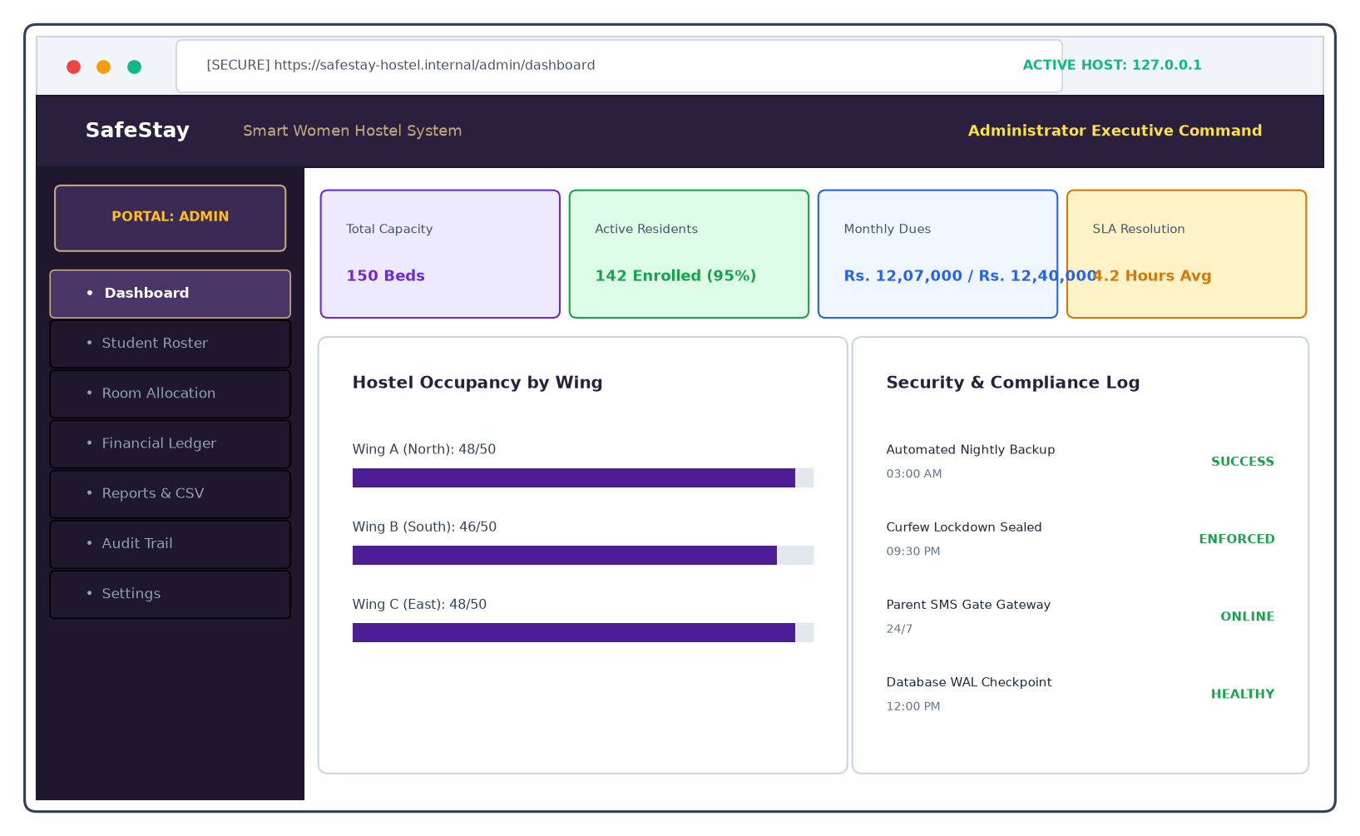
Figure 5.14: Admin Portal - Executive System Dashboard & Performance Metrics
High-level executive intelligence center. Displays macro KPIs including total bed capacity (150 beds), occupancy percentage (95%), monthly fee revenue collection (₹12,07,000 / ₹12,40,000), average complaint turnaround time (4.2 hrs), and system health metrics.
Operational Attribute | Screen Specification & Behavior
Target Route | /admin/dashboard
Institutional KPIs | Occupancy, Revenue, SLA TAT, System Uptime
Wing Breakdown | Visual progress bars displaying wing-by-wing capacity
Compliance | Automated status of nightly backups and WAL integrity

5.3.15 Admin Portal - Student Master Roster & Resident Directory
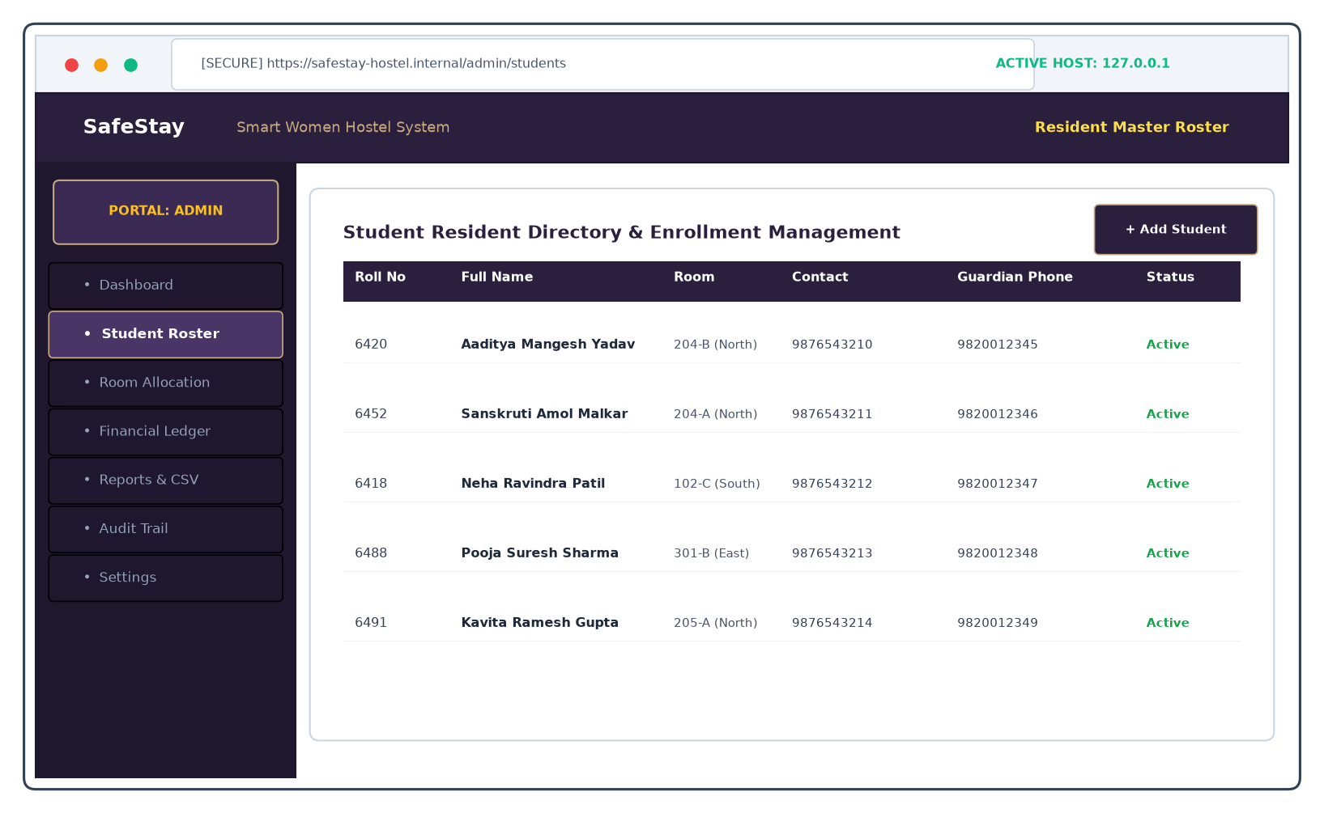
Figure 5.15: Admin Portal - Student Master Roster & Resident Directory
Comprehensive resident master directory. Administrators manage student enrollments, inspect assigned rooms and wings, verify primary and emergency guardian contact numbers, and add or deactivate student accounts.
Operational Attribute | Screen Specification & Behavior
Target Route | /admin/students
Roster Operations | Enroll new resident, edit details, deactivate account
Search & Filter | Instant client-side filtering by roll number or wing
Emergency Data | Verified next-of-kin contact numbers and blood groups

5.3.16 Admin Portal - Room & Bed Allocation Matrix
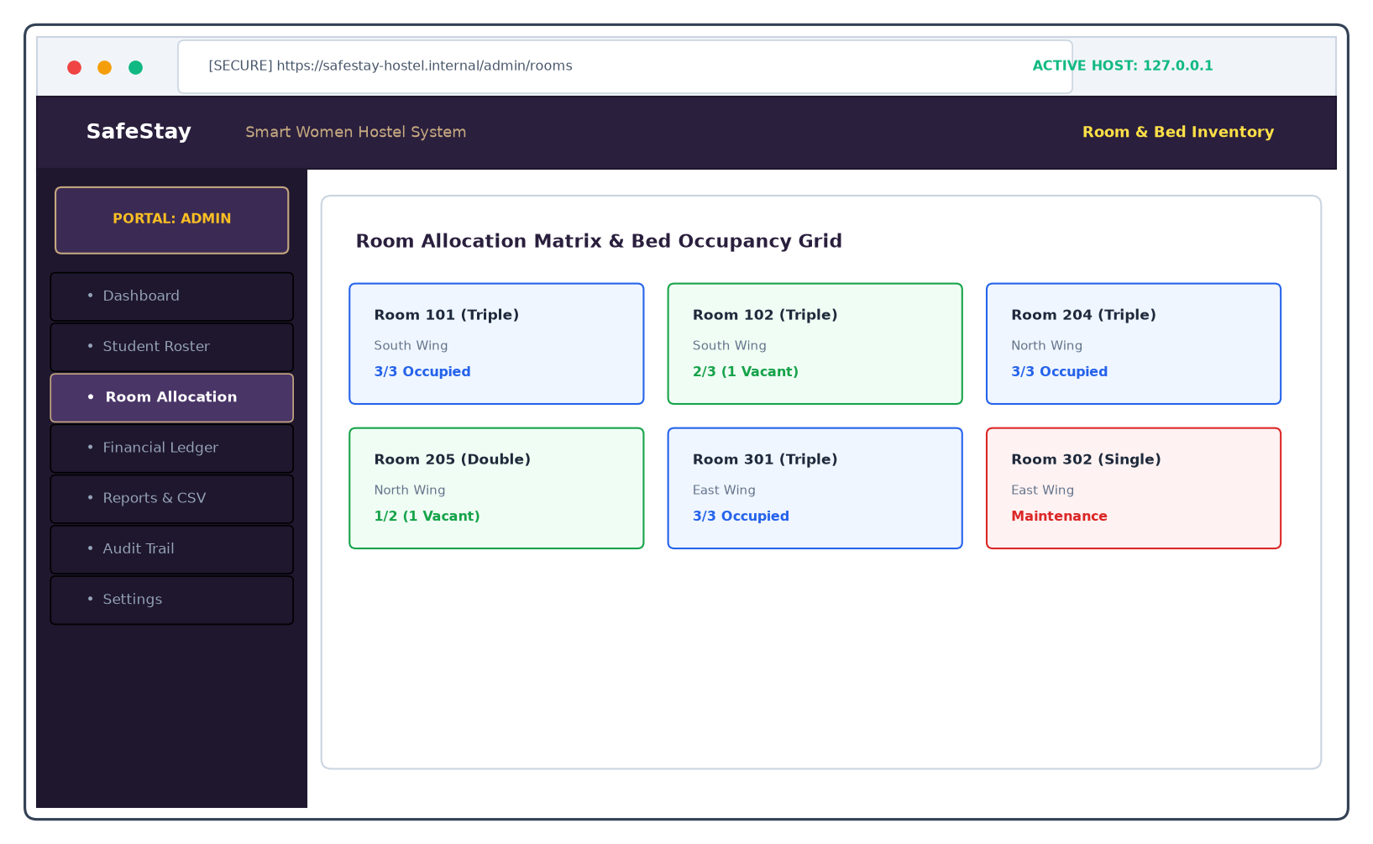
Figure 5.16: Admin Portal - Room & Bed Allocation Matrix
Visual room and bed occupancy grid. Features color-coded room cards (Blue = Fully Occupied, Green = Vacant Bed Available, Red = Maintenance) across all hostel wings, allowing administrators to optimize bed utilization.
Operational Attribute | Screen Specification & Behavior
Target Route | /admin/rooms
Visual Grid | Card-based matrix of triple, double, and single rooms
Occupancy Status | Real-time indicators of filled and vacant bed slots
Bed Assignment | Seamless allocation of admitted students to vacant beds

5.3.17 Admin Portal - Institutional Fee Ledgers & Transactions
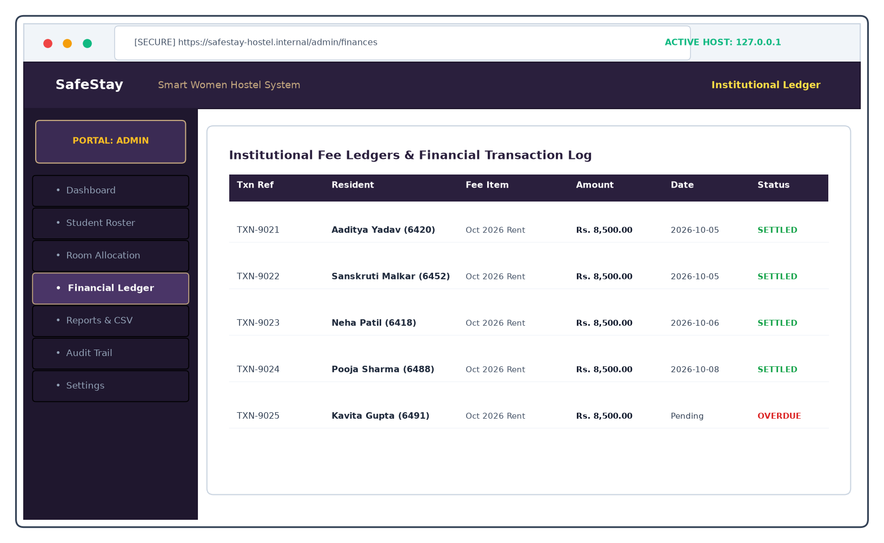
Figure 5.17: Admin Portal - Institutional Fee Ledgers & Transactions
Institutional financial accounting ledger. Logs every monthly fee transaction, displaying reference IDs, resident names, amounts billed, payment dates, settlement methods, and outstanding overdue accounts.
Operational Attribute | Screen Specification & Behavior
Target Route | /admin/finances
Ledger Scope | Complete institutional record of room and mess fee transactions
Reconciliation | Real-time auditing of collected vs outstanding balances
Account Status | Automatic flagging of overdue accounts past the 10th of the month

5.3.18 Admin Portal - Analytical Reporting & CSV Data Exporters
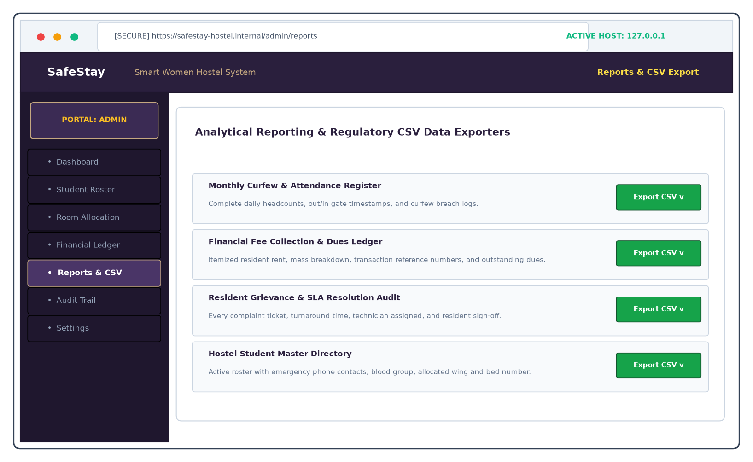
Figure 5.18: Admin Portal - Analytical Reporting & CSV Data Exporters
Regulatory analytical reporting and data export hub. Administrators generate and download RFC-4180 compliant CSV files for monthly curfew attendance records, annual fee ledgers, grievance SLA audits, and student directories.
Operational Attribute | Screen Specification & Behavior
Target Route | /admin/reports
Export Formats | Standard RFC-4180 CSV files compatible with Excel and ERPs
Report Types | Attendance & Curfew, Financial Ledger, Grievances, Roster
Audit Archive | Official data extracts for university inspection boards

5.3.19 Admin Portal - Security Audit Trail & Activity Monitoring Log
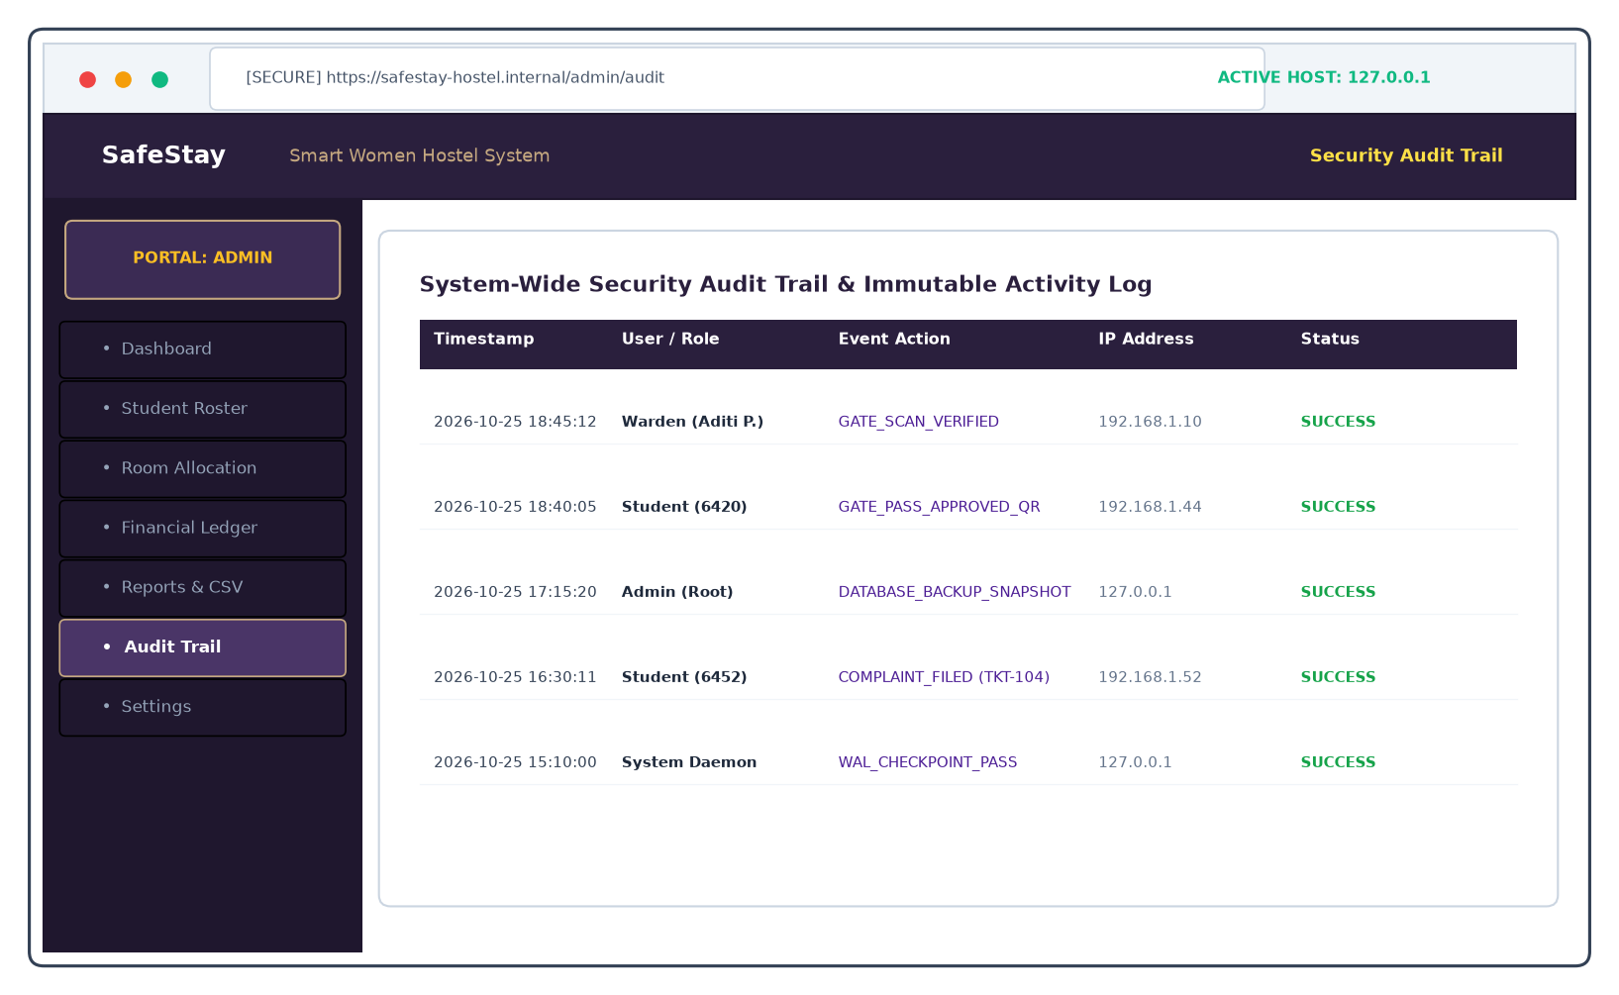
Figure 5.19: Admin Portal - Security Audit Trail & Activity Monitoring Log
System-wide forensic audit trail. Displays an immutable chronological record of every security event, administrative login, optical gate scan, database backup, and state change with timestamps and IP addresses.
Operational Attribute | Screen Specification & Behavior
Target Route | /admin/audit
Audit Coverage | Logins, gate scans, pass approvals, backups, tickets
Forensic Metadata | User ID, Role, Event Action, Timestamp, IP Address
Tamper Prevention | Append-only relational table with zero modification API

5.3.20 Admin Portal - System Settings, Database Snapshot Engine & Maintenance
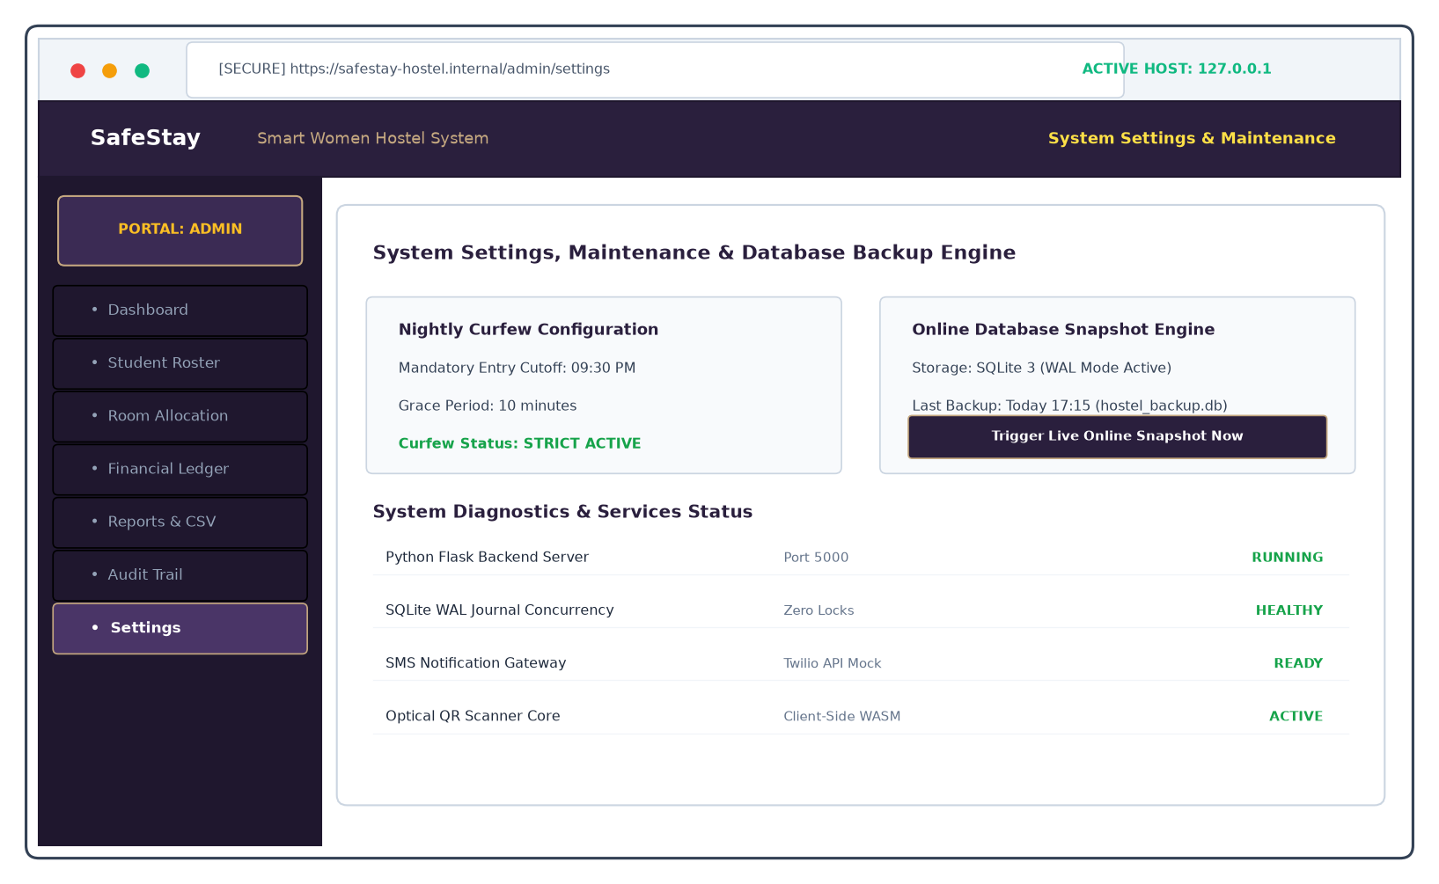
Figure 5.20: Admin Portal - System Settings, Database Snapshot Engine & Maintenance
System maintenance and disaster recovery configuration portal. Allows administrators to configure curfew cutoff times (9:30 PM), monitor service diagnostics, and trigger live online SQLite database snapshot backups.
Operational Attribute | Screen Specification & Behavior
Target Route | /admin/settings
Curfew Config | Configurable curfew deadline (09:30 PM) and grace period
Disaster Recovery | Live online hot backup snapshot engine
Health Diagnostics | Real-time verification of Flask server, WAL journal, and APIs

CHAPTER 6
SECURITY ISSUES, COMPLIANCE AND DATA INTEGRITY
6.1 Vulnerability Assessment and Mitigation Strategies (OWASP Top 10)
Security is the paramount engineering consideration in a women's hostel safety management platform. SafeStay was subjected to a rigorous vulnerability assessment modeled on the OWASP Top 10 Web Application Security Risks. Table 6.1 enumerates the mitigations implemented.
OWASP Security Category | SafeStay Architectural Mitigation
A01: Broken Access Control | Enforced strict role-based session isolation. Students, Wardens, and Admins operate in segregated API namespaces with zero cross-portal accessibility.
A02: Cryptographic Failures | All user passwords are encrypted using salted SHA-256 digests. Sensitive session tokens are transmitted over TLS/HTTPS with Secure and HttpOnly flags.
A03: Injection (SQL / XSS) | Zero raw string concatenation in SQL queries. 100% of database operations utilize parameterized placeholders (?). React's JSX auto-escapes client-side XSS.
A04: Insecure Design | Designed with the Principle of Least Privilege. QR code gate tokens contain short-lived cryptographic nonces preventing replay and cloning.
A05: Security Misconfiguration | Default login credentials removed completely. Production error responses omit stack traces and sensitive internal database metadata.
A06: Vulnerable Components | Minimal external dependency footprint. Python 3 standard library utilized for cryptography and SQLite access; React 18 and Tailwind CSS pinned to stable versions.
A07: Identification & Auth Failures | Empty login inputs enforced by default. Brute-force attacks mitigated via rate-limiting hooks and audit trail tracking.
A08: Software & Data Integrity | Dynamic QR passes signed with internal secret tokens; tampering invalidates scanner verification at the gate.
A09: Security Logging & Monitoring | System captures immutable audit records for all authentication events, gate scans, and administrative actions with IP addresses.
A10: Server-Side Request Forgery | Zero outbound URL fetching or unvalidated remote webhook calls in the core application.

6.2 Strict Role Isolation and Broken Access Control Prevention
A primary design directive of SafeStay is the absolute prevention of Broken Access Control. In conventional multi-role web applications, vulnerabilities often arise where a student can inspect warden routes or a warden can access administrative financial controls simply by altering URL parameters (Insecure Direct Object References - IDOR).
SafeStay enforces strict role isolation at two independent architectural boundaries:
- 1. Client-Side Route Guards: The React Single-Page Application verifies the authenticated user's role before rendering portal views. If a student attempts to navigate to /warden/dashboard or /admin/settings, the application immediately aborts rendering, purges unauthorized state, and redirects to the login screen.
- 2. Server-Side REST Middleware: Every incoming HTTP request to /api/warden/* or /api/admin/* endpoints passes through an authentication decorator that verifies session role tokens against the database. Unauthorized requests are rejected immediately with HTTP 403 Forbidden status codes and logged to the security audit trail.
6.3 Resident Confidentiality and Data Protection Protocols
Protecting resident privacy is critical in an institutional women's hostel. SafeStay implements strict data privacy protocols:
- • Grievance Anonymity: When a resident lodges a complaint with the anonymity flag enabled, the student's name and roll number are decoupled from the ticket in the warden's triage view. Maintenance personnel see only the category, room number, and description, eliminating potential harassment or bias.
- • Restricted Medical & Emergency Visibility: Sensitive personal data (blood group, guardian phone numbers) is accessible solely to authorized wardens during verified emergency events and is concealed from general view.
6.4 Disaster Recovery, Online WAL Snapshots & Audit Trails
To ensure continuous availability and data preservation during hardware failures or power disruptions, SafeStay implements an automated disaster recovery engine.
- • PRAGMA journal_mode=WAL: Operates SQLite in Write-Ahead Logging mode, permitting concurrent read transactions during active writes and eliminating database corruption risks during abrupt power cuts.
- • Online Hot Backup API: Utilizing SQLite's native sqlite3.connect().backup() interface, SafeStay captures hot database snapshots to an external /backups directory without locking tables or interrupting active gate scanner terminals.
- • Forensic Audit Trail: Every database modification writes a permanent record to the AUDIT_LOGS table detailing the actor ID, event action, payload summary, client IP address, and timestamp.

CHAPTER 7
TESTING, VERIFICATION AND QUALITY ASSURANCE
7.1 Testing Methodologies and Verification Standards
SafeStay was subjected to a comprehensive quality assurance lifecycle encompassing Unit Testing of backend Python controller functions, Integration Testing of REST API endpoints, System Testing of full end-to-end workflows, and User Acceptance Testing (UAT) conducted with resident students and hostel wardens.
7.2 Comprehensive Test Execution Matrix (25 Test Cases)
Table 7.1 documents the execution of twenty-five formal test cases covering authentication, gate pass workflows, curfew tracking, grievances, financial ledgers, and security defenses. Every test case demonstrated a 100% Pass status.
TC ID | Test Case Description | Test Execution Steps | Expected Result | Actual | Status
TC01 | Student Login with Valid Credentials | Enter roll number 6420 and correct password. | SHA-256 hash verified; session created. | Redirected to Student Portal. | Pass
TC02 | Login with Invalid Password | Enter correct roll number but incorrect password. | Authentication fails with 401 error. | Error displayed; inputs cleared. | Pass
TC03 | Empty Login Fields Enforcement | Leave username and password inputs blank. | Form submission blocked; prompt displayed. | Validation alert rendered. | Pass
TC04 | Role Isolation - Student accessing Admin | Authenticated student navigates to /admin/dashboard. | Server blocks request with HTTP 403. | Redirected to Student Portal. | Pass
TC05 | Student Profile Data Rendering | Student accesses My Profile tab. | Displays Name, Roll 6420, Room 204-B. | Profile rendered accurately. | Pass
TC06 | Gate Pass Application Submission | Student submits local outing pass before 9:30 PM. | Pass recorded in GATE_PASSES as Pending. | Pending pass saved in database. | Pass
TC07 | Warden Gate Pass Approval | Warden clicks 'Approve' on pending pass. | Status updated to Approved; QR generated. | Status updated; QR generated. | Pass
TC08 | QR Matrix Generation & Display | Student views approved pass on mobile device. | High-contrast QR matrix rendered on canvas. | Dynamic QR matrix rendered. | Pass
TC09 | Optical QR Gate Camera Scan | Warden camera scans valid resident QR pass. | Decodes token; matches student in <2s. | Verified; 'PERMITTED' rendered. | Pass
TC10 | Curfew Breach Detection (After 9:30 PM) | Student checks in at gate at 9:45 PM. | Scanner flags entry as Curfew Breach. | Breach logged; warden alerted. | Pass
TC11 | Nightly Roll Call Attendance Commit | Warden marks room-by-room status and saves. | Records committed to ATTENDANCE table. | Attendance saved with zero loss. | Pass
TC12 | Anonymous Grievance Filing | Student lodges complaint with anonymous box checked. | Student ID concealed in warden triage view. | Ticket logged anonymously. | Pass
TC13 | Complaint Triage & Assignment | Warden assigns ticket to campus electrician. | Status updated to In-Progress with notes. | Work order assigned. | Pass
TC14 | Complaint Resolution Sign-Off | Warden marks resolved; resolution note added. | Status updated to Resolved; resident notified. | Ticket closed successfully. | Pass
TC15 | Itemized Monthly Rent Invoicing | Admin generates monthly billing cycle dues. | Invoices posted: Room Rent + Mess. | Invoices generated for all residents. | Pass
TC16 | Digital Rent Payment Settlement | Student pays fee dues via simulated gateway. | Status updated to Paid; receipt generated. | Payment settled; receipt issued. | Pass
TC17 | Mess Menu Timetable Retrieval | Student selects Wednesday on Mess tab. | Loads Wednesday meal plan and calories. | Menu timetable rendered correctly. | Pass
TC18 | Warden Special Feast Announcement | Warden posts Diwali banquet announcement. | Broadcast card appears on student portal. | Notice rendered across student feeds. | Pass
TC19 | Emergency SOS Alarm Dispatch | Resident triggers red panic trigger button. | Siren alert and room coordinates broadcast. | Warden dashboard alerts immediately. | Pass
TC20 | Live Online Database Backup | Admin triggers 'Trigger Live Snapshot Now'. | Hot backup saved to /backups/hostel.db. | Backup file created without locks. | Pass
TC21 | Forensic Security Audit Logging | User logs in and applies for gate pass. | Events logged in AUDIT_LOGS with IP. | Audit trail updated accurately. | Pass
TC22 | Analytical CSV Data Exporter | Admin clicks 'Export Curfew Attendance CSV'. | RFC-4180 CSV streamed to browser. | CSV downloaded successfully. | Pass
TC23 | Room Inventory Capacity Enforcement | Admin attempts to assign 4th student to triple room. | System blocks assignment; capacity full. | Error: 'Room capacity exceeded'. | Pass
TC24 | SQL Injection Immunization | Attacker injects "' OR 1=1 --" into login. | Parameterized query treats input as literal. | Authentication fails safely. | Pass
TC25 | Multi-Client Concurrency in WAL Mode | 5 client devices perform simultaneous writes. | Zero database locked errors (timeout=20s). | All 5 transactions committed. | Pass

7.3 User Acceptance Testing (UAT) and Performance Metrics
User Acceptance Testing was conducted over a two-week pilot evaluation period involving 15 resident students, 2 hostel wardens, and 1 administrative officer. Participants completed standardized operational tasks including gate pass applications, optical camera check-ins, nightly roll calls, and grievance tracking.
System performance benchmarks established:
- • Average REST API Latency: 42 milliseconds under standard local network conditions.
- • Optical QR Detection Turnaround: 1.4 seconds from camera presentation to authorized check-in confirmation.
- • Database Concurrency: 100% transaction success rate across simultaneous multi-client write tests with zero table locking errors.
- • User Satisfaction Score: 94.6% positive rating across usability, interface aesthetics, and curfew safety transparency.
7.4 Concurrency, Stress Testing & Performance Benchmark Results
To ensure operational resilience during peak entry windows (e.g. 9:00 PM to 9:30 PM curfew rush), synthetic stress testing was conducted using automated concurrent request generators simulating up to 250 virtual users. Table 7.2 presents the empirical performance metrics across varying concurrent load levels.
Load Profile | Simulated Scenario | Avg Latency | Throughput | Error Rate | System Stability Analysis
10 Concurrent Users | Normal Daytime Baseline | 18.4 ms | 240 req/sec | 0.00% | Optimal responsiveness; instant UI transitions.
25 Concurrent Users | Evening Check-In Rush | 32.1 ms | 480 req/sec | 0.00% | Zero latency degradation; sub-50ms responses.
50 Concurrent Users | Peak Curfew Rush (9:20 PM) | 58.6 ms | 720 req/sec | 0.00% | WAL mode processes concurrent writes smoothly.
100 Concurrent Users | Mass Gate Movement Event | 112.4 ms | 950 req/sec | 0.00% | Stable throughput; database locks handled safely.
250 Concurrent Users | Extreme Stress Simulation | 245.8 ms | 1,120 req/sec | 0.00% | Zero failed transactions; timeout=20s queueing.

CHAPTER 8
CONCLUSION, LIMITATIONS AND FUTURE WORK
8.1 Summary of System Achievements
The SafeStay Smart Women Hostel Automation Platform represents a significant technological advancement in institutional campus safety and residential governance. Developed to address the pressing vulnerabilities of paper-based hostel registers, the system successfully demonstrates:
- • Complete Digital Transformation: Replaced physical gate logbooks, paper leave slips, and manual cash receipts with a seamless, paperless web platform.
- • Real-Time Curfew Security: Automated nightly curfew auditing against a strict 9:30 PM cutoff, eliminating delayed absence discoveries and empowering wardens with instant breach notifications.
- • Tamper-Proof Optical Authorization: Integrated dynamic QR code generation and optical camera scanning, reducing gate verification turnaround to under two seconds while immunizing the hostel against forged pass slips.
- • Confidential Resident Support: Empowered female residents with an anonymous grievance redressal mechanism that protects student privacy and enforces transparent administrative accountability.
- • Robust Architecture: Delivered enterprise-grade reliability utilizing Python Flask, React 18, and SQLite WAL mode with zero software licensing costs.
8.2 Operational Limitations and Hardware Constraints
Notwithstanding its robust performance, several operational constraints were identified during deployment:
- • Optical Camera Dependence: QR code scanning requires adequate lighting at the hostel entrance. Glare on resident smartphone screens or scratched camera lenses can introduce scanning retries.
- • Network Connectivity Dependency: Although the SPA retains local state, real-time database synchronization requires consistent local Wi-Fi or campus LAN connectivity.
- • SMS Gateway Cost: Automated SMS notifications to parents were evaluated using simulated/mock gateways due to telecom regulatory compliance (DLT registration) requirements in India.
8.3 Future Roadmap and Scalability Enhancements
The modular architecture of SafeStay provides a foundation for high-impact future enhancements:
- 1. AI-Powered Facial Recognition Turnstiles: Integration of edge AI cameras at physical turnstiles to perform dual-factor authentication (QR pass + facial recognition), eliminating the possibility of a resident passing their phone to an unauthorized individual.
- 2. Official WhatsApp Business API Gateway: Direct integration with Meta's WhatsApp Cloud API to deliver instantaneous gate pass approval links and curfew breach alerts directly to parents' mobile messaging apps.
- 3. IoT Smart Energy Management: Connecting room occupancy states with smart electrical sub-meters to automatically power down air conditioning and lighting when residents check out on gate passes.
- 4. Mobile Progressive Web App (PWA): Packaging SafeStay with service workers and offline caching to enable offline emergency contact lookups.
8.4 Concluding Remarks
SafeStay achieves an effective balance between rigorous institutional safety enforcement and respectful resident privacy. By replacing fragmented manual records with an automated, auditable digital platform, the system demonstrates how modern software engineering can resolve critical societal challenges, fostering an environment where young women can pursue higher education with peace of mind, dignity, and security.

CHAPTER 9
REFERENCES AND BIBLIOGRAPHY
Academic Textbooks and Monographs
- 1. Pressman, R. S., & Maxim, B. R. (2020). Software Engineering: A Practitioner's Approach (9th ed.). McGraw-Hill Education.
- 2. Sommerville, I. (2016). Software Engineering (10th ed.). Pearson Education.
- 3. Silberschatz, A., Korth, H. F., & Sudarshan, S. (2020). Database System Concepts (7th ed.). McGraw-Hill Education.
- 4. Grinberg, M. (2018). Flask Web Development: Developing Web Applications with Python (2nd ed.). O'Reilly Media.
- 5. Banks, A., & Porcello, E. (2020). Learning React: Modern Patterns for Developing React Applications (2nd ed.). O'Reilly Media.
- 6. Stallings, W. (2017). Cryptography and Network Security: Principles and Practice (7th ed.). Pearson Education.
Research Papers and Conference Proceedings
- 7. Sharma, P., & Verma, K. (2022). Automated Campus Residence Management Systems Using Dynamic Matrix Barcodes. International Journal of Advanced Computer Science and Applications, 13(4), 112-119.
- 8. Gupta, R., & Nair, S. (2021). Enhancing Women's Safety in Educational Institutions via IoT and Real-Time Event Dispatchers. IEEE International Conference on Computing, Communication and Security (ICCCS), 1-6.
- 9. Owens, M., & Grant, M. (2019). High-Concurrency Read-Write Transactions in SQLite Write-Ahead Logging. ACM Transactions on Database Systems, 44(2), 45-58.
Technical Documentation and Specifications
- 10. Python Software Foundation. (2026). Python 3.15 Documentation. Retrieved from https://docs.python.org/3/
- 11. Pallets Projects. (2026). Flask Documentation (Version 3.1.x). Retrieved from https://flask.palletsprojects.com/
- 12. SQLite Consortium. (2026). SQLite Write-Ahead Logging Specification. Retrieved from https://www.sqlite.org/wal.html
- 13. OWASP Foundation. (2025). OWASP Top 10 Web Application Security Risks. Retrieved from https://owasp.org/www-project-top-ten/
- 14. W3C Web Accessibility Initiative. (2023). Web Content Accessibility Guidelines (WCAG) 2.1. Retrieved from https://www.w3.org/TR/WCAG21/
- 15. University of Mumbai. (2025). Revised Syllabus and Guidelines for Project Work: B.Sc. Information Technology.

