This application is developed using React.js, Node.js, MySQL, Google APIs, Ethereal, and other technologies. We will discuss each of the features we have built one by one.

**Login:** This is the login page where users can access the application by entering their email and password. It is the same login page for all users, including Admins, Consultants, and regular users. We have implemented JWT authentication, which means that once a user logs in, they will remain logged in even after reloading the page, unless they explicitly log out by pressing the logout button.A screenshot of a computer

**Register:** The register button allows users to sign up as either an Admin or a regular user. Initially, an Admin account is created as a regular user. To grant Admin privileges, we can make changes to our SQL table. We have implemented password hashing for enhanced security during authentication.A screenshot of a computer

**Home Page:** On this page, both users and Admins can view their profiles and access the current month's calendar. Users can select dates on the calendar to book appointments with consultants. To view available slots, the user needs to select a date first.

**Admin Home Page:** This is the admin's home page, providing additional features for managing and creating slots according to their schedules. Admins can also delete slots as needed.A screenshot of a computer

Once the admin creates slots, they will be reflected on the home page as available slots for users to book.

Here, you can see that slots have been deleted and created.

This is the user's home page view, where they can only book slots by selecting specific dates on the calendar, as shown in the figure.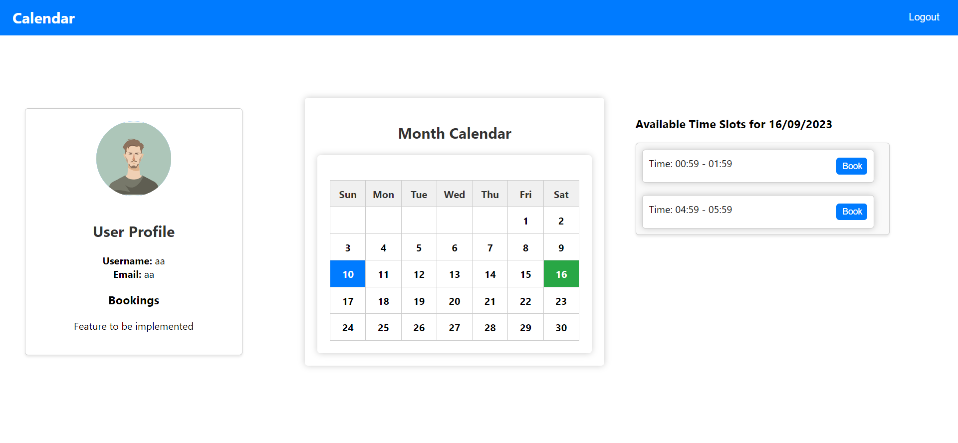

Here is a demonstration of how the home page will look when the user has booked a slot with the consultant.

**Emails:** Here, we utilize Ethereal email services to send confirmation emails to the consultant regarding slot bookings.

**Event Creation:** In the consultant's calendar, events are created displaying the time, date, and title of meetings with users.

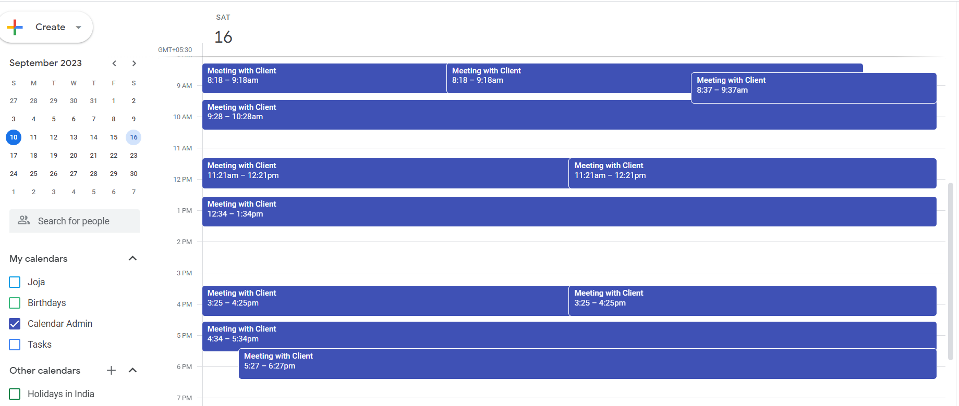

**MySQL Dashboard:** Our MySQL dashboard provides a comprehensive view of all the data collected and stored by our application.