This is a test document that contains details about the assembly that uses part DEF.
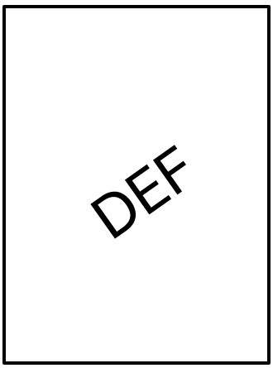
Part DEF is a component that has a pressure setting of 60 bar. This part is used to actuate the cylinders on the machine.

