This is a test document that contains details about the assembly that uses a part PQR
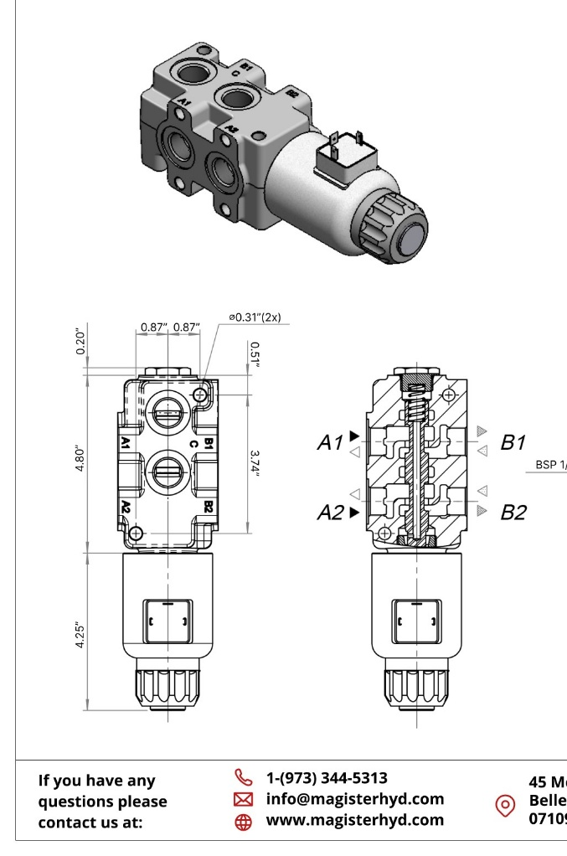
Part PQR is a component that pressure setting of 60 bar. This part is used to actuate the cylinders on the machine
A valve is a mechanical device designed to regulate, direct, or control the flow of fluids—such as liquids, gases, or slurries—within a system. It works by opening, closing, or partially obstructing passageways, allowing operators or automated systems to manage pressure, flow rate, and direction with precision. At its core, a valve consists of a body, an internal mechanism (such as a disc, ball, gate, or spool), and an actuator that moves the mechanism. Actuation can be manual, using levers or wheels, or automatic through hydraulic, pneumatic, or electric controls.
Valves are essential components in countless industries, including oil and gas, manufacturing, water treatment, power generation, and hydraulics. In hydraulic systems specifically, valves maintain system stability by controlling fluid flow to cylinders and motors, ensuring accurate movement and force. Different valve types—such as check valves, relief valves, directional control valves, and pressure-reducing valves—serve specialized functions, from preventing backflow to protecting equipment from overpressure.

