TUsersCSLite Security Component

for Delphi 3/4/5/6
and C++ Builder 5/6

User’s Manual



Web Site: http://www.toolsandcomp.com/
e-mail: info@toolsandcomps.com
Overview
About the Lite Version
What's new on version 1.2
What's new on version 1.1
Installing TUsersCSLite
How the componente TUsersCSLite works
1. Creating the user's tables
2. Using the TUsersCSLite inside the Delphi's IDE
3. Other properties of the TUsersCSLite
4. Properties of the TUser Class
5. Methods and Events of the component TUsersCSLite
Customizing the cryptography functions
Support to other Idioms

Overview
TUsersCSLite (Client/Server version) is a component that make simple implement the control of security in programs written in Delphi. With a little configuration at component level at desing time, your application is ready to control the permissions of its users. With TUsersCSLite you do not need to write code for implementing the user's control. You just need to connect it to the TMenu component of your main form and the component take cares of everything for you.
Through the connection with the menu of your application's main form, the TUsersCSLite allows that the security administrator of your application grants permissions to the user for each item in the menu. All the user's permissions are shown in a tree that imitate the menu hierarchy of your application. The administrator just need to click in the desired item to grant or not the user's permissions to this item. When the user starts the application, the component TUsersCSLite will disable or make invisible (in accordance with the profile the users belongs to) the menu items the user do not have permissions.
The component TUsersCSLite has a audit module, that allows to verify the utilization of the programs by the user.
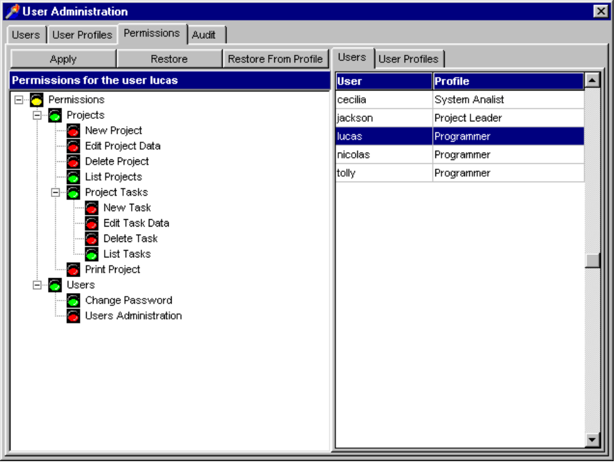
The administration module is very easy of use, mainly for the end user of your application. In this module, the administrator can:
- Create users;
- Create users profiles;
- Associate users with a profile;
- Grant permissions for users (individually) and for profiles, visually;
- Update permissions for all users that belongs to a profile;
- Change user's data and password;
- Enforces the change of password for all users of a profile at each interval of days especified;
- Put the user (or all users of a profile) in a audit mode, to verify the use of the application by the user, among other actions.
The component TUsersCSLite can be used with any DBMS avaiable on the market that supports the ANSI-SQL standard and that can be accessed by Delphi using BDE or ODBC. The actual vesion of the component also includes support to Paradox and MS-Access data files.
Another important TUsersCSLite feature is that that tables for users's control can be shared among any number of applications at the same time, and the administrator don’t need to add users again for all applications.
TUsersCSLite is implemented in pure Object Pascal, inclusive the module of administration of users, that is implemented together with the component. External librarys are not made necessary neither additional programs that need to be sent together with your Delphi program so that the component works correctly. You just need to send the security tables with your application.

About the Lite Version
TUsersCSLite is a freeware version of our security component TUsersCS. TUsersCSLite is based is a old version of the component (v1.2) which only protect menu items, but is still very usefull for several situations.
This version does not includes sources, but they are available for only USD 89.00 (Developer License), if you need it. Please visit our site for information on registration to obtain the sources for TUsersCSLite.
Tools&Comps grants you the rights to use TUsersCSLite in freeware as well in comercial applications, but we still remain the proprietary of the component. For more information about the license terms, read the file LICENSE.TXT.

What's new on version 1.2
The component TUsersCSLite is on the version 1.2. The change in this version is the storage format for date values. That now are stored as numeric values, that will guarante the component portability. Date values was stored in mm/dd/yyyy (depending of the Windows configuration)
TUsersCSLite nows supports MS-Access files. The developer now can use the component in a MS-Access database.

What's new on version 1.1
The component TUsersCSLite is on the version 1.1, that brings some news, better internal implementations and also some BUG corrections.
TUsersCSLite now brings a new event, OnLonin, where the developer can custom the login screen of its application. Now, for example, the developer cam create a login screen with its company logo.
Another new characterist in this version is the possibility of customizations of the cryptography functions used by the component. Now the developer can implement it's own cryptography functions, increasing the security.
Version 1.1 treats better the application's menu, don't lefting the menu separator togheter when the menu items among then are invisible when the user don't have permissions to uch itens, making the separators invisible too, making the appearence better.
Now, TUsersCSLite will ignore all the menu itens the was left invisible/unabled by the developer at desing time. In this case, these itens will not appear at the user's permissions tree.
In this version a BUG related to Oracle servers was corrected. The utility UsersCSLite Setup now can create the users database in Oracle servers without problems. Now all the tables of the security system has the UCS_ prefix.
Another well asked characteristc is the support to Paradox tables. Now the developer also can create the user's database using this file format.

Installing TUsersCSLite
In order to install the TUsersCSLite in Delphi 3/4/5/6:
- Choose the menu option File|Open, open the file C:\ToolsAndComps\UsersCSLite\Delphi?\ucs_lite.dpk and then click on the button Install.
- Choose the menu option Tools|Enviroment Options|Library|Library Path and add C:\ToolsAndComps\UsersCSLite\Delphi?, then click on the button OK.
- If necessary, add the directory where is located the file DSGNINTF.PAS to the Library Path (it is the directory Source\ToolsAPI of your Delphi installation)

How the componente TUsersCSLite works

Creating the user's tables
The first step in order to use the TUsersCSLite is create the tables that will store the information of the users of your system. The component TUsersCSLite has an utility that aid in the creation of the security tables, the UCSSetup.EXE.
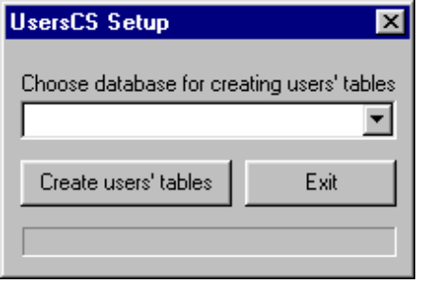
In order to create the user's tables, you should choose the alias (database name) where you want to create the tables (you must create previously an alias at the BDE or a DSN in the ODBC administrator of your computer). After inputing the necessary data, just clic in the button " Create users's tables " so that the utility will create the tables in accordance with the specified information. The tables that will be created are:
- UCS_USERS
- UCS_USERINFO
- UCS_PROFILES
- UCS_PROGS
- UCS_UACCESS
- UCS_PACCESS
- UCS_HISTORY
- UCS_AUDIT
Tip: You can create the users's tables in the same database that your application will work or you can create a específic database for the users's control.
Note: The security of the users's tables must be the same of the data your application will work.
When the utility UCSSetup.EXE creates the tables of users, it automatically inserts a record with name of 'master' user, with password also 'master' and total access to the system. That is the user that will manage the system of security of your programs, not being possible delete such user, but its possible to change its password (what is recommended).
Note: For an better security, the password of all users are encrypted.

Using the TUsersCSLite inside the Delphi's IDE
In order to use the TUsersCSLite in your programs, in the components' palette, select the ToolsAndComps page, then add the component to the main form of your program.
In order to the component works correctly, you must insert initially the value of the following properties in the Object Inspector:
AppKey: String[20]
Key for the application. This property is mandatory and allows the security tables be shared among your applications. It must be unique among the applications that will share the same security database. Note that the component cannot verify that this key is unique, so, you must take care about it.
DatabaseName: String
Indicate the alias that that component TUsersCSLite will connect to open the security tables.
IMPORTANT: Throught the alias specified as parameter, the component will try to open the users's database (Created with the utility UCSSetup) using the alias' properties, including the user and the password that your application uses for open your database. Note that the component must be "authorized" to access the users's database. This authorization can be made in the follow way:

- Ask to your DBA to create a user in your database and that such users, and just it, will have permissions to access the users's tables.
- Add a TDatabase component to your main form and connect it to the database where are stored the users's tables.
- In the property Params of the TDatabase, add the follow lines:
USER NAME=" User Name Created by the DBA"
PASSWORD="User's Password"
- Change the value of the property LoginPrompt to FALSE
- Connect the component TUsersCSLite of your main form to the TDatabase component created.

See the samples in the component package.

Menu: TMenu
Indicates the menu component that the TUsersCSLite will control. If your form has a TMenu Component, the TUsersCSLite will automatically be connected to it.

Important: Notice that these should be the values that you entered when created the tables of users using the utility UCSSetup.EXE. Without the correct values, the component won't works properly.

Other properties of the TUsersCSLite
AutoLogin: Boolean
Specifies if the component excute the Login in the system automatically, when the application starts. If AutoLogin is True, the component calls the function of Login when the application is loading. If the user doesn't get logged in the application after 3 tentatives, the component finishes the application. If AutoLogin is False the function of Login should be called manually.
ActualUser: TUser
That property contains data about the user that is logged in the system.

Properties of the TUser Class
UserName: String
Name of the user that is logged
RealName: String
Real Name of the user that is logged
UserId: Integer
Number of identification of the user that is logged
Password: String
Password of the user that is logged.
Note: The component keeps a password history of all users, to enforce then to use different passwords everytime it changes your password. In order to user the same password, the users's administrator must remove the password from the password history of the users, in the administration module.
LastPwdChange: TDateTime
Last date the user changed its password
ExpirationDate: TDateTime
The date that the user will expire in the application. Starting to this date, the user will can not login in the application. I order to use the application again, the seciruty administrator must set the user active again and change his expiration date. This property just make sense if the property UserExpire is TRUE.
Important: Note that this value belongs to the application. It means that the user has a different expiration date for each application.
UserExpire: Boolean
Indicates if the user will be valid in the application after the expiration date.
Important: Note that this value belongs to the application. It means that the user can expire or not, depending of the application.
UserActive: Boolean
Indicates if the user is active.
Important: Note that this value belongs to the application. It means that the user can be active or not, depending of the application.
Profile: String
Returns the profile name the user belongs to.
ProfileId: Integer
Returns the profile identifier the user belongs to.
AuditMode: Boolean
Indicates if the user is in audit mode or not.

Methods and Events of the component TUsersCSLite
Login: boolean
That method should be used in order to call the screen of Login of the system. If after 3 tentatives, the user doesn't get logged in the system, that function is going to return False. For a login well happened, that function is going to return True. The call to that function is made necessary when the AutoLogin property is False. In this case, the developer should write the necessary code so that the application could not be used for an user not authorized. See the examples.
ChangeUserPassword
That method permits the logged user to change his password. Must be called by the developer.
UsersAdm
Calls the module of administration of users of the system. Must be called by the developer.
The OnLogin Event
The component TUsersCSLite now have the OnLogin event, that is called every time that the Login method is executed. This event exists to allow the developer to customize the login screen of its application, so the developer can, for example, ask for another parameters or shows the company logo.
The OnLogin event needs three parameters, the user name, the password (not encrypted) to verify is the user is valid, and also the ModalResult value from the custom form. See a sample of use of this event:

procedure TForm1.UsersCSLite1Login(var UserName, Password: String;
var ModalResult: TModalResult);
begin
frmCustomLogin:=TfrmCustomLogin.Create(Application);
frmCustomLogin.ShowModal;
ModalResult:=frmCustomLogin.ModalResult;
UserName:=frmCustomLogin.Usuario.Text;
Password:=frmCustomLogin.Senha.Text;
FrmCustomLogin.Release;
end;

Customizing the cryptography functions
Now, the TUsersCSLite component allows the developer to customize the criptography functions, beeing its criterium what algorithim to use.
The criptography functions are used by the component and by the UCSSetup program. The component uses the functions through the file cripto.pas and the UCSSetup program, through the DLL ucs_crypto.dll.
Modifying the cryptography algorithims
1. Open the project ucs_crypto.dpr, that is in the directory c:\ToolsAndComps\UsersCSLite\Ucs_Crypto
2. Open the file crypto.pas. This is the file where are the cryptography functions.
3. Modify the algorithims from the functions Encrypt and Decrypt. Don't change the functions definitions, otherwise the component and the UCSetup program will can not use then.
4. Recompile the DLL project
5. Copy the generated DLL to the directories where are the UCSetup programs
6. Open the file ucs_lite.dpk and recompile the package
Note: if you change the cryptography functions, certify to cryptograph again the users´s passwords that are in the database. Remember that you must decrypt the passwords with the old function first and then encrypt with the new function.

Support to other Idioms
The component TUsersCSLite was designed so that the developer could modify the language used by the component easily. The current version has translations of all their strings of interface with the user in Portuguese, Spanish and English. For each one of the mentioned languages, the package of the component TUsersCSLite comes with the resources file already compiled(UsersCSRes.RES), the source file of the STRING TABLE (UsersCSRes.RC) and the file with the constants (UsersCSRes.PAS). In order to compile your program for one of the mentioned languages, include in your project, the UsersCSLiteRes.Pas file that is in the directory of the wanted language.
If you want to use the component in German, for example, follow these steps:
- Inside the directory ToolsAndComps\UsersCSLite\Resources, create a directory for the wanted language
- Copy all the files of the directory of some of the languages for the new directory.
- Translate the UsersCSLiteRes.RC file for the wanted language.
- Compile the new UsersCSLiteRes.RC file using the utility BRCC32.EXE, that is in the BIN directory of your Delphi installation. Consult your Delphi documentation to regarding the use of the BRCC32.EXE.
- Add to your project, the UsersCSLiteRes.Pas file that is in the directory of the new language. The new generated UsersCSLiteRes.RES file should also be in that directory.
- Rebuild your project.

