|  |
| --- |
|  |
| TFSVersioning Version 1.5.0.0 Update Guide |
| Assembly Attribute Value Update Extensions |
|  |
| **Mark Nichols** |
| **July 12, 2011** |

**© 2011 Microsoft Corporation**

This document is part of the TfsVersioning project (CodePlex) and is subject to the Ms-PL Open Source License

Contents

Summary: 3

Files 3

Installation 3

Compatibility 3

Assembly Attribute Replacement 4

Replacement Patterns 5

Example of Combining Patterns and Text 5

Static Values and Dynamic Attribute Value Replacement 6

Examples 7

Example 1: Replacement Patterns in the Build Definition 7

Result: 7

Example 2: Replacement Patterns in the Version Seed File 9

Version Seed File 9

Result: 10

# Summary:

This document describes the additional assembly attribute update capabilities of TfsVersioning version 1.5. This document only describes the additions made to the product which includes control over updating several assembly attributes (described in detail below). For information about TfsVersioning that is not described here, please review the “**TfsVersioning User and Development Guide**”.

This addition to TfsVersioning will allow you to generate descriptive dynamic (build-time) values in your assemblies. It will also allow you to insert common values across all assemblies in a build and manage them either in a common file (version seed file) or directly through a build definition.

# Files

**TfsBuild.Versioning.Activities.dll**: This is the custom build activity and is a direct replacement if you are currently using a previous version.

**VersioningBuildTemplate15.xaml**: This build template provides an updated interface in the build definition to add the replacement patterns for an extended list of assembly attributes (detailed and defined below). This file is an addition to any existing build templates that may be in place.

# Installation

Installation of version 1.5 is the same as the previous version. For more information see the “**TfsVersioning User and Development Guide**”.

# Compatibility

The TfsVersioning 1.5 custom build activity is backward compatible with previous build templates. This means you can introduce the version 1.5 custom build activity assembly without having to replace or update existing build definitions. Previous build templates and definitions will continue to modify the AssemblyVersion and AssemblyFileVersion attributes as before but will not show the interface to modify the extended list of attributes.

# Assembly Attribute Replacement

The list below describes the various attributes that can be controlled through the TfsVersioning custom activity.

|  |  |
| --- | --- |
| Attribute | Replaces |
| Assembly Title Pattern | Assembly Title Attribute: String value specifying a friendly name for the assembly. For example, an assembly named comdlg might have the title Microsoft Common Dialog Control. |
| Assembly Description Pattern | Assembly Description Attribute: String value specifying a short description that summarizes the nature and purpose of the assembly. |
| Assembly Configuration Pattern | Assembly Configuration Attribute: String value indicating the configuration of the assembly, such as Retail or Debug. The runtime does not use this value. |
| Assembly Company Pattern | Assembly Company Attribute: String value specifying a company name. |
| Assembly Product Pattern | Assembly Product Attribute: String value specifying product information. |
| Assembly Copyright Pattern | Assembly Copyright Attribute: String value specifying copyright information. |
| Assembly Trademark Pattern | Assembly Trademark Attribute: String value specifying trademark information. |
| Assembly Culture Pattern | Assembly Culture Attribute: Enumerated field indicating the culture that the assembly supports. An assembly can also specify culture independence, indicating that it contains the resources for the default culture. |
| Assembly Informational Version Pattern | Assembly Informational Version Attribute: String value specifying version information that is not used by the common language runtime, such as a full product version number. |

# Replacement Patterns

The patterns described below allow you to designate values that are taken from the system at build time and define build-specific, detailed attributes and attributes that are managed in a much more controlled fashion. The patterns below can be combined with text to create more complex and informative descriptions within an application’s assembly attributes.

They can be used anywhere within the attribute patterns but, in all cases; the values within the attributes must abide by the rules set forth within the .NET environment. For example, “Assembly Culture Pattern” values must abide by the possible enumerated values within .NET or compile-time errors may result.

(In all cases below, the examples assume the date is October 5, 2011 - 12:57:00 PM - GMT -05:00)

|  |  |
| --- | --- |
| Pattern | Replaced Value |
| $TPROJ | TFS Team Project Name |
| $REQBY | Build Requested By ID – Example: “domain:userid” |
| $BNAME | Build Definition Name – Example: “BuildVersioning - Dev - v1.5” |
| $UTIME | Universal Time – Example: “10/5/2011 5:57:00 PM” |
| $LDATE | Long Date – Example: “Wednesday, October 05, 2011” |
| $LTIME | Long Time – Example: “12:57:00 PM” |
| $SDATE | Short Date – Example: “10/5/2011” |
| $STIME | Short Time – Example: “12:57 PM” |
| $BNUM | Build Number (This is the full build number as defined by the “Build Number Format” property in the build definition.)  Example: “BuildVersioning - Dev - v1.5_20111005.27” |
| $YYYY | Full year value. – Example: “2011” |
| $YY | 2 digit year value – Example: “11” |
| $MM or $M | 1 or 2 digit month of the year – Example: “10” |
| $DD or $D | 1 or 2 digit day of the month – Example: “5” |
| $J | Julian Date - YYDDD – Example: “11278” |
| $B | Build Number of the Day (This is typically the last number value in the “Build Number Format”. Example: Looking at the value above in $BNUM, the build number is “27” |

## Example of Combining Patterns and Text

You may want to include specific build information within your assembly (in addition to the numeric version info) to help you during debugging and deployment. Information about how and when the code was built will definitely help as you make decisions around what has been tested and what can be deployed. For example: TFS labels your code as part of every build. You may decide that it would be beneficial to include the label information in an assembly attribute along with the universal time that it was built AND who initiated the build.

To satisfy these needs, the Assembly Informational Version Pattern could be set to:

“**$BNUM on $UTIME by $REQBY**”. This combination of replacement patterns and text will create a descriptive notation contained in the assembly that can be read by anyone just by looking at the file properties in Windows Explorer. More description on this capability is detailed below.

## Static Values and Dynamic Attribute Value Replacement

Static values are those values set directly within the AssemblyInfo.* files. Dynamic values are those set within the build definition or version seed file – both can contain replacement values that are generated during the build based.

If you would like to utilize static values within the AssemblyInfo file and not have them modified during the build then leave those attribute values blank in the build definition or don’t include them in the version seed file. If the TfsVersioning activity does not see a replacement value for an attribute, it will not attempt to replace that value in the AssemblyInfo file. So, you only need to include the attribute values that you want to change.

# Examples

## Example 1: Replacement Patterns in the Build Definition

Below is an example of a build definition that modifies the AssemblyVersion, AssemblyFileVersion and AssemblyInformationalVersion attributes. Note: the following build definitions utilize the updated build assembly and the updated build template “VersioningBuildTemplate15.xaml”.

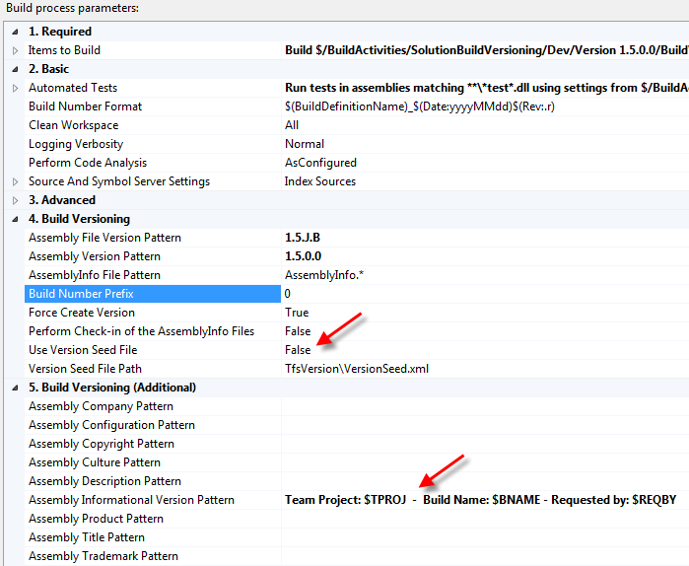

## Result:

* “Use Version Seed File” is set to False so the patterns for modifying the assembly attribute properties are taken from the build definition.
* The “Assembly File Version Pattern” is 1.5.J.B which appears (in Windows 7 file properties for the current date) as 1.5.11194.2.
* “Assembly Informational Version Pattern” is “Team Project: $TPROJ - Build Name: $BNAME - Requested by: $REQBY” which will display the:
  + Team Project name
  + Build Name
  + Requested by ID
* The rest of the assembly attribute properties are either taken from the “AssemblyInfo” file or general defaults.

A screen shot of the file “Properties/Details” dialog box from Windows Explorer.

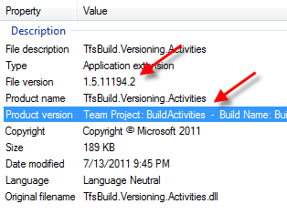

## Example 2: Replacement Patterns in the Version Seed File

Below is an example of a build definition that modifies the AssemblyVersion, AssemblyFileVersion and AssemblyInformationalVersion attributes.

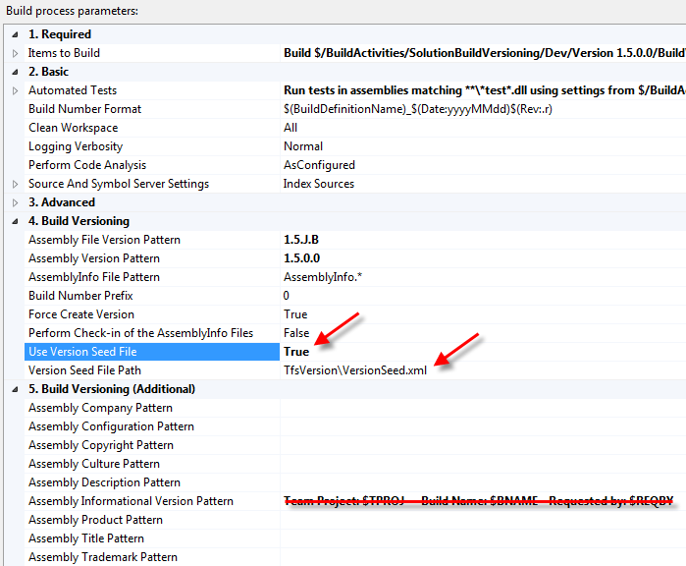

## Version Seed File

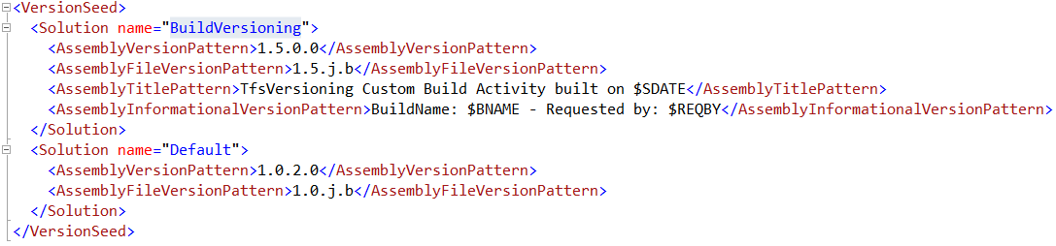

As you can see above, the only values (outside of the version numbers) that will be modified in the AssemblyInfo file(s) are the AssemblyTitle and AssemblyInformationalVerion attributes.

## Result:

* “Use Version Seed File” is set to True so the patterns for modifying the assembly attribute properties are taken from the “version seed” (XML) file.
* The “Assembly File Version Pattern” is 1.5.J.B which appears (in Windows 7 file properties for the current date) as 1.5.11194.4.
* “Assembly Informational Version Pattern” is “BuildName: $BNAME - Requested by: $REQBY” which will display the:
  + Build Name
  + Requested by ID
* Even though the “Assembly Informational Version Pattern” is set to a value in the build definition, it is not used because the “Use Version Seed File” property is set to True.
* The Assembly Title is set to: “TfsVersioning Custom Build Activity built on $SDATE”
* The rest of the assembly attribute properties are either taken from the “AssemblyInfo” file or general defaults.

A screen shot of the file “Properties/Details” dialog box from Windows Explorer.

