Marking System Student Portal — Project Report
Project Title: Marking System Student Portal (Python CLI)
Course/Subject: CSE1021
Submitted By: Aadrika Kumar
Submitted To: Prof. Dr GR Hemalakshmi
Date: 24th Nov`25

2. Introduction
This project is a command-line based student marks calculating portal.
It includes password-verified admin login and basic student portal functionalities such as viewing student details, edit data, freeze/unfreeze data, viewing marks, and producing detailed result. The primary goal is to simulate a secured, menu-driven portal system using Python, showcasing modular programming, input validation, and a user-friendly terminal UI using ANSI colors.
3. Problem Statement
Educational institutions often require a lightweight, local interface for administering and viewing student information. A simple tool is needed that:
- Allows secure authentication
- Provides easy navigation
- Stores & displays academic data
- Simulates real-world student portal interactions
4. Functional Requirements
User functions:
- Login System: Authenticate using admin password and limit attempts.
- Student Operations: View details, edit details, freeze/unfreeze data, detailed report, search by initial letter.
- System Menu: Numeric menu navigation and exit option.
5. Non-functional Requirements
- Usability: Simple CLI navigation with numbered options.
- Security: Password-protected; limited attempts.
- Performance: Fast response for menu actions.
- Portability: Cross-platform (Windows/Mac/Linux) with Python 3.
- Maintainability: Modular functions for easy updates.
- User Experience: Color-coded CLI output.
6. System Architecture
Three-layer architecture used:
Presentation Layer (CLI Menu, Input/Output Handling)
↓
Logic Layer (Authentication, Certification Management, Marks, UI formatting, View all detail, Search by name, Search by Initial Letter, Freeze/Unfreeze Data, View Detailed Report)
↓
Data Layer (In-code lists/dictionaries)
7. Design Diagrams

7.1 Use Case Diagram
+-------------------+
| Admin |
+-------------------+
|
| Login
v
+---------------------------+
| Student Portal System |
+—————————————+—————————————+
/ | | \
/ | | \
View Details Edit Details Freeze Data Search By Name

7.2 Workflow Diagram
Start
│
▼
Enter Password → Valid? → No → Attempts Left? → No → Exit
│ Yes
▼
Show Menu → Select Option
│
├─ View Details → Display → Back to Menu
├─ Detailed Report → Save → Back to Menu
├─ Edit Details → Display → Back to Menu
├─ Freeze Data - Display → Back to Menu
|——Search By Initial Letter - Display - Back to Menu
└─ Exit → End

7.3 Sequence Diagram
User -> System: Start Program
User -> System: Enter Password
System -> User: Login Success / Failure
User -> System: Select Menu Option
System -> Data Layer: Add/Fetch/Update
Data Layer -> System: Result
System -> User: Display Output
8. Design Decisions & Rationale
- CLI chosen for simplicity and portability.
- Hardcoded in-memory data to keep the project focused on logic rather than persistence.
- Colour-coded UI to improve terminal readability.
- Single admin password suffices for project scope; expand later for roles.
9. Implementation Details
Language: Python 3
Key modules and functions:
- login(): Handles password input and validation using getpass.
- ensure_assigned(): Ensures certificate assigned date exists.
- add_student(), edit_student(), view_all(), detailed_report(): CRUD operations in-memory.
- cert_score(days): Certificate scoring logic based on days late.
- grade(p): Maps percentage to letter grade.
Certificate Scoring Table:
Days Late | Score
0 | 10
1 | 9
2 | 8
3 | 7
4 | 6
5–10 | 5
>10 | 2
Not Submitted | 0
Grade Calculation Table:
Percentage | Grade
>= 90 | A
>= 75 | B
>= 60 | C
>= 33 | D
< 33 | F
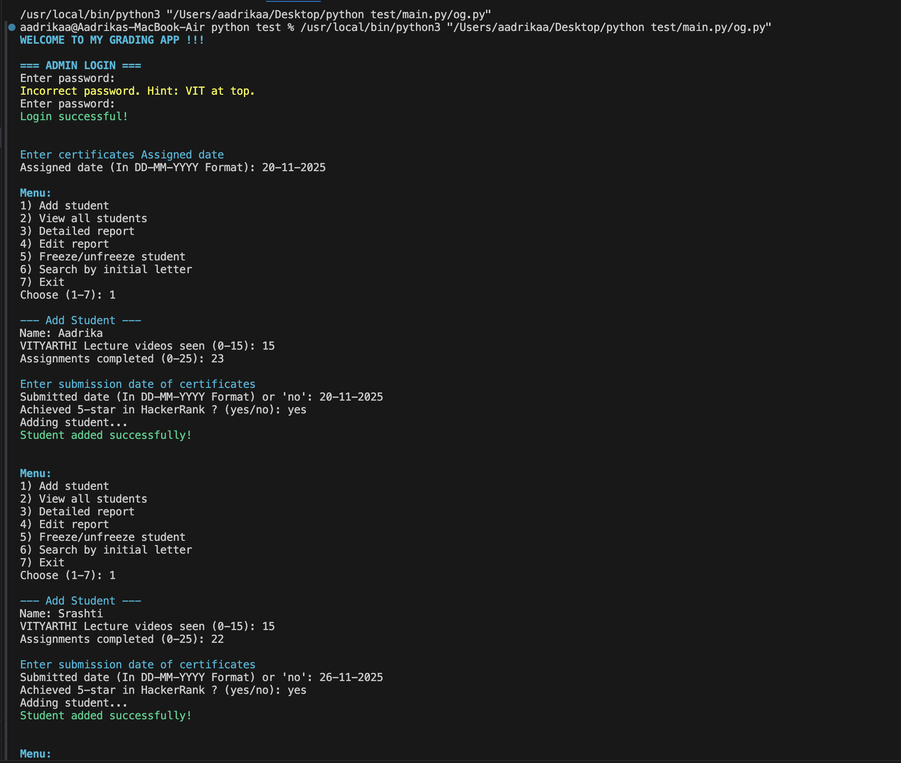
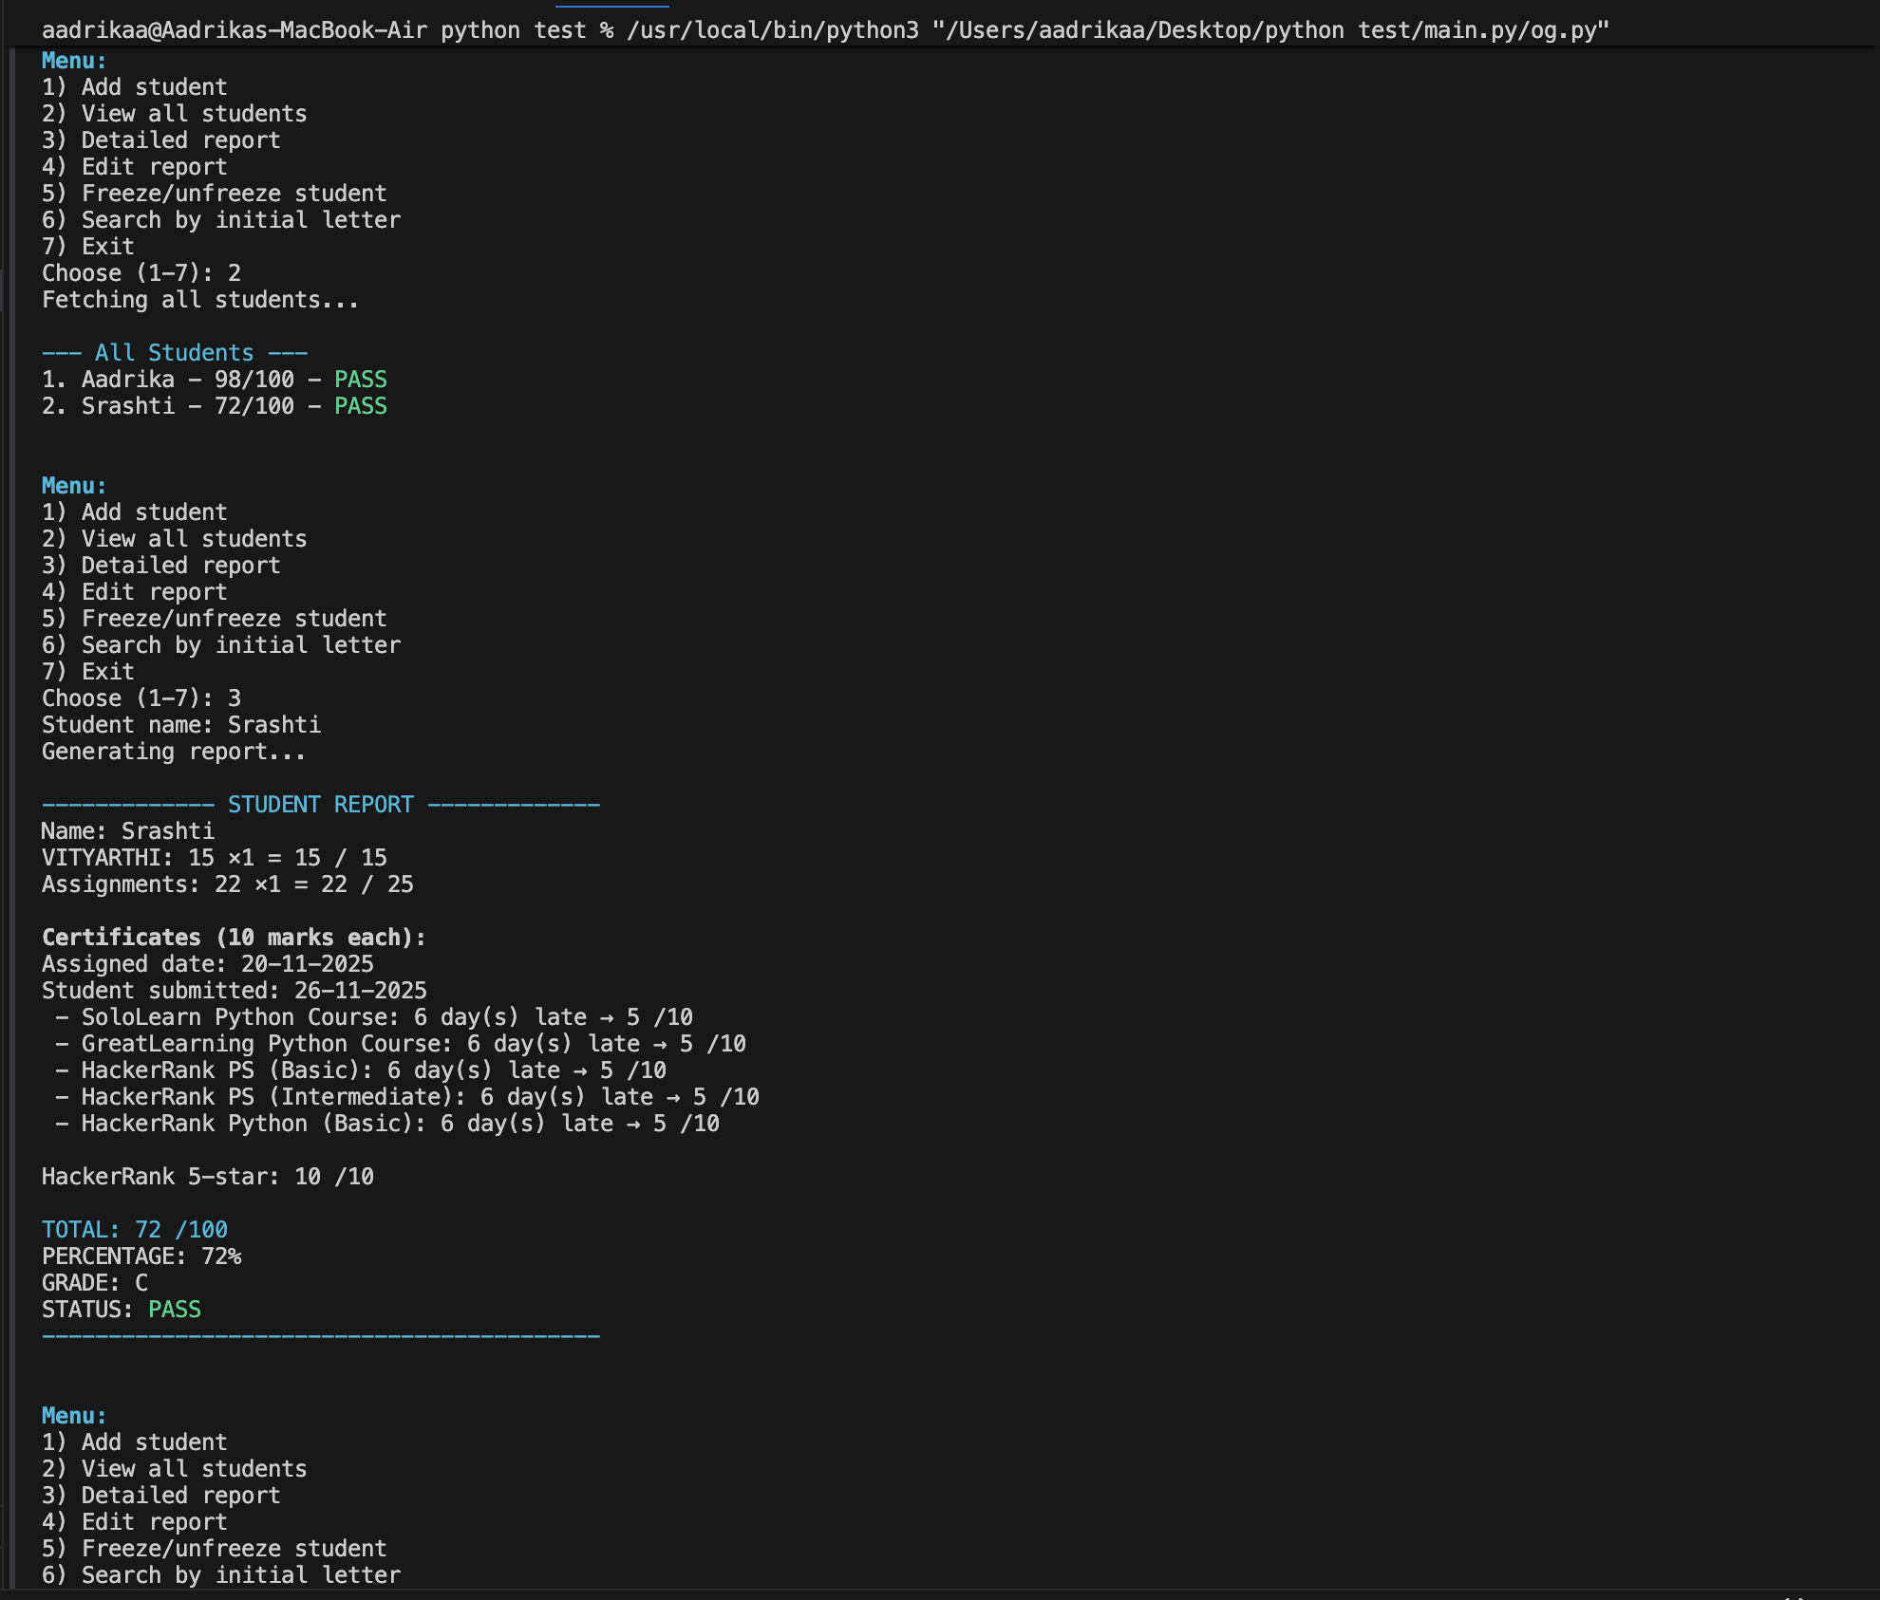
10.Screenshots / Results

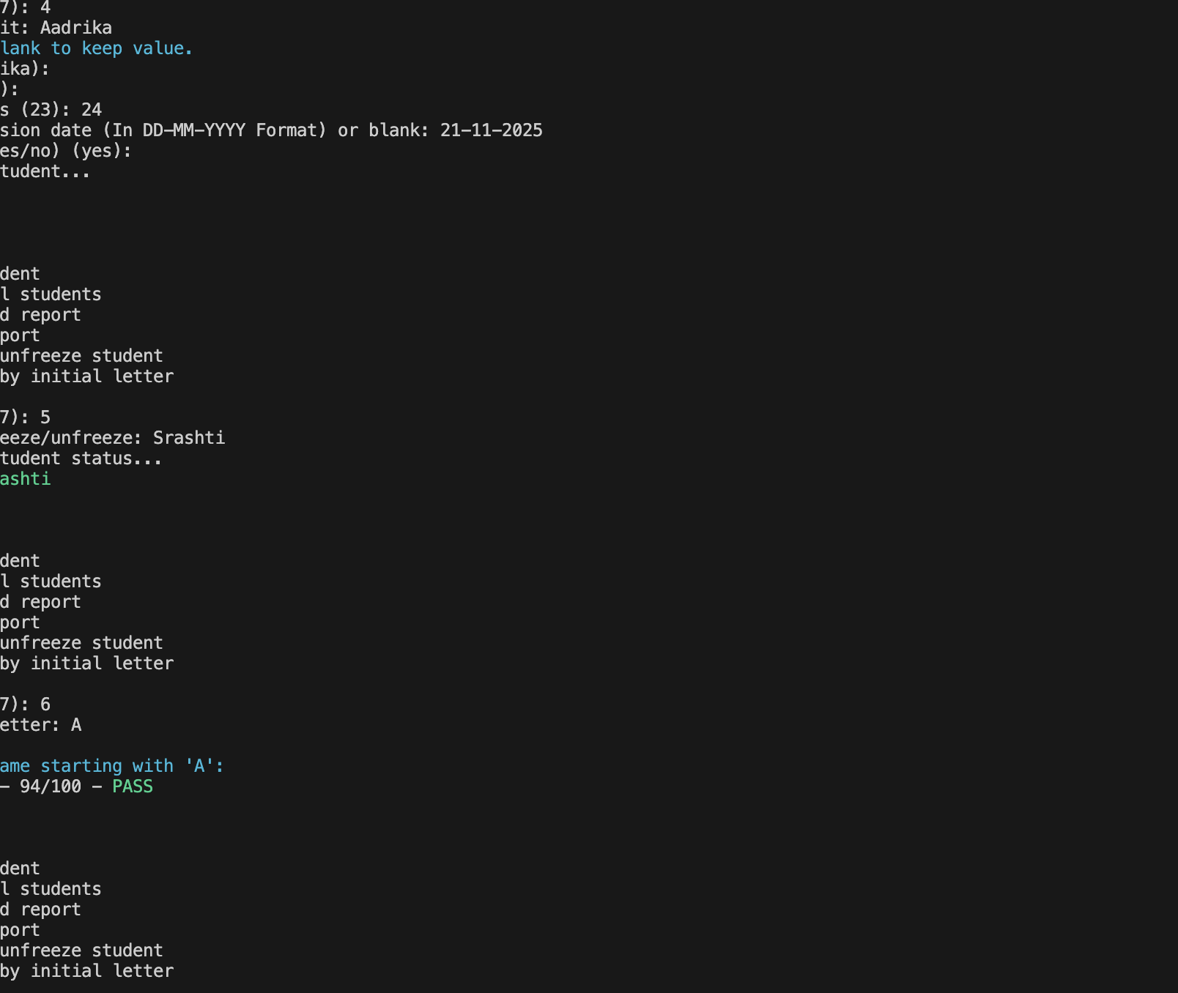

11. Testing Approach
Manual testing steps:
- Test login with correct and incorrect passwords and confirm attempt limit works.
- Add a student with certificates submitted on time and late; verify calculated scores.
- Edit student and confirm totals update correctly.
- Freeze a student and ensure edits are blocked.
- Search by initial letter with various inputs.
14
12. Challenges Faced
- Handling invalid input gracefully across the CLI.
- Correctly updating certificate scores after editing submission dates.
- Creating an intuitive CLI UX with colour codes that work cross-platform.
13. Learnings & Key Takeaways
- Built a modular CLI application and improved input validation.
- Understood scoring and grading logic and its edge-cases.
- Learned to present technical documentation in a structured format.

