CSE0001 – Digital Literacy
Task 2 — Student Digital Portfolio
Aadyant Bhatt | 25BAI11331 | B.Tech CSE AIML | VIT Bhopal University

Platform Screenshots

1. GitHub — Profile README
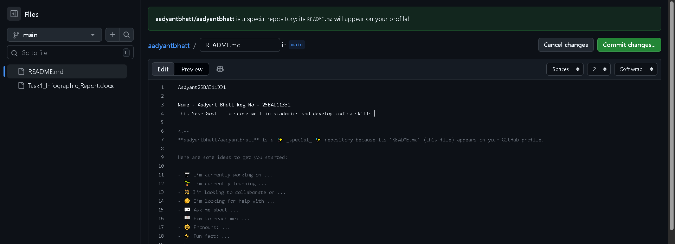
Figure 1: GitHub Profile https://github.com/aadyantbhatt/aadyantbhatt | Shows name, branch (B.Tech CSE AIML), year (2025–29), and learning goals 2. LinkedIn — Professional Profile
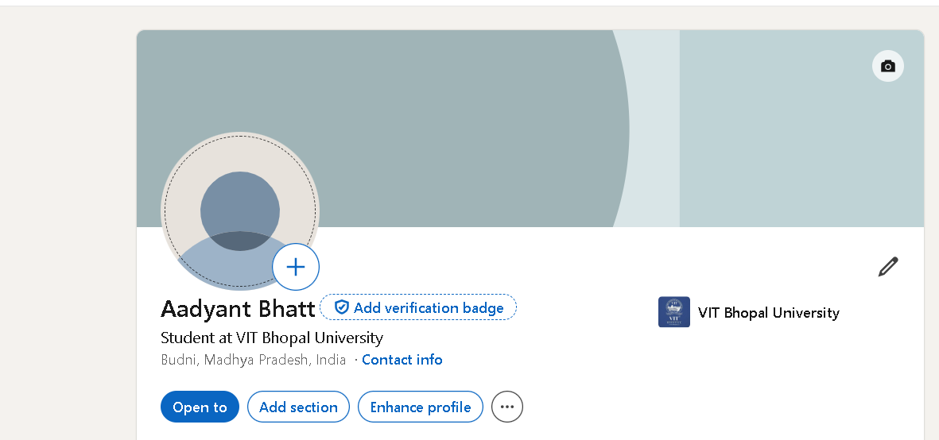
Figure 2: LinkedIn Profile — linkedin.com/aadyant-bhatt-9681293bb/ | Student at VIT Bhopal University |
Education section filled with current degree details

3. Kaggle — Data Science Platform
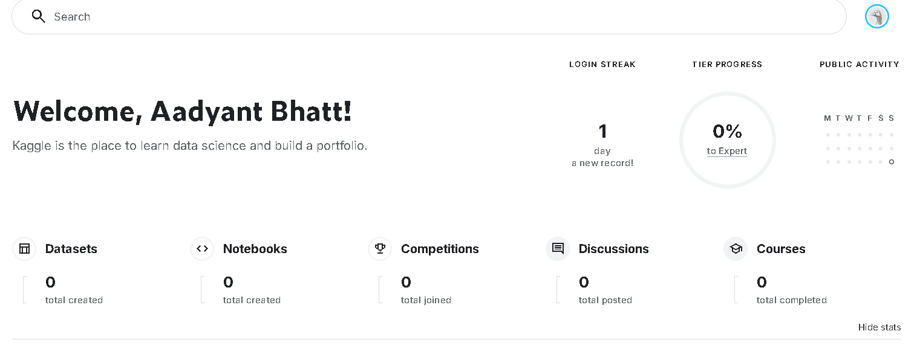
Figure 3: Kaggle Dashboard — Welcome screen Aadyant Bhatt 25BAI11331 | Account created and ready to explore datasets, notebooks, and competitions

Task 2 About

I set up my professional digital presence across three key platforms: GitHub, LinkedIn, and Kaggle. Each platform serves a distinct purpose in building a well-rounded digital identity as a student and future technology professional.
GitHub is a platform used for hosting and sharing code repositories. It allows developers to showcase projects, collaborate with others, and track contributions over time. I created a Profile README on GitHub with my name, branch, year, and a learning goal, which now acts as a personal introduction to anyone who visits my profile. Over the next four years, I plan to use GitHub to push projects, assignments, and any personal coding work so that I build a consistent, visible portfolio of my technical growth.
LinkedIn is the world's largest professional networking platform. It is used by employers, recruiters, and academic institutions to evaluate candidates. I set up my profile with my education details — B.Tech CSE at VIT Bhopal University (2025–2029). Over the next four years, I plan to keep adding skills, internships, certifications, and projects as I complete them, making the profile a live record of my professional development.
Kaggle is a platform focused on data science and machine learning. It hosts competitions, datasets, notebooks, and free courses. Although I am just getting started, I plan to use Kaggle in my second and third year to explore data analysis, participate in beginner competitions, and complete structured courses in Python and machine learning.

End of Task 2 | CSE0001 – Digital Literacy | VIT Bhopal University

