ASG Airlines - Performance Analysis

1. Objective
The objective of this project was to clean and prepare the given raw data analyze a flight operations dataset using Microsoft Power BI and develop an interactive analytical dashboard covering overall operations, flight duration, and route patterns.

2. Dataset

3. Data Cleaning & Preparation

flights_df
The flights_df table underwent the following cleaning and preparation steps:
Removed duplicate records to ensure each flight was represented only once in the dataset.
Remapped "UNKNOWN" placeholder values across relevant columns to appropriate null or standardized values, based on the context of each field.
Performed type normalization on key columns (e.g., converting date/time fields to proper datetime types, ensuring numeric fields such as duration were stored as numeric types rather than strings).
Checked duration validity by identifying and reviewing flights with implausible or inconsistent duration values, flagging potential anomalies for further review.

bookings_df and payments_df
The bookings_df and payments_df tables were processed together as follows:
Merged bookings_df and payments_df into a single table using their common payment association (payment ID) to consolidate booking and payment information.
Removed columns that fall under PII category to protect customer identity
Mapped missing values in the merged dataset based on the associated payment records, filling gaps where a corresponding payment record provided the missing information.
Performed type normalization on the merged dataset to ensure consistent data types across shared and derived columns.
Note: bookings_df and payments_df relate to passenger booking and payment information and were not required by the four core performance KPIs (Average Flight Duration, Route-wise Traffic, Delays/Anomalies, Distribution of Flights by Airline). They were cleaned for completeness but were not carried into the final analytical/reporting layer.

passengers_df
This table contained only values that were considered PIIs. Therefore, it was dropped as a whole.

Exporting
Once cleaning and preparation were complete, the processed data was exported in Parquet format and stored in the cleaned zone, serving as the curated dataset for downstream analysis and the Power BI dashboard. Parquet was chosen over CSV to preserve the data types established during cleaning (e.g., datetime and numeric fields) and for its more compact, efficient storage format.

4. Measures Created
The following measures were created in Power BI:

Total Flights
Total Flights = DISTINCTCOUNT(flights_df[flight_id])

Total Airlines
Total Airlines = DISTINCTCOUNT(flights_df[airline])

Total Routes
Total Routes = DISTINCTCOUNT(flights_df[Route])

Average Flight Duration
Average flight duration was calculated using the available duration data.

Average Flight Duration (Hours)
The average duration was converted from minutes into hours for easier interpretation.

Shortest Flight
The minimum flight duration was identified from the dataset.

Longest Flight
The maximum flight duration was identified from the dataset.

Total Flight Hours
Total Flight Hours =DIVIDE(SUM(flights_df[duration_minutes]), 60))

5. Dashboard Structure

Page 1 — Operations Overview
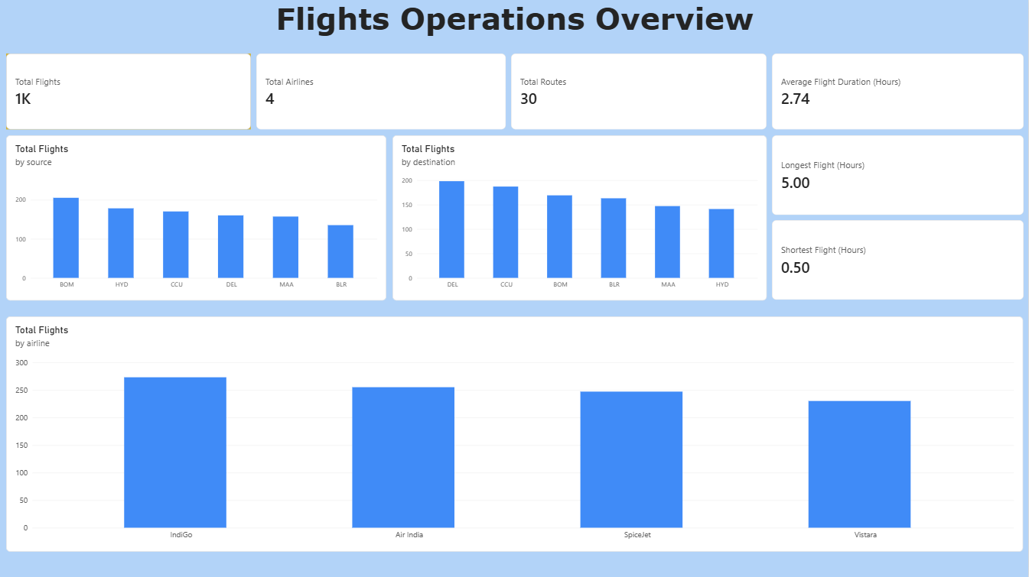

Page 2 — Duration Analysis
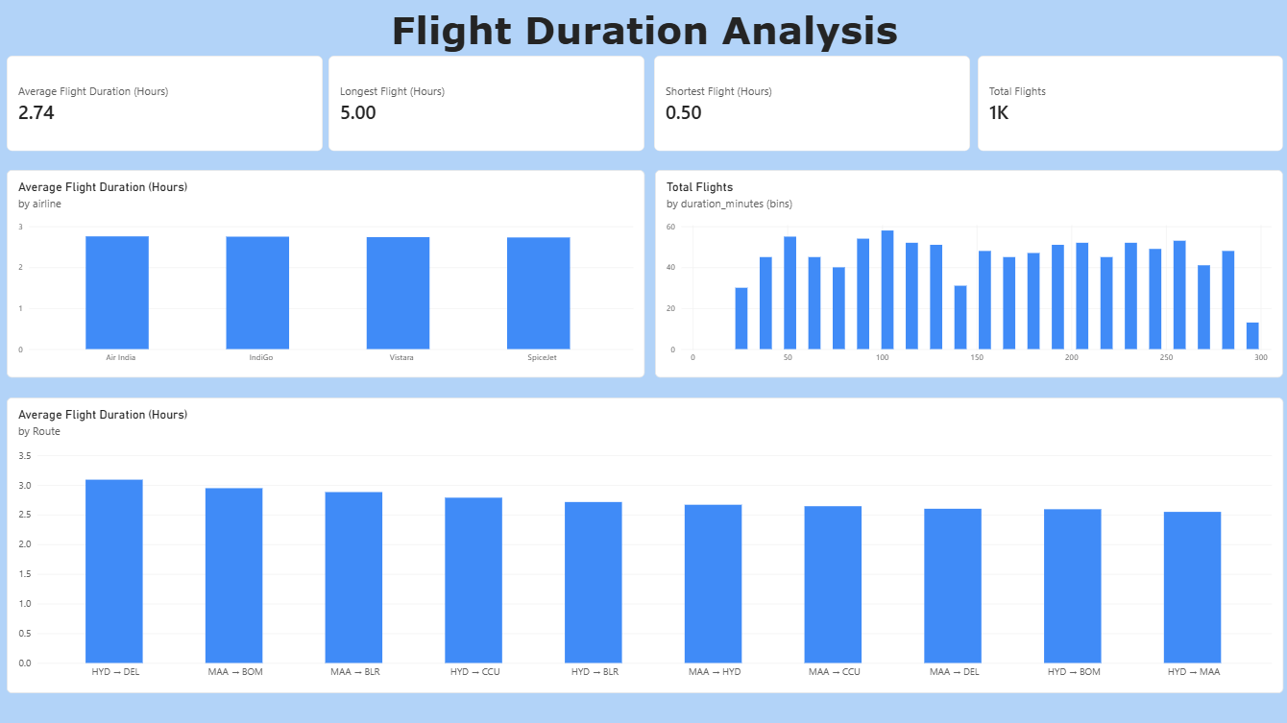

Page 3 — Route Analysis
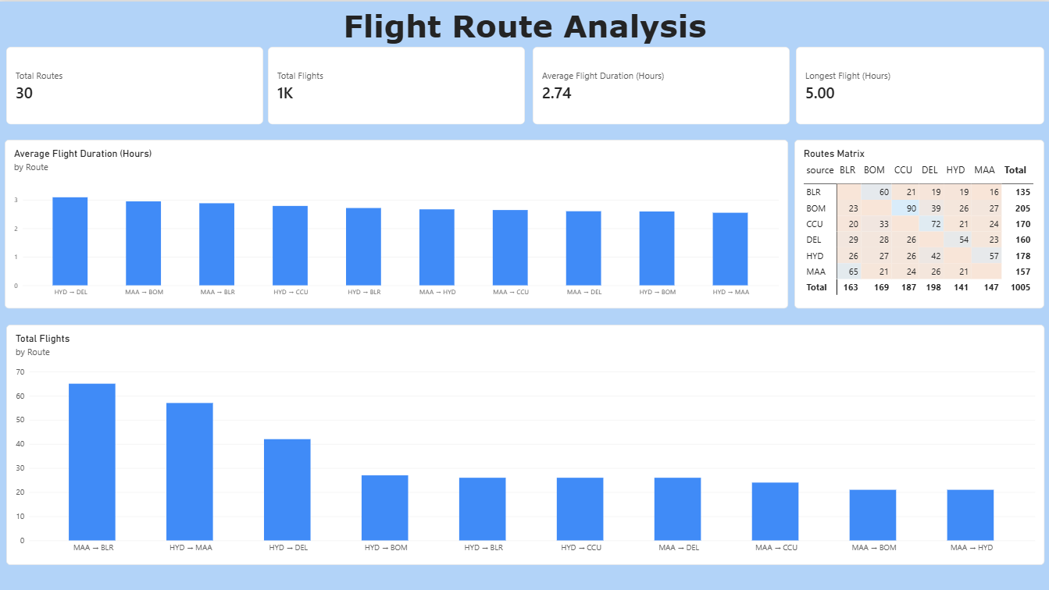

6. Key Analytical Observations
The dashboard can be used to identify:
- Airlines with the highest number of flights.
- Sources and destinations with the greatest flight activity.
- Airlines contributing the greatest total flight hours.
- The most common flight-duration ranges.
- The busiest routes in the network.
- Routes with comparatively longer average flight durations.
- Unusually short or long flights that may warrant further investigation.
Specific observations from the dashboard:
- Highest-volume airline: IndiGo
- Most active source: Mumbai (BOM)
- Most active destination: Delhi (DEL)
- Most frequent route: Chennai to Bengaluru (MAA - BLR)
- Longest average-duration route: Hyderabad to Delhi (HYD - DEL)
- Overall average flight duration: 2.74 hours

7. Limitations
The dataset does not contain scheduled and actual departure/arrival timestamps or an explicit delay field. Therefore, actual flight delays and on-time performance cannot be calculated from the available data.
Accordingly, the analysis focuses on flight volume, duration patterns, route activity, and potential duration anomalies rather than claiming to measure flight delays.

8. Conclusion
The Power BI dashboard provides a consolidated view of flight operations through three analytical perspectives: overall operations, duration characteristics, and route activity.
The dashboard enables users to interact with the data through cross-filtering between visualizations and investigate operational patterns across airlines, locations, durations, and routes.

