**ASSIGNMENT-01**

**ADVANCE PROGRAMMING**

**Name: Hafiz Muhammad Aafaq**

**CMS-ID: 212419 BSCS-7A**

**OPENCART**

The Open Source Software, I am using is **OpenCart** which is an online E-Commerce site. It is an online E-Commerce site which is Php-based and is using MYSQL database with HTML components and it uses Model-View-Controller (MVC) software architecture. It is PHP-based, using a MySQL database and HTML components. It provides support for different languages and currencies. Ì chose **OpenCart** because of its:

1. Easy configurability
2. Simplicity.
3. User-friendliness.

The installation was easy because everything was clearly instructed and no additional work or information was needed. I have also tried some other OSS but for me, OpenCart was simplest of all.

**From User Perspective:**

**As a Visitor/Customer:**

The below given snapshots are of the landing page of the site for a visitor or customer. One can see almost everything that is needed on the landing page. As a user I find it pretty convenient to use it. I can order different things, can also change the currency, can make a compliant and retake my money if the product is damaged. I can also use different payment methods. I can get a proper receipt once I have brought a product. I can check my order history and my wish list as well, I can easily contact the admin in case of any query or complaint. The customer service facility is also added here which is a good impression for those who are new to E-commerce.

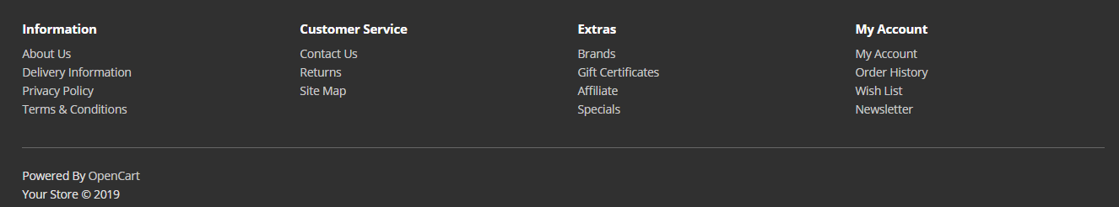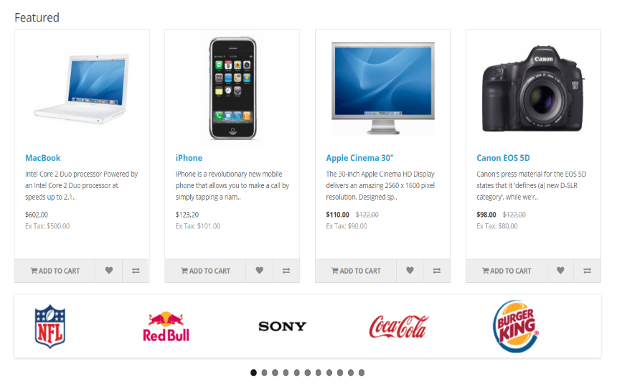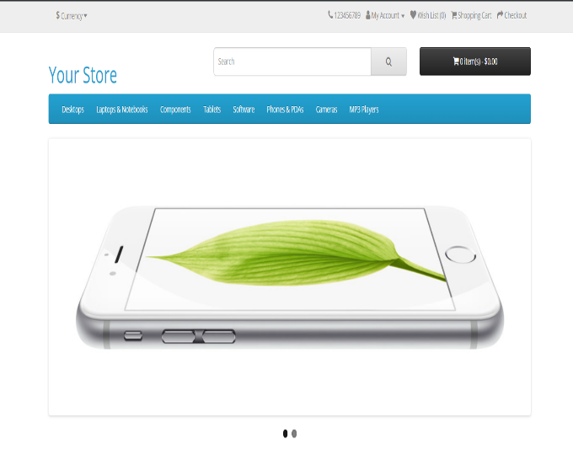

**As an Administrator:**

The landing page of the Administrator is given after the paragraph. Firstly, you need to login as an admin then you can access this page. At the left side, there are several options provided including catalog, extensions, system, design etc. One can see the sales analytics, number of online people, total sales, total customers etc. If one wants to add new extensions one can go to extensions option and can easily add external extensions or those which are already given. We can also enable or disable already given extensions. Similarly, admin can give other users some rights or can take rights or may be can block a user. One can also add apply different themes, can edit theme and the language. One can also add ads in the main site.

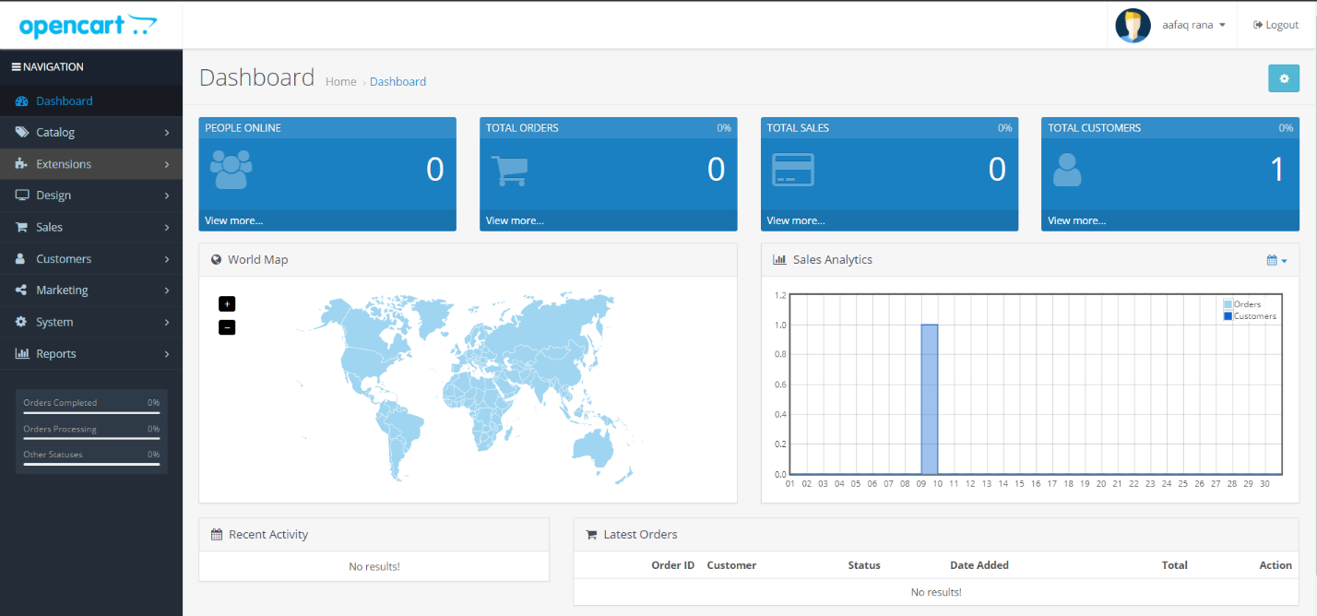

**Exploring Database:**

There are 138 tables in the database storing different types of data in it i.e. data of users, their purchase history, the data showing in different pages of customer/visitor site and so on.

Like the banner shown in the bottom of the landing page is:



Their data is stored as:

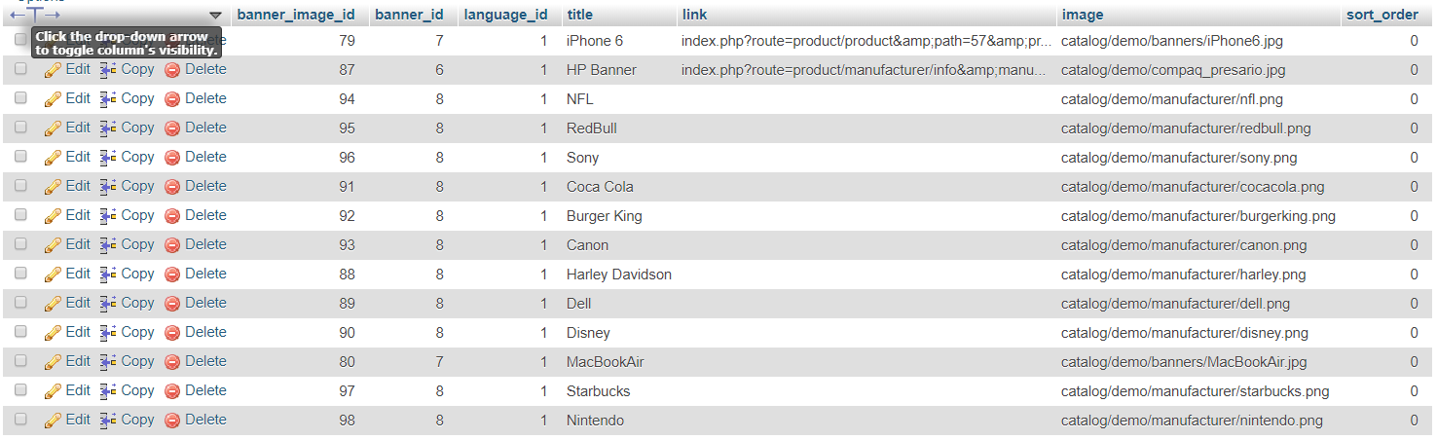

Similarly, the data of other things shown in the landing page and in the other pages of the customer/visitor site and the admin site is given in this database.

Like the data of the admin is given as:



From my point of view, this database is following all the rules and regulations that a database designer must apply, which means it is a good database, that is made after carefully designing the ERD and following the basic A.C.I.D. rules as well.

**From Coder Perspective:**

The OSS is following the MVC architecture which means the as the User uses the software, it controls the input which means there are certain events generated and some changes are made which are handled by the Controller folder files, the Controller folder files than manipulates the files in the Model folder which on changing, updates the view of the user. Hence, the user only sees those changes which are made by himself.

These are the folders containing the files in the admin folder that are used by the admin page:

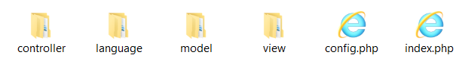

The controller and model contain almost same name files but the major difference is that the controller files are used by the user when using the frontend while the model files are used and manipulates the controller files. The view folder contains the CSS Styling, JavaScript, Templates, Images and the Fonts used.

These are the folders containing the files used in the customer/visitor site (excluding admin folder):

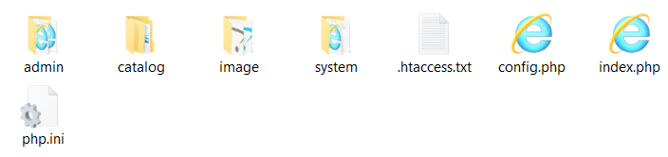

Admin folder is used by the admin site.

**Adding Some Online Available Plug-ins/ Modules/ Extensions:**

The Online available extension I used is **Basic Captcha** which is used when we need to return the product due to some complaint or we need to contact for assistance.

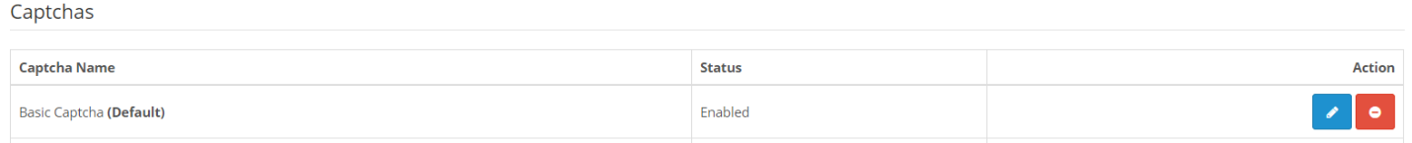Adding the online available Extension and enabling it:

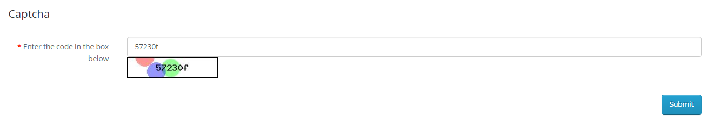The added Extension while trying to contact the admin: