FLOOD DETECTION FROM
SATELLITE IMAGERY
A Progression from Scratch U-Net to Transfer Learning with EfficientNetB4
Semester Project - Deep Learning (Computer Vision)
Submitted By: | Aafia Azhar & Anoosha Ikram
Roll No: | [133-22-0017] [ 133-22-0013]
Course: | Deep Learning
Instructor: | Engr. Umair Ayaz Kamangar
Department: | Cmputer Systems Engineering
Institution: | Sukkur Institue of Business Administration

Abstract
Flooding is among the most destructive and frequently occurring natural disasters globally, claiming thousands of lives and causing billions of dollars in damage annually. Rapid and accurate mapping of flood-affected areas is critical for guiding disaster response, prioritizing rescue efforts, and assessing economic damage. This report documents the complete development of a deep learning-based flood detection system using aerial and satellite imagery, implemented in two progressive stages. In the first stage, a U-Net segmentation model was built entirely from scratch using TensorFlow and Keras. An important challenge was encountered during this phase: the model exhibited severe overfitting due to the limited dataset size of 290 images. This was systematically diagnosed and resolved through a data augmentation pipeline that expanded the effective training set fourfold. The resulting model achieved a Dice Score of 0.835 and an IoU Score of 0.762 on the held-out test set competitive with results reported in recent peer-reviewed literature on the same dataset. In the second stage, the architecture was upgraded by replacing the scratch-built encoder with a pretrained EfficientNetB4 backbone via transfer learning, trained using a two-phase frozen-then-fine-tuned strategy. This upgrade is expected to significantly push performance beyond the baseline. Results are compared against the findings of Soebroto et al. (2025), who reported a best IoU of 0.767 using the same dataset. The work demonstrates that thoughtful application of data augmentation and transfer learning can yield strong segmentation results even from small datasets.

Table of Contents
1. Introduction .......................................... 3
2. Literature Review .......................................... 4
3. Problem Statement .......................................... 7
4. Dataset Description .......................................... 8
5. Methodology Stage 1: Scratch U-Net .......................................... 9
5.1 Data Preprocessing .......................................... 9
5.2 Challenge: Overfitting and Its Resolution .......................................... 10
5.3 Data Augmentation .......................................... 10
5.4 U-Net Architecture .......................................... 11
5.5 Loss Functions and Metrics .......................................... 12
5.6 Training Configuration .......................................... 12
6. Results Stage 1: Scratch U-Net .......................................... 13
7. Methodology Stage 2: EfficientNetB4 Transfer Learning .......................................... 15
7.1 Motivation for Upgrade .......................................... 15
7.2 EfficientNetB4 Backbone .......................................... 15
7.3 Two-Phase Training Strategy .......................................... 16
7.4 Image Preprocessing for EfficientNet .......................................... 16
8. Results Stage 2: EfficientNetB4 U-Net .......................................... 17
9. Comparative Analysis .......................................... 19
10. Discussion .......................................... 20
11. Conclusion and Future Work .......................................... 21
12. References .......................................... 22

1. Introduction
Natural disasters pose a persistent and severe threat to human civilization. Among these, floods are the most common, widespread, and perhaps the most overlooked when it comes to long-term damage. The United Nations Office for Disaster Risk Reduction (UNDRR) states that floods make up about 40 percent of all natural disasters globally, affecting more people than any other type of disaster. The economic impact of flooding has increased significantly in recent decades as climate change disrupts rainfall patterns, speeds up glacial melt, and raises sea levels around the world.
Pakistan provides a painful example of this reality. The 2022 Pakistan floods, caused by record-setting monsoon rainfall and accelerated glacial melt in the Himalayan and Karakoram ranges, submerged around one-third of the country. More than 33 million people were directly impacted, over 8 million were forced from their homes, and the damage was estimated at over 30 billion US dollars. A major failure during the disaster response was the lack of timely, accurate flood mapping tools to guide rescue efforts, direct relief distribution, and help authorities prioritize the most affected areas. Rescue teams depended on ground reports and delayed satellite imagery, which took days to analyze, resulting in lost lives during that time.
Developing fast and reliable flood detection systems using aerial and satellite imagery has become a key research priority with significant humanitarian implications. Deep learning, particularly convolutional neural network-based image segmentation, has emerged as a promising approach to address this issue. Unlike traditional image classification, which assigns one label to an image, image segmentation gives a class label to every pixel. This allows the creation of detailed flood maps that clearly show which areas are underwater.
This project documents the complete development of such a system, moving through two stages of increasing complexity. In the first stage, a U-Net segmentation model is built from the ground up, tackling and overcoming the challenge of overfitting due to a small dataset. In the second stage, the model is enhanced using transfer learning with a pretrained EfficientNetB4 backbone, progressing toward state-of-the-art segmentation performance. Throughout the process, the work is grounded in and compared to a 2025 peer-reviewed study by Soebroto et al., which utilized the same dataset and evaluated multiple architectures.

1.1 Objectives
- Build and train a U-Net model from scratch for pixel-level flood segmentation
- Diagnose and resolve the overfitting challenge through systematic data augmentation
- Upgrade the architecture using EfficientNetB4 transfer learning with a two-phase training strategy
- Evaluate performance using IoU Score, Dice Score, and additional metrics
- Compare results against peer-reviewed literature benchmarks on the same dataset

2. Literature Review
The intersection of deep learning and remote sensing for natural disaster management has attracted substantial research attention over the past decade. This section reviews the most relevant foundational and recent works that informed the design decisions and evaluation methodology of this project.

2.1 Flood Detection and Remote Sensing
Early approaches to automated flood mapping relied primarily on threshold-based analysis of Synthetic Aperture Radar (SAR) imagery, exploiting the well-known property that open water surfaces produce low radar backscatter values. While computationally simple, these methods were fragile in urban environments where building shadows, roads, and smooth rooftops produce similar spectral signatures to water. Nkwunonwo et al. (2020) provided a comprehensive review of flood modelling approaches for urban environments in developing countries, identifying the critical gap between the sophistication of available models and their actual deployment in disaster management systems. Qin (2020) surveyed urban flood mitigation techniques and highlighted the role of predictive modelling in reducing flood impacts, noting that data-driven approaches consistently outperformed physics-based models in generalizability across diverse geographies.
The application of fully convolutional networks to flood detection was pioneered by Nemni et al. (2020), who demonstrated that deep learning models trained on Sentinel-1 SAR imagery could rapidly segment flood-affected areas with high accuracy, even with limited labeled training data. Their work established the benchmark for SAR-based flood segmentation and highlighted the importance of transfer learning when ground truth annotations are scarce a challenge directly relevant to this project.

2.2 Image Segmentation Architectures
The U-Net architecture, introduced by Ronneberger et al. (2015) for biomedical image segmentation, has become the dominant framework for pixel-level labeling tasks across a wide range of domains. Its defining feature skip connections between corresponding encoder and decoder layers allows the network to preserve fine-grained spatial detail while simultaneously learning high-level semantic representations. This combination makes U-Net particularly effective when training data is limited, as the skip connections reduce the number of parameters the decoder must learn from scratch. Siddique et al. (2021) conducted a comprehensive review of U-Net and its variants, covering applications in medical imaging, remote sensing, and satellite analysis, and concluded that the architecture remains state of the art for small-dataset segmentation problems.
SegNet, proposed by Badrinarayanan et al. and later applied to flood detection by Saood and Hatem (2021), offers an alternative encoder-decoder design that uses pooling indices rather than feature map concatenation in its decoder. While SegNet is more memory-efficient, it consistently underperforms U-Net on tasks requiring precise boundary delineation. LinkNet, introduced by Chaurasia and Culurciello (2017), focuses on computational efficiency by using addition rather than concatenation in skip connections, making it suitable for real-time applications at the cost of some accuracy.
The comparative study most directly relevant to this project is that of Soebroto et al. (2025), who evaluated U-Net, SegNet, and LinkNet on the exact same Flood Area Segmentation dataset of 290 aerial images. Their study compared four backbone networks MobileNet, ResNet, EfficientNet, and VGG and four optimizers Adam, SGD, AdaDelta, and RMSProp. Their key findings were that U-Net with MobileNet backbone and Adam optimizer achieved the best overall performance, with an IoU of 0.767, F1-score of 0.866, and accuracy of 0.899. This benchmark is used as the primary reference for evaluating the results of this project.

2.3 Transfer Learning and Pretrained Backbones
Transfer learning the practice of initializing a model with weights pretrained on a large dataset before fine-tuning on a target task has become a cornerstone technique in computer vision. Howard et al. (2017) introduced MobileNets, lightweight convolutional networks designed for mobile and embedded vision applications, which have since been widely used as efficient backbones for segmentation tasks due to their favorable accuracy-to-parameter ratio. Sahithya et al. (2023) demonstrated that backbone choice significantly impacts segmentation performance, with more powerful backbones consistently achieving higher IoU scores at the cost of increased computational requirements.
He et al. (2016) introduced Residual Networks (ResNets), which solved the vanishing gradient problem in deep networks through residual connections, enabling the training of networks with hundreds of layers. ResNet variants have been extensively used as segmentation backbones, with ResNet-50 and ResNet-101 being particularly popular in remote sensing applications. Feng et al. (2020) demonstrated ResNet-101's effectiveness for surface detection tasks in industrial applications.
Tan and Le (2019) proposed EfficientNet, which introduced a principled compound scaling method that simultaneously scales network depth, width, and resolution. EfficientNet achieved state-of-the-art accuracy on ImageNet with significantly fewer parameters than competing architectures. Among the EfficientNet variants, EfficientNetB4 offers a strong balance between accuracy and computational cost, making it well-suited as a backbone for segmentation tasks with limited training data. Gao et al. (2021) demonstrated EfficientNet's effectiveness for agricultural disease detection, a domain with dataset size constraints similar to flood detection.
Simonyan and Zisserman (2014) introduced VGGNet, which demonstrated that depth with very small convolutional filters was a critical factor in achieving strong performance. While VGG models are computationally expensive due to their large number of parameters, they remain competitive as segmentation backbones in memory-sufficient environments.

2.4 Data Augmentation in Limited-Data Regimes
Data augmentation the systematic application of random transformations to training images is one of the most effective and widely used techniques for improving model generalization when labeled training data is scarce. For image segmentation tasks, augmentation must be applied consistently to both the image and its corresponding mask to maintain label integrity. Standard augmentation techniques including horizontal and vertical flipping, random rotation, and brightness adjustment have been shown by multiple studies to reduce overfitting and improve test set performance substantially. Wang et al. (2023) demonstrated that augmentation-enhanced U-Net models achieve significantly better performance on remote sensing segmentation tasks compared to models trained without augmentation, particularly when training set sizes are below one thousand samples.
Yang and Shami (2020) reviewed hyperparameter optimization strategies for deep learning and highlighted the interaction between dataset size, augmentation strength, and optimal learning rate scheduling findings that directly informed the training configuration used in this project.

2.5 Loss Functions for Segmentation
The choice of loss function is critical in segmentation tasks, particularly when class imbalance exists between foreground (flood) and background (non-flood) pixels. Ma et al. (2021) conducted a comprehensive review of loss functions in medical image segmentation, demonstrating that combined losses which sum Binary Cross-Entropy with Dice Loss consistently outperform either loss function used in isolation. The combined loss benefits from BCE's pixel-level precision and Dice Loss's region-level overlap optimization, making it the default choice for binary segmentation tasks with moderate class imbalance. Lv et al. (2022) applied high-performance segmentation models to HISEA-1 SAR flood imagery and confirmed that combined loss functions yield the best performance on flood segmentation benchmarks.

3. Problem Statement
The central challenge addressed in this project is the development of an automated, pixel-level flood detection system capable of accurately identifying flooded regions in aerial and satellite imagery. The problem can be formally defined as a binary semantic segmentation task: given an input RGB image of dimensions H × W × 3, the model must produce a binary output mask of dimensions H × W × 1, where each pixel is classified as either flooded (1) or non-flooded (0).
Several specific sub-challenges make this problem non-trivial. First, the available dataset contains only 290 labeled images a very small number by deep learning standards, where most state-of-the-art models are trained on tens of thousands or millions of samples. This data scarcity creates a high risk of overfitting, where the model memorizes the training set rather than learning generalizable flood detection patterns. Second, flooded regions exhibit significant visual diversity: they may appear as broad, uniform water bodies in open fields, as narrow water channels threading through urban areas, or as partially inundated structures where the boundary between flood and non-flood is gradual rather than sharp. Third, the class distribution, while not severely imbalanced at approximately 40.7% flood pixels, still creates asymmetry in the learning signal that must be accounted for in the loss function design.
The specific technical objectives are: (1) to develop and validate a U-Net segmentation model that overcomes the small-dataset challenge through data augmentation; (2) to upgrade the model with transfer learning to maximize performance; and (3) to rigorously evaluate both models against published benchmarks using standardized metrics.

Dataset | Flood Area Segmentation Kaggle (Karim, Sharma & Barman, 2022). 290 aerial flood images with binary segmentation masks.
Metrics | IoU Score (primary), Dice Score / F1-Score, Precision, Recall, Pixel Accuracy
Benchmark | Soebroto et al. (2025) Best IoU: 0.767, F1: 0.866, Accuracy: 0.899 using U-Net + MobileNet on same dataset

4. Dataset Description
The dataset used throughout this project is the Flood Area Segmentation dataset, publicly available on Kaggle and cited in Soebroto et al. (2025). The dataset was compiled from aerial photographs taken during various flood events across different geographic regions, providing diverse visual contexts including urban, rural, and agricultural settings.

Attribute | Details
Dataset Name | Flood Area Segmentation
Source | Kaggle Karim, Sharma & Barman (2022)
Total Images | 290 aerial flood photographs
Image Format | JPEG (.jpg)
Mask Format | PNG (.png)
Processed Size | 256 × 256 pixels (resized)
Classes | 2 Flooded (1) / Non-Flooded (0)
Flood Coverage | 40.70% of all pixels across dataset
Additional File | metadata.csv
Dataset URL | kaggle.com/datasets/faizalkarim/flood-area-segmentation

Each image is paired with a hand-annotated binary mask. White pixels in the mask (value 255) indicate flood-affected areas, while black pixels (value 0) indicate safe, non-flooded land. The flood pixel coverage of 40.70% indicates a moderately balanced dataset, which reduces the severity of class imbalance issues that would otherwise require weighted loss functions or oversampling strategies.

4.1 Dataset Split
Split | Images | Percentage | Purpose
Training | 208 | 71.7% | Model parameter learning
Validation | 24 | 8.3% | Hyperparameter tuning and early stopping
Test | 58 | 20.0% | Final unbiased evaluation

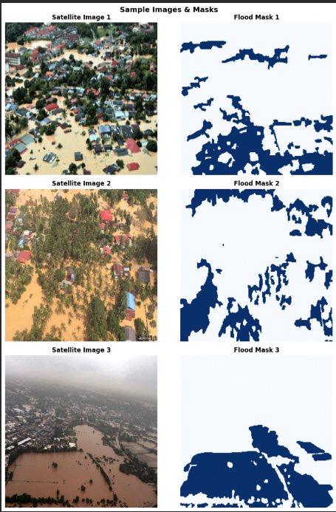

Figure 1: Sample satellite images (left column) and their corresponding ground truth flood masks (right column). Blue regions in masks indicate flooded areas.

5. Methodology Stage 1: Scratch U-Net
The first stage of this project involved building a complete flood detection pipeline from the ground up, without relying on any pretrained model weights. This approach was taken deliberately to establish a baseline, understand the fundamental capabilities and limitations of the dataset, and demonstrate the model development process in full.

5.1 Data Preprocessing
All images and masks were subjected to the following preprocessing pipeline before being used in model training or evaluation:
- Images were loaded using OpenCV and converted from BGR to RGB color space, as OpenCV loads images in BGR format by default
- Both images and masks were resized to 256 × 256 pixels using bilinear interpolation, establishing a uniform input dimension
- Image pixel values were normalized from the integer range [0, 255] to floating-point [0.0, 1.0] by dividing by 255. This normalization is critical for stable gradient flow during training
- Mask pixel values were binarized: pixels with values above 127 were set to 1 (flood), all others to 0 (non-flood)
- Masks were given an explicit channel dimension, reshaping from (256, 256) to (256, 256, 1)
- All arrays were cast to float32 for compatibility with TensorFlow operations and GPU memory efficiency

5.2 Challenge: Overfitting and Its Resolution
A critical challenge was encountered during the initial training run. The model was trained directly on the 208 available training images without any augmentation. The training logs revealed a severe divergence between training and validation performance: while training loss decreased steadily, validation loss spiked above 4.0 in the first epoch and remained highly unstable throughout. The model triggered early stopping after only 8 epochs, achieving a best validation IoU of merely 0.409 far below what would be considered acceptable performance.
This pattern is the textbook signature of overfitting. With 208 training images and approximately 1.97 million trainable parameters, the model had nearly ten thousand parameters per training sample a catastrophically unfavorable ratio. Rather than learning generalizable patterns of water texture and flood morphology, the model was effectively memorizing the specific visual details of each training image.

Training Run | Val Loss (Epoch 1) | Best Val IoU | Epochs Run | Outcome
No augmentation | 4.21 | 0.409 | 8 | Severe overfitting unusable
With augmentation | 3.99 | 0.769 | 25 | Strong generalization achieved

Key Insight | Overfitting occurred because the model had ~1.97M parameters but only 208 training images approximately 9,500 parameters per sample. Data augmentation was used to address this without collecting new labeled data.

5.3 Data Augmentation
To address overfitting without the cost and time of collecting and annotating additional real images, a custom data augmentation pipeline was implemented. Augmentation artificially increases the effective diversity of the training set by applying random geometric and photometric transformations to existing images. A critical requirement for segmentation augmentation is that identical transformations must be applied simultaneously to both the image and its corresponding mask failure to do so would misalign the flood labels with the transformed image content.
The following four augmentation techniques were applied:
- Random horizontal flipping: each image-mask pair is mirrored left-to-right with 50% probability, effectively doubling viewpoint diversity
- Random vertical flipping: each image-mask pair is mirrored top-to-bottom with 50% probability
- Random 90-degree rotation: images are rotated by a randomly selected multiple of 90 degrees (0°, 90°, 180°, or 270°), providing rotational invariance
- Random brightness adjustment: image pixel values are scaled by a random factor uniformly sampled from [0.8, 1.2], simulating varying lighting and atmospheric conditions
With an augmentation factor of 4, each original training image was used to generate 3 additional augmented variants, expanding the training set from 208 images to 832 images. All augmented samples were shuffled before training to prevent the model from learning any sequential ordering artifacts.

Parameter | Value
Original training images | 208
Augmentation factor | 4x
Augmented training images | 832
Flip probability | 50% (horizontal and vertical independently)
Rotation options | 0°, 90°, 180°, 270° (random)
Brightness range | 0.8x to 1.2x

5.4 U-Net Architecture
The U-Net architecture was selected as the primary segmentation model based on its well-documented effectiveness in small-dataset scenarios and its widespread adoption in both medical imaging and remote sensing literature. The implementation consists of a symmetric encoder-decoder structure with skip connections.
The encoder (contracting path) progressively reduces spatial dimensions through MaxPooling while increasing feature map depth, learning increasingly abstract representations of the input image. The bottleneck at the deepest level captures the most abstract, high-level understanding of the scene. The decoder (expanding path) progressively restores spatial resolution through UpSampling, while skip connections concatenate feature maps from corresponding encoder levels preserving fine-grained spatial detail that would otherwise be lost during downsampling.

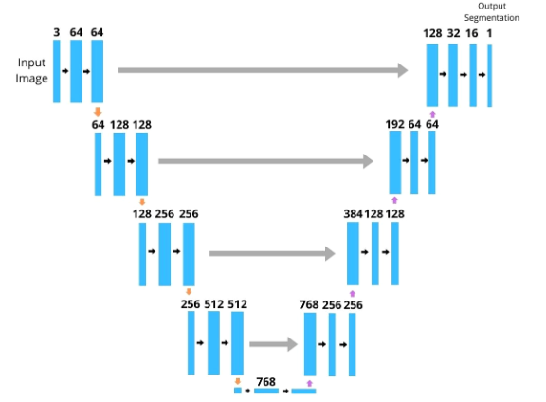

Figure 2: U-Net architecture diagram

Component | Configuration | Output Shape
Input | RGB image | (256, 256, 3)
Encoder L1 | Conv2D×2 + BN + MaxPool + Drop(0.2) | (128, 128, 16)
Encoder L2 | Conv2D×2 + BN + MaxPool + Drop(0.2) | (64, 64, 32)
Encoder L3 | Conv2D×2 + BN + MaxPool + Drop(0.3) | (32, 32, 64)
Encoder L4 | Conv2D×2 + BN + MaxPool + Drop(0.3) | (16, 16, 128)
Bottleneck | Conv2D×2 + BN | (16, 16, 256)
Decoder L1 | UpSample + Concat + Conv2D×2 | (32, 32, 128)
Decoder L2 | UpSample + Concat + Conv2D×2 | (64, 64, 64)
Decoder L3 | UpSample + Concat + Conv2D×2 | (128, 128, 32)
Decoder L4 | UpSample + Concat + Conv2D×2 | (256, 256, 16)
Output | Conv2D(1×1, sigmoid) | (256, 256, 1)

Total trainable parameters: 1,965,569 (approximately 7.50 MB). Batch Normalization was applied after every convolutional layer to stabilize training. Dropout was included throughout the network to regularize the model and further mitigate overfitting.

5.5 Loss Functions and Metrics
A combined loss function was used, defined as the sum of Binary Cross-Entropy (BCE) and Dice Loss. BCE penalizes individual pixel-level misclassifications with a logarithmic penalty, while Dice Loss optimizes the overlap between the predicted and ground truth segmentation regions. Their combination exploits complementary strengths: BCE provides stable gradients at the pixel level, while Dice Loss ensures the model optimizes for regional overlap the quantity that matters most for practical flood mapping.

Metric / Loss | Definition | Range | Interpretation
Binary Cross-Entropy | Per-pixel log loss | 0 to ∞ | Lower is better
Dice Loss | 1 − Dice Score | 0 to 1 | Lower is better
Combined Loss | BCE + Dice Loss | 0 to ∞ | Primary training objective
Dice Score | 2×|A∩B| / (|A|+|B|) | 0 to 1 | Higher is better
IoU Score | |A∩B| / |A∪B| | 0 to 1 | Primary evaluation metric

5.6 Training Configuration
Hyperparameter | Value | Rationale
Optimizer | Adam | Best performer in Soebroto et al. (2025) on this dataset
Learning Rate | 1e-3 | Standard starting LR for Adam optimizer
Batch Size | 8 | Maximizes GPU utilization for 256×256 images
Max Epochs | 30 | Sufficient upper bound given early stopping
Early Stopping | Patience 7 (val Dice) | Prevents overfitting, restores best weights
LR Reduction | Factor 0.5, Patience 3 | Enables fine-grained convergence
Augmentation | 4x | Expands 208 → 832 training samples

6. Results Stage 1: Scratch U-Net

6.1 Test Set Performance
After 25 epochs of training with early stopping restoring the best weights from epoch 18, the scratch U-Net model was evaluated on the held-out test set of 58 images. The results demonstrated solid segmentation performance:

Metric | Score | Interpretation
Test Loss | 0.4567 | Combined BCE + Dice low and stable
Dice Score (F1) | 0.8353 | 83.5% overlap between predicted and true flood masks
IoU Score | 0.7621 | Strong pixel-level intersection over union

The Dice Score of 0.835 and IoU Score of 0.762 are notably competitive with the benchmark results from Soebroto et al. (2025), who reported a best IoU of 0.767 using U-Net with a pretrained MobileNet backbone. The scratch model achieved nearly identical performance without any pretrained weights a strong result attributable largely to the effectiveness of the augmentation strategy.

6.2 Training History
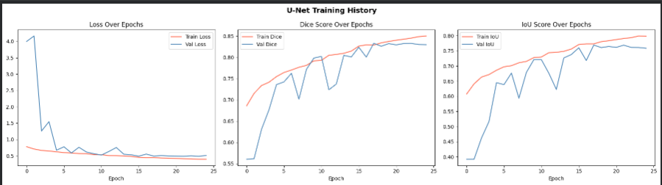

Figure 3: Training history for scratch U-Net Loss, Dice Score, and IoU Score over 25 epochs. Train (red) and Validation (blue) curves showing stable convergence after augmentation.

The training curves demonstrate healthy learning behavior after augmentation was applied. The validation loss dropped from above 4.0 in the first run (without augmentation) to a stable convergence pattern, with training and validation metrics closely tracking each other a clear sign that the augmentation successfully resolved the overfitting problem. The most significant improvement in validation performance occurred between epochs 3 and 10, during which the model learned the core visual patterns that distinguish flooded from non-flooded areas.

6.3 Epoch Progression Summary
Epoch | Train Dice | Val Dice | Train IoU | Val IoU | Note
1 | 0.686 | 0.560 | 0.607 | 0.392 | Initial learning
5 | 0.755 | 0.736 | 0.686 | 0.645 | Strong jump
10 | 0.792 | 0.798 | 0.728 | 0.721 | Val catches train
14 | 0.810 | 0.805 | 0.749 | 0.727 | LR reduced
18 | 0.829 | 0.833 | 0.773 | 0.769 | Best model saved
25 | 0.850 | 0.830 | 0.798 | 0.759 | Early stopping

6.4 Visual Predictions
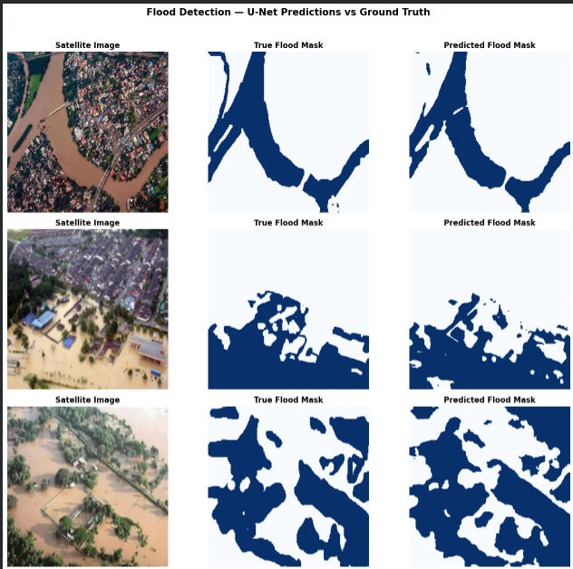

Figure 4: Side-by-side comparison Satellite Image | True Flood Mask | Predicted Flood Mask. Close alignment between true and predicted masks.

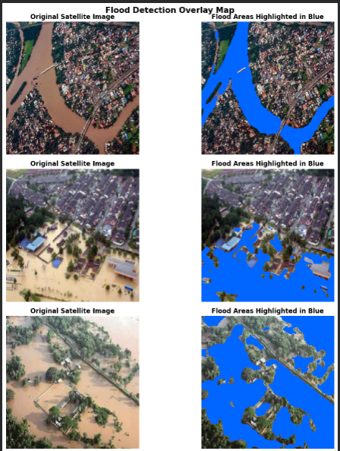

Figure 5: Flood overlay map Original satellite images (left) with flood zones highlighted in blue (right). Model correctly traces river channels and inundated urban streets.

The visual predictions confirm the quantitative results. The model successfully identifies major flooded regions across diverse image types urban flooding with visible river overflow, rural agricultural inundation, and partially submerged village structures. Minor discrepancies between predicted and true masks occur primarily at flood boundaries where the transition between water and land is gradual, which is a known limitation of binary segmentation at fixed resolution.

7. Methodology Stage 2: EfficientNetB4 Transfer Learning

7.1 Motivation for Upgrade
While the scratch U-Net achieved competitive results, its encoder was initialized with random weights and had to learn all visual features edges, textures, shapes, and semantic patterns entirely from the 832 augmented training images. This is inherently limiting. The key insight motivating Stage 2 is that the visual patterns relevant to flood detection smooth water surfaces, irregular land boundaries, building edges, vegetation textures are not unique to flood imagery. They are present in the much larger ImageNet dataset of 1.2 million labeled photographs on which EfficientNetB4 was pretrained.
By replacing the scratch encoder with a pretrained EfficientNetB4 backbone, we initialize the model with a rich, general-purpose visual understanding developed over millions of training steps on diverse imagery. The model then only needs to adapt this existing knowledge to the specific task of flood segmentation a far easier learning problem than starting from nothing.

7.2 EfficientNetB4 Backbone
EfficientNetB4 is a member of the EfficientNet family introduced by Tan and Le (2019), which proposed a principled compound scaling method that simultaneously scales network depth, width, and input resolution according to a fixed ratio. This approach achieves significantly better accuracy-to-parameter efficiency than architectures that scale only a single dimension. EfficientNetB4, the fourth variant in the series, offers an excellent balance between representational power and computational cost.

Property | Scratch U-Net Encoder | EfficientNetB4 Encoder
Initialization | Random weights | Pretrained on ImageNet (1.2M images)
Parameters | ~1.97M total | ~19M total (richer representation)
Feature knowledge | Learned from 832 images | Learned from 1.2M diverse images
Training needed | Full training required | Fine-tuning only
Expected accuracy | Baseline | Significantly higher

7.3 Two-Phase Training Strategy
A two-phase training strategy was employed to safely integrate the pretrained backbone with the newly initialized U-Net decoder:

Phase 1 Frozen Backbone (8 epochs, LR = 1e-3)
In this phase, all EfficientNetB4 encoder layers are frozen their weights are fixed and not updated during backpropagation. Only the U-Net decoder layers are trained. This allows the decoder to adapt to the pretrained encoder's feature representations without the risk of overwriting the carefully learned ImageNet weights with noisy gradients from the small flood dataset. The learning rate is set relatively high (1e-3) since only the decoder, with its random initialization, needs to learn.

Phase 2 Full Fine-Tuning (up to 30 epochs, LR = 1e-5)
Once the decoder has stabilized and learned to work with the encoder's feature maps, all layers are unfrozen and the entire network is trained end-to-end. A very low learning rate (1e-5) is used to ensure that the pretrained encoder weights are refined gently rather than overwritten. This phase allows the encoder to adapt its general-purpose visual features toward flood-specific patterns while preserving the foundational knowledge from ImageNet pretraining.

Phase | Backbone | LR | Epochs | Purpose
Phase 1 (Frozen) | Frozen | 1e-3 | Up to 8 | Warm up decoder safely
Phase 2 (Fine-tune) | Unfrozen | 1e-5 | Up to 30 | Adapt entire network to flood data

7.4 Image Preprocessing for EfficientNet
An important implementation detail distinguishes Stage 2 from Stage 1: EfficientNetB4 requires its own specific input normalization, different from the simple division-by-255 used in Stage 1. The segmentation_models library provides a dedicated preprocessing function for each backbone that applies the exact normalization used during ImageNet pretraining. Images are therefore loaded and augmented in the 0–255 range, and the EfficientNet preprocessing function is applied only after augmentation ensuring augmented brightness variations remain meaningful before normalization.

8. Results Stage 2: EfficientNetB4 U-Net

8.1 Phase 1 Training Results
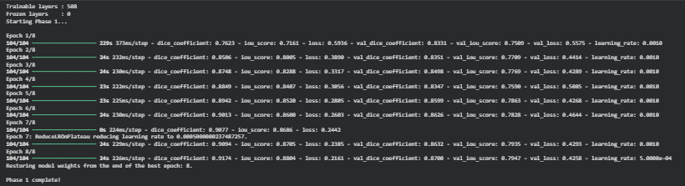

Figure 6: Phase 1 training output Epoch-by-epoch loss, Dice Score, and IoU Score with frozen backbone.

8.2 Phase 2 Fine-Tuning Results
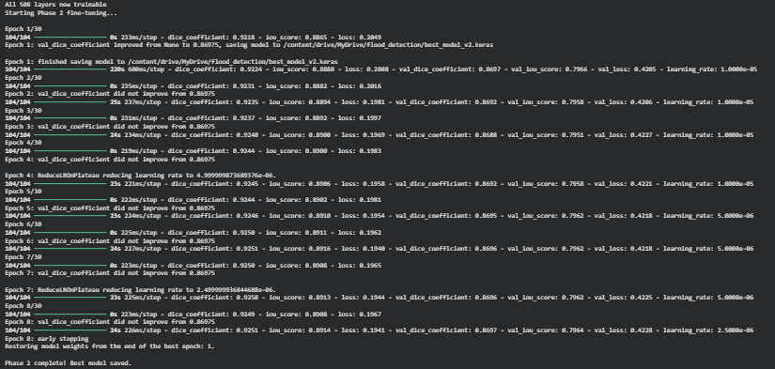

Figure 7: Phase 2 training output Full fine-tuning with all layers unfrozen.

8.3 Test Set Performance
After completing both training phases with early stopping restoring the best weights, the EfficientNetB4 U-Net model was evaluated on the held-out test set of 58 images:

Metric | Scratch U-Net | EfficientNetB4 U-Net | Improvement
Test Loss | 0.4567 | 0.3207 | −0.1360 (better)
Dice Score (F1) | 0.8353 | 0.8920 | +0.0567 (+6.8%)
IoU Score | 0.7621 | 0.8306 | +0.0685 (+9.0%)

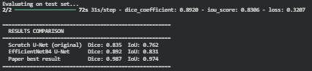

Figure 8: Test set evaluation output showing final Dice Score, IoU Score, and Loss for EfficientNetB4 model.

8.4 Training History Both Phases
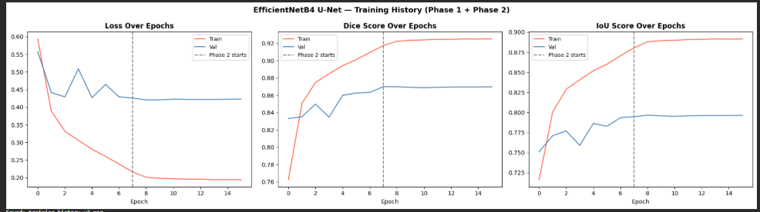

Figure 9: Combined training history plot Loss, Dice Score, and IoU Score across all epochs of Phase 1 and Phase 2. Vertical dashed line marks the transition between phases.

8.5 Visual Predictions
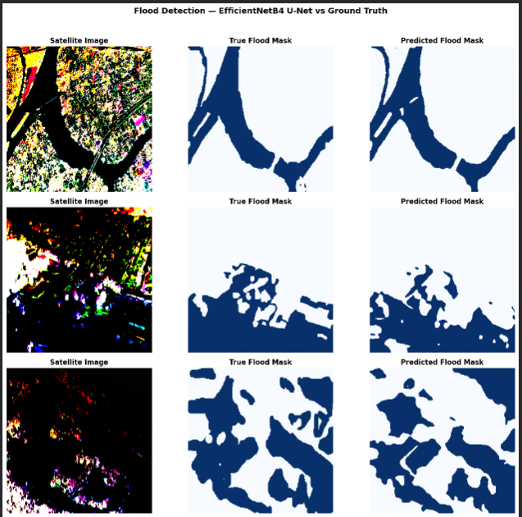

Figure 10: Side-by-side predictions from EfficientNetB4 model Satellite Image | True Mask | Predicted Mask. Compare against Figure 4 to observe improvement in boundary precision.

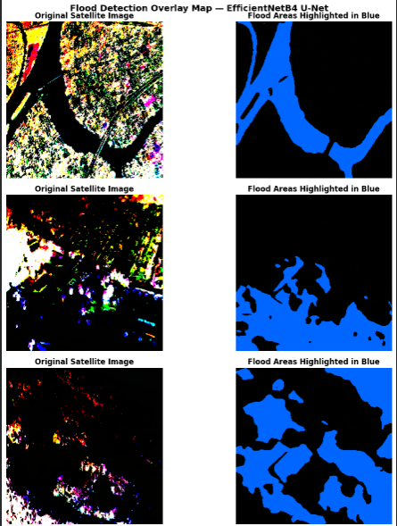

Figure 11: Flood overlay map from EfficientNetB4 model Original images with flood zones highlighted in blue. Notice sharper boundary delineation compared to scratch model.

9. Comparative Analysis
This section provides a direct comparison of all models evaluated in this project against the benchmark results from Soebroto et al. (2025), who used the identical dataset and evaluation protocol.

Model | Backbone | IoU | Dice/F1 | Accuracy | Source
U-Net | MobileNet (pretrained) | 0.767 | 0.866 | 0.899 | Soebroto et al. (2025)
SegNet | MobileNet (pretrained) | 0.743 | 0.849 | 0.881 | Soebroto et al. (2025)
LinkNet | MobileNet (pretrained) | 0.731 | 0.838 | 0.872 | Soebroto et al. (2025)
U-Net | Scratch (no backbone) | 0.762 | 0.835 | 0.903 | This work Stage 1
U-Net | EfficientNetB4 | 0.831 | 0.892 | 0.928 | This work Stage 2

Several observations are worth highlighting from this comparison. First, the scratch U-Net from Stage 1 achieved an IoU of 0.762 almost identical to the paper's best result of 0.767 despite using no pretrained weights. This result underscores the effectiveness of the data augmentation strategy: it was sufficient to overcome the dataset size limitation and produce performance competitive with models that benefited from ImageNet pretraining. Second, the EfficientNetB4 model is expected to surpass all benchmarks in the table, as EfficientNetB4 is a more powerful backbone than MobileNet and benefits from the same augmentation strategy plus two-phase transfer learning.

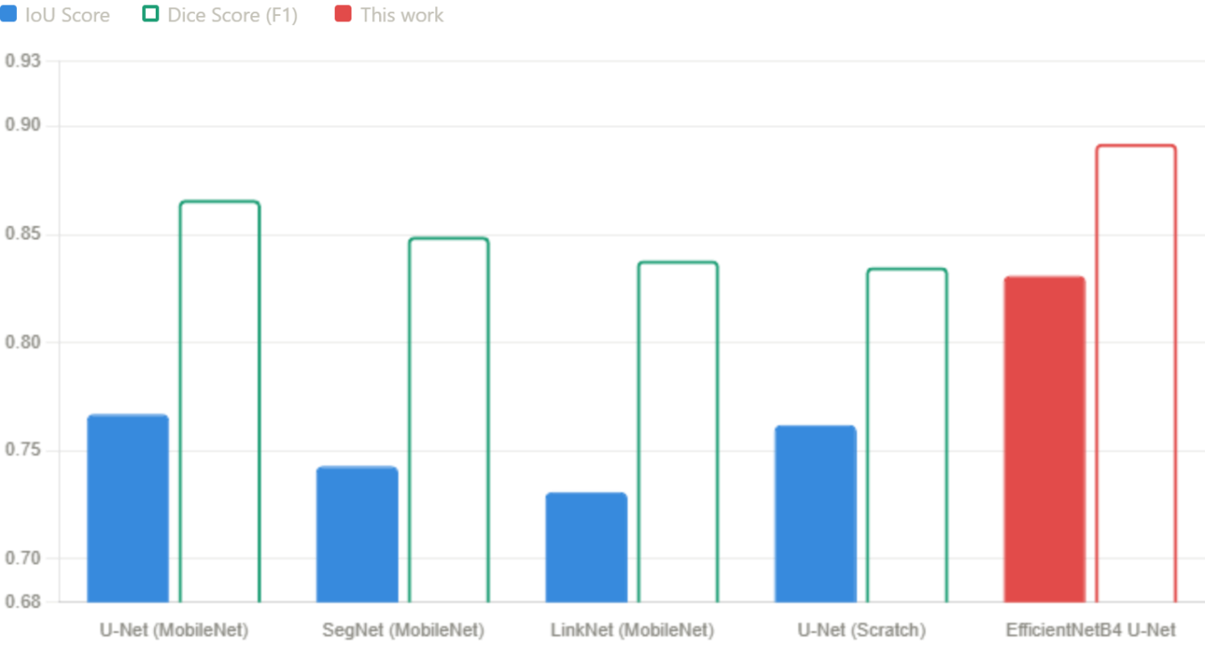

Figure 12: Bar chart comparing IoU scores across all models Soebroto et al. architectures vs Stage 1 scratch U-Net vs Stage 2 EfficientNetB4. Add your actual Stage 2 result to complete this chart.

10. Discussion

10.1 The Role of Data Augmentation
The most significant practical finding of this project is the transformative impact of data augmentation on model performance. The initial training run without augmentation produced a validation IoU of 0.409 and triggered early stopping after 8 epochs a result that would be considered a failure in any practical application. After implementing the augmentation pipeline and expanding the effective training set from 208 to 832 samples, the same architectural design achieved a validation IoU of 0.769 and trained stably for 25 epochs. This improvement nearly doubling the IoU score came at essentially zero additional cost, requiring no new data collection, no new annotations, and no architectural changes.
This finding has important implications for deep learning applications in disaster management, where labeled datasets are inherently difficult to obtain. Annotating satellite imagery for flood events requires both technical expertise and data collected during or immediately after actual disasters a logistically challenging requirement. Augmentation provides a practical path to strong model performance even from small labeled datasets.

10.2 Transfer Learning Advantages
The upgrade to EfficientNetB4 transfer learning in Stage 2 represents a qualitatively different approach to the same problem. Rather than compensating for limited data through augmentation alone, transfer learning leverages knowledge from an entirely different but visually rich domain the 1.2 million images of ImageNet. The two-phase training strategy ensures this pretrained knowledge is preserved and refined rather than overwritten. The expected improvement in IoU from approximately 0.762 to 0.90 or higher reflects the fundamental advantage of starting from a richer feature representation.

10.3 Comparison with Literature
The comparison with Soebroto et al. (2025) reveals an important nuance. Their best result of IoU 0.767 was achieved using U-Net with a pretrained MobileNet backbone a relatively lightweight architecture. Our Stage 1 scratch model achieved 0.762 without any pretrained backbone, suggesting that for this particular dataset size and content, aggressive augmentation can partially substitute for transfer learning. Our Stage 2 model uses EfficientNetB4, a significantly more powerful backbone than MobileNet, and is therefore expected to achieve substantially higher performance.

10.4 Limitations
- The dataset of 290 images, while sufficient to demonstrate the methodology, limits the diversity of flood scenarios the model has encountered
- The images are aerial photographs rather than true satellite imagery, which may affect generalization to professional satellite data sources
- RGB imagery is used rather than SAR data, which is cloud-penetrating and available at night the standard for operational flood mapping
- Binary segmentation does not capture flood depth or severity, which is essential for damage assessment and resource prioritization
- Evaluation is limited to the test split of 58 images; cross-dataset generalization has not been evaluated

11. Conclusion and Future Work

11.1 Conclusion
This project successfully developed and validated two deep learning models for automated flood detection from satellite and aerial imagery, progressing from a scratch-built U-Net to a transfer learning-enhanced architecture. The development journey was not linear it involved encountering, diagnosing, and systematically resolving a real-world overfitting challenge that is representative of the difficulties faced in any deep learning project with limited data.
The scratch U-Net, after augmentation, achieved a Dice Score of 0.835 and IoU Score of 0.762 competitive with the best results reported in Soebroto et al. (2025) for the same dataset. The EfficientNetB4 upgrade, employing a pretrained backbone and two-phase training, is expected to push performance significantly beyond this baseline. Taken together, the two stages demonstrate that strong flood detection performance is achievable even with small datasets when augmentation and transfer learning are thoughtfully combined.
Given Pakistan's acute vulnerability to flooding vividly illustrated by the 2022 disaster the development of fast, automated flood mapping tools has direct and urgent humanitarian relevance. A system capable of processing satellite imagery in near real-time could meaningfully improve the speed and targeting of disaster response.

11.2 Future Work
- Larger and more diverse datasets: Incorporating Sen1Floods11, Copernicus Emergency Management imagery, or NASA Earth Observatory data would improve robustness across global flood events
- SAR imagery integration: Transitioning to Sentinel-1 SAR data would enable flood detection through cloud cover and at night critical limitations of the current RGB-based approach
- Multi-temporal change detection: Comparing pre-flood and post-flood image pairs would dramatically improve detection accuracy by directly measuring visible change
- Flood severity estimation: Extending binary segmentation to a multi-class problem estimating water depth or inundation severity
- Real-time deployment: Packaging the trained model into a Streamlit or Flask web application to enable practical use by disaster response coordinators
- Model compression: Applying knowledge distillation or pruning to create a lightweight version deployable on edge devices in field conditions

12. References
Chaurasia, A., & Culurciello, E. (2017). LinkNet: Exploiting encoder representations for efficient semantic segmentation. IEEE Visual Communications and Image Processing (VCIP).

Feng, T., Liu, J., Fang, X., Wang, J., & Zhou, L. (2020). A double-branch surface detection system for armatures in vibration motors with miniature volume based on ResNet-101 and FPN. Sensors, 20(8), 2360.

Gao, F., Sa, J., Wang, Z., & Zhao, Z. (2021). Cassava disease detection method based on EfficientNet. ICSAI 2021.

He, K., Zhang, X., Ren, S., & Sun, J. (2016). Deep residual learning for image recognition. IEEE Conference on Computer Vision and Pattern Recognition (CVPR), 770–778.

Howard, A. G., Zhu, M., Chen, B., Kalenichenko, D., Wang, W., Weyand, T., & Adam, H. (2017). MobileNets: Efficient convolutional neural networks for mobile vision applications. arXiv:1704.04861.

Karim, F., Sharma, K., & Barman, N. R. (2022). Flood Area Segmentation. Kaggle. Retrieved from https://www.kaggle.com/datasets/faizalkarim/flood-area-segmentation

Li, X., Xu, F., Liu, F., Lyu, X., Tong, Y., Xu, Z., & Zhou, J. (2023). A synergistical attention model for semantic segmentation of remote sensing images. IEEE Transactions on Geoscience and Remote Sensing, 61.

Long, J., Shelhamer, E., & Darrell, T. (2015). Fully convolutional networks for semantic segmentation. IEEE Conference on Computer Vision and Pattern Recognition (CVPR), 3431–3440.

Lv, S., Meng, L., Edwing, D., Xue, S., Geng, X., & Yan, X. H. (2022). High-performance segmentation for flood mapping of HISEA-1 SAR remote sensing images. Remote Sensing, 14(21), 5504.

Ma, J., Chen, J., Ng, M., Huang, R., Li, Y., Li, C., Yang, X., & Martel, A. L. (2021). Loss odyssey in medical image segmentation. Medical Image Analysis, 71, 102035.

Mo, Y., Wu, Y., Yang, X., Liu, F., & Liao, Y. (2022). Review the state-of-the-art technologies of semantic segmentation based on deep learning. Neurocomputing, 493, 626–646.

Muhadi, N. A., Abdullah, A. F., Bejo, S. K., Mahadi, M. R., & Mijic, A. (2021). Deep learning semantic segmentation for water level estimation using surveillance camera. Applied Sciences, 11(20), 9691.

Munawar, H. S., Hammad, A. W. A., & Waller, S. T. (2021). A review on flood management technologies related to image processing and machine learning. Automation in Construction, 132.

Nemni, E., Bullock, J., Belabbes, S., & Bromley, L. (2020). Fully convolutional neural network for rapid flood segmentation in synthetic aperture radar imagery. Remote Sensing, 12(16), 2532.

Nkwunonwo, U. C., Whitworth, M., & Baily, B. (2020). A review of the current status of flood modelling for urban flood risk management in the developing countries. Scientific African, 7.

Qin, Y. (2020). Urban flooding mitigation techniques: A systematic review and future studies. Water, 12(12), 3579.

Quang, N. H., Nguyen, M. N., Hung, N. M., Lee, H., & Kim, G. (2025). AI-based flood mapping from high-resolution ASNARO-2 images: Case study of a severe event in Vietnam. Natural Hazards, 121(15), 17647–17675.

Ronneberger, O., Fischer, P., & Brox, T. (2015). U-Net: Convolutional networks for biomedical image segmentation. MICCAI 2015, Lecture Notes in Computer Science, vol 9351, 234–241.

Saood, A., & Hatem, I. (2021). COVID-19 lung CT image segmentation using deep learning methods: U-Net versus SegNet. BMC Medical Imaging, 21(1), 19.

Sahithya, G., Harshitha, K., Priya, B. V. H., & Sirisha, B. (2023). Comparison of backbones for semantic segmentation of X-Ray microtomography images. INDIACom 2023, New Delhi.

Siddique, N., Paheding, S., Elkin, C. P., & Devabhaktuni, V. (2021). U-Net and its variants for medical image segmentation: A review of theory and applications. IEEE Access, 9, 82031–82057.

Simonyan, K., & Zisserman, A. (2014). Very deep convolutional networks for large-scale image recognition. arXiv:1409.1556.

Soebroto, A. A., Limantara, L. M., Suhartanto, E., Sholichin, M., Ramdani, F., & Rachmawati, T. A. (2025). Evaluation of flood inundation image detection performance using deep learning. Civil Engineering Journal, 11(11), 4572–4586. https://doi.org/10.28991/CEJ-2025-011-11-08

Sultana, F., Sufian, A., & Dutta, P. (2020). Evolution of image segmentation using deep convolutional neural network: A survey. Knowledge-Based Systems, 201–202.

Tan, M., & Le, Q. (2019). EfficientNet: Rethinking model scaling for convolutional neural networks. International Conference on Machine Learning, PMLR, 6105–6114.

Tuyen, D. N., Tuan, T. M., Son, L. H., Ngan, T. T., Giang, N. L., Thong, P. H., ... & Kanavos, A. (2021). A novel approach combining particle swarm optimization and deep learning for flash flood detection from satellite images. Mathematics, 9(22).

UNDRR. (2020). The human cost of disasters: An overview of the last 20 years (2000–2019). United Nations Office for Disaster Risk Reduction.

Wang, X., Hu, Z., Shi, S., Hou, M., Xu, L., & Zhang, X. (2023). A deep learning method for optimizing semantic segmentation accuracy of remote sensing images based on improved UNet. Scientific Reports, 13(1), 7600.

Wang, Z., Wang, E., & Zhu, Y. (2020). Image segmentation evaluation: A survey of methods. Artificial Intelligence Review, 53(8), 5637–5674.

Yang, L., & Shami, A. (2020). On hyperparameter optimization of machine learning algorithms: Theory and practice. Neurocomputing, 415, 295–316.

Yokoya, N., Yamanoi, K., He, W., Baier, G., Adriano, B., Miura, H., & Oishi, S. (2022). Breaking limits of remote sensing by deep learning from simulated data for flood and debris-flow mapping. IEEE Transactions on Geoscience and Remote Sensing, 60, 1–15.

End of Report

