Week 1·Generative AI & Prompt Engineering

Prompt Basics — Zero-Shot vs Few-Shot Showdown

Task Description

Before we build anything fancy, you need to feel why prompt wording changes everything. In this task you'll take one real problem and solve it two different ways — once with almost no guidance (zero-shot) and once by showing the AI examples first (few-shot). You'll see firsthand how much more reliable and accurate the AI becomes when you guide it properly. This is the single most important lesson in prompt engineering, so take your time.

Pick a real problem: classify 10 customer support messages as "Complaint", "Question", or "Praise"

Write a zero-shot prompt (just the instruction, no examples) and run it in ChatGPT, Claude, and Gemini

Write a few-shot prompt (instruction + 3 labeled examples) and run the same 10 messages again

Compare accuracy between the two approaches in a short table (zero-shot vs few-shot, per tool)

Write 3-4 sentences on which approach worked best and why you think that happened

The 10 test messages
Use this exact set across all three tools so your comparison is fair:
- "My order arrived broken and customer service hasn't responded in 3 days."
- "Do you offer international shipping to Canada?"
- "This is the best product I've bought all year, thank you!"
- "I've been charged twice for the same order, please fix this ASAP."
- "How do I reset my password?"
- "Your support team was so helpful today, really appreciated it."
- "The app keeps crashing every time I try to check out."
- "What are your business hours?"
- "I love the new update, it's so much faster now."
- "I've asked three times for a refund and no one is helping me."
Ground truth (for scoring accuracy):
1 | Complaint
2 | Question
3 | Praise
4 | Complaint
5 | Question
6 | Praise
7 | Complaint
8 | Question
9 | Praise
10 | Complaint

CHATGPT ZERO-SHOT RESULTS:
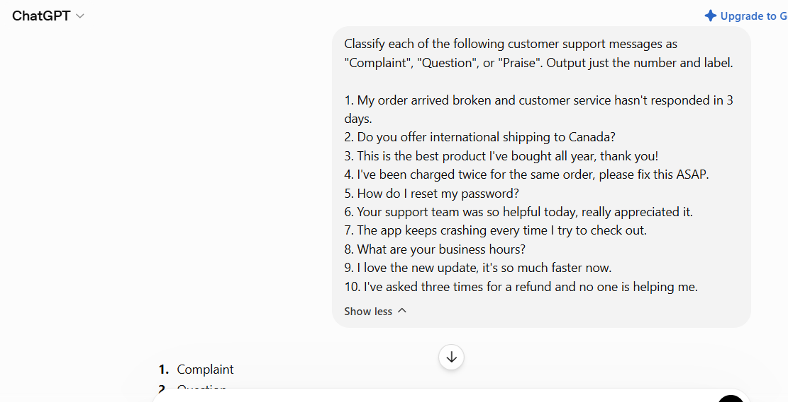
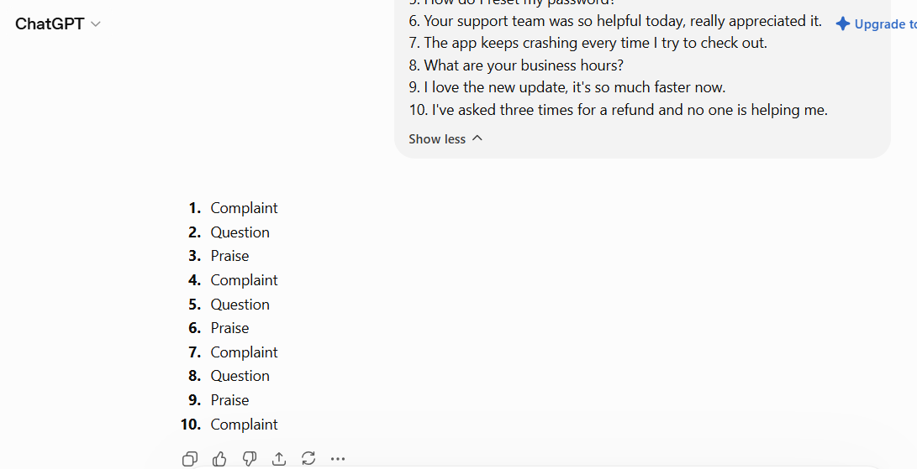

CLAUDE ZERO-SHOT RESULTS:
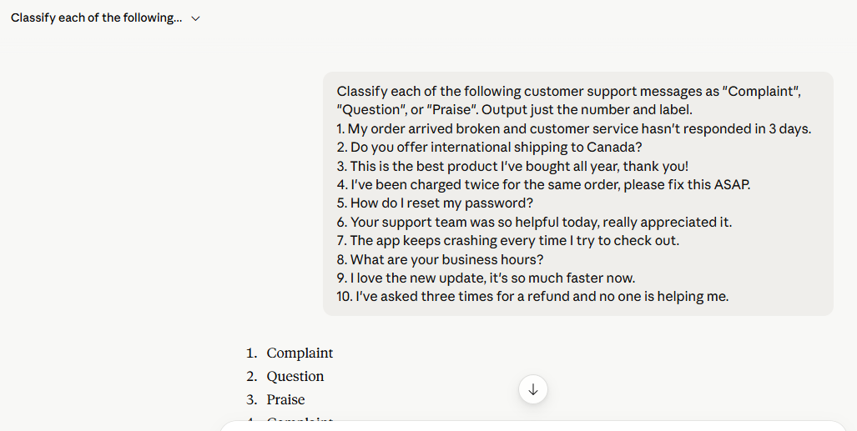
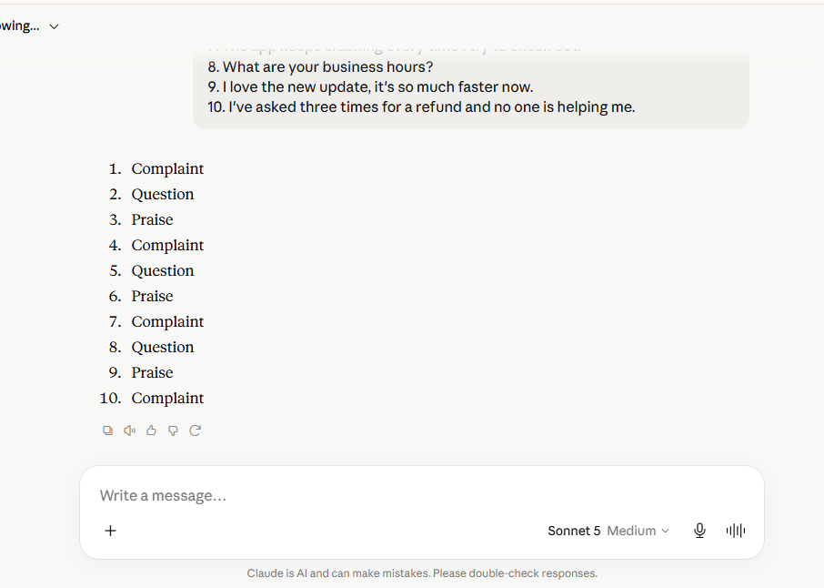

GEMINI ZERO-SHOT RESULTS:
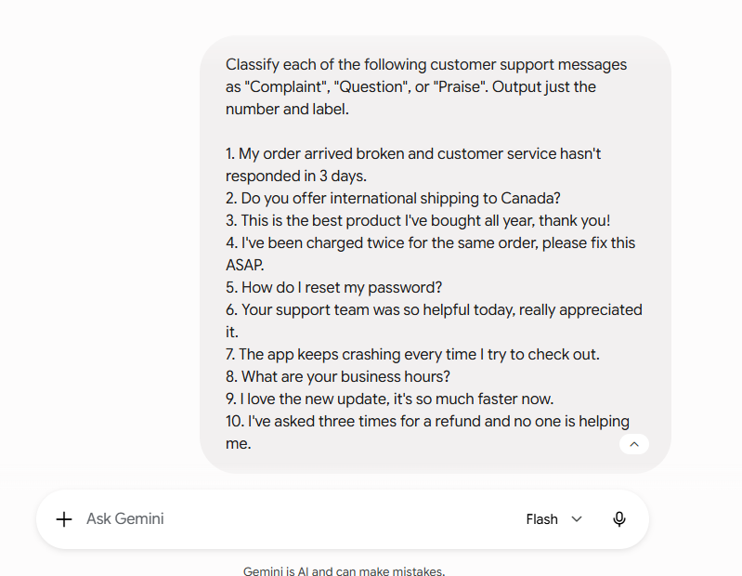
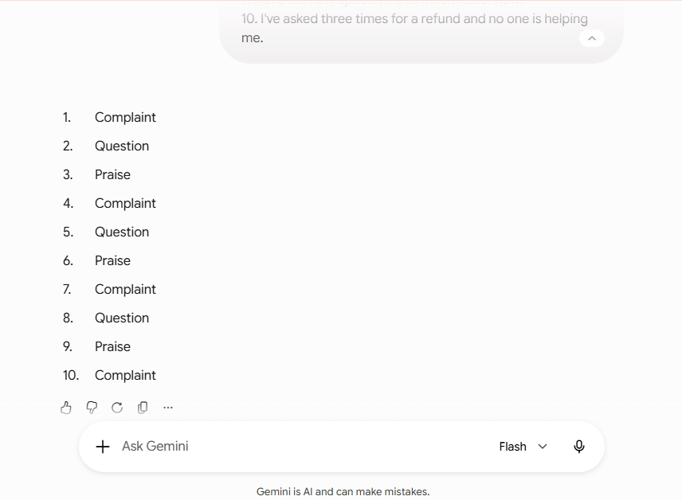

CHATGPT: Few-shot prompt
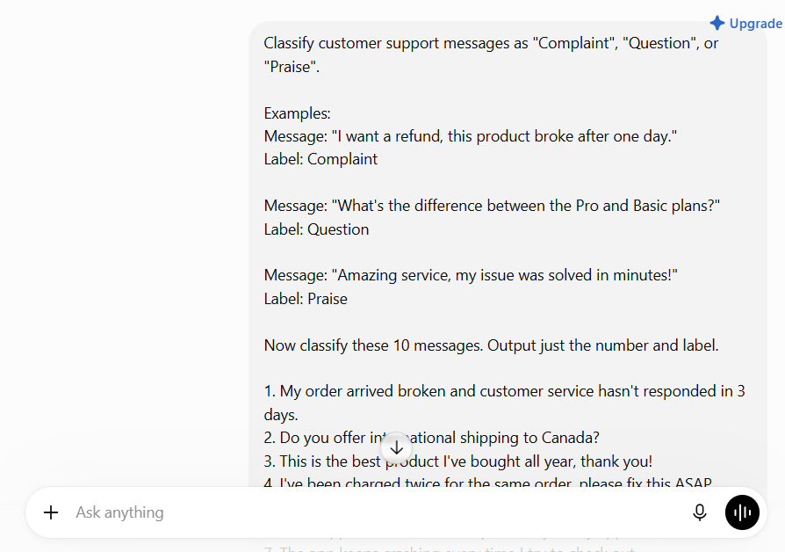
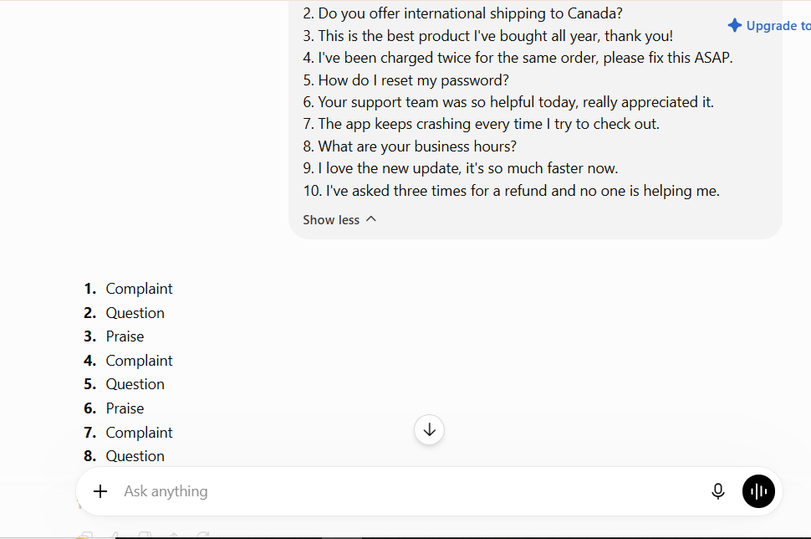
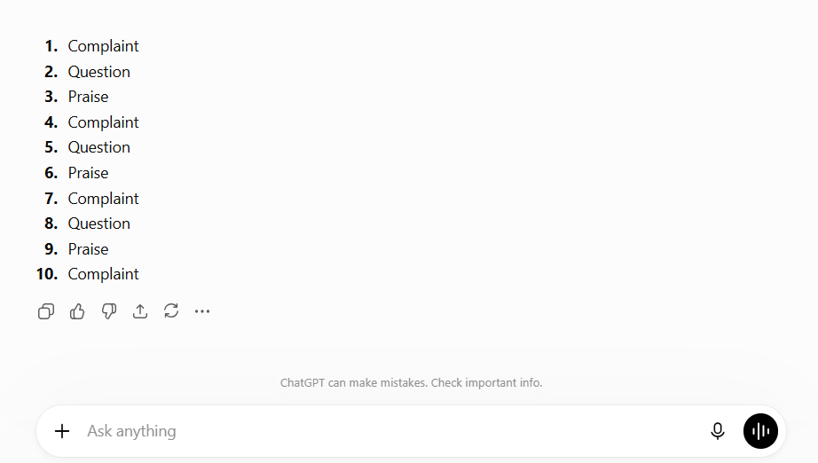

CLAUDE : Few-shot prompt
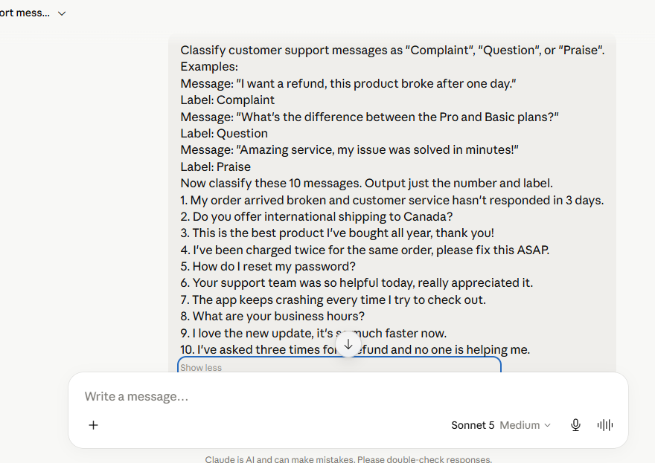
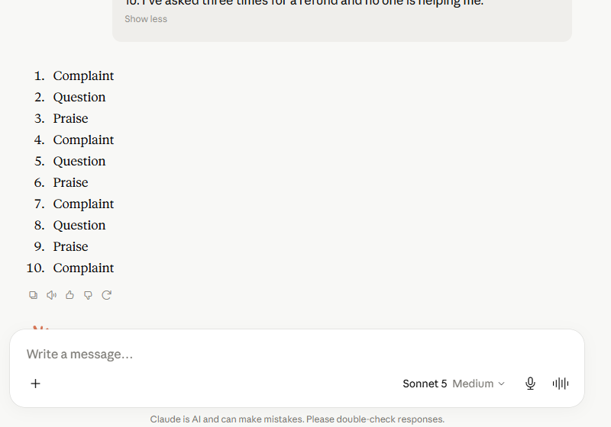

GEMINI : Few-shot prompt
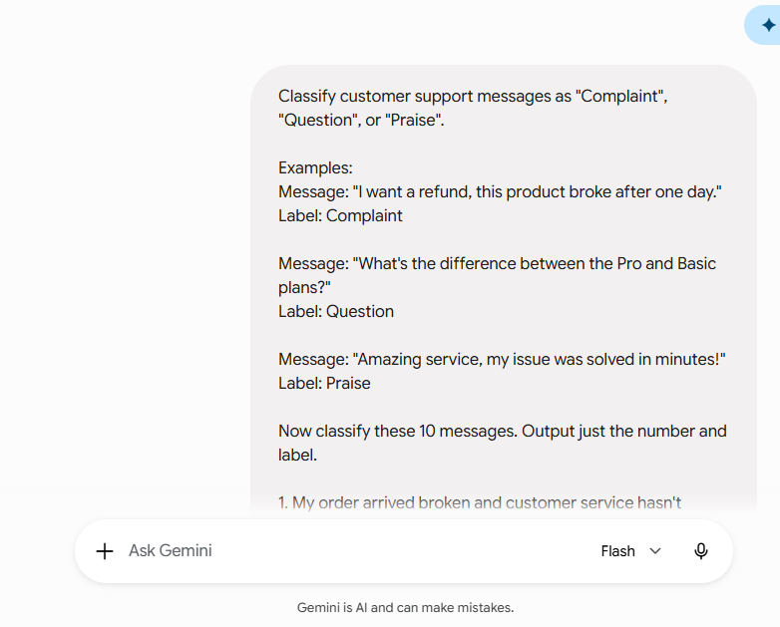
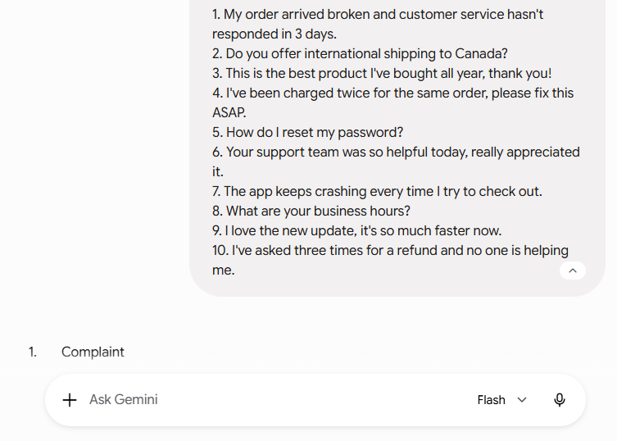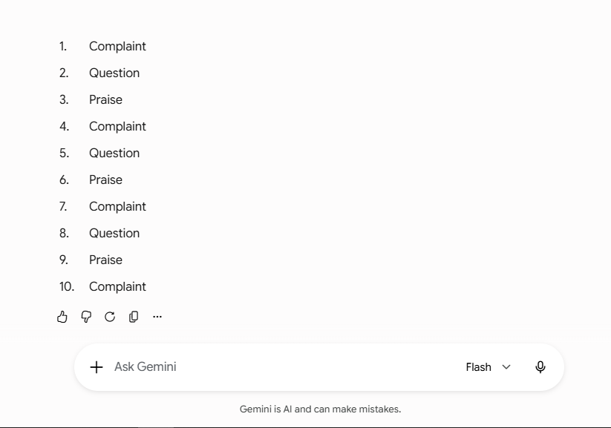

RESULTS TABLE:

Tool | Zero-shot Accuracy | Few-shot Accuracy
ChatGPT | 10/10 | 10/10
Claude | 10/10 | 10/10
Gemini | 10/10 | 10/10

RESULTS ANALYSIS:
All three AI models correctly classified all ten customer support messages using both the zero-shot and few-shot prompts, achieving 100% accuracy in each case. In this particular task, there was no measurable difference between the two prompting techniques because the classification problem was simple and the categories were clearly defined. However, few-shot prompting is generally more beneficial for complex or ambiguous tasks, as the provided examples help the model better understand the expected output format and reasoning. This experiment demonstrates that while zero-shot prompting can be sufficient for straightforward tasks, few-shot prompting is often a more reliable choice for challenging real-world scenarios.

