Prompt Library v1 — Social Media Captions

Author: Aafia | Week 1 — Generative AI & Prompt Engineering

The Reusable Template

The idea: one fixed skeleton, five labeled sections, and a set of `{placeholders}` you swap out per use. You never rewrite the structure only the variables change.
ROLE:
You are a social media copywriter who specializes in {platform} captions
for {industry} brands. You write in a {tone} voice and understand what
makes people stop scrolling.

CONTEXT:
The brand is {brand_name}, a {business_description}. The target audience
is {audience}. This post is about: {topic_or_product}.

TASK:
Write {number} caption options for a {platform} post announcing/
promoting {topic_or_product}. The goal of the post is {goal} (e.g.
drive engagement, get link clicks, build brand awareness).

FORMAT:
- Caption length: {length} (e.g. 1–2 sentences for X, 3–5 lines for
Instagram, short punchy line for TikTok)
- Include {number_of_emojis} relevant emojis
- End with a call-to-action: {cta}
- Include {number_of_hashtags} relevant hashtags at the end

CONSTRAINTS:
- Do not use generic filler phrases like "check this out" or "exciting news"
- Keep the tone consistent with {tone} throughout
- No more than {max_words} words total
- Avoid claims that need legal/factual backing unless explicitly given

That's it — Role, Context, Task, Format, Constraints, every time. Below are 5 filled-in versions of this template, each tested with outputs.

- Prompt #1 — Instagram: Product Launch (Coffee Brand)

Filled Template:

ROLE: You are a social media copywriter who specializes in Instagram
captions for food & beverage brands. You write in a warm, energetic voice.

CONTEXT: The brand is Brew & Co, a specialty coffee shop launching a
new seasonal drink. The target audience is young professionals aged
22-35 who love coffee culture. This post is about: the launch of their
new "Cinnamon Maple Cold Brew."

TASK: Write 3 caption options for an Instagram post announcing the new
drink. The goal is to drive foot traffic to the store this week.

FORMAT:
- Caption length: 3-5 lines
- Include 3-4 relevant emojis
- End with a call-to-action: "Come try it before it's gone"
- Include 5 relevant hashtags

CONSTRAINTS:
- No generic filler like "exciting news" or "check this out"
- Keep tone warm and energetic
- Max 60 words

Tested Output:
CHATGPT:
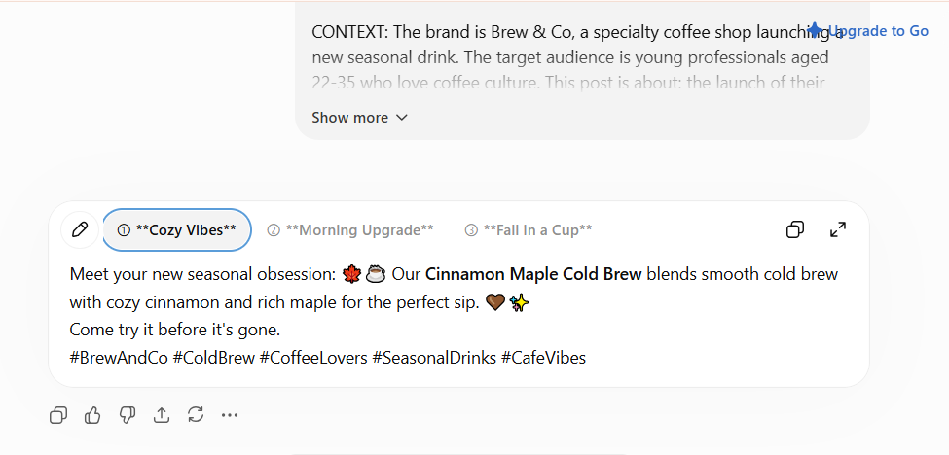

- Prompt #2 — LinkedIn: Portfolio Project Announcement

Filled Template:

ROLE: You are a social media copywriter who specializes in LinkedIn
captions for students and early-career tech professionals. You write
in a confident, professional-but-approachable voice.

CONTEXT: The brand is a Computer Systems Engineering student's personal
brand. The target audience is recruiters, professors, and fellow
students in the tech/AI space. This post is about: publishing a new
deepfake detection project (CNN-based) on GitHub as part of a Final
Year Project.

TASK: Write 2 caption options for a LinkedIn post announcing the
project. The goal is to build credibility and attract engagement from
people in AI/ML.

FORMAT:
- Caption length: 5-7 lines
- Include 1-2 relevant emojis (LinkedIn — keep minimal)
- End with a call-to-action: "Link to the repo in comments"
- Include 4 relevant hashtags

CONSTRAINTS:
- No generic filler like "exciting news" or "thrilled to announce"
- Keep tone confident, not boastful
- Max 90 words

Tested Output:
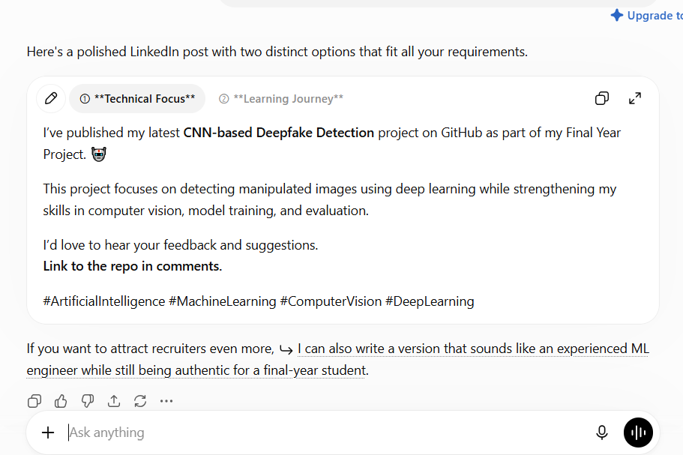

- Prompt #3 — X/Twitter: Tech Tip Teaser

Filled Template:

ROLE: You are a social media copywriter who specializes in X (Twitter)
captions for developer-focused brands. You write in a punchy, no-fluff voice.

CONTEXT: The brand is DevBytes, a page sharing quick coding tips. The
target audience is junior developers and CS students. This post is
about: a thread teaser on "5 Git commands every student should know."

TASK: Write 3 caption options for a tweet teasing the thread. The goal
is to drive clicks into the full thread.

FORMAT:
- Caption length: 1-2 sentences
- Include 1 relevant emoji
- End with a call-to-action: "Thread below 🧵"
- Include 2 relevant hashtags

CONSTRAINTS:
- No generic filler like "check this out"
- Keep tone punchy and direct
- Max 35 words

Tested Output:
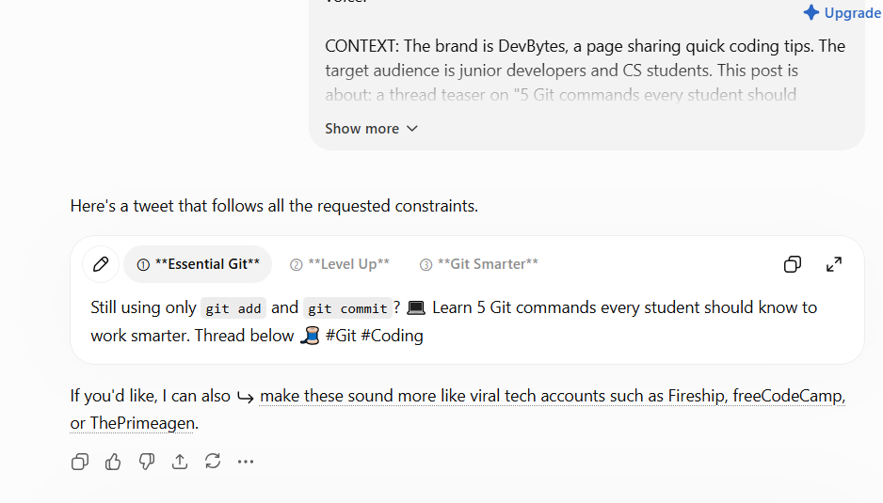

- Prompt #4 — Facebook: Small Business Sale

Filled Template:

ROLE: You are a social media copywriter who specializes in Facebook
captions for local retail businesses. You write in a friendly,
community-focused voice.

CONTEXT: The brand is Sana's Closet, a small boutique clothing store.
The target audience is local women aged 20-45 who follow the page for
new arrivals and deals. This post is about: a 3-day 20% off sale on
the new winter collection.

TASK: Write 2 caption options for a Facebook post announcing the sale.
The goal is to drive in-store and online visits this weekend.

FORMAT:
- Caption length: 4-6 lines
- Include 2-3 relevant emojis
- End with a call-to-action: "Sale ends Sunday — shop now"
- Include 3 relevant hashtags

CONSTRAINTS:
- No generic filler like "don't miss out"
- Keep tone friendly and warm
- Max 55 words

Tested Output:
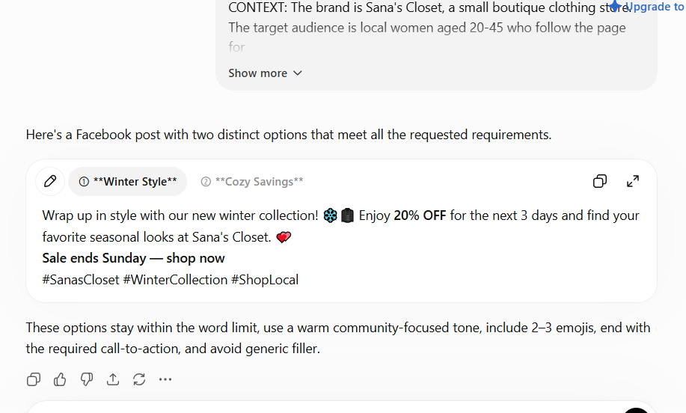

- Prompt #5 — TikTok/Reels: Behind-the-Scenes

Filled Template:

ROLE: You are a social media copywriter who specializes in TikTok/Reels
captions for personal brand and student creator content. You write in
a casual, relatable voice.

CONTEXT: The brand is a CS student sharing her FYP journey. The target
audience is other students and aspiring developers who follow for
"real life of an engineering student" content. This post is about: a
day spent debugging her deepfake detection model at 2am before a
deadline.

TASK: Write 2 caption options for a Reel/TikTok showing behind-the-
scenes of the debugging session. The goal is relatability and
engagement (comments/shares).

FORMAT:
- Caption length: 1-3 short lines
- Include 2 relevant emojis
- End with a call-to-action: "tell me I'm not the only one"
- Include 3 relevant hashtags

CONSTRAINTS:
- No generic filler like "exciting news"
- Keep tone casual and relatable
- Max 30 words
Tested Output:
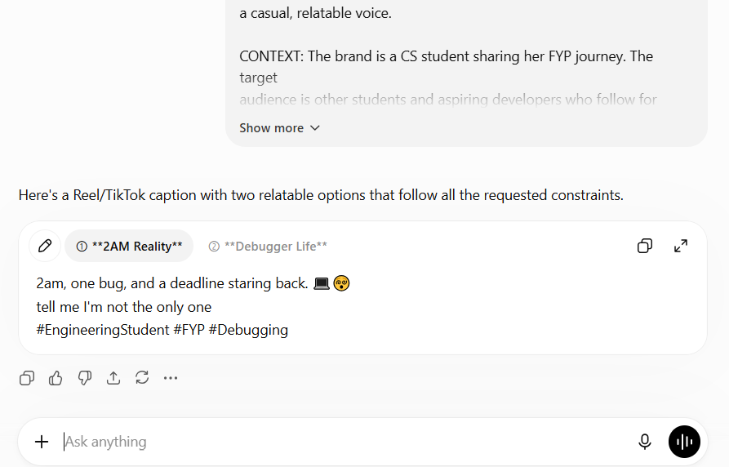
Prompt Library v1 — built for Neurofive Solutions Week 1 task 02.

