Chain-of-Thought & Persona Prompting — Before/After Comparison

Task: Generative AI & Prompt Engineering — CoT & Persona Prompting

Author: Aafia Azhar

1. The Problem (needs multi-step reasoning)

A company has a budget of $100,000 and must choose only one project to invest in.
Project A:
- Initial investment: $50,000
- Expected annual profit: $15,000 for 5 years
- Risk level: Low
Project B:
- Initial investment: $80,000
- Expected annual profit: $22,000 for 5 years
- Risk level: Medium
Considering the total profit, net profit after investment, and the risk level, which project should the company choose? Justify your recommendation.

2. Run #1 — Plain, Direct Prompt (no reasoning instruction)
Prompt used:
A company is choosing between two projects.
Project A:
- Initial investment: $50,000
- Expected annual profit: $15,000 for 5 years
Project B:
- Initial investment: $80,000
- Expected annual profit: $22,000 for 5 years
Which project should the company choose? Explain your answer briefly.
RESULTS: (PLAIN TEXT)
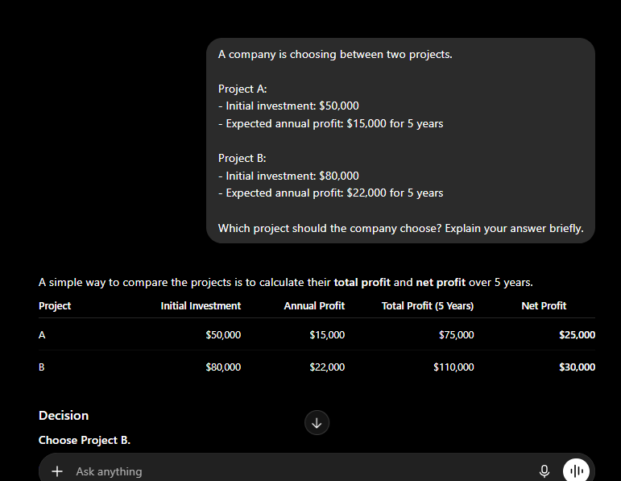
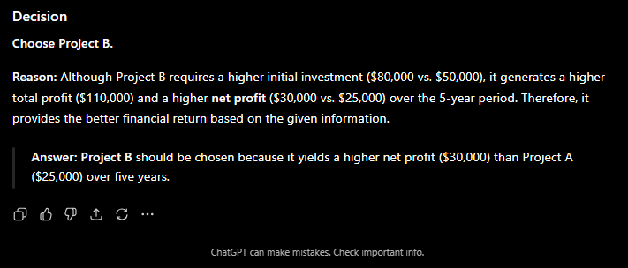

3. Run #2 — Chain-of-Thought + Persona Prompt
Prompt used:
You are a senior financial analyst with 15 years of experience helping companies make investment decisions.
Think step-by-step before answering. Carefully compare both projects by calculating the total expected profit, net profit after the initial investment, and overall return. Then recommend the better project and clearly explain the reasoning behind your decision in a structured format.
Scenario:
Project A:
- Initial investment: $50,000
- Expected annual profit: $15,000 for 5 years
Project B:
- Initial investment: $80,000
- Expected annual profit: $22,000 for 5 years
RESULTS: (COT+PERSONA)
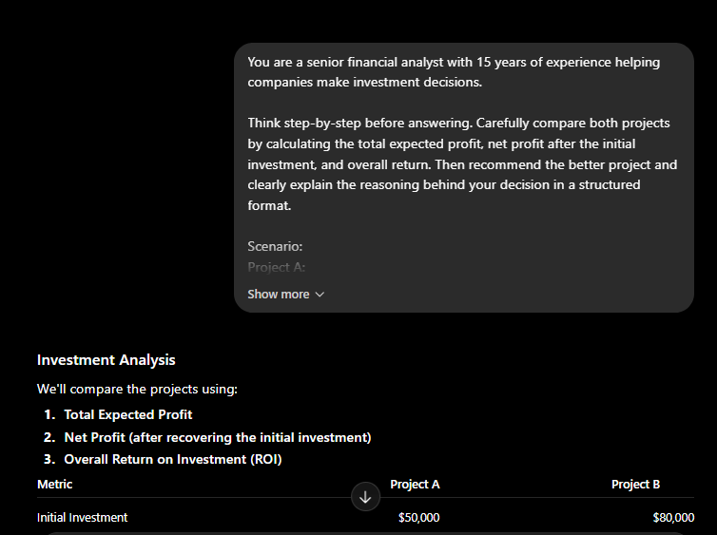
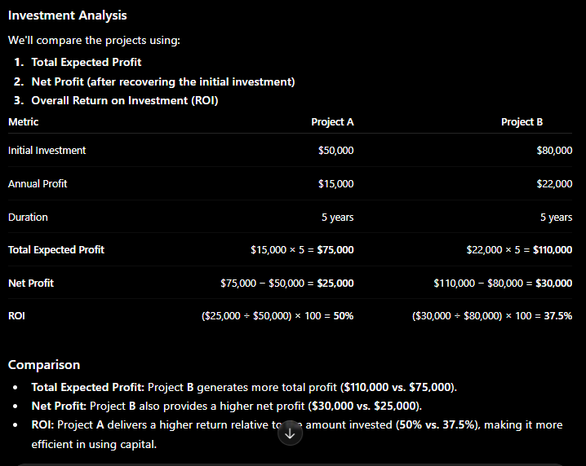
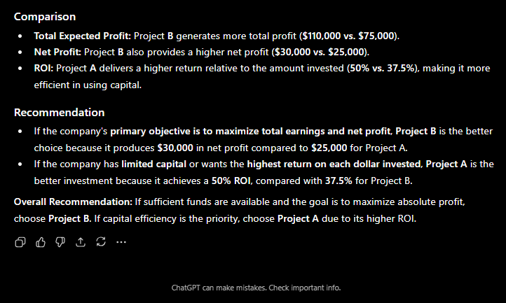

4. Correctness Check (worked by hand)
Given:
Project | Initial Investment | Annual Profit | Duration | Risk
A | $50,000 | $15,000 | 5 years | Low
B | $80,000 | $22,000 | 5 years | Medium

Step 1: Calculate Total Profit
- Project A:
$15,000 × 5 = $75,000
- Project B:
$22,000 × 5 = $110,000
Step 2: Calculate Net Profit
Net Profit = Total Profit − Initial Investment
- Project A:
$75,000 − $50,000 = $25,000
- Project B:
$110,000 − $80,000 = $30,000
Step 3: Compare the Projects
Criteria | Project A | Project B
Total Profit | $75,000 | $110,000 ✅
Net Profit | $25,000 | $30,000 ✅
Risk | Low ✅ | Medium

Final Decision
- If the company's main goal is maximizing profit, Project B is the better choice because it generates $30,000 net profit, which is $5,000 more than Project A.
- If the company is very risk-averse, Project A may be preferred because it has a lower risk level, despite earning less profit.
Overall Recommendation: Project B, as it provides the highest total and net profit, and the increase in risk is only from Low to Medium, making it a reasonable trade-off.

5. Why CoT + Persona Changed the Result

Using Chain-of-Thought (CoT) prompting encouraged the AI to analyze the problem step by step instead of jumping directly to a conclusion. Assigning the AI the persona of a senior financial analyst made the response more professional and focused on relevant business factors such as profit calculations, net return, and risk assessment. As a result, the second response was more structured, detailed, and easier to understand. Overall, combining CoT with a relevant persona improved the clarity, reasoning process, and quality of the final recommendation..

