Account Number 8777 70 510 1282141

Billing Date May 31, 2025

Services From

May 23, 2025 to Jun 02, 2025

Page 1 of 3

Hello Hidaya Thulla Patnam,

Thank you for choosing Xfinity.

**$50.26**

**Amount due**

$50.00

$0.26

**$50.26**

Page 3

Page 3

Regular monthly charges Taxes, fees and other charges

**New charges**

$50.26

-$50.26

**$0.00**

**Your bill at a glance**

For 26603 WILLOW LN, KATY, TX, 77494-5417

Previous balance

Credit card payment - thank you Jun 10

**Balance forward**

 **Thanks for paying by Automatic Payment**

Your automatic payment on Jun 10, 2025, will include your amount due, plus or minus any payment related activities or adjustments, and less any credits issued before your bill due date.



**Your bill explained**

* This page gives you a quick summary of your monthly bill. A detailed breakdown of your charges begins on page 3.

Need help?

Visit [xfinity.com/customersupport](http://xfinity.com/customersupport) or see page 2 for other ways to contact us.

Detach the bottom portion of this bill and enclose with your payment Please write your account number on your check or money order

Do not include correspondence with payment



9602 S 300 W. STE B

SANDY UT 84070-3302

Hidaya Thulla Patnam

26603 WILLOW LN

KATY, TX 77494-5417

# 877770510128214100050260

Account number **8777 70 510 1282141**

Automatic payment Jan 10, 2025

**Please pay $50.26**

## Credit card payment will be applied May 18, 2025

COMCAST

P.O. BOX 60533

CITY OF INDUSTRY CA 91716-0533

Account Number 8777 70 510 1282141

Billing Date

May 31, 2025

Services From

May 23, 2025 to Jun 02, 2025

Page 2 of 3

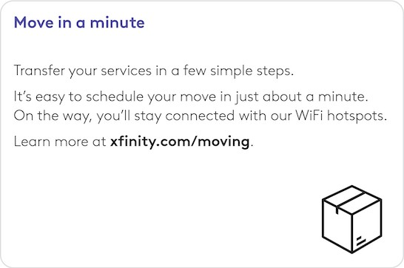 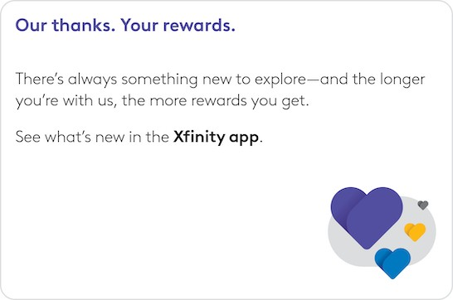

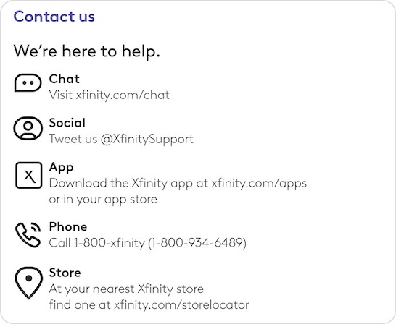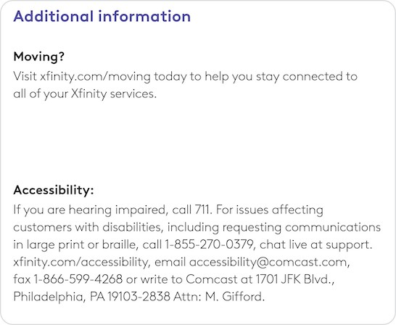

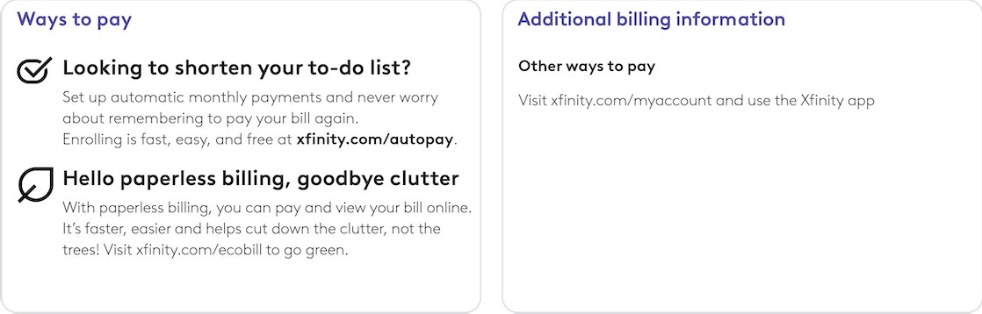

Account Number 8777 70 510 1282141



**What's included?**

**Internet:** Download as fast as 400 Mbps Visit [xfinity.com/myaccount](https://login.xfinity.com/login) for more details

You've saved $48.00 this month with your promotional, automatic payments and service discounts.

You receive a monthly discount for using automatic payment and paperless billing.

|  |  |  |
| --- | --- | --- |
| **Regular monthly charges** |  | **$50.00** |
| **My Xfinity plan** |  | **$50.00** |
| **My Xfinity services**  **Internet:** Fast | $83.00 | **$83.00** |
| **Discounts** |  | **-$33.00** |
| Promotional Discount -$28.00  Includes a 24 month $28.00 Promotional Discount that will end on Apr 02, 2025 | | |
| Automatic Payments Discount Including Paperless Billing | -$5.00 |  |

Billing Date May 31, 2025

Services From

May 23, 2025 to Jun 02, 2025

Page 3 of 3



|  |
| --- |
| **Equipment & services $0.00** |
| Internet Equipment $0.00  Rental.  Includes a 24 month $15.00 Service Discount that will end on Apr 02, 2025 |

**Additional information**

The State Cost Recovery Charge is imposed by Comcast on its Texas subscribers to recover a portion of its expenses associated with charges imposed on Comcast by the State of Texas; Comcast is not required by law to collect this cost.

|  |  |  |
| --- | --- | --- |
| **Taxes, fees and other charges** |  | **$0.26** |
| **Other charges** |  | **$0.26** |
| State Cost Recovery Charge | $0.26 |  |

FCC Community ID: TX0776.

You have 120 days from the date of this bill to dispute any charges included on this bill.