Warehouse Management System
Project Report
Version 1.0
June 23, 2026

Table of Contents

1. Executive Summary
The Warehouse Management System (WMS) is a full-stack web application built to digitize warehouse operations that are traditionally tracked through spreadsheets or paper logs. It replaces manual processes with a centralized platform covering inventory tracking, storage space allocation, approval-based stock control, reporting, and analytics.
The system is built with Django REST Framework on the backend and React with TypeScript on the frontend, using JWT authentication and a relational database. It is structured around seven distinct backend applications and exposes roughly 30 REST endpoints, all documented through an interactive Swagger interface.

2. Project Objectives
The project set out to address four core problems common in manual warehouse operations:
- Inefficient storage utilization, where shelf space is allocated by guesswork rather than capacity data.
- Misplaced or untracked inventory, making it difficult to locate products quickly.
- Delayed or unaudited stock changes, with no record of who changed what and when.
- Lack of visibility into warehouse performance, such as occupancy trends or slow-moving stock.
To address these, the system was designed around five pillars: structured storage hierarchy (warehouse → zone → rack → shelf), capacity-validated allocation, role-based approval workflows, full audit logging, and AI-assisted space and demand insights.

3. Scope of Work

3.1 In scope
- Product and inventory CRUD with SKU-based identification.
- Four-level warehouse storage hierarchy with capacity tracking.
- Stock movement logging (in, out, transfer) with full history.
- Approval workflow for stock transfers and quantity adjustments.
- Seven-tier role-based access control (Admin, Manager, Supervisor, Staff, Picker/Operator, Auditor, Viewer).
- Search, multi-field filtering, sorting, and pagination across all list views.
- Reporting (inventory, warehouse utilization, product location, stock movement) with CSV, Excel, and PDF export.
- Analytics dashboard with occupancy, space, and stock-trend visualizations.
- AI-assisted shelf recommendation, ABC product classification, velocity analysis, and demand forecasting.
- Notification system for low stock, shelf capacity, and report-ready events.
- Full audit logging of create, update, and delete actions with user and timestamp.
- OpenAPI/Swagger documentation, automated unit and integration tests, and live deployment.

3.2 Out of scope
- Barcode/RFID hardware integration.
- Multi-tenant support for managing multiple independent companies.
- Native mobile applications (the web app is responsive but not packaged natively).

4. System Architecture
The system follows a standard three-tier architecture: a React single-page application, a Django REST API, and a relational database. Authentication uses short-lived JWT access tokens with longer-lived refresh tokens. The backend is split into seven Django apps, each owning a distinct concern.
App | Responsibility
users | Authentication, custom user model with roles, permission classes, audit log
warehouses | Warehouse, zone, rack, and shelf models and capacity logic
inventory | Products, inventory records, stock movements, transfer/adjustment requests, space optimization and forecasting
reports | Report generation, dashboard summary, CSV/Excel/PDF export
notifications | Low stock, capacity, and system alerts
careers | Job application intake (auxiliary module)

Architecture decisions and their rationale:
- JWT over session auth — keeps the API stateless and works cleanly with a separately hosted frontend.
- Role permission classes layered by capability (read-only, floor-staff write, manager-level approval) rather than a single is_admin flag, so new roles can be slotted into existing permission tiers without rewriting view logic.
- Best-fit and first-fit shelf allocation algorithms kept in a dedicated optimization module, separate from views, so the allocation strategy can be swapped or tuned independently of the API layer.
- Audit logging implemented as a mixin applied to viewsets, ensuring create/update/delete actions are logged consistently without repeating logic in every view.

5. Data Flow Diagram
Data flows from the user through the React frontend, which makes authenticated REST calls to the Django API. The API routes requests into three core engines: the inventory engine (CRUD, allocation, stock), the approval engine (transfer and adjustment review), and the reports engine (aggregation and forecasting). All three read from and write to the same relational database. Every write is recorded in the audit log, and certain writes — such as a quantity falling below its reorder level, or a shelf nearing capacity — also trigger the notification engine. Both audit and notification outputs, along with export services, feed back into what the user sees in the frontend display.
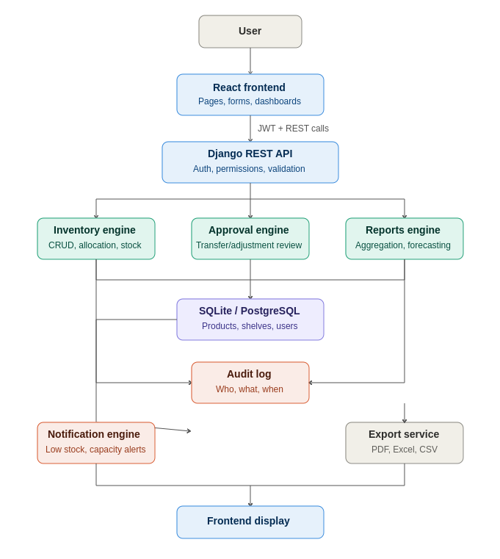

6. User Roles and Access Control
Access is controlled through seven roles, each mapped to one of four permission tiers used across the API:
Role | Access level
Admin | Full access to all data, users, and system configuration
Manager | Create, update, delete on operational data; approve/reject requests
Supervisor | Same as Manager for approvals; full access to floor-level operations
Staff | Create, update, delete on products, inventory, and stock records
Picker/Operator | Create and update stock movements and transfer requests only
Auditor | Read-only access to all records, including audit logs
Viewer | Read-only access to operational data

7. Testing Summary
A total of 26 test cases were executed across six categories: unit, integration, validation, security, UI, and performance. All 26 passed. The full results are maintained in the project's TEST_REPORT.md; a summary is reproduced below.
Test type | Total | Passed | Failed
Unit tests | 8 | 8 | 0
Integration tests | 4 | 4 | 0
Validation tests | 4 | 4 | 0
Security tests | 4 | 4 | 0
UI tests | 3 | 3 | 0
Performance tests | 3 | 3 | 0
Total | 26 | 26 | 0

Security testing specifically verified that unauthenticated requests are rejected (401), that role-restricted endpoints reject lower-privilege roles (403), that search inputs are sanitized against SQL injection, and that expired tokens are rejected. Performance testing using Locust confirmed sub-second response times for inventory, stock movement, and report endpoints under simulated concurrent load.

8. Challenges and Resolutions
Challenge | Resolution
Preventing over-allocation of shelf space during concurrent writes | Capacity is validated server-side against live occupied_capacity before any write is committed, rather than trusting client-supplied totals
Balancing flexible roles against simple permission logic | Roles were grouped into reusable permission classes (e.g. IsAdminManagerOrStaff) instead of checking each role individually in every view
Keeping audit logs consistent across many viewsets | A shared AuditLogMixin centralizes create/update/delete logging so it cannot be skipped accidentally in a new viewset
Generating exportable reports without duplicating query logic | Report data is computed once and stored as JSON on the Report model; CSV/Excel/PDF exporters all read from that same stored result

9. Results
The completed system implements 16 data models across seven Django applications, exposing approximately 30 REST API endpoints, all documented via an interactive Swagger UI. The frontend consists of 18 routed pages covering every major workflow from warehouse setup through analytics.
Measured outcomes against the original objectives:
- Storage allocation: shelf assignment now includes a capacity check that rejects over-allocation, plus an AI-assisted best-fit recommendation that suggests a suitable shelf based on a product's required volume.
- Traceability: every create, update, and delete action is recorded in an audit log with user, action, resource, and timestamp.
- Approval control: stock transfers and quantity adjustments require Manager or Supervisor sign-off before taking effect, with full approval history retained.
- Visibility: the analytics dashboard surfaces occupancy percentage, available space, total products, ABC classification, product velocity, and demand forecasts.

10. Future Improvements
- Barcode or QR-code scanning for faster stock-in/stock-out at the shelf.
- Multi-warehouse transfer requests that span separate facilities, not just shelves within one warehouse.
- Push or email notifications in addition to in-app alerts.
- Expanded demand forecasting using a longer historical window as more stock movement data accumulates.

11. Conclusion
The Warehouse Management System meets its original objectives: it replaces manual, error-prone tracking with a centralized, role-controlled platform that validates storage capacity, maintains a complete audit trail, and surfaces actionable insights through its analytics and AI-assisted features. All 26 planned test cases pass, the API is fully documented, and the application is deployed and accessible online.

