Warehouse Management System
User Manual
Version 1.0
June 23, 2026

Table of Contents

1. Introduction
The Warehouse Management System (WMS) is a web-based platform for tracking inventory, managing warehouse storage space, and controlling stock movements across multiple locations. It centralizes product, inventory, and warehouse data so that staff can find items quickly, avoid over-filling shelves, and keep an auditable record of every change.
This manual explains how to use the system from the point of view of someone logging in for the first time, covering navigation, day-to-day tasks, and the approval process for stock changes.

1.1 Who this manual is for
This manual is written for all users of the system, regardless of role. Sections that only apply to certain roles (for example, approving requests) are marked accordingly.

1.2 Accessing the system
Open a web browser and go to the application URL provided by your administrator. You will land on a login screen. If you do not yet have an account, use the Register link, or ask your administrator to create one for you.

2. User Roles and Permissions
Every account is assigned exactly one role. Your role determines which pages you can see and which actions you can perform. The table below summarizes what each role can do.
Role | Typical user | What they can do
Admin | System administrator | Full access: manage users, all data, and system settings.
Manager | Warehouse manager | Approve or reject requests, manage products, inventory, and warehouses.
Supervisor | Warehouse supervisor | Approve floor-level requests; manage day-to-day inventory operations.
Staff | Warehouse staff | Create and update products, inventory, and stock movements.
Picker/Operator | Floor operator | Record stock movements and submit transfer or adjustment requests.
Auditor | Compliance/audit staff | Read-only access to records and audit logs.
Viewer | General staff | Read-only access to view data; cannot make changes.
If a page or button is missing for your account, it is most likely restricted to a different role.

3. Getting Around the Dashboard
After logging in, you arrive at the Dashboard. The left sidebar lists every section you have access to: Dashboard, Warehouses, Zones, Racks, Shelves, Inventory, Products, Categories, Stock Movements, Analytics, Approvals, Notifications, and User Management.
The top bar contains a page search box, a light/dark mode toggle, a recent activity panel, a notifications bell, and your profile menu (where you can log out).

3.1 How data moves through the system
The diagram below shows what happens behind the scenes when you use the application: your actions in the browser are sent to the API, which routes them to the relevant engine (inventory, approvals, or reports), all of which read from and write to the same database. Every change is recorded in the audit log, and certain changes trigger notifications back to you.
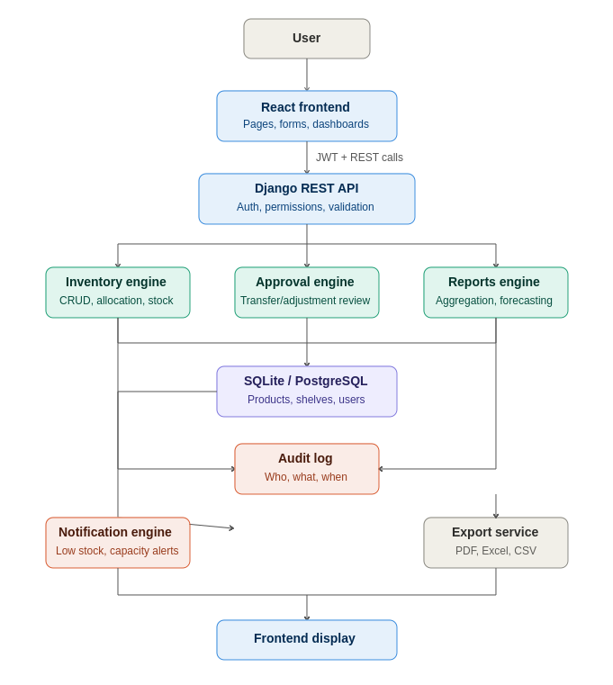

4. Setting Up Warehouse Structure
Storage in the system is organized in four levels, from largest to smallest:
- Warehouse — a physical building or site.
- Zone — an area within a warehouse (for example, cold storage or receiving).
- Rack — a row of shelving within a zone.
- Shelf — the individual storage unit where inventory is physically placed.
To add a new level, open the corresponding page (Warehouses, Zones, Racks, or Shelves) and click the green Add button in the top-right corner. Fill in the required fields — each shelf and rack has a capacity value used later for space validation — and click Save.

5. Managing Products and Inventory

5.1 Adding a product
Go to Products and click + Add Product. Each product requires a name, a unique SKU (product code), a category, and its unit volume and unit weight. The unit volume is important: it is used by the system to check whether a shelf has enough free space before stock is placed there.

5.2 Recording inventory
Go to Inventory and click + Add Inventory Record. Select the product, choose a shelf, and enter the quantity. Before choosing a shelf manually, you can click the ✨ Suggest Best Shelf button — the system will calculate the required space for that product and quantity and recommend a shelf with enough free capacity, using a best-fit allocation strategy. Click Use this shelf to apply the suggestion, or pick a different shelf yourself.
The system will not let you place more stock on a shelf than its remaining capacity allows. If you try, you will see a validation error explaining that the shelf does not have enough free space.

5.3 Stock movement history
Every time stock is added, removed, or transferred, a record is kept on the Stock Movements page. Each entry shows the product, the type of movement (Stock In, Stock Out, or Transfer), the quantity, and the timestamp, so you can trace the history of any item.

6. Approval Workflow
Some operations — moving stock between locations (Transfers) and correcting recorded quantities (Adjustments) — require manager or supervisor approval before they take effect.

6.1 Submitting a request
From the Stock Movements or Inventory page, choose to submit a Transfer or Adjustment request rather than making the change directly. Provide a reason for the request. It will be created with a status of Pending.

6.2 Reviewing a request (Managers and Supervisors)
Go to Approvals. The page has two tabs, Transfers and Adjustments. Each pending request shows who submitted it, the reason, and the requested change. Click Approve to apply the change, or Reject to deny it. Once a decision is made, the request moves out of the pending list and into approval history, recording who reviewed it and when.

6.3 Approval history
Past decisions remain visible on the Approvals page with their final status (Approved or Rejected), the reviewer's name, and the review timestamp, giving a complete history of every request.

7. Searching, Filtering, and Sorting
Every list page (Products, Warehouses, Inventory, and others) includes a search box at the top for filtering by name, code, or SKU. Where applicable, you can also filter by zone, rack, or shelf, and combine multiple filters at once.
Click any column header to sort the table by that field — for example, sort Products by name, or Inventory by quantity or last updated date. Large tables are split into pages; use the Previous and Next buttons, and the page indicator (for example, "Page 1 of 1 (3 total)"), to navigate.

8. Reports
The Reports module generates four kinds of reports: Inventory, Warehouse Utilization, Product Location (Space), and Stock Movement summaries. Create a report, wait for it to complete, and then download it as CSV, Excel, or PDF using the export buttons next to the report.

9. Analytics Dashboard
The Analytics page shows key figures at a glance: warehouse occupancy percentage, available space, total products, and recent stock movement trends, along with supporting charts.
It also surfaces AI-assisted insights generated from your stock movement history:
- ABC Classification — ranks products by contribution to overall activity.
- Product Velocity — shows which products move fastest and slowest.
- Demand Forecast — predicts expected demand for the coming weeks.
These insights help decide which products need closer attention or better shelf placement.

10. Notifications
The system raises four types of alerts, shown on the Notifications page and as a badge on the bell icon in the top bar:
- Low Stock — a product's quantity has fallen below its reorder level.
- Space Full — a shelf has reached or is approaching full capacity.
- Report Ready — a requested report has finished generating.
- System — general system messages.
Click a notification to mark it as read, or use Mark All as Read to clear the list.

11. User Management (Admins)
Administrators can open User Management to view all accounts, assign roles, and deactivate accounts that should no longer have access. Changes to roles take effect immediately.

12. Managing Your Account
Click your username in the top-right corner to view your profile details. Use the Log Out button in the sidebar or profile menu to end your session. If you forget your password, use the Forgot Password link on the login page to receive a reset email.

13. Troubleshooting and Support
Issue | What to check
I can't see a page or button | Your role may not have access to that feature. Contact an Admin.
"Not enough shelf capacity" error | Choose a different shelf, reduce quantity, or use Suggest Best Shelf.
My request is stuck as Pending | It is waiting for a Manager or Supervisor to review it on Approvals.
I was logged out unexpectedly | Your session token expired; log in again.
A report shows "Failed" | Try generating it again; if it persists, contact your administrator.
For issues not covered here, contact your system administrator.

