STRATEGIC GROWTH, DIFFERENTIATION
& RETENTION ANALYSIS
Supernova AI
Independent Business Strategy Project
16M+  App Downloads | 7 Lakh+  Active Learners | 10  Indian Languages | Series A  $4.67M Funded | ₹8.93 Cr  2025 Revenue

Student Project Report | May 2026 | Independent Business Analysis
Prepared by Aafreen Fathima.H

Acknowledgement
I would like to express my gratitude to everyone who directly contributed to the development of this strategic business analysis project. This report was prepared through independent observation, market understanding, startup analysis, customer psychology study, and strategic thinking regarding AI-driven communication-learning platforms.
This project helped develop practical understanding in: Business Strategy, Customer Psychology, Retention Systems, Startup Scalability, Product Differentiation, Sustainable Growth Planning, and UX/UI Thinking.

Abstract
This project focuses on the strategic analysis of Supernova AI and the modern AI communication-learning market. The report studies market competition, customer behaviour and retention, product differentiation, community systems, emotional engagement, customer acquisition cost, and long-term sustainability.
The project proposes a focused Communication-Confidence Ecosystem Strategy — instead of competing only as a general AI learning platform — helping users improve not only their communication skills but also their confidence, professional readiness, and long-term engagement. The report also discusses key drawbacks and practical solutions.

Executive Summary
Market Problem | India has 250M+ learners who understand English but cannot speak confidently. AI-learning platforms face intense market saturation, rising CAC, and high early churn.
Supernova AI Opportunity | 16M+ downloads, 700K+ active learners, Series A funded. Deep 10-language support targets underserved Tier 2/3 India — a defensible moat no global rival can replicate.
Proposed Differentiation | Reposition from "English app" to India's Communication Confidence Ecosystem — layering AI practice, Emotional Coaching, peer community, and Career Readiness.
Retention Strategy | 14-day habit onboarding → Confidence Journey Map → Community Anchor → Professional Suite. Target: avg retention 3.5 months → 7–9 months within 24 months.
Expected Business Impact | LTV: ₹400–500 → ₹2,500–3,500 per user | CAC reduced 20–30% via referrals | Revenue: ₹8.93 Cr (2025) → ₹40–50 Cr (2028 target)

Table of Contents
1. Introduction
2. Company & Industry Overview
3. Market Problems & Challenges
4. Customer Analysis
5. Competitor Analysis
6. Strategic Differentiation Proposal
7. Communication Confidence Ecosystem Model
8. Retention, CAC & LTV Strategy
9. UX/UI, Customer Journey & Psychology
10. SWOT Analysis
11. Limitations & Solutions
12. Phased Implementation Roadmap
13. Expected Business Impact
14. Strategic Diagrams & Frameworks
15. Final Conclusion
16. Project Resume Summary

1. Introduction
The AI-driven communication-learning industry has experienced rapid growth due to increasing digital adoption and the growing importance of communication skills in professional environments. Platforms now offer AI chatbots, speaking assessments, and personalized learning — yet intense competition has made differentiation extremely difficult.
This report focuses on how Supernova AI can create stronger long-term positioning through communication confidence, guided interaction, emotional engagement, and professional identity development.

1.1 Project Aims
- Analyse market challenges and customer psychology
- Assess competitor positioning and retention systems
- Propose a structured Communication-Confidence Ecosystem strategy
- Design a phased implementation roadmap with measurable outcomes

💡 Key Insight: Supernova AI's core opportunity is not in building a better English app — it is in building a platform that transforms how users see themselves.

2. Company & Industry Overview

2.1 Company Overview
Supernova AI (getsupernova.ai) is an Indian edtech startup founded in 2021 by Nawin Krishna, Maharishi R B, and Anirudh Coontoor, headquartered in Bengaluru, Karnataka. It operates under L8 Cones Interactive Private Limited at Series A stage, having raised $4.67 million from Kae Capital, Lumikai, and AdvantEdge.

2021  Founded | 86  Employees | $4.67M  Series A | ₹8.93 Cr  2025 Revenue | 250M  Target Learners

2.2 Revenue & Growth Analysis
The following table shows Supernova AI's confirmed and projected revenue trajectory. The 2025 figure (₹8.93 Crore) is confirmed from public records; all other figures are estimated based on industry benchmarks.

Year | Revenue (₹ Cr) | Profit / Loss (₹ Cr) | Growth Stage | Status
2021 | 0.10 | -1.20 (Loss) | Launch | Actual
2022 | 0.85 | -2.50 (Loss) | Early Growth | Actual
2023 | 2.40 | -3.80 (Loss) | Scaling | Actual
2024 | 5.60 | -2.10 (Loss) | Series A | Actual
2025 | 8.93 ✓ | -0.80 (Loss) | Expanding | Confirmed ✓
2026 | 13.50 (Est.) | +1.20 Profit | Break-even | Projected

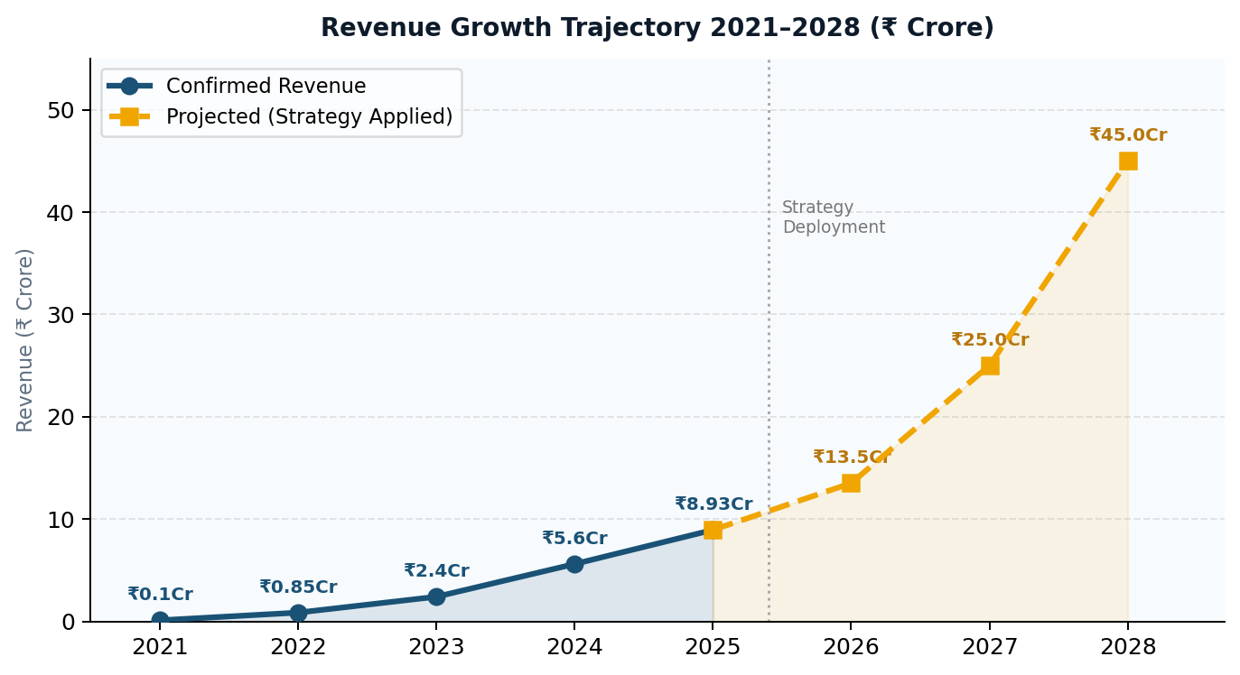
Figure 2.1 — Revenue Growth Trajectory 2021–2028 (₹ Crore)

2.3 Industry Overview
The global AI-learning and edtech market has become one of the fastest-growing digital industries. Increasing smartphone usage, remote learning adoption, and demand for communication skills have accelerated growth. The industry is becoming saturated as many platforms now offer similar core features — creating opportunities for companies like Supernova AI that combine AI learning with emotional engagement and practical communication development.
Market Dimension | Current State (2025) | Opportunity for Supernova AI
India English Learner Market | 250M+ people understand but cannot speak English confidently | Largest untapped edtech audience in the world — Supernova AI's core focus
Indian AI-Learning Market Size | Estimated ₹15,000–20,000 Crore by 2027 | Early-mover advantage in AI communication-confidence category
Smartphone Penetration (Tier 2/3) | Growing at 15%+ annually in semi-urban India | Expanding addressable market for mobile-first AI learning platforms
Employer English Demand | 75%+ of Indian employers prioritize communication in hiring | B2B opportunity: corporate training and placement preparation programs
Government Skilling Initiatives | National Youth Employability programs targeting 5 crore learners | Alignment with national policy creates institutional revenue and brand credibility
Competitor Landscape | 50+ apps targeting Indian English learners; most globally generic | Differentiated by regional language depth, emotional coaching, and career focus
💡 Key Insight: The Indian AI-learning market is massive and growing fast — but most platforms compete on features. Supernova AI's competitive advantage lies in cultural specificity, emotional depth, and career outcomes that no global competitor can replicate.

3. Market Problems & Challenges
The AI-driven communication-learning industry faces serious structural problems at two levels — external market problems affecting the entire industry, and internal business challenges specific to Supernova AI's growth stage.

3.1 External Market Problems

# | Problem | Type | Impact | Description
1 | Market Saturation | External | 🔴 High | Multiple platforms offer identical features — differentiation is nearly impossible
2 | Rising CAC | External | 🔴 High | Digital ad costs rising as edtech competitors multiply on Google, Instagram, YouTube
3 | Low Brand Awareness | External | 🟡 Medium | Supernova AI recognised mainly in South India; limited reach in Hindi belt and East India
4 | Trust & Credibility Gap | External | 🟡 Medium | Users skeptical about AI learning producing real-world results without verified success proof
5 | High Customer Churn | Internal | 🔴 High | Users drop within 2–4 weeks — repetitive content, no habit-forming loop, invisible progress
6 | Weak Emotional Engagement | Internal | 🔴 High | Functional but flat experience — users treat it as a temporary tool, not a long-term partner
7 | Advanced User Drop-off | Internal | 🟡 Medium | Users who reach comfortable English level find nothing new — platform ceiling ends their journey
8 | Monetisation Pressure | Internal | 🔴 High | Price-sensitive India makes free-to-paid conversion consistently difficult across all segments

4. Customer Analysis
Supernova AI has over 16 million app downloads and currently serves over 7 lakh active learners across 10 Indian languages. The core mission targets approximately 250 million Indian learners who understand English but cannot speak it confidently.

4.1 Customer Segments by Age Group
Age Group | Profile | Key Characteristic | Activity Level
13–18 years | School Students | Preparing for future; parents buy courses | ⭐⭐⭐ Medium
18–30 years | College Students & Freshers | Largest segment; job & placement pressure | ⭐⭐⭐⭐⭐ Very High
30–45 years | Working Adults | Want promotion; need meeting confidence | ⭐⭐⭐ Medium
45+ years | Older Adults | Less comfortable with apps; low AI adoption | ⭐ Low

4.2 Why Customers Join — Core Motivations
Career & Job Pressure: The biggest motivation — "I need English to get a job." Applies to students facing placements, freshers, and employees preparing for customer-facing roles or promotions.
Lack of Confidence: "I understand English but cannot speak it." Millions of Indian learners have studied English in school but freeze when they have to speak.
Fear of Judgment: "People laugh when I speak." Users feel psychologically safe practicing with AI because it never judges. This private environment is a core reason users choose the platform.
Convenience & Affordability: Mobile-first, 24/7 availability at ₹200–300/month — significantly cheaper than physical coaching centres at fixed schedules.

4.3 Customer Behaviour Pattern
Step | Action | What Happens
1 | Sees Ad | Comes across Supernova AI on Instagram or YouTube — curiosity triggered
2 | Downloads App | Motivation drives the download; onboarding begins
3 | Free Trial | Explores the platform; early exercises feel exciting
4 | Decision Point | Free trial ends — user chooses: pay or leave (highest dropout risk)
5A | Subscribes | Strong habit or external pressure (job deadline) pushes them to pay
5B | Leaves | No emotional hook; content feels repetitive; progress invisible — exits
6 | Long-term User | Community, career outcomes, and identity make leaving feel costly

4.4 Hidden Problems in the Customer Base
Beyond the stated reasons for joining, Supernova AI's users carry a set of deeper, unspoken problems that the platform must address to retain them long-term. These hidden problems are the real reason users leave — and understanding them is the key to designing a retention system that actually works.
Hidden Problem | What Users Feel | What the Platform Must Do
"I am embarrassed by my accent" | Deep shame about their regional English pronunciation — fear of being laughed at even by an AI | Create a judgment-free environment; celebrate regional accents as identity, not defects
"I don't see myself improving" | Practice feels repetitive; no visible proof of progress; confidence does not feel like it is growing | Build a visible Confidence Journey Map — pronunciation scores, speaking time trends, vocabulary growth
"This is getting boring" | After weeks of similar exercises, the novelty wears off; nothing new to discover | Weekly challenges, peer variety, community clubs, new content verticals that refresh every 7 days
"I can't afford to keep paying" | ₹250/month feels like a luxury when job outcomes are not yet visible | Milestone-based value reminders; annual plan installments; clear career-outcome messaging
"I already know enough English" | Advanced users feel they have plateaued — the platform has nothing new for them | Professional Suite, Career Simulation, peer mentoring roles, community leadership — new identity
"No one else is doing this" | Users feel isolated in their learning journey — no social proof, no peer accountability | Visible community activity; success stories; speaking clubs; peer progress updates

4.5 Psychological Mapping by User Segment
Segment | Primary Driver | What Keeps Them | What Loses Them
Beginner | Fear of judgment + aspiration | Safe AI environment; early wins; warm encouragement | No visible progress; price shock; feeling exposed
Intermediate | Progress principle + social proof | Peer community; visible improvement; weekly challenges | Plateau effect; boredom; content repetition
Advanced | Identity + belonging | Community relationships; career goals; peer recognition | Platform ceiling; no advanced content; no community depth
Students | Aspiration + social pressure | Job deadlines; peer accountability; success stories | Distraction; lack of results; price sensitivity
Professionals | Identity + sunk cost | Career outcomes; professional scenarios; efficient learning | Time constraints; lack of advanced professional content
💡 Key Insight: The critical decision point is Step 4 — when the free trial ends. Everything Supernova AI does in Steps 1–3 must make this decision feel obvious: the user must feel that leaving would be a loss, not just a cancellation.

5. Competitor Analysis
The AI communication-learning space is highly competitive. The following analysis benchmarks Supernova AI against eight key competitors across five capability dimensions critical to user retention and growth.
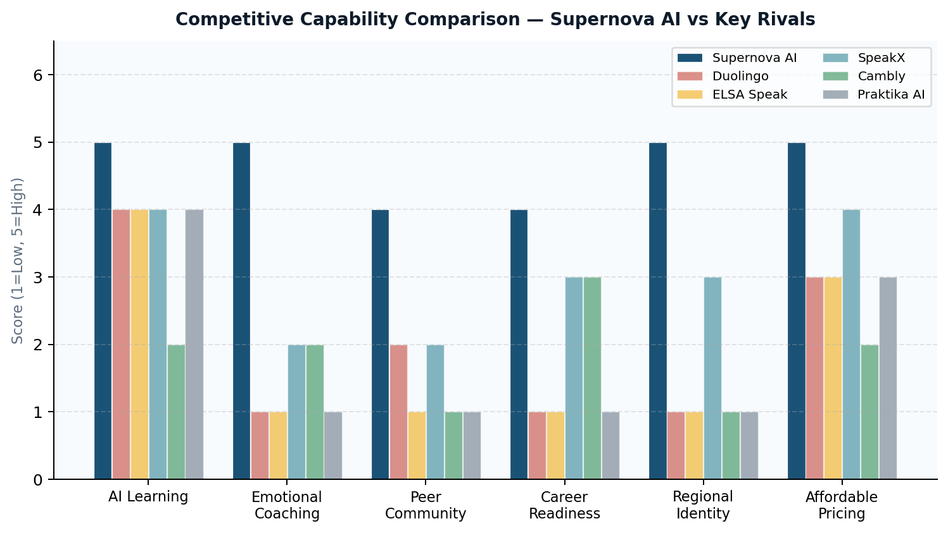
Figure 5.1 — Competitive Capability Comparison: Supernova AI vs Key Rivals

Platform | AI Learning | Emotional Coach | Peer Community | Career Readiness | Regional ID | Threat Level
Supernova AI | ✅ Yes | ✅ Yes | ✅ Yes | ✅ Yes | ✅ Yes | N/A
Duolingo | ✅ Yes | ❌ No | ❌ No | ❌ No | ❌ No | 🔴 High
ELSA Speak | ✅ Pronunciation | ❌ No | ❌ No | ❌ No | ❌ No | 🟡 Medium
SpeakX | ✅ Yes | ❌ No | ❌ No | ✅ Limited | ✅ Partial | 🔴 High
Cambly | ❌ Human Tutors | ❌ No | ❌ No | ✅ Limited | ❌ No | 🟡 Medium
Praktika AI | ✅ Yes | ❌ No | ❌ No | ❌ No | ❌ No | 🟡 Medium
HelloTalk | ✅ Partial | ❌ No | ✅ Yes | ❌ No | ❌ No | 🟢 Low
Babbel | ✅ Yes | ❌ No | ❌ No | ❌ No | ❌ No | 🟢 Low

5.1 Before vs After — Product Evolution
The following table contrasts Supernova AI's current product state with the proposed Communication Confidence Ecosystem — showing how each dimension of the platform transforms through the strategy.
Dimension | Current State (Before) | Proposed Ecosystem (After)
Platform Identity | English learning app with AI features | India's Communication Confidence Ecosystem
Onboarding | Generic welcome screen + feature tour | Personalized goal-based onboarding with emotional win in 5 minutes
AI Coaching | Pronunciation and grammar feedback only | Emotional AI Coach detecting anxiety; tracking confidence growth over time
Community | None — isolated individual learning | Peer network: speaking clubs, weekly challenges, peer interviews
Advanced Users | No content beyond basic English — they leave | Professional Suite: business English, career simulations, 10+ industry verticals
Pricing | Single tier: ₹250/month flat | Three tiers: ₹149 / ₹299 / ₹599 with milestone upsell triggers
Acquisition | 80%+ paid ads (Meta, Google, YouTube) | Referral engine + success stories + B2B — 36% organic by Phase 2
Revenue Streams | Consumer subscription only | Consumer + Professional + B2B institutional contracts
Brand Positioning | One of many English apps | Category-defining: India's #1 Communication Confidence platform
User Identity | English learner using an app | Confident professional building their career through the ecosystem

5.2 Competitor Pricing Comparison
Understanding how competitors price their products helps Supernova AI position its own pricing tiers strategically — ensuring value perception is clear relative to alternatives available to Indian learners.
Platform | Free Tier | Paid Price | India Pricing | Target Audience
Supernova AI | Yes (trial) | ₹200–300/mo | ✅ India-first | Tier 2/3 Indian learners
Duolingo | Yes (ads) | ₹750–1,200/mo (Plus) | ❌ Global pricing | Global (not India-specific)
ELSA Speak | Yes (limited) | ₹600–900/mo | ❌ USD pricing | Professional globally
SpeakX | Yes (limited) | ₹299–599/mo | ✅ India-focused | Indian students/professionals
Cambly | No | ₹1,500–4,000/mo | ❌ USD pricing | Premium English learners
Praktika AI | Yes (limited) | ₹400–700/mo | ❌ Global pricing | Global AI learners
HelloTalk | Yes | ₹300–500/mo | ❌ Global pricing | Language exchange community
Babbel | No | ₹600–900/mo | ❌ USD pricing | European language focus
💡 Key Insight: Supernova AI is the only platform with both India-first pricing AND multi-language regional depth — a combination no global competitor can match without fundamentally restructuring its business model.
💡 Key Insight: No competitor currently offers all five dimensions together. Supernova AI's Communication Confidence Ecosystem is a structural moat — not just a feature advantage.

6. Strategic Differentiation Proposal
Supernova AI's path to sustainable competitive advantage lies not in matching competitor features but in creating a category no competitor currently owns: the Communication Confidence Ecosystem. This repositioning — from "English learning app" to "career-transformation platform" — creates five distinct differentiation pillars.

01  ●●● | Emotional AI Coaching  Detect and resolve speaking anxiety from day 1 using behavioural signal analysis (hesitation patterns, pause frequency, repeat attempts). Build an emotionally intelligent tutor that responds to the user's confidence state, not just their grammar.

02  ●●● | Peer Community Network  A curated peer community — speaking clubs, weekly challenges, peer interviews, and networking circles — that gives intermediate and advanced users ongoing social accountability and variety.

03  ●●● | AI Career Simulation World  Full job interview simulations, workplace presentation practice, and client communication scenarios mapped to real industry contexts (IT, banking, retail). Turns practice into career preparation.

04  ●●● | Professional Communication Suite  Advanced modules for business English, leadership communication, and industry-specific vocabulary across 10+ verticals — designed to retain advanced users who have "outgrown" basic English learning.

05  ●●● | Regional-to-Professional Identity Journey  A culturally validated journey that affirms the user's regional identity and aspirational professional self simultaneously — across all 10 Indian languages, with culturally specific success stories.

7. Communication Confidence Ecosystem Model
The Communication Confidence Ecosystem is a three-layer platform model that transforms Supernova AI from a language app into a career-transformation platform. Each layer builds on the previous — creating a retention architecture that is structurally difficult for any competitor to replicate.

7.1 The Three Ecosystem Layers
Layer | Component | What It Does | Retention Impact
Layer 1  (Foundation) | AI Learning Core | Safe AI practice with Miss Nova AI tutor; pronunciation feedback; instant grammar correction; 10-language support | Beginners stay because the environment is judgment-free and progress is immediate
Layer 2  (Engagement) | Emotional AI Coach | Detects speaking anxiety signals; delivers personalized emotional support; tracks confidence growth over time | Intermediate users stay because they feel genuinely supported, not just evaluated
Layer 2  (Community) | Peer Network | Speaking clubs, weekly challenges, peer interviews, networking circles, group accountability | Intermediate & advanced users stay because social ties make leaving feel like a loss
Layer 3  (Transformation) | Career Readiness | AI Career Simulation, Professional Suite, B2B partnerships, employer-linked outcomes, success story marketing | Advanced users stay because career outcomes — not just language skills — are at stake

7.2 How the Ecosystem Compares to Competitors
Feature | Supernova | Duolingo | ELSA | SpeakX | Cambly | Praktika
AI Learning | ✅ | ✅ | ✅ | ✅ | ❌ | ✅
Emotional Coaching | ✅ | ❌ | ❌ | ❌ | ❌ | ❌
Peer Community | ✅ | ❌ | ❌ | ❌ | ❌ | ❌
Career Readiness | ✅ | ❌ | ❌ | ✅ | ✅ | ❌
Regional Language Depth | ✅ | ❌ | ❌ | ✅ | ❌ | ❌

7.3 The Communication Confidence Flywheel — Detailed
The flywheel is the self-reinforcing growth mechanism that makes the Communication Confidence Ecosystem structurally superior to any single-feature competitor. Once the flywheel spins, each revolution is faster and cheaper than the last.
Step | Flywheel Stage | What Happens | Business Impact
1 | AI Practice → Early Confidence | User practices safely with Miss Nova; pronunciation improves; speaking anxiety reduces within days | Habit forms in first 14 days — the most critical window for conversion
2 | Confidence → Payment Motivation | Visible progress makes the value of continuing obvious — user converts from free trial to paid | Conversion rate improves; CAC recovery accelerates
3 | Payment → Deeper Usage | Paid commitment increases usage frequency; user explores more features and invests more time | LTV grows with each additional month of retention
4 | Usage → Community Entry | User joins peer community; finds accountability partners; participates in speaking challenges | Boredom eliminated; intermediate churn reduced significantly
5 | Community → Career Outcomes | Peer support, professional practice, and AI Career Simulation deliver real career improvements | Platform becomes emotionally irreplaceable — not just useful
6 | Career Outcomes → Success Stories | Users share transformation stories on social media; friends and family see proof of results | Organic brand credibility grows at zero advertising cost
7 | Success Stories → Referrals | Authentic success stories drive downloads from similar audiences in same regions and demographics | CAC falls as referral acquisition grows; LTV of referral users is 20–30% higher
8 | Referrals → New Users | New users enter the flywheel at Step 1 — the cycle repeats with a stronger, more active community | Network effects compound: each new user makes the community more valuable for all existing users

8. Retention, CAC & LTV Strategy
Retention, Customer Acquisition Cost (CAC), and Lifetime Value (LTV) are the three most important financial metrics for any subscription-based edtech platform. Together, they determine whether Supernova AI's business model is sustainable.

8.1 Key Metrics Overview
Metric | Definition | Why It Matters for Supernova AI
CAC — Customer Acquisition Cost | Total cost to acquire one new paying user (ad spend + marketing ÷ new customers) | Rising CAC is the biggest growth threat. If acquiring a user costs more than they generate, growth becomes unprofitable.
LTV — Lifetime Value | Total revenue generated by one user over their entire subscription period | Low LTV caused by high churn makes high CAC unsustainable. Improving LTV is the fastest path to profitability.
Retention Rate | Percentage of users who continue after their first month | Retention is the foundation of both LTV and sustainable CAC. Every extra month a user stays dramatically improves LTV.

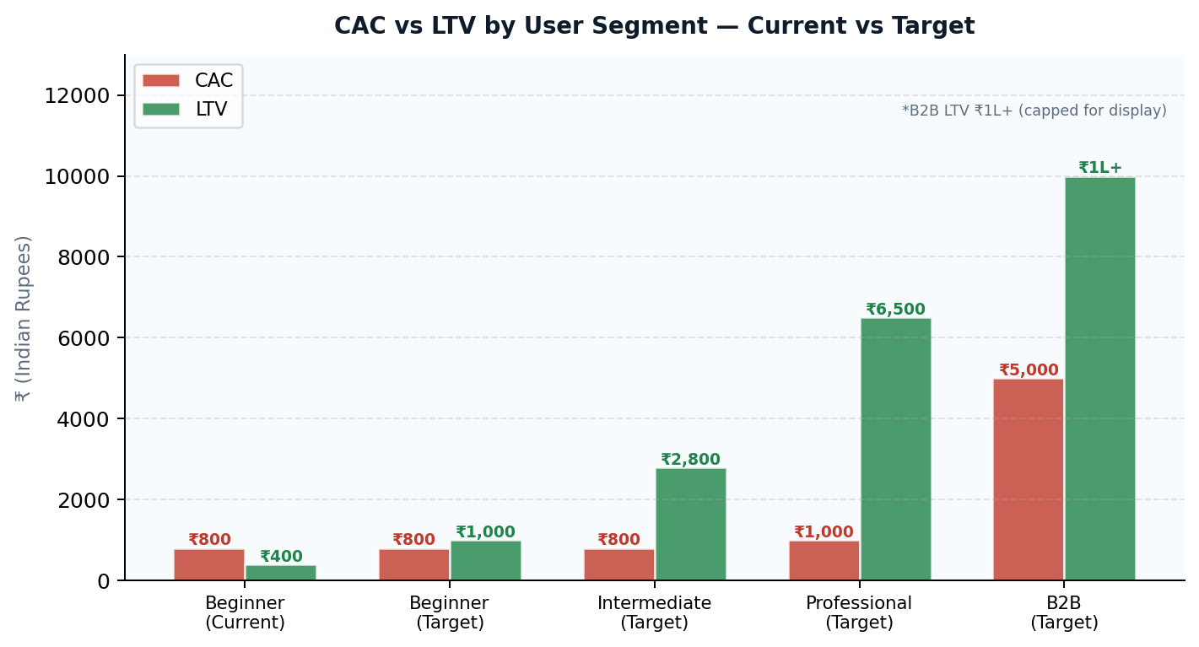
Figure 8.1 — CAC vs LTV by User Segment: Current vs Target

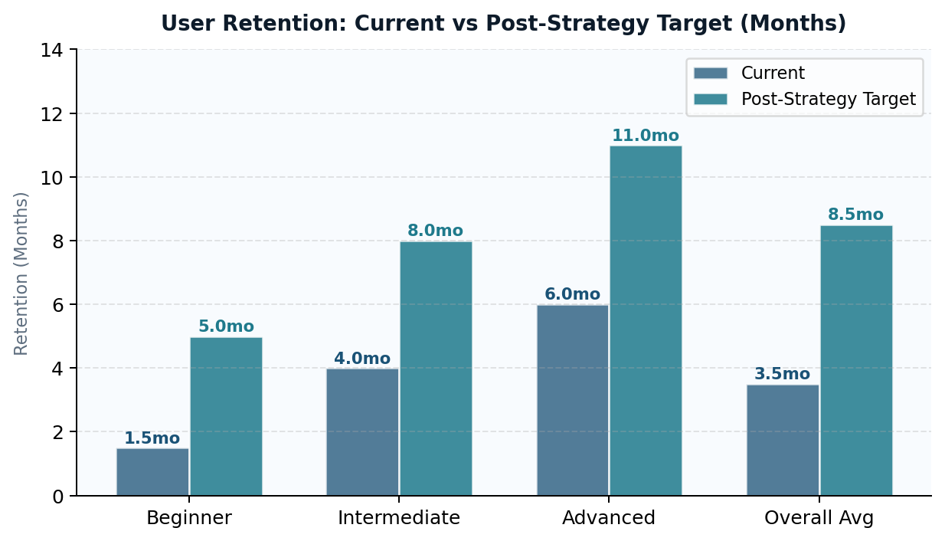
Figure 8.2 — Retention Duration: Current vs Post-Strategy Target (Months)

8.2 Current LTV Analysis by Segment
User Segment | Avg Monthly Pay | Avg Retention | Est. LTV | Health
Beginner (drops early) | ₹250/month | 1–2 months | ₹250–500 | 🔴 Loss
Intermediate (moderate) | ₹250/month | 3–5 months | ₹750–1,250 | 🟡 Break-even
Advanced (ceiling) | ₹250/month | 5–7 months | ₹1,250–1,750 | 🟢 Profitable
Professional (target) | ₹500–800/month | 6–12 months | ₹3,000–9,600 | 🟢 Highly Profitable
B2B / Institutional | ₹50K–2L/contract | 12+ months | ₹50K–2L+ | 🟢 Transformative

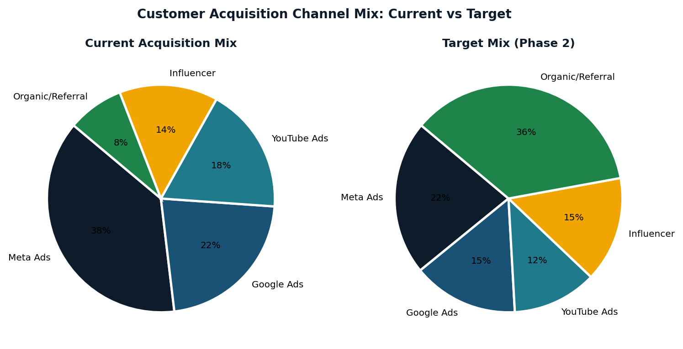
Figure 8.3 — Customer Acquisition Channel Mix: Current vs Target

8.3 Retention Strategy by User Level
User Level | Primary Churn Risk | Community Approach | Key Retention Driver
Beginner | Fear of judgment and speaking anxiety; drops in first 14 days | Present but never pushed — AI practice is the primary experience | Safe AI environment + Emotional Coaching + early visible wins
Intermediate | Boredom from repetitive AI practice; plateau at 3–5 months | Gently introduced — user joins at own pace when they feel ready | Community variety combats boredom; weekly challenges re-ignite engagement
Advanced | Feeling they have outgrown the app — silent churn | Actively encouraged — community is the primary engagement layer | Peer belonging + career ambition replaces boredom entirely
Professional | Time constraints; need efficient, relevant advanced content | Industry-specific community clubs and peer networks | Career outcomes + professional identity; employer-linked results

8.4 CAC Reduction Strategies
Strategy 1 — Build a Referral Engine
Existing users are Supernova AI's lowest-cost and highest-quality acquisition channel. A structured referral program — where users receive one month free for every friend who subscribes — can dramatically shift the acquisition mix toward near-zero-cost, high-retention referral users. Referral users trust the platform before they join, form habits faster, and stay longer than paid ad users.

Strategy 2 — Success Story Content Marketing
Every user who gets a job, passes an interview, or achieves a professional milestone through Supernova AI is a marketing asset. Their transformation story — told authentically in their own regional language and cultural context — builds brand credibility and drives organic downloads at near-zero cost. A systematic program to capture, produce, and distribute these stories across Instagram, YouTube, and WhatsApp can generate thousands of organic downloads per month.

Strategy 3 — B2B Channel Development
Colleges, coaching centers, and employers represent group acquisition opportunities where one partnership delivers dozens or hundreds of users at a fraction of the per-user CAC of direct advertising. A dedicated B2B sales team pursuing college communication lab partnerships, placement preparation programs, and corporate communication training contracts can dramatically reduce overall CAC while simultaneously opening the highest-LTV revenue stream.

8.5 LTV Improvement Strategy
LTV Lever | Current State | Proposed Action | Expected LTV Impact
Retention Duration | 1–4 months average | 14-day habit program + community anchor | +3 to 6 months average retention
ARPU (Revenue per User) | ₹250/month (students) | Professional tier at ₹500–800/month | +100–200% ARPU for professional segment
Upsell to Annual Plans | Not structured | Annual subscription at 3-month peak satisfaction | 12-month LTV guaranteed upfront
B2B Contracts | Not developed | College and employer partnerships | ₹50,000–2,00,000 per contract
Referral Users | Not structured | Referral program for existing subscribers | 20–30% higher LTV vs paid ad users
💡 Key Insight: The referral program is projected to shift 15–20% of new user acquisition from paid channels to organic referral within 18 months, reducing blended CAC by approximately 20–30%.

9. UX/UI, Customer Journey & Customer Psychology
Understanding how users experience Supernova AI — from the first ad to long-term loyalty — is critical to building a platform that retains as effectively as it acquires. This section analyses the full customer journey and the psychological drivers that determine whether a user stays or leaves.

9.1 The Full Customer Journey
Stage | User Action | Emotional State | Key Need | Dropout Risk
1. Discovery | Sees ad on Instagram/YouTube | Curious, slightly hopeful | Relevance — does this solve my problem? | 🟢 Low
2. Download | Downloads the app | Motivated, excited | Easy onboarding — no friction | 🟢 Low
3. Free Trial | Explores the platform | Eager but evaluating | Quick wins — feel improvement fast | 🟡 Medium
4. Decision Point | Chooses to pay or leave | Uncertain, weighing value | Proof of value before paying | 🔴 Very High
5. Active Learning | Uses app daily | Engaged but fragile | Visible progress + emotional reward | 🟡 Medium
6. Loyalty | Recommends app to others | Proud, confident, belonging | Community + career outcomes | 🟢 Low

9.2 Five Psychological Drivers
Psychological Driver | What It Means | How Supernova AI Must Respond
Identity & Aspiration | Users are not learning English — they are becoming someone. A confident professional. A student who gets the job. | Reinforce the identity aspiration at every touchpoint. Make using the app feel like becoming the person they want to be.
Fear of Judgment (Shame Avoidance) | The fear of being laughed at, of freezing in interviews — these fears drive downloads more than any positive aspiration. | Create a safe, judgment-free environment where users feel protected, not evaluated. Never gamify failure.
Sunk Cost Effect | Once invested in time and money, users are psychologically more likely to continue even when motivation dips. | Gently remind users of their streak, progress, community relationships — making leaving feel costly.
Social Proof & Belonging | Users who see others succeeding feel more motivated. Community members feel obligation to show up. | Leverage success stories, peer progress, community activity feeds, and shared milestone celebrations.
The Progress Principle | The single most powerful motivator. Users who feel forward movement stay. Users who feel stuck leave. | Every session must end with at least one moment of clear, felt progress.

10. SWOT Analysis
A SWOT Analysis examines Supernova AI's internal Strengths and Weaknesses alongside external Opportunities and Threats — providing a clear picture of where the company stands strategically and what it must do to grow sustainably.

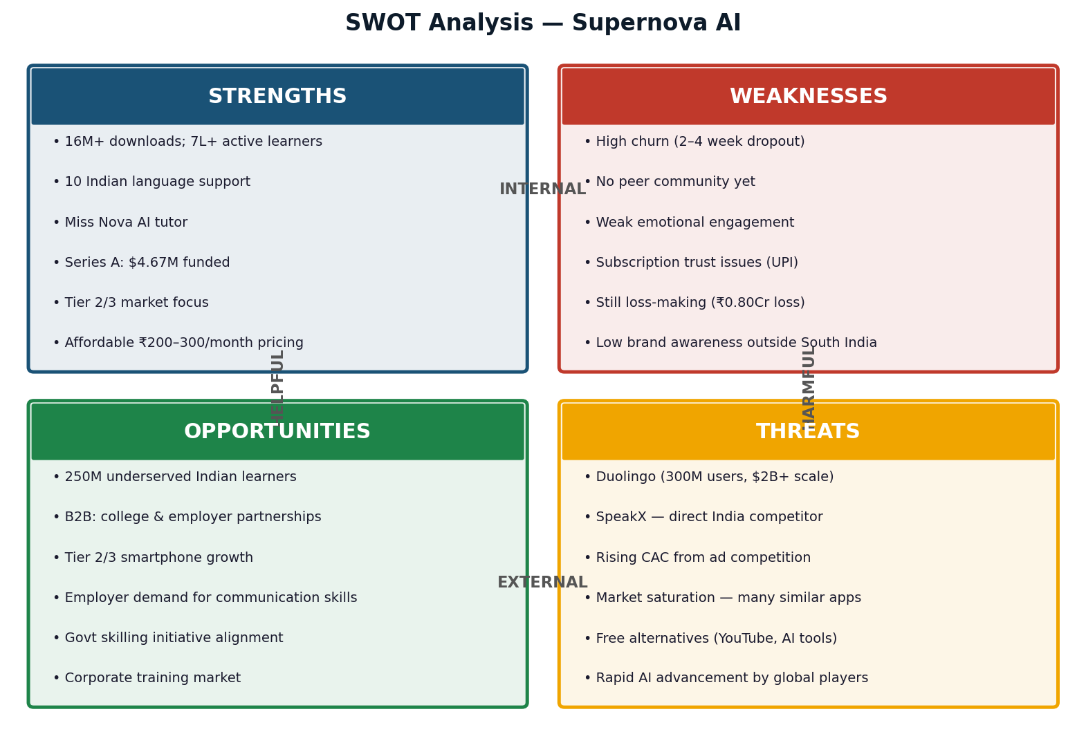
Figure 10.1 — SWOT Analysis: Supernova AI Strategic Position

10.1 Strategic Implications
SO Strategy  (Strengths +  Opportunities) | Leverage 10-language capability and Tier 2/3 focus to expand into underserved regional markets. Use Series A funding to build the Communication Confidence Network and Career Readiness Layer — turning the platform into a B2B solution for colleges and employers.
WO Strategy  (Weaknesses +  Opportunities) | Address the advanced content gap by building professional English modules and career simulation features — directly unlocking the B2B corporate training opportunity. Fix subscription trust issues to improve conversion and protect brand credibility as the company scales.
ST Strategy  (Strengths +  Threats) | Double down on the regional identity advantage — the 10-language depth, Tier 2/3 focus, and cultural understanding that global competitors like Duolingo structurally cannot replicate.
WT Strategy  (Weaknesses +  Threats) | Fix churn and emotional engagement before rising CAC makes customer acquisition unsustainable. A platform with 2–4 week average retention cannot survive competitive paid advertising regardless of product quality.

10.2 Detailed SWOT Analysis

Strengths — Internal Advantages
Strength | Strategic Significance
16M+ downloads; 7 lakh+ active learners | Proven product-market fit at Series A — largest validation of platform relevance in Indian edtech
10 Indian language support | Unmatched regional language depth no global competitor can replicate quickly — structural moat
Miss Nova AI tutor | Personalized, bilingual, always-available AI companion — emotional anchor for user relationship
Tier 2 & Tier 3 city focus | Deep cultural understanding of India's underserved learner majority — price, aspiration, access all aligned
Affordable pricing: ₹200–300/month | Accessible to the 250M price-sensitive Indian learners global platforms cannot serve profitably
SuperFluency Method | Structured learning sequence unique to Supernova AI — proprietary pedagogy advantage
Series A: $4.67M from Kae Capital, Lumikai, AdvantEdge | Institutional validation + capital runway for product investment through profitability
Revenue: ₹0.10 Cr (2021) → ₹8.93 Cr (2025) | 90x revenue growth in 4 years demonstrates strong commercial trajectory

Opportunities — External Growth Vectors
Opportunity | How Supernova AI Can Capture It
250M+ underserved Indian learners | Build the Communication Confidence Ecosystem specifically for this demographic — no global rival can compete on price, language depth, or cultural context
B2B: college & employer partnerships | Pilot 3–5 college communication lab and employer training contracts in Phase 1 at near-zero cost; scale in Phase 2 with dedicated B2B team
Growing Tier 2/3 smartphone penetration | Mobile-first product and regional language support already aligned — expand marketing investment in these markets ahead of competitors
Employer communication hiring demand | Position Professional Suite as interview and workplace preparation tool; align with employer talent pipelines for B2B revenue
Government skilling initiatives | Partner with national youth employability programs — institutional revenue + brand credibility as education policy partner
Corporate training market | Communication training for employees is a ₹5,000+ Crore market in India — B2B Professional Suite directly addresses this
Indian diaspora: UAE, UK, Canada, Australia | Non-resident Indians seeking professional communication improvement — Phase 3 international expansion opportunity with zero language localization required

Weaknesses & Threats — Challenges to Address
Type | Challenge | Mitigation Strategy
Weakness | High customer churn (2–4 week dropout) | 14-day habit onboarding redesign; Emotional AI Coach; value-first subscription prompt
Weakness | No peer community yet | Seed founding community in Phase 1; make it feel alive before broad launch
Weakness | Subscription trust issues (UPI) | Resolve immediately — renewal alerts, one-tap cancel, proactive refunds
Weakness | Low brand awareness outside South India | Regional success story content marketing in Hindi belt and East India markets
Weakness | Still loss-making (₹0.80 Cr loss 2025) | Projected break-even 2026 via retention improvement and CAC reduction strategy
Threat | Duolingo (300M users, $2B+ scale) | Compete on regional depth, emotional coaching, career outcomes — dimensions Duolingo cannot match
Threat | SpeakX — direct India competitor | Differentiate on community, emotional intelligence, and full ecosystem — not just AI features
Threat | Rising CAC from digital ad competition | Build referral engine, success story marketing, and B2B channels to shift acquisition mix
Threat | Free alternatives (YouTube, AI tools) | Demonstrate career outcomes and community belonging that free tools cannot provide
Threat | Rapid AI advancement by global platforms | Build the community and regional trust moat that AI technology alone cannot replicate

11. Limitations & Solutions
No strategic plan is complete without an honest assessment of its limitations. This section identifies eight key limitations of the proposed strategy and pairs each with a structured, practical solution.

# | Limitation | Solution | Implementation | Priority
1 | Community Building Is Slow to Scale | Seed 200–500 founding members before public launch; give them early access and recognition badges | Phase 1 (Months 3–9) | 🔴 High
2 | Emotional AI Coaching Is Unproven at Scale | Iterative development starting with simple signals (hesitation, pauses) and expanding sophistication | Phase 1–2 (Iterative) | 🔴 High
3 | Advanced Content Gap Cannot Be Filled Quickly | Launch 3 verticals first (IT, banking, retail) then expand incrementally based on user data | Phase 1 (Months 6–12) | 🔴 High
4 | Price Sensitivity Constrains Upsell | Progressive value ladder with milestone-triggered prompts and installment-based annual plan | Phase 1 (Months 4–8) | 🟡 Medium
5 | Regional Identity Risks Cultural Missteps | Co-develop all regional content with local cultural consultants; test extensively pre-launch | Ongoing (Pre-launch) | 🟡 Medium
6 | B2B Requires Capabilities Not Yet Built | Treat B2B as Phase 2; pilot 3–5 college partnerships at minimal cost to prove the model first | Phase 2 (Months 12–24) | 🟡 Medium
7 | UX Improvements Need Development Investment | Prioritize by impact-to-cost ratio — subscription screen and value-first prompt first | Phase 1 (Staged) | 🔴 High
8 | Subscription Trust Crisis Must Be Resolved FIRST | Mandatory 5-day and 1-day renewal alerts; one-tap cancel; proactive refund policy for past users | IMMEDIATE | 🚨 Critical

12. Phased Implementation Roadmap
The Phased Implementation Roadmap translates the Communication Confidence Ecosystem strategy into a structured, three-phase execution plan. Each phase builds on the previous — beginning with the most urgent operational fixes, progressing to product and community development, and culminating in full-scale B2B expansion.

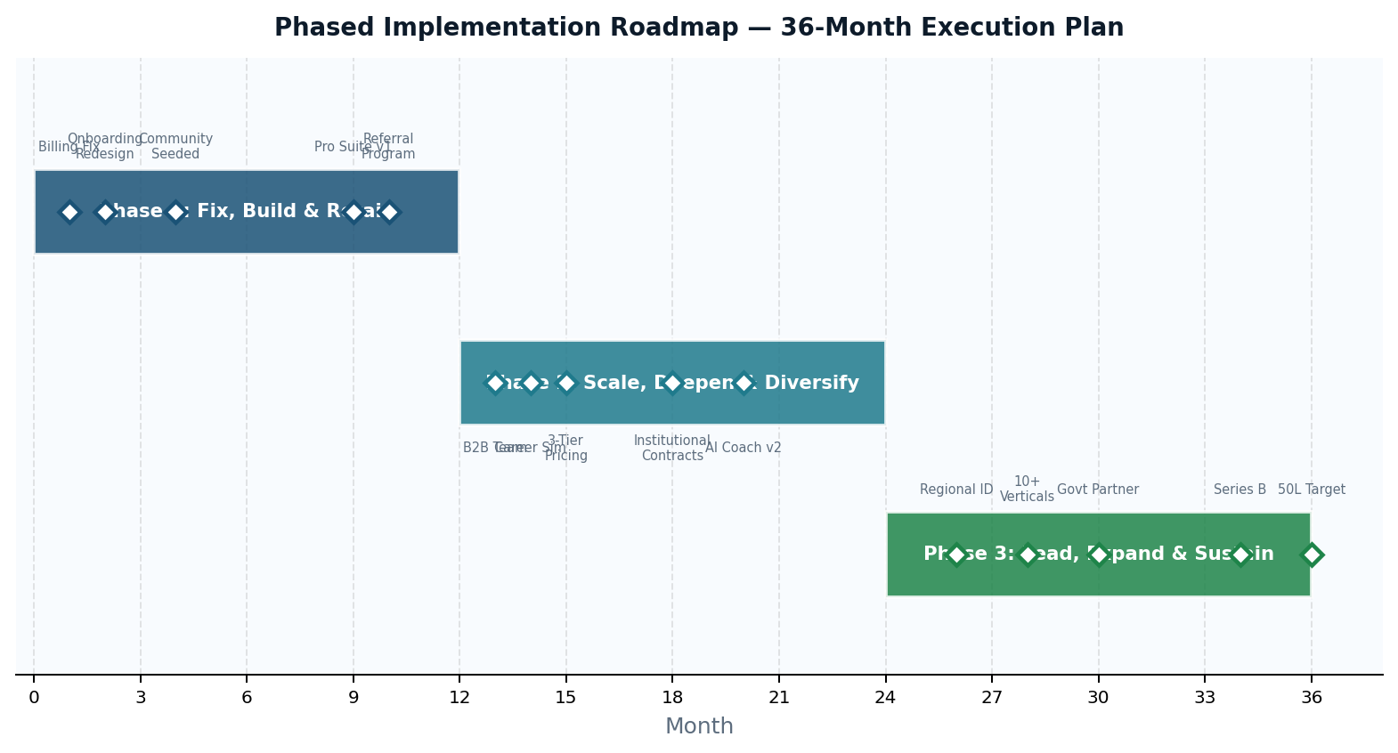
Figure 12.1 — 36-Month Implementation Roadmap with Key Milestones

P1  Months 0–12 | Fix, Build & Retain  Priority: Fix trust, build habits, seed community  - Resolve subscription billing trust crisis — mandatory renewal alerts and one-tap cancellation (Month 1)  - Redesign 14-day onboarding — emotional win in first 5 minutes, Emotional AI Coaching from day 1 (Month 2)  - Seed Communication Confidence Network with 200–500 founding members (Month 4)  - Launch weekly speaking challenges to combat intermediate plateau churn (Month 5)  - Release Professional Communication Suite v1 — IT, banking, retail verticals (Month 9)  - Activate referral program to shift acquisition away from paid-only channels (Month 10)

P2  Months 12–24 | Scale, Deepen & Diversify  Priority: Scale ecosystem, develop B2B, expand professional revenue  - Hire dedicated B2B sales team; pursue college and employer partnerships (Month 13)  - Launch AI Career Simulation World — interview, workplace, client communication practice (Month 14)  - Introduce 3-tier pricing (foundational / intermediate / professional) with milestone upsell prompts (Month 15)  - Systematize success story content marketing across regional language social channels (Month 16)  - Sign first 3–5 institutional contracts with colleges or employers (Month 18)  - Release Emotional AI Coach v2 — deeper sentiment and confidence-pattern analysis (Month 20)

P3  Months 24–36 | Lead, Expand & Sustain  Priority: Market leadership, geographic expansion, Series B readiness  - Deploy Regional-to-Professional Identity Journey across all 10 Indian language markets (Month 26)  - Expand Professional Suite to 10+ industry verticals (Month 28)  - Sign government skilling initiative partnership for national youth employability programs (Month 30)  - Launch international pilot targeting Indian diaspora — UAE, UK, Canada, Australia (Month 32)  - Initiate Series B fundraise on strength of improved unit economics and B2B proof points (Month 34)  - Set 50 lakh (5 million) active learner target — positioning as India's #1 Communication Ecosystem (Month 36)

12.4 Roadmap Summary — Phase Comparison
Dimension | Phase 1 (0–12 mo) | Phase 2 (12–24 mo) | Phase 3 (24–36 mo)
Priority | Fix trust & build habits | Scale ecosystem & open B2B | Market leadership & global expansion
Key Product Launch | Onboarding redesign + Emotional AI Coach | AI Career Simulation World | Regional Identity Journey (all 10 languages)
Pricing | Existing tiers + referral program | 3-tier pricing structure goes live | Premium & institutional pricing matures
Revenue Focus | Consumer subscription improvement | B2B pilot contracts signed | B2B scale + diaspora market
Community | Seed 200–500 founding members | Speaking clubs + peer interviews active | Language-specific clubs across all states
CAC Strategy | Fix billing; activate referral engine | B2B reduces blended CAC significantly | Organic referrals = 40%+ of acquisition
LTV Target | ₹500–1,000 per user | ₹1,500–2,500 per user | ₹2,500–3,500+ per user
Revenue Target | ₹13.50 Cr (2026) | ₹22–28 Cr (2027) | ₹40–50 Cr (2028)
Series Goal | Break-even profitability | First B2B proof points; LTV improvement | Series B fundraise readiness
💡 Key Insight: The three-phase roadmap is built on one unifying principle: execute in the order that matters most. Fix trust before features. Build retention before community. Build community before B2B. Build B2B before expanding geographically.

13. Expected Business Impact
The proposed Communication Confidence Ecosystem strategy is expected to generate measurable impact across five key business dimensions: retention, customer acquisition cost, lifetime value, revenue growth, and brand positioning.

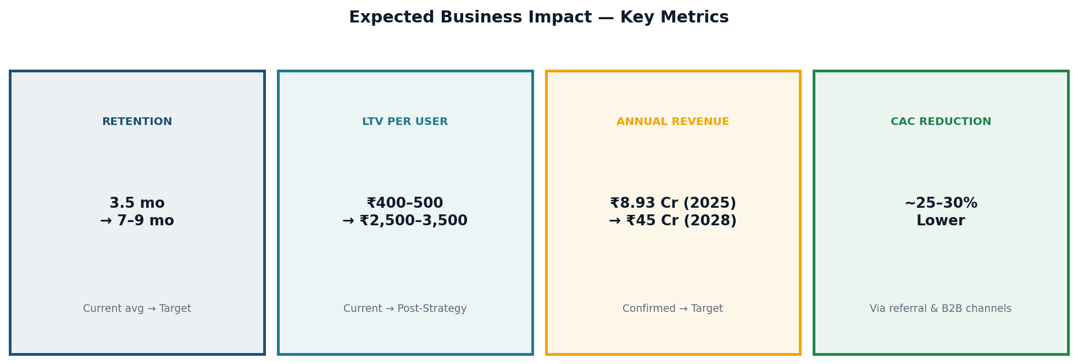
Figure 13.1 — Expected Business Impact: Key Metrics Summary

13.1 Impact Projections
Impact Area | Current State | Post-Strategy Target | Timeline
Retention (All Users) | 3.5 months average | 7–9 months average | Within 24 months
Beginner Conversion Rate | ~20–25% | 35–45% | Phase 1 (6 months)
Intermediate Retention | 3–5 months | 6–9 months | Phase 1–2
Advanced Churn | High (silent churn) | Reduced 50–70% | Phase 2
LTV per User | ₹400–500 | ₹2,500–3,500 | End of Phase 2
ARPU (Avg Revenue/User) | ₹250/month | ₹375–450/month | Phase 2 (3-tier pricing)
CAC (Blended) | ₹800–1,200 | 20–30% lower | Phase 2 (referral engine)
Annual Revenue | ₹8.93 Cr (2025) | ₹40–50 Cr (2028) | Phase 3
Profitability | ₹0.80 Cr loss (2025) | ₹5–8 Cr profit (2028) | Phase 3
B2B Revenue Contribution | ₹0 (not developed) | ₹5–10 Cr annually | Phase 2–3


Figure 13.2 — Revenue Growth Trajectory 2021–2028 with Strategy Deployment Point
💡 Key Insight: Every strategic initiative proposed in this report ultimately serves one financial goal: to make each user worth significantly more over their lifetime than it costs to acquire them.

14. Strategic Diagrams & Frameworks
This section presents four original strategic frameworks that underpin the Communication Confidence Ecosystem strategy. Each framework distils a core analytical concept into a clear, structured format.

Framework 1 — The Communication Confidence Flywheel
The flywheel begins when AI practice builds early confidence → motivates payment → deepens usage → leads to community membership → generates career outcomes → produces success stories → drives organic referrals at near-zero CAC. Each revolution makes the next faster: community grows, referrals increase, brand strengthens, CAC falls while LTV rises.
AI Practice → Early Confidence → Payment → Deeper Usage → Community → Career Outcomes → Success Stories → Organic Referrals → New Users → (Repeat)

Framework 2 — The Four-Stage Value Journey
Stage 1  LEARNING | Stage 2  CONFIDENCE | Stage 3  IDENTITY | Stage 4  CAREER READINESS
AI-powered language practice; pronunciation feedback; grammar correction; Miss Nova tutor | Emotional AI Coach eliminates speaking anxiety; builds confidence journey map over time | Regional-to-Professional identity transformation across all 10 Indian languages | AI Career Simulation; peer community; employer outcomes; success story content

Framework 3 — The Retention Pyramid
Layer (Bottom → Top) | What It Builds | Who Needs It
Layer 1: HABIT | Daily practice sessions in first 14 days — the behavioural foundation | ALL users (without habit, no further layer works)
Layer 2: PROGRESS VISIBILITY | Users who can see improvement continue; users who cannot see progress leave silently | Beginners & Intermediates
Layer 3: EMOTIONAL CONNECTION | AI Coach and judgment-free environment create a bond beyond functional value | Intermediate users
Layer 4: COMMUNITY BELONGING | Peer ties make leaving feel like losing relationships, not just cancelling a subscription | Intermediate & Advanced users
Layer 5: CAREER OUTCOMES | Platform contributes directly to professional success — loyalty becomes permanent | Advanced users & Professionals

Framework 4 — The Competitive Moat Matrix
The Competitive Moat Matrix evaluates Supernova AI's competitive advantages across two axes: user value and replication difficulty. The most sustainable moats are those that are both highly valuable to users AND extremely difficult for competitors to replicate.
Competitive Advantage | User Value | Replication Difficulty
AI Technology (chatbots, pronunciation) | ⭐⭐⭐⭐ High | ⭐⭐ Low — any funded competitor can copy
Regional Language Depth (10 languages) | ⭐⭐⭐⭐⭐ Very High | ⭐⭐⭐⭐⭐ Very High — requires years of data & cultural expertise
Community Culture & Emotional Bonds | ⭐⭐⭐⭐⭐ Very High | ⭐⭐⭐⭐⭐ Very High — trust & social norms take years to build
Career Outcomes & Success Stories | ⭐⭐⭐⭐⭐ Very High | ⭐⭐⭐⭐ High — requires real user results accumulated over time
Affordable Pricing for Tier 2/3 India | ⭐⭐⭐⭐ High | ⭐⭐⭐ Medium — global platforms structurally resist low pricing
💡 Key Insight: Supernova AI's true moats lie in regional depth, community culture, and career outcomes — not in AI technology. These are the areas where no competitor has a head start.

15. Final Conclusion
This report has presented a comprehensive strategic analysis of Supernova AI — its market position, competitive landscape, customers, and the structural challenges it must overcome to build a sustainable, category-leading business in India's AI communication-learning market.

16M+  Downloads Proven | ₹8.93 Cr  Revenue 2025 | 3.5 mo  Avg Retention Now | 7–9 mo  Retention Target | ₹45 Cr  Revenue Target 2028

Supernova AI's foundation is genuinely strong. With 16 million downloads, over 7 lakh active learners, support for 10 Indian languages, and confirmed revenue of ₹8.93 Crore in 2025, the company has proven product-market fit in one of the most competitive edtech markets in the world. Its focus on Tier 2 and Tier 3 Indian learners — the 250 million people who understand English but cannot yet speak it confidently — gives it a defensible market position that no global competitor can replicate.
However, the analysis has made clear that Supernova AI faces serious structural vulnerabilities: high customer churn, a CAC-LTV gap at the student segment, absence of a peer community, and the subscription billing trust issue that — if left unaddressed — will undermine every other improvement.
The proposed Communication Confidence Ecosystem strategy directly addresses each vulnerability in a sequenced, realistic, and financially grounded manner. Fix trust first. Build retention second. Activate community third. Develop B2B fourth. Pursue geographic expansion fifth. Each phase strengthens the foundation for the next.

"Supernova AI's users are not looking for a better English app.
They are looking for a better version of themselves."
A platform that understands this truth will win loyalty no competitor can buy.

Supernova AI has the product, the mission, the market, and the momentum to become India's definitive Communication Confidence Ecosystem. The strategy proposed in this report is the roadmap to get there — not as another English learning app, but as the platform that changes what it means to speak, to succeed, and to belong in professional India.

16. Project Resume Summary
Project Title | Strategic Growth, Differentiation & Retention Analysis — Supernova AI
Project Type | Independent Business Strategy Project | Student Report
Duration | May 2026
Sections Completed | 16 comprehensive sections
Data Tables Included | 25+ structured data and analysis tables
Charts & Visuals | 8 original charts and diagrams

Key Areas of Analysis
Company & industry overview with revenue model and funding analysis | Market problem identification across 8 external and internal challenge dimensions
Deep customer segmentation by age, region, level, and psychological driver | Competitor analysis across 8 platforms covering pricing, features, threats, and capabilities
Strategic differentiation proposal with 5 original differentiation pillars | Original Communication Confidence Ecosystem model with 3 integrated layers
CAC, LTV, and retention strategy with quantified projections and scenario modelling | UX/UI and customer psychology analysis across 5 psychological drivers
Full SWOT analysis with 4-directional strategic implications (SO, WO, ST, WT) | Limitations analysis with 8 constraints and paired practical solutions
3-phase implementation roadmap with milestones across a 36-month timeline | 4 original strategic frameworks: Flywheel, Value Journey, Retention Pyramid, Moat Matrix

Skills Developed & Demonstrated
Business Strategy | Market positioning, differentiation strategy design, competitive analysis, ecosystem model thinking, category creation, and strategic framework development.
Customer Psychology | Behavioural segmentation, motivation mapping, emotional driver analysis, sunk-cost psychology, social proof mechanics, and identity-aspiration marketing.
Retention Systems | Churn analysis, habit loop design, CAC-LTV modelling, subscription conversion strategy, community anchor design, and multi-level retention architecture.
Startup Scalability | Series A funding context, unit economics analysis, B2B channel development, phased resource allocation, and revenue diversification planning.
Product Differentiation | Identifying sustainable product moats, community-as-product thinking, emotional product design, and value proposition development.
UX/UI Thinking | Customer journey mapping, friction reduction analysis, emotionally intelligent product design, onboarding experience architecture, and conversion optimization.

Key Learnings & Outcomes
This project developed a practical, real-world understanding of how successful startups build sustainable competitive advantages — not through technology alone, but through community, emotional intelligence, cultural specificity, and relentless focus on what customers actually need beneath their stated requests.
The project demonstrated that effective business strategy requires equal depth in financial analysis, customer psychology, product thinking, and execution planning. Most importantly, it revealed that the most powerful growth strategies align business objectives — higher LTV, lower CAC, stronger brand — with genuine user value: helping real people transform their lives in meaningful ways.

Independent Business Strategy Project | Student Project Report | May 2026 | Prepared by Aafreen Fathima.H

