CompTia A+
MODULE: Hardware and Components Basics: Understanding of Hardware and its components
Day 2: Motherboard and CPU Theory
TASKS
1. Draw a labelled diagram of an ATX motherboard and mark at least 8 different slots and ports (such as RAM slots, PCIe slots, SATA ports, USB headers, CPU socket, power connector, etc.).
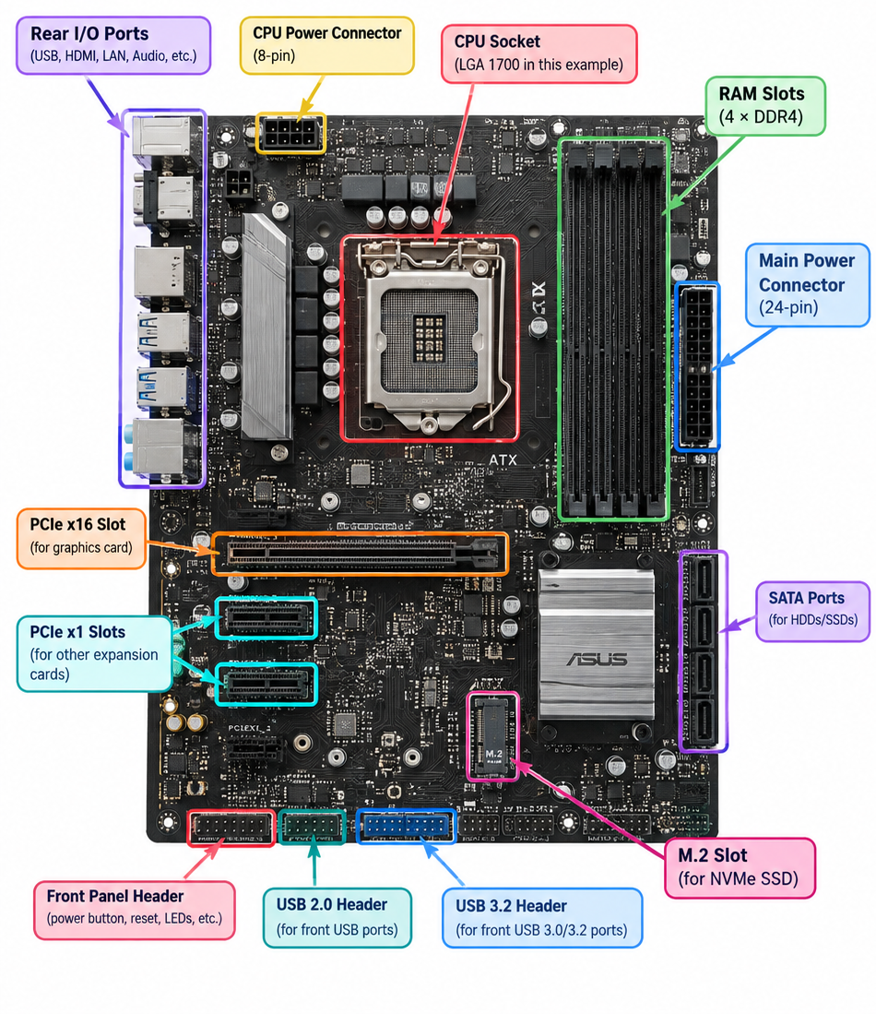
2. Research and list 3 popular CPU socket types (for example: LGA1151, AM4, LGA1200) and name one compatible CPU model for each.
CPU Socket Type | Compatible CPU Model
LGA1151 | Intel Core i7-9700K
AM4 | AMD Ryzen 5 5600
LGA1200 | Intel Core i5-10600K

- LGA1151: Supports Intel 8th and 9th Gen desktop CPUs; the i7-9700K is an LGA1151 processor.
- AM4: AMD Ryzen 5 5600 uses the AM4 socket.
- LGA1200: Intel 10th and 11th Gen desktop processors use LGA1200; the i5-10600K is one example.
3. Explain in your own words the primary functions of the CPU and the chipset on a motherboard, and describe how they work together when you open a music app like Spotify.

