|  |
| --- |
| College LaSalle |
| Project - Internet Programming Technical Manual |
|  |
| Presented to: Mihai Maftei |

|  |
| --- |
| Author:….Aafrin Sayani  3/12/2021 |

**Start by adding a short description of your project, and the languages (technologies) used**

Languages:

1. English

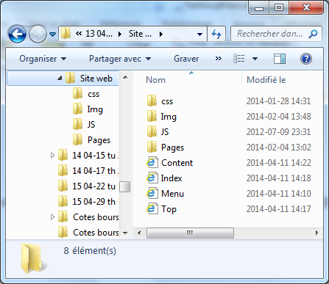**Presenting how the files/folders are organised.**

* 1. Index.html
  2. Trips.htm
  3. Menu.htm
  4. Top.htm
  5. finalSearch.htm
  6. cookies.htm
  7. reference.html
  8. MenuT.htm
  9. Form.htm
  10. Login.js

1. Css
   1. General.css
   2. Style.css
2. Img
   1. All images for countries and destinations
3. Pages
   1. Introduction.htm

**Present the functions and/or methods that you create or you did use into the web project.**

|  |  |
| --- | --- |
| **Function/Method** | **Description** |
| Document.getElementById() | Gets the username and password from the input field which has username and password as id ………………. |
| alert() | It pops-up an alert showing the invalid or valid credentials |
| authenticate_login() | Authenticates user with the global variable username and password and according to the validation shows the homepage or popup. |
| load()  function authenticate_logout()  document.querySelector('#fname').value  greet()  function setCookie(*cname*, *cvalue*, *exdays*)  function getCookie(*cname*)  function checkCookie()  onload="checkCookie()" | Load uses the JS which hides or shows the content page according to the validations  Logs our or hides the menu page when user  logs out.  Gets the value from the name of the input field  Checks if all input fields are entered or not.  It sets the cookie  Gets the cookies from user input  Checks the cookie.  Loads the cookie while loading the page. |

**Present the difficulties that you have, what was the hardest and the easiest part of your project.**

For me the hardest part was the cookies else rest of the things was little bit easier although it was lengthy but in the end I was able to complete the project thank you for this project I learnt so many things from this project.