1. Create a remote "repository" with project name cloudethix_git_yourname. Create
one file named demo.txt in the master branch of the remote repository. Once a
file is created , clone the repository locally. On the local repository create 3
branches: feature/login and feature/mainline, release. Add login.txt file to
feature/login branch and push that branch to remote repository. Create PR and
approve the PR and then merge the feature/login branch to the remote master
branch.

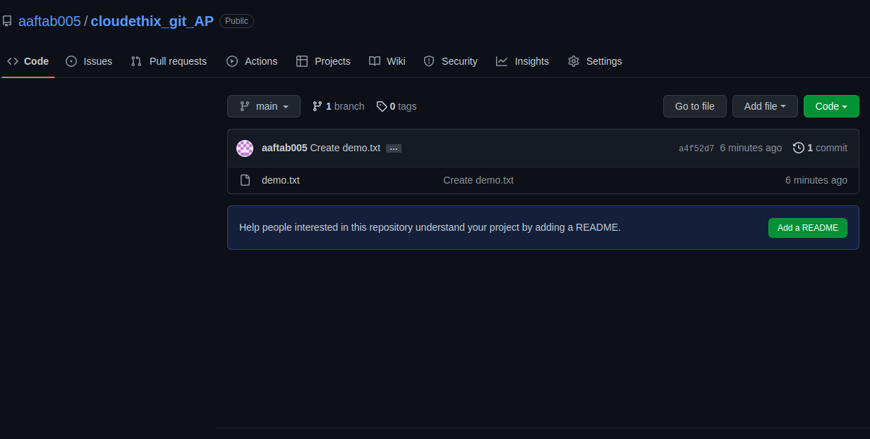

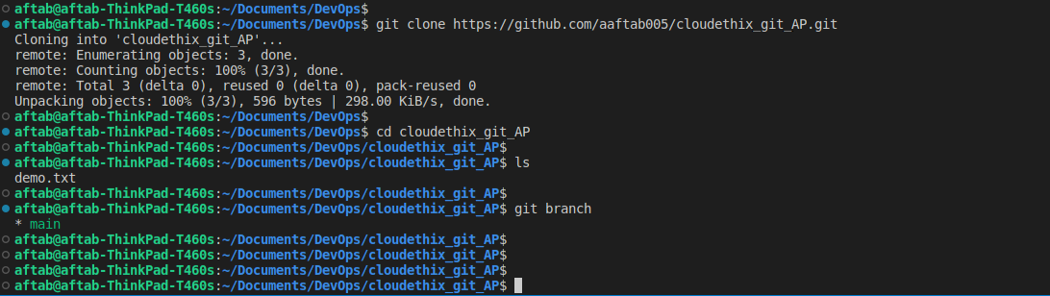

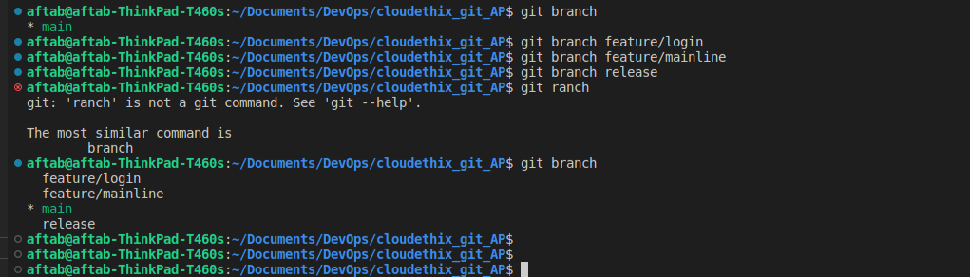

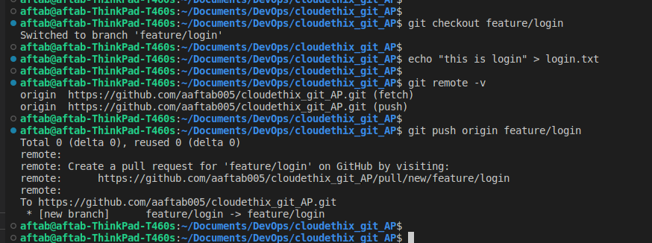

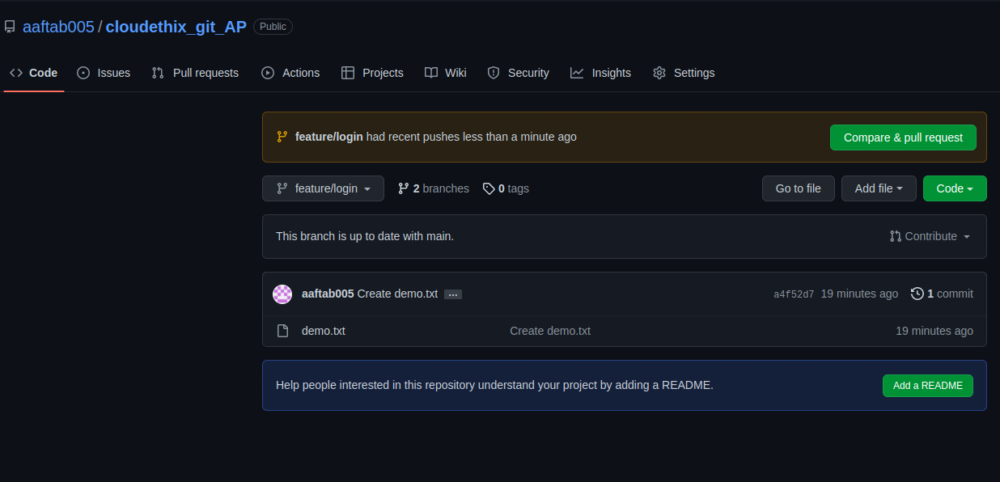

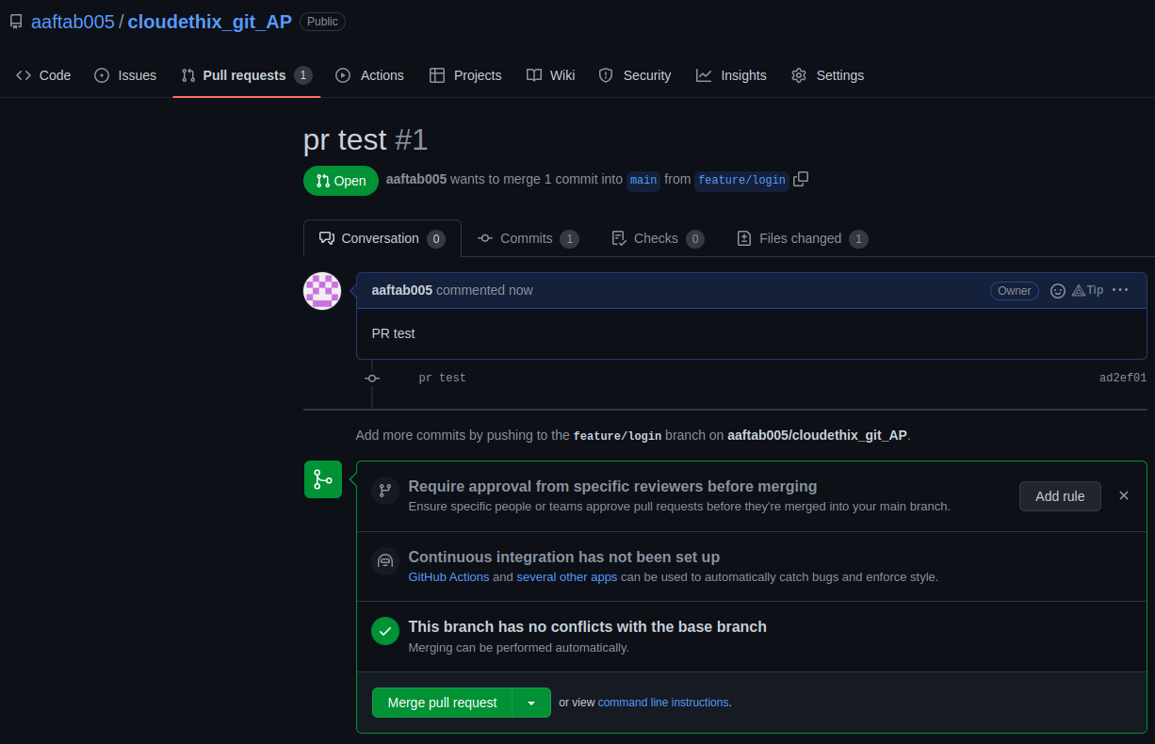

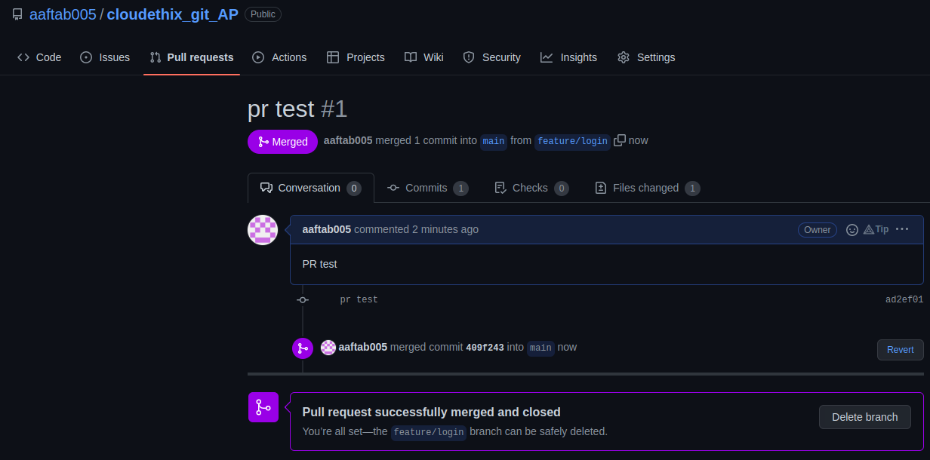

2. Add files to the feature/mainline branch to local repo and push that branch to
remote. Then add some files to the feature/mainline remote branch from the UI.
Then fetch the latest changes on local feature/mainline with Fetch and Pull
command.

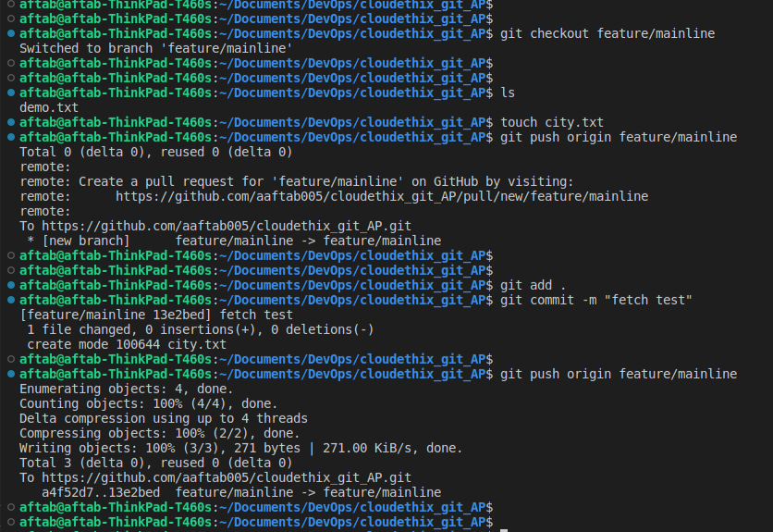
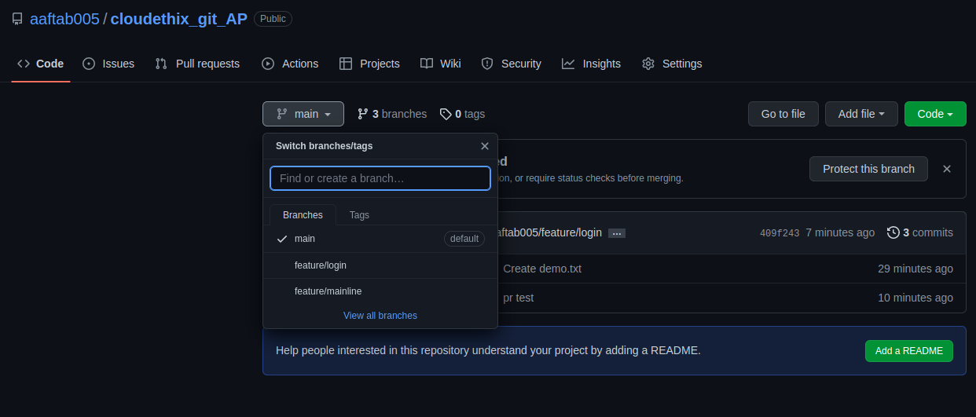

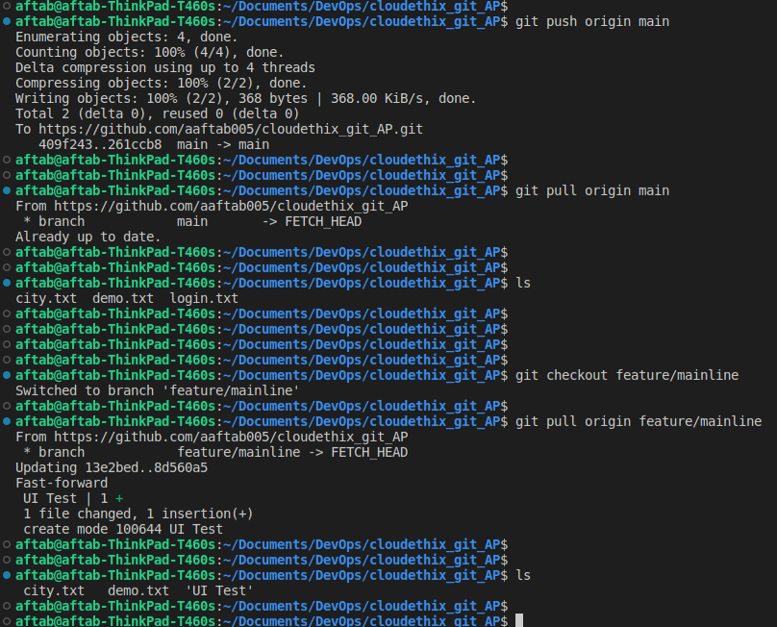
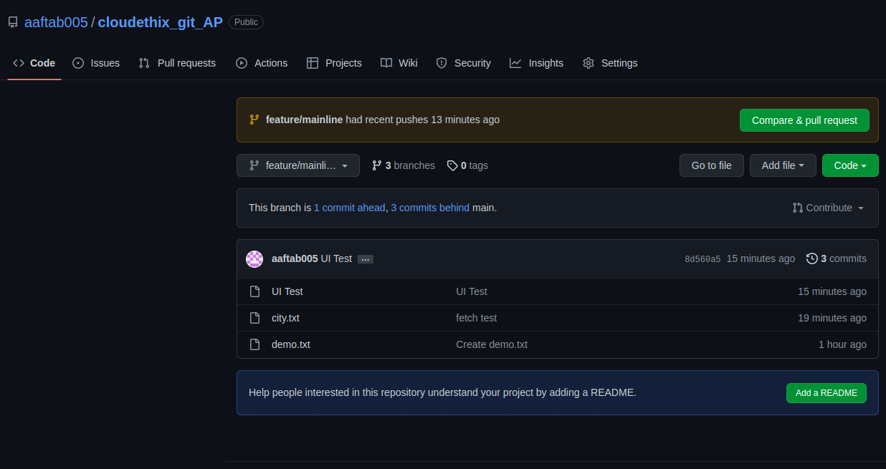

3. Fork below public repository to your account. Then clone the repository locally.
Create 2 branches cloud_dev01. Then add cloud_dev02 to that repository locally
and hello.txt , moto.txt and world.txt to one branch and add another 3 files to
another branch. Then push cloud_dev02 branch to the Forked repository on the
remote.
https://github.com/ripienaar/free-for-dev

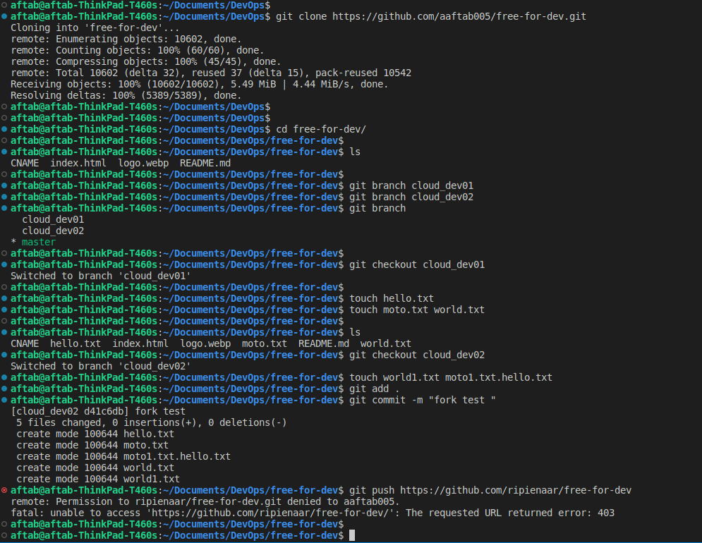

4. Create a remote repository merge_confilct_demo. Add some files in the remote
master branch. Clone the repository locally. Create 2 branches locally named
demo/merge and demo/conflicts. Add a merge.txt file in both branches with some
data like "Hello CloudEthiX…." And "Fello CloudEthiX…." respectively and
commit. Then merge demo/conflicts branch to demo/merge branch and solve the
merge conflicts.

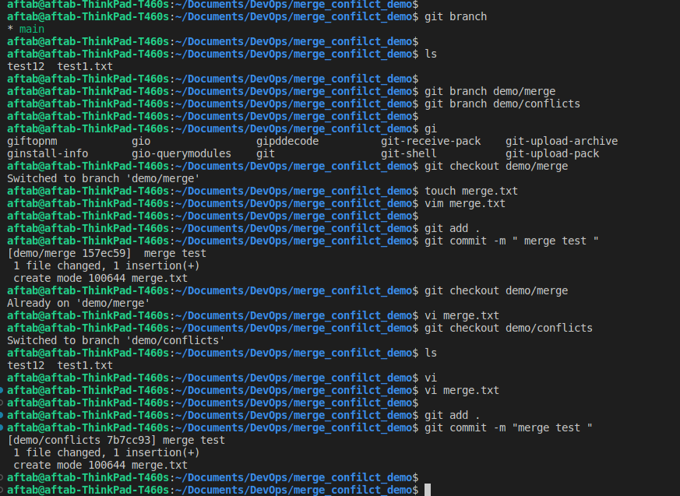
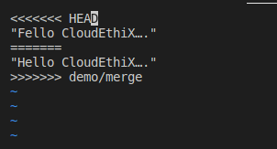

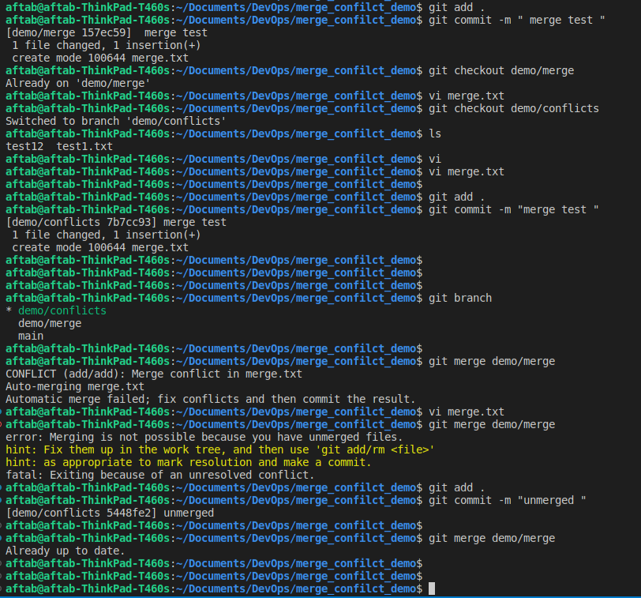

5. Create PR to merge the cloud_dev02 branch to Forked repository. Approve the PR and
merge cloud_dev02 branch to master branch remotely.

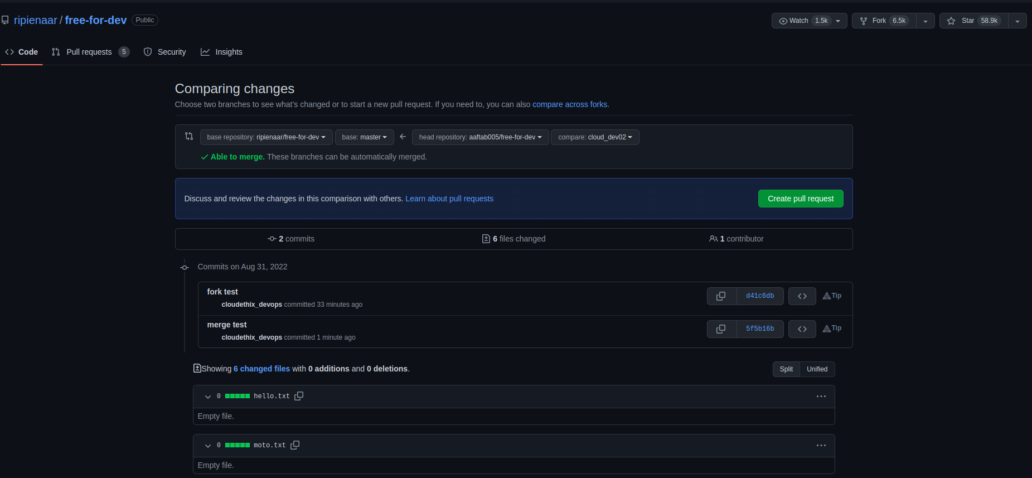

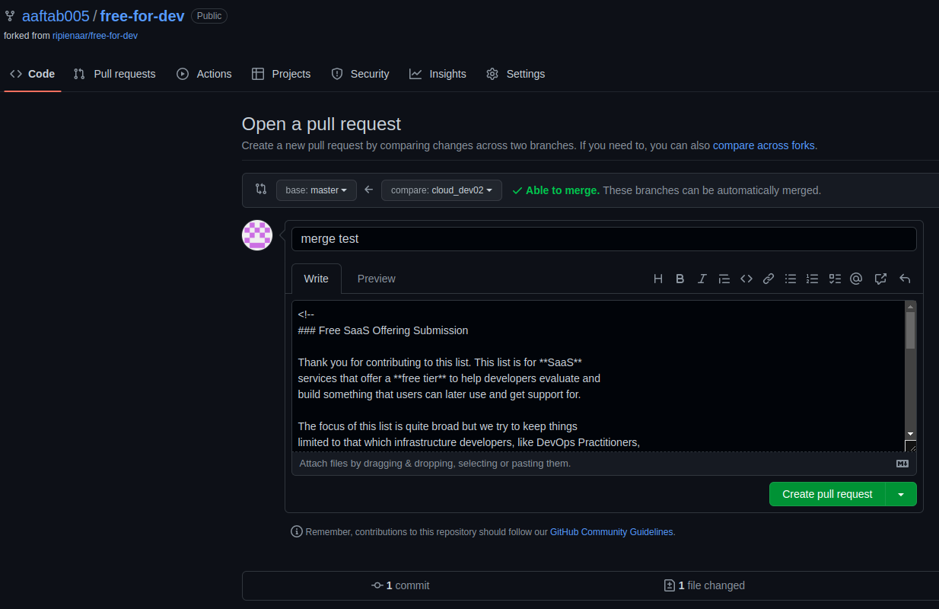
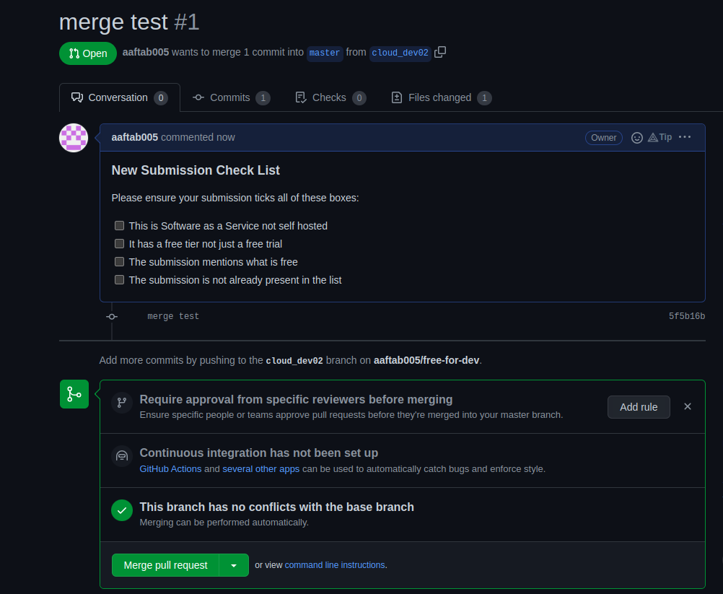

6. Fetch latest changes from master branch of remote forked repository to local
master branch. Then merge forked remote master branch with local master
branch. Check If all the latest files are there. Then checkout to local cloud_dev03
branch locally. Then Pull latest changes from the remote master branch.

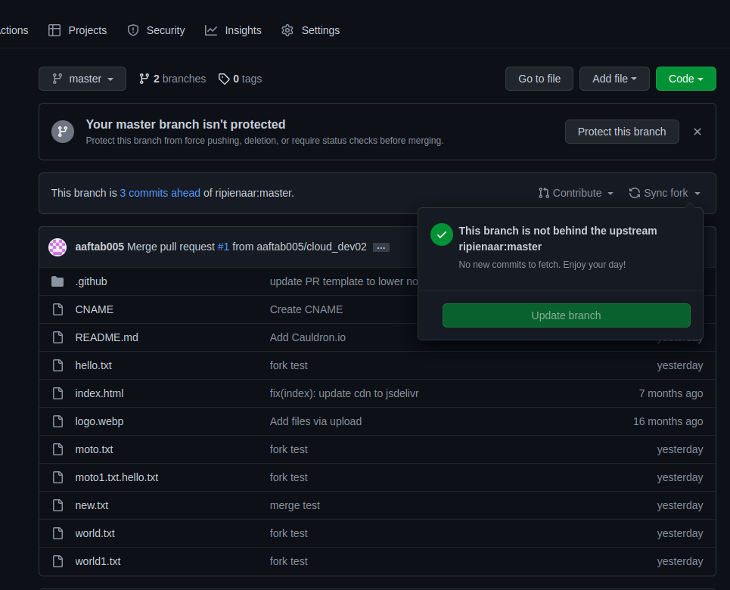

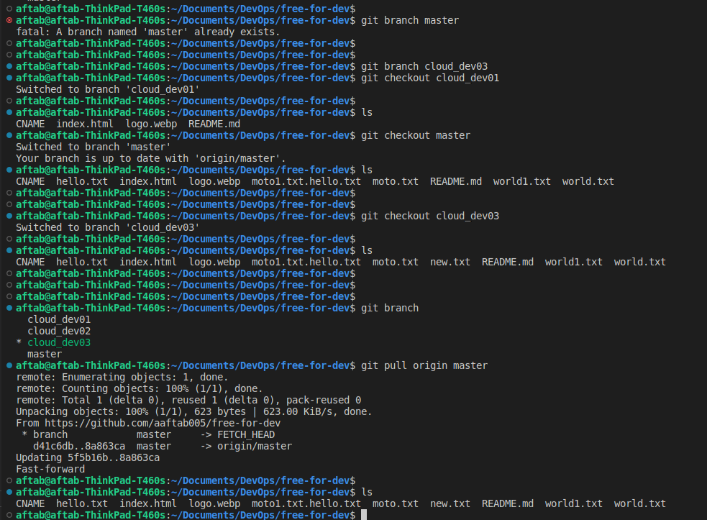

7. Checkout to the cloud_dev01 branch locally and rebase the remote master
branch of the forked repository.

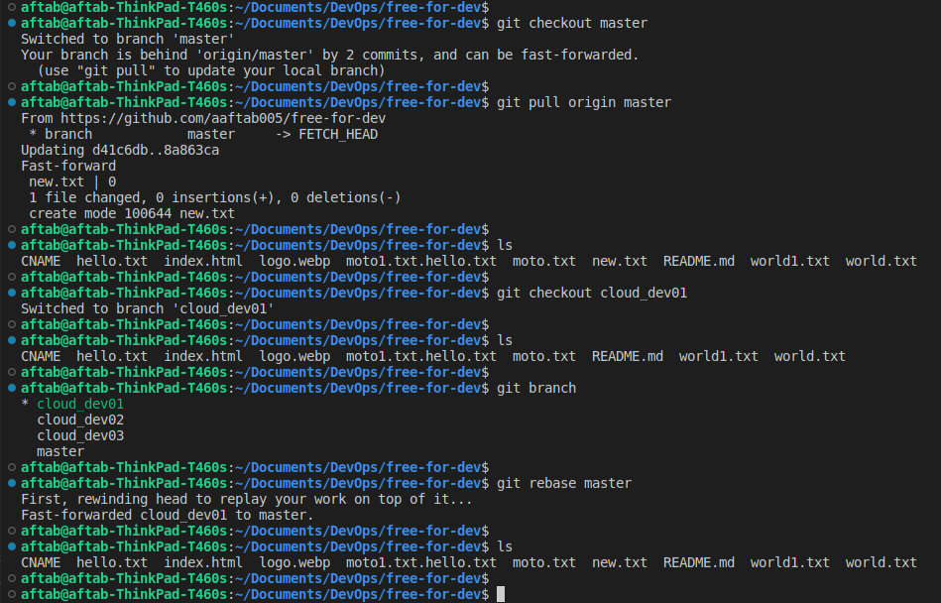

8. Create one repository locally. Commit any 3 files to the local repository. And the
revert back the commits.

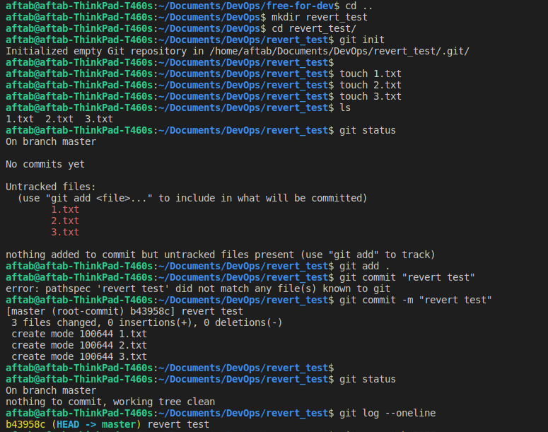

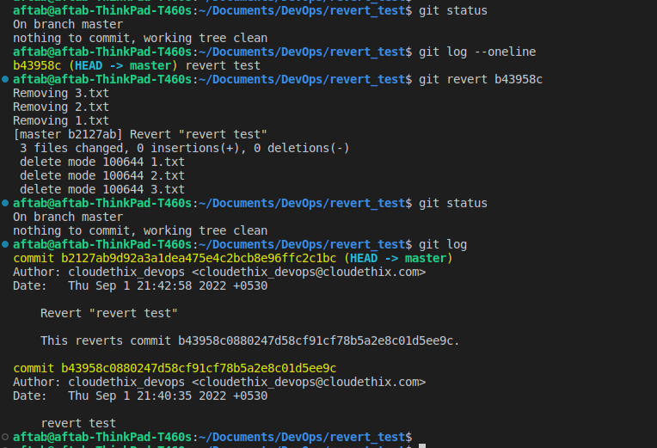

9. Create one local repository. commit some files to the local master branch.
Checkout to master_02 branch. Create 2 more files. Add those to the staging
area. Create stash area and those files. Then list and delete the stash.

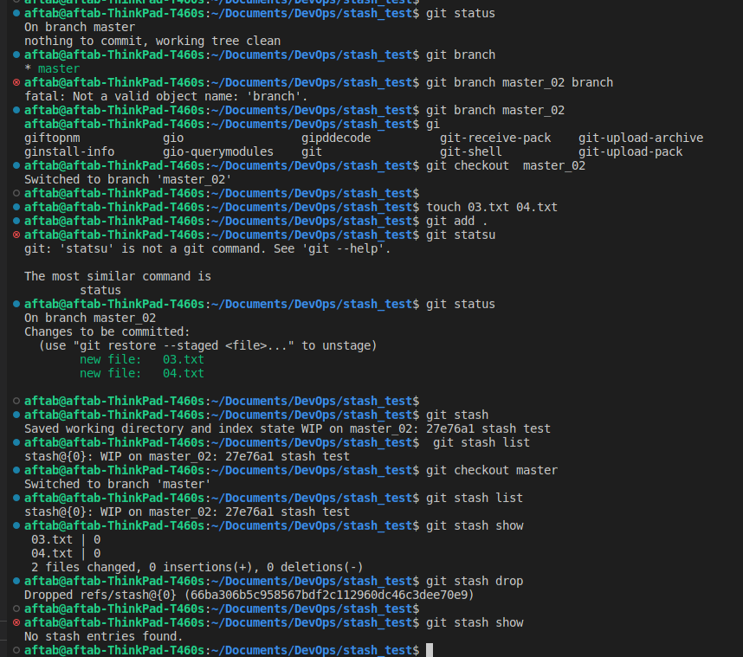

10. Create a local repository, initialise it and create 3 branches: develop, hotfix and
release. Checkout to hotfix branch and commit cloudethix.txt and once
committed amend the commit message.

