Problem statement:

We are trying to help a Business owner to open a new Gas Refilling station in any City. The target audience in this Project are obviously People who intend to open new Gas Stations or it can be used by Franchise Gas Companies to select the next location of their station.

The Conventional solution for this problem would be Checking locations of existing gas stations and simply selecting Locations which do not have a gas station for a large radius. This would not be an apt solution for this problem in cases like:

Opening a Gas station in a farming area with Very low Traffic Flow.

Or a Gas Station very close to another close gas Station won’t be a good choice.

So, The solution to this problem is not very straightforward and challenging.

Data Sections:

Using Foursquare API we fetch all Gas Stations in New York City with Co-ordinates.

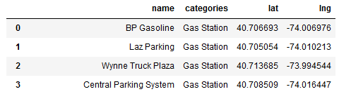

In addition to this there is requirement of Traffic volume Flow of all popular Roads in the City. For this I will be using a dataset provided by New York State Government.

This data set includes hourly Traffic Volume counts of almost all roads in New York city.

Using Geocoder, coordinates of these Roads are added to this Dataset to Calculate distance of busy roads with nearest gas stations.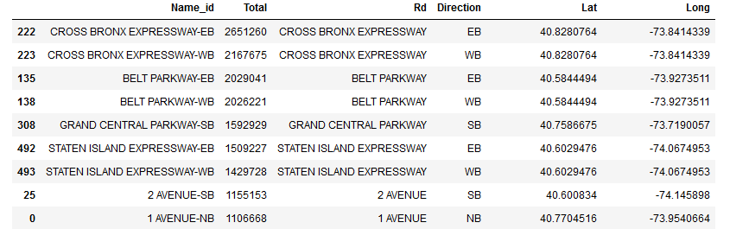

Traffic volume Dataset, NYC (2017-2018)