SOFTWARE REQUIREMENTS SPECIFICATION (SRS)
Traffic Management System (Simulation)
Version: 1.0
Authors: Student / Project Team
Date: 09-09-2026
Status: Draft / For Academic Approval

Revision History
Version | Date | Author | Change Summary | Approval
1.0 | 09-09-2026 | Student / Project Team | Initial SRS prepared for traffic management simulation.
Approvals
Role | Name | Signature / Email | Date
Course Coordinator
Project Guide
Table of Contents
1. Introduction
2. Overall Description
3. External Interface Requirements
4. System Features (Detailed Functional Requirements)
5. Non-Functional Requirements
5.1 Security Objectives and Security Requirements
6. Quality Attributes & Acceptance Tests
7. System Models and UML Use-Case Diagrams
8. Requirements Traceability Matrix (RTM)
1. Introduction
1.1 Purpose
This Software Requirements Specification defines the functional, non-functional, interface, security, and verification requirements for a Traffic Management System (Simulation). The system models traffic flow at intersections and road segments, processes simulated traffic conditions, controls traffic signals, detects congestion, and provides visual and statistical outputs for evaluation.
1.2 Scope
The simulation covers vehicle generation, road/intersection modelling, traffic-signal control, traffic-density monitoring, congestion detection, emergency-vehicle handling, incident simulation, and performance reporting. It is intended as an academic simulation and does not directly control real-world traffic infrastructure.
1.3 Audience
Primary stakeholders are project developers, testers, faculty evaluators, simulation operators, and users studying traffic-control strategies.
1.4 Definitions and Acronyms
Term | Meaning
TMS | Traffic Management System
Simulation | Computer-based model of traffic and signal behaviour
Vehicle Agent | A simulated vehicle participating in traffic flow
Intersection | Road junction controlled by one or more traffic signals
Traffic Density | Number or concentration of vehicles on a road segment
ETA | Estimated Time of Arrival
GUI | Graphical User Interface
RTM | Requirements Traceability Matrix
1.5 Assumptions
- The system operates in a controlled simulation environment with configurable road networks and traffic parameters.
- Traffic data may be generated synthetically by the simulator rather than collected from physical sensors.
- The simulation is designed for repeatable experiments, comparison of traffic-control strategies, and academic demonstration.
- The system shall not be interpreted as a certified real-world traffic-control product.
2. Overall Description
2.1 Product Perspective
The system is a standalone or locally networked simulation application. Its major components are the simulation engine, traffic model, signal-control module, congestion/anomaly detector, visualization interface, scenario manager, and reporting module.
2.2 Major Product Functions
- Create and configure road networks, intersections, lanes, and traffic signals.
- Generate vehicles using configurable traffic-flow parameters.
- Simulate vehicle movement, queues, signal states, and travel time.
- Collect and display traffic density, queue length, throughput, and delay.
- Detect congestion and simulated traffic incidents.
- Apply fixed-time or adaptive signal-control strategies.
- Provide emergency-vehicle priority in simulation scenarios.
- Pause, resume, reset, and step through a simulation.
- Compare simulation runs and generate summary reports.
2.3 User Roles and Characteristics
Role | Characteristics / Responsibilities
Simulation Operator | Configures scenarios, starts/stops simulations, and observes results.
Traffic Analyst | Examines congestion, delay, throughput, and compares control strategies.
Administrator | Manages configuration, experiment files, and access to protected functions.
System / Sensor Agent | Provides simulated traffic observations to the simulation engine.
2.4 Operating Environment
- Desktop/laptop computer running a supported operating system such as Windows or Linux.
- Modern web or desktop GUI, depending on implementation.
- Simulation data stored locally in files or a lightweight database.
- Recommended minimum: 4 GB RAM, dual-core processor, and sufficient disk space for experiment logs.
2.5 Constraints
- Simulation accuracy depends on the chosen traffic model and input parameters.
- The system is limited to the road-network scale supported by available computing resources.
- Real-world traffic laws, sensor calibration, and physical signal-controller interfaces are outside the simulation scope.
3. External Interface Requirements
3.1 User Interface
- The GUI shall provide controls for creating/loading a scenario and starting, pausing, resuming, and resetting the simulation.
- The main visualization shall show roads, intersections, vehicles, and traffic-signal states.
- The interface shall display key metrics such as vehicle count, average delay, queue length, throughput, and congestion status.
- Warnings and errors shall be presented using clear messages and shall not expose internal implementation details.
3.2 Hardware Interface
No dedicated physical traffic-control hardware is required. Optional input devices such as a keyboard, mouse, or touchscreen may be used for simulation operation.
3.3 Software Interfaces
- Scenario/configuration file interface for road networks and simulation parameters.
- Optional database or file-storage interface for experiment results.
- Optional API interface for receiving simulated sensor data.
- Chart/report generation component for exporting experiment results.
3.4 Communications
If the simulator is divided into multiple processes or uses an external data source, communication shall use a documented local or network protocol. Invalid or incomplete messages shall be rejected safely and logged without terminating the simulation.
4. System Features — Detailed Functional Requirements
Each requirement uses the form TMS-F-### and includes priority, source/stakeholder, acceptance criteria, test-case reference, and comments/dependencies. The project contains more than the required 15 functional requirements.
Req ID | Requirement | Type | Priority | Source / Stakeholder | Acceptance / Test Ref | Test Case | Comments / Dependencies
TMS-F-001 | The system shall allow the operator to create a traffic scenario with configurable roads and intersections. | Functional | High | Operator | Scenario created with valid parameters. | TC-SCN-01 | Depends on Scenario Manager.
TMS-F-002 | The system shall allow traffic-signal phases and timings to be configured for each controlled intersection. | Functional | High | Operator | Configured phase sequence is applied in simulation. | TC-SIG-01 | Depends on Signal Controller.
TMS-F-003 | The system shall generate simulated vehicles according to configurable arrival-rate parameters. | Functional | High | Analyst | Vehicle generation follows the selected rate within defined tolerance. | TC-VEH-01 | Depends on Vehicle Generator.
TMS-F-004 | The system shall simulate vehicle movement across connected road segments and intersections. | Functional | High | Analyst | Vehicles move according to valid route and signal conditions. | TC-VEH-02 | Depends on Traffic Engine and road-network model.
TMS-F-005 | The system shall enforce red, yellow, and green signal states in vehicle movement decisions. | Functional | High | Analyst | Vehicles stop/proceed according to active signal state. | TC-SIG-02 | Depends on Signal Controller and Traffic Engine.
TMS-F-006 | The system shall calculate traffic density for configured road segments. | Functional | High | Analyst | Displayed density matches simulated vehicle count/calculation. | TC-MET-01 | Depends on Metrics Engine.
TMS-F-007 | The system shall calculate queue length at controlled intersections. | Functional | High | Analyst | Queue metric updates as vehicles join or leave a queue. | TC-MET-02 | Depends on Metrics Engine.
TMS-F-008 | The system shall calculate average vehicle delay and travel time for a simulation run. | Functional | High | Analyst | Metrics are generated after vehicles complete routes. | TC-MET-03 | Depends on Metrics Engine and completed-route data.
TMS-F-009 | The system shall calculate traffic throughput for selected roads or intersections. | Functional | Medium | Analyst | Throughput equals completed vehicle movements over the selected period. | TC-MET-04 | Depends on Metrics Engine.
TMS-F-010 | The system shall detect congestion when configured traffic thresholds are exceeded. | Functional | High | Analyst | Congestion alert appears when threshold condition is met. | TC-CON-01 | Depends on congestion thresholds and detector.
TMS-F-011 | The system shall support fixed-time signal-control operation. | Functional | High | Operator | Signals follow configured fixed-time cycle. | TC-CTRL-01 | Depends on Signal Controller.
TMS-F-012 | The system shall support an adaptive signal-control strategy based on simulated traffic conditions. | Functional | High | Analyst | Signal timing changes when configured traffic conditions change. | TC-CTRL-02 | Depends on Metrics Engine and Signal Optimizer.
TMS-F-013 | The system shall allow a simulated emergency vehicle to be identified and prioritized. | Functional | High | Operator | Emergency vehicle receives configured priority behaviour. | TC-EMG-01 | Depends on Emergency Handler.
TMS-F-014 | The system shall support simulation of traffic incidents such as blocked lanes or stalled vehicles. | Functional | Medium | Analyst | Incident changes traffic state and is visible to the operator. | TC-INC-01 | Depends on Incident Manager.
TMS-F-015 | The system shall allow the simulation to be paused, resumed, stepped, and reset. | Functional | High | Operator | Each control produces the expected simulation state. | TC-CTL-01 | Depends on Simulation Engine state control.
TMS-F-016 | The system shall display real-time simulation state and key performance indicators. | Functional | High | Operator | Dashboard values refresh during execution. | TC-GUI-01 | Depends on Simulation GUI and Metrics Engine.
TMS-F-017 | The system shall save simulation configuration and experiment results for later comparison. | Functional | Medium | Analyst | Saved file/result can be reloaded without data loss. | TC-REP-01 | Depends on experiment storage.
TMS-F-018 | The system shall generate a summary report containing traffic metrics and selected control strategy. | Functional | Medium | Analyst | Report contains scenario, strategy, and measured metrics. | TC-REP-02 | Depends on Report Generator and stored metrics.
TMS-F-019 | The system shall validate scenario parameters before starting a simulation. | Functional | High | Operator | Invalid configuration prevents execution and shows a useful error. | TC-SCN-02 | Depends on validation layer.
TMS-F-020 | The system shall maintain an event log for significant simulation events and errors. | Functional | Medium | Administrator | Events contain timestamp, type, and relevant context. | TC-LOG-01 | Depends on logging component.
5. Non-Functional Requirements (Detailed)
NFRs are measurable and tied to acceptance tests. IDs use TMS-NF-###.
Req ID | Requirement | Category | Priority | Acceptance / Measurement
TMS-NF-001 | The simulation shall update the visual traffic state at least 10 times per second under normal test load. | Performance | High | ≥10 UI updates/s in benchmark scenario. TC-NF-01
TMS-NF-002 | A standard simulation scenario shall start within 5 seconds after valid configuration is submitted. | Performance | High | Startup time ≤5 s for reference scenario. TC-NF-02
TMS-NF-003 | The system shall complete a 30-minute simulated run without an unhandled application failure. | Reliability | High | 100% completion across 5 consecutive runs. TC-NF-03
TMS-NF-004 | The system shall maintain consistent simulation state when pause/resume/reset operations are performed. | Reliability | High | State remains valid across 20 control cycles. TC-NF-04
TMS-NF-005 | The GUI shall provide readable labels, consistent controls, and clear status indicators. | Usability | Medium | Usability checklist passes. TC-NF-05
TMS-NF-006 | The system shall support at least 500 simultaneously simulated vehicles in the reference scenario. | Scalability | Medium | No critical errors at 500 vehicles. TC-NF-06
TMS-NF-007 | Saved experiment files shall be reloadable with the same configuration values. | Maintainability | Medium | Configuration comparison shows no unintended changes. TC-NF-07
TMS-NF-008 | The system shall record timestamps for important events and simulation measurements. | Auditability | Medium | Required events contain valid timestamps. TC-NF-08
5.1 Data Requirements
- Scenario data shall include roads, intersections, lanes, signal phases, vehicle-generation parameters, and simulation duration.
- Experiment data shall include selected strategy and measured metrics such as throughput, delay, queue length, and congestion events.
- Corrupted or unsupported configuration files shall not be silently accepted.
5.2 Security Objectives and Security Requirements
5.2.1 Security Objectives
- SO-01 — Integrity: Protect scenario/configuration and experiment-result data from unauthorized modification during normal use.
- SO-02 — Access Control: Restrict administrative functions and sensitive configuration operations to authorized users or roles.
- SO-03 — Safe Failure: Invalid external input or malformed scenario data shall fail safely without causing uncontrolled system behaviour.
5.2.2 Security Requirements
Req ID | Requirement | Type | Priority | Acceptance Criteria / Test
TMS-SR-001 | The system shall require authentication before allowing protected administrative configuration changes. | Security | High | Unauthenticated user cannot access protected functions. TC-SEC-01
TMS-SR-002 | The system shall enforce role-based permissions for operator, analyst, and administrator functions. | Security | High | Unauthorized role access is rejected. TC-SEC-02
TMS-SR-003 | The system shall validate and sanitize imported scenario/configuration data before processing. | Security | High | Malformed input is rejected without application crash. TC-SEC-03
TMS-SR-004 | The system shall protect stored credentials and shall not write passwords or authentication secrets to normal event logs. | Security | High | Log review contains no credentials. TC-SEC-04
TMS-SR-005 | The system shall record security-relevant events such as failed authentication and denied administrative actions. | Security | Medium | Audit log contains required security events. TC-SEC-05
TMS-SR-006 | If network communication is used for external sensor/API input, the system shall use authenticated and encrypted communication where supported by the deployment. | Security | Medium | Connection uses configured secure channel. TC-SEC-06
5.2.3 Security Assumptions
- The simulation is not intended to operate as a safety-critical real traffic signal controller.
- Access credentials, if implemented, are managed by the project deployment environment.
6. Quality Attributes & Acceptance Tests
6.1 Quality Attributes
Attribute | Target
Performance | Reference scenario meets the defined UI-update and startup targets.
Reliability | Simulation completes repeated reference runs without unhandled failure.
Usability | An operator can configure, run, pause, and reset a scenario without ambiguity.
Scalability | Reference configuration supports at least 500 simulated vehicles.
Maintainability | Scenario and result formats are documented and modules have clear responsibilities.
Testability | Key metrics and simulation events can be observed and verified through logs or the GUI.
6.2 Acceptance Test Suites
Suite | Representative Tests | Pass Condition
Scenario & Configuration | TC-SCN-01, TC-SCN-02 | Valid scenarios run; invalid scenarios are rejected.
Signals & Vehicle Flow | TC-SIG-01, TC-SIG-02, TC-VEH-01, TC-VEH-02 | Vehicle movement and signal behaviour match requirements.
Traffic Metrics | TC-MET-01 to TC-MET-04 | Density, queue, delay, and throughput are correctly calculated.
Control Strategies | TC-CTRL-01, TC-CTRL-02 | Fixed-time and adaptive strategies behave as configured.
Emergency & Incidents | TC-EMG-01, TC-INC-01 | Priority and incident scenarios produce expected changes.
Performance & Reliability | TC-NF-01 to TC-NF-04 | Measured targets are satisfied.
Security | TC-SEC-01 to TC-SEC-06 | Protected operations and input validation pass.
Reporting & Logging | TC-REP-01, TC-REP-02, TC-LOG-01 | Results can be saved/reloaded and reports/logs are generated.
6.3 Exit Criteria
- All high-priority functional requirements are implemented and verified.
- No critical non-functional or security failures remain.
- Acceptance tests are documented and the RTM has traceability for all selected requirements.
- The reference simulation produces repeatable results under the documented test configuration.
7. System Models and UML Use-Case Diagrams
7.1 UML Use-Case Diagram — Simulation Operation
This diagram represents the main interaction between the simulation operator and the traffic-management simulation. The actor is connected only to the operator-facing use cases.
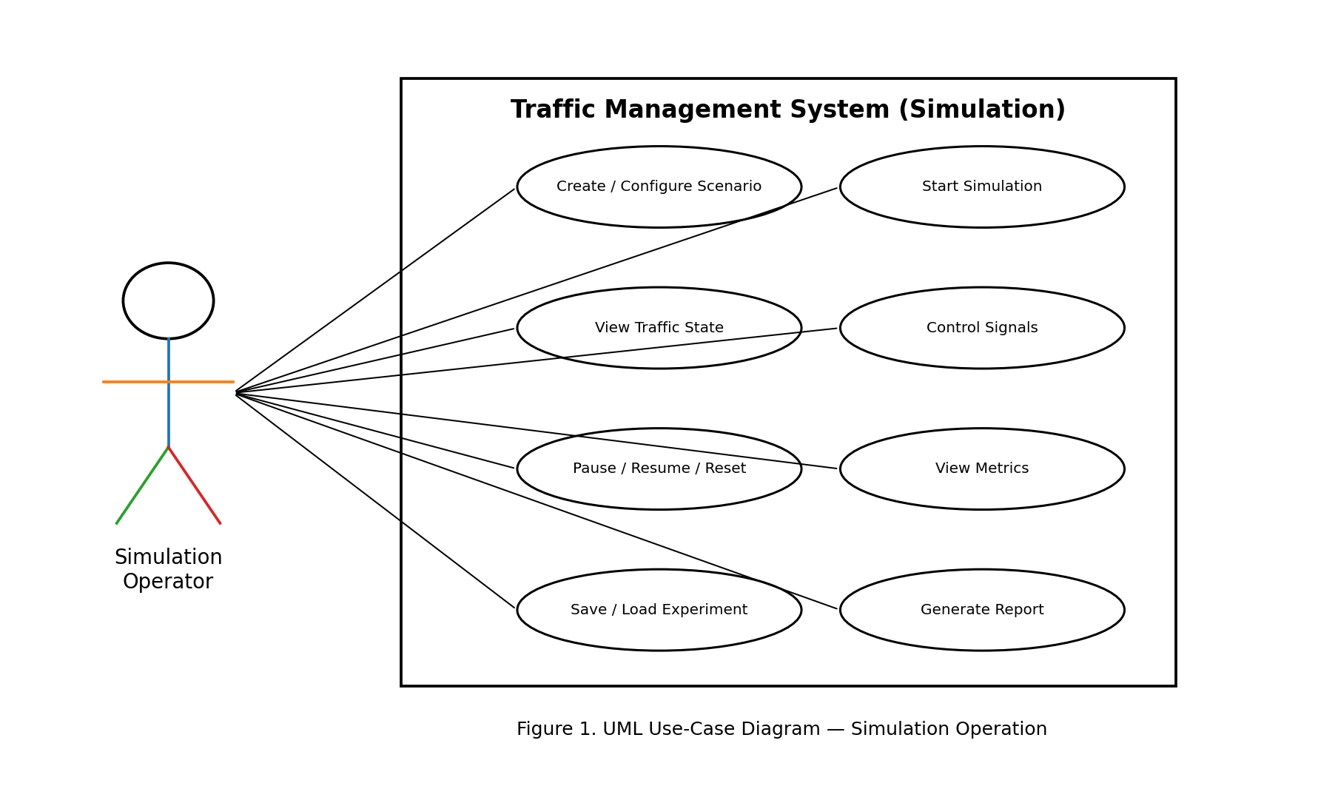
7.2 UML Use-Case Diagram — Traffic Response
This diagram represents traffic-data input and response functions. Traffic Sensor provides traffic data, while Emergency Service participates in emergency-route handling. Internal response flow is shown between the relevant system use cases.
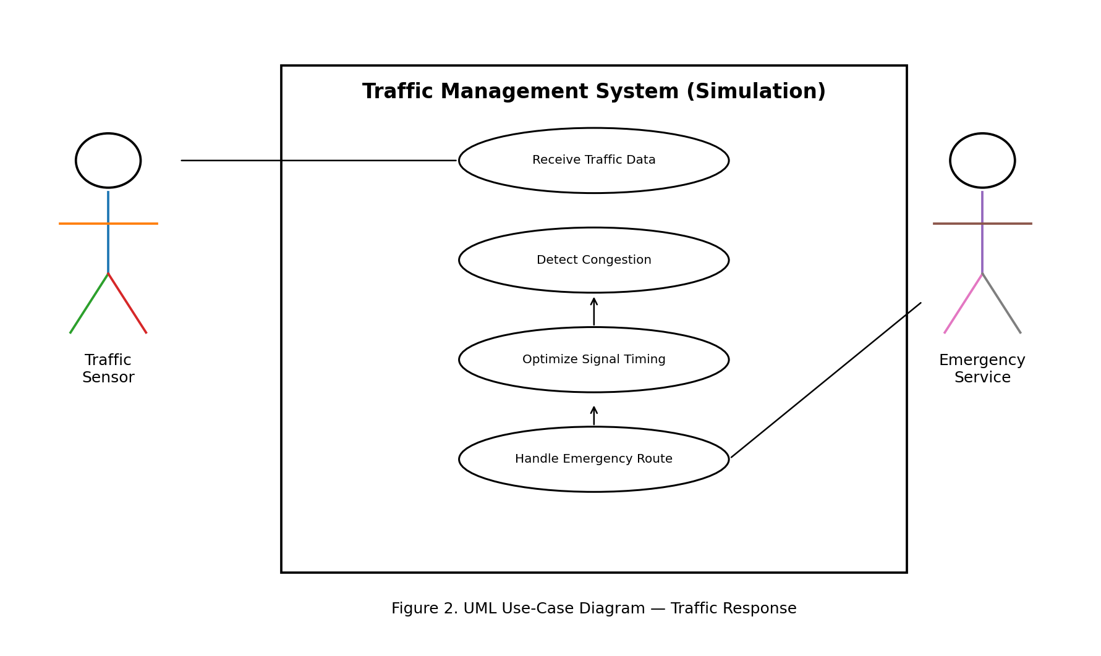
8. Requirements Traceability Matrix (RTM)
The RTM connects requirements to design modules and verification tests. Status values are N = Not implemented, P = Partially implemented, A = Accepted.
Req ID | Requirement Short | Section / Design Spec | Module | Test Case(s) | Status
TMS-F-001 | Create scenario | 4 / DS-SCN-01 | Scenario Manager | TC-SCN-01 | N
TMS-F-002 | Configure signals | 4 / DS-SIG-01 | Signal Controller | TC-SIG-01 | N
TMS-F-003 | Generate vehicles | 4 / DS-VEH-01 | Vehicle Generator | TC-VEH-01 | N
TMS-F-004 | Simulate movement | 4 / DS-VEH-02 | Traffic Engine | TC-VEH-02 | N
TMS-F-006 | Traffic density | 4 / DS-MET-01 | Metrics Engine | TC-MET-01 | N
TMS-F-007 | Queue length | 4 / DS-MET-02 | Metrics Engine | TC-MET-02 | N
TMS-F-010 | Detect congestion | 4 / DS-CON-01 | Congestion Detector | TC-CON-01 | N
TMS-F-012 | Adaptive control | 4 / DS-CTRL-02 | Signal Optimizer | TC-CTRL-02 | N
TMS-F-013 | Emergency priority | 4 / DS-EMG-01 | Emergency Handler | TC-EMG-01 | N
TMS-F-014 | Traffic incident | 4 / DS-INC-01 | Incident Manager | TC-INC-01 | N
TMS-F-018 | Generate report | 4 / DS-REP-02 | Report Generator | TC-REP-02 | N
TMS-NF-001 | UI update rate | 5 / DS-PERF-01 | Simulation GUI | TC-NF-01 | N
TMS-NF-006 | 500 vehicles | 5 / DS-SCAL-01 | Traffic Engine | TC-NF-06 | N
TMS-SR-001 | Admin authentication | 5.2 / DS-SEC-01 | Access Control | TC-SEC-01 | N
TMS-SR-003 | Input validation | 5.2 / DS-SEC-03 | Validation Layer | TC-SEC-03 | N
End of Software Requirements Specification

