Software Architecture and Design Specification
Project: Traffic Management System (Simulation)
Version: 1.0
Authors:
Date: 14-09-2026
Status: Draft

Revision History
Version | Date | Author | Change Summary
0.1 | 09-01-2026 |  | Initial draft — scope, architecture pattern, component breakdown.
1.0 | 14-09-2026 |  | Added UML class & sequence diagrams, API design, threat model, traceability matrix.

Approvals
Role | Name | Signature / Date
Project Lead
Instructor / Reviewer

1. Introduction

1.1 Purpose
This document specifies the software architecture and design of the Traffic Management System (Simulation), a discrete-event simulation platform that models signalized road intersections, vehicle flow, and adaptive signal control for research, training, and demonstration purposes.

1.2 Scope
The system covers: simulated intersection and road-network modelling, sensor-driven and time-based signal phase control, emergency-vehicle signal preemption, incident and congestion event handling, historical event logging, and a real-time monitoring dashboard. Physical hardware integration is out of scope — all sensor and signal inputs are simulated.

1.3 Audience
Developers, QA engineers, security reviewers, course instructors/evaluators, and maintenance teams extending the simulation.

1.4 Definitions
- TMS — Traffic Management System
- Intersection Controller — logical unit coordinating all signals at one junction
- Phase — a signal state combination (e.g., North-South Green / East-West Red)
- Preemption — temporary override of normal signal timing for priority vehicles
- ADR — Architecture Decision Record
- TLS — Transport Layer Security
- STRIDE — Spoofing, Tampering, Repudiation, Information disclosure, Denial of service, Elevation of privilege

2. Document Overview

2.1 How to use this document
This document provides the architectural deliverables for the simulation: UML class and sequence diagrams, the chosen architecture pattern and rationale, API design for key components, a STRIDE-based threat model, and a requirements traceability matrix.

2.2 Related Documents
- Software Requirements Specification (SRS) — Traffic Management System (Simulation)
- Software Test Plan (STP)
- Requirements Traceability Matrix (RTM) — summarized in Section 3.8

3. Architecture

3.1 Goals & Constraints
Goals: deterministic and repeatable simulation runs, real-time (or accelerated) visualization, extensibility to new intersection topologies, and accurate modelling of signal-timing and preemption logic.
Constraints: single-machine deployment for coursework/demo use, simulation clock must support configurable tick rates, and all simulated data must be clearly distinguishable from any real traffic data source.

3.2 Stakeholders & Concerns
- Students / Researchers — correctness and observability of the simulation model
- Instructors / Evaluators — clarity of architecture, adherence to design principles
- Developers — modularity and ease of extending new intersection or vehicle behaviors
- Operators (simulated) — reliability and responsiveness of the monitoring dashboard

3.3 Component (UML) Diagram
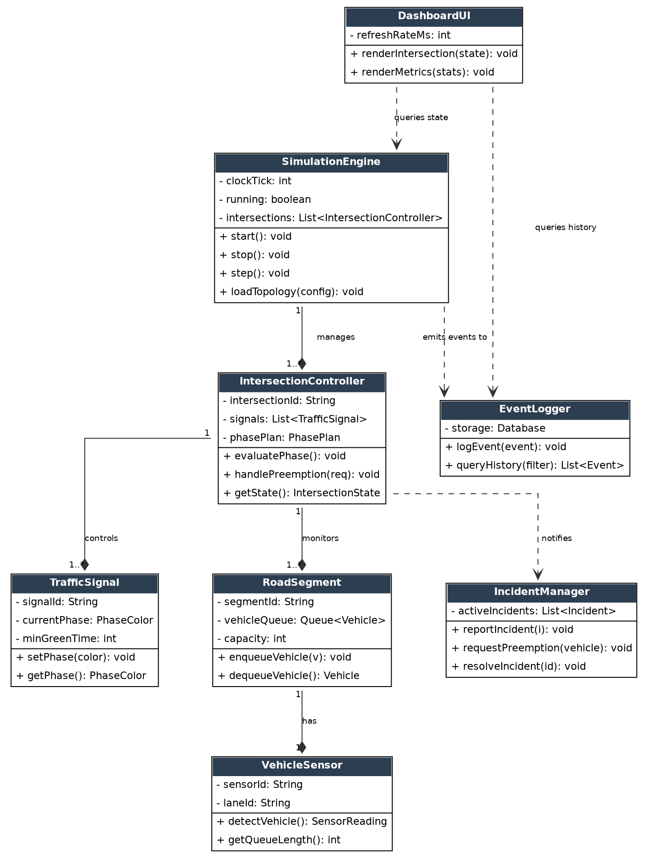
Figure 1 — UML Class Diagram: core components of the Traffic Management System (Simulation).

3.4 Component Descriptions
- Simulation Engine: owns the master clock, advances simulation ticks, and manages the set of Intersection Controllers.
- Intersection Controller: coordinates the signals and road segments at a single junction; evaluates phase transitions and handles preemption requests.
- Traffic Signal: represents one signal head; exposes phase state (RED/AMBER/GREEN) and enforces minimum green/clearance times.
- Vehicle Sensor: simulated inductive-loop/camera sensor that reports vehicle presence and queue length per lane.
- Road Segment: models a lane's vehicle queue and capacity, feeding congestion data to the controller.
- Incident Manager: receives incident reports (e.g., emergency vehicle approach, accident) and issues preemption or rerouting requests.
- Event Logger: persists phase changes, incidents, and preemption events for auditing and analytics.
- Dashboard UI: polls simulation and event state to render live intersection status and metrics.

3.5 Chosen Architecture Pattern and Rationale
An event-driven, layered simulation architecture was chosen: a core Simulation Engine layer drives discrete time steps, a Domain layer (Intersection Controller, Traffic Signal, Road Segment, Incident Manager) encapsulates traffic logic, and a Presentation/Integration layer (Dashboard UI, Event Logger) consumes state and events. This separates deterministic simulation logic from I/O and visualization concerns, and keeps each intersection's logic independently testable.
A full microservices decomposition (one service per intersection) was rejected as unnecessary operational complexity for a single-process simulation; a monolithic, non-event-driven design was also rejected because it would tightly couple the simulation clock to UI rendering and make it difficult to log or replay individual events.

3.6 Technology Stack & Data Stores
- Core simulation & domain logic: Java (or Python, per implementation track) with an event-loop/discrete-event scheduler
- API layer: REST endpoints (Spring Boot / FastAPI equivalent) for simulation control and state queries
- Event storage: relational database (e.g., MySQL/PostgreSQL) for the event log and traceability data
- Dashboard: web-based front end polling/subscribing to simulation state (HTTP/WebSocket) with TLS in any networked deployment
- Configuration: topology and phase-plan definitions loaded from versioned JSON/YAML config files

3.7 Risks & Mitigations
Risk | Mitigation
Simulation clock drift or stalled tick loop under load | Watchdog on the Simulation Engine tick; alert and safe-restart on missed ticks.
Incorrect preemption leaving an intersection in an unsafe phase | Enforced minimum clearance/all-red interval before any priority phase change.
Event Logger backlog causing memory growth | Bounded in-memory queue with async batched writes and back-pressure.
Config errors producing invalid topologies | Schema validation of topology/phase-plan files at load time before simulation start.

3.8 Traceability to Requirements
Req. ID | Requirement | Realized By
R1 | Signal phase must respond to real-time vehicle presence | Vehicle Sensor -> Intersection Controller (evaluatePhase)
R2 | Emergency vehicles must be able to preempt normal signal timing | Incident Manager -> Intersection Controller (handlePreemption)
R3 | All phase changes and incidents must be auditable | Intersection Controller -> Event Logger (logEvent)
R4 | Operators must be able to view live intersection state | Dashboard UI -> Simulation Engine (getState)
R5 | System must support multiple independent intersections | Simulation Engine 1..* Intersection Controller

3.9 Security Architecture
Threat Modeling (STRIDE):
- Spoofing -> simulated sensor/controller messages are authenticated via signed internal tokens between components; the API layer requires authenticated requests for any control action (start/stop/preempt).
- Tampering -> topology and phase-plan config files are checksum-validated at load time; event log entries are append-only.
- Repudiation -> every phase change, preemption, and config load is written to the Event Logger with a timestamp and originating component ID.
- Information Disclosure -> all networked API/dashboard traffic uses TLS; no raw config or credentials are exposed in logs or dashboard responses.
- Denial of Service -> rate limiting on the control API and a bounded event queue prevent a burst of preemption/incident requests from stalling the simulation clock.
- Elevation of Privilege -> role-based access control separates read-only dashboard users from operators permitted to start/stop the simulation or trigger manual preemption.

4. Design

4.1 Design Overview
The Traffic Management System (Simulation) is designed as layered, event-driven modules: the Simulation Engine advances a discrete clock; Intersection Controllers subscribe to sensor and incident events and emit signal-state changes; the Event Logger and Dashboard UI are downstream consumers of state and events. This keeps the core traffic-control logic decoupled from persistence and visualization, and makes each flow independently testable and replayable.

4.2 UML Sequence Diagrams
Two representative flows are documented below: (1) sensor-triggered signal phase change under normal operation, and (2) emergency vehicle signal preemption.
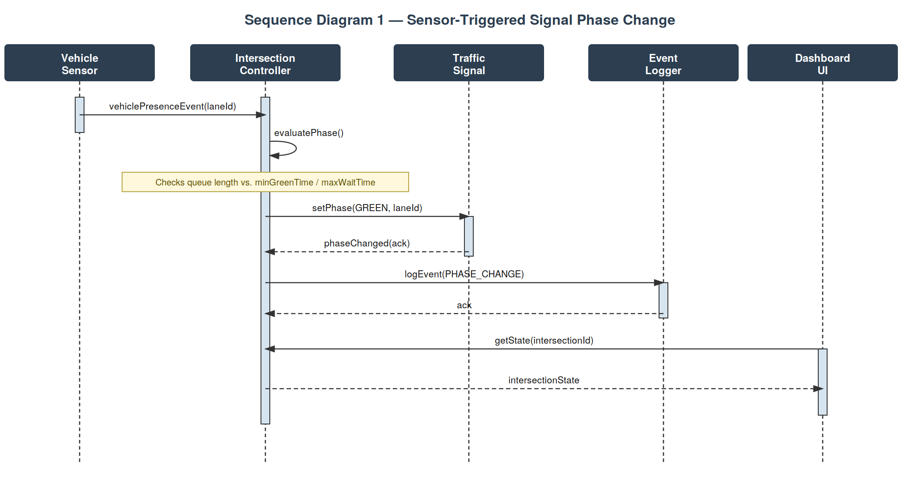
Figure 2 — Sequence Diagram 1: Sensor-Triggered Signal Phase Change.
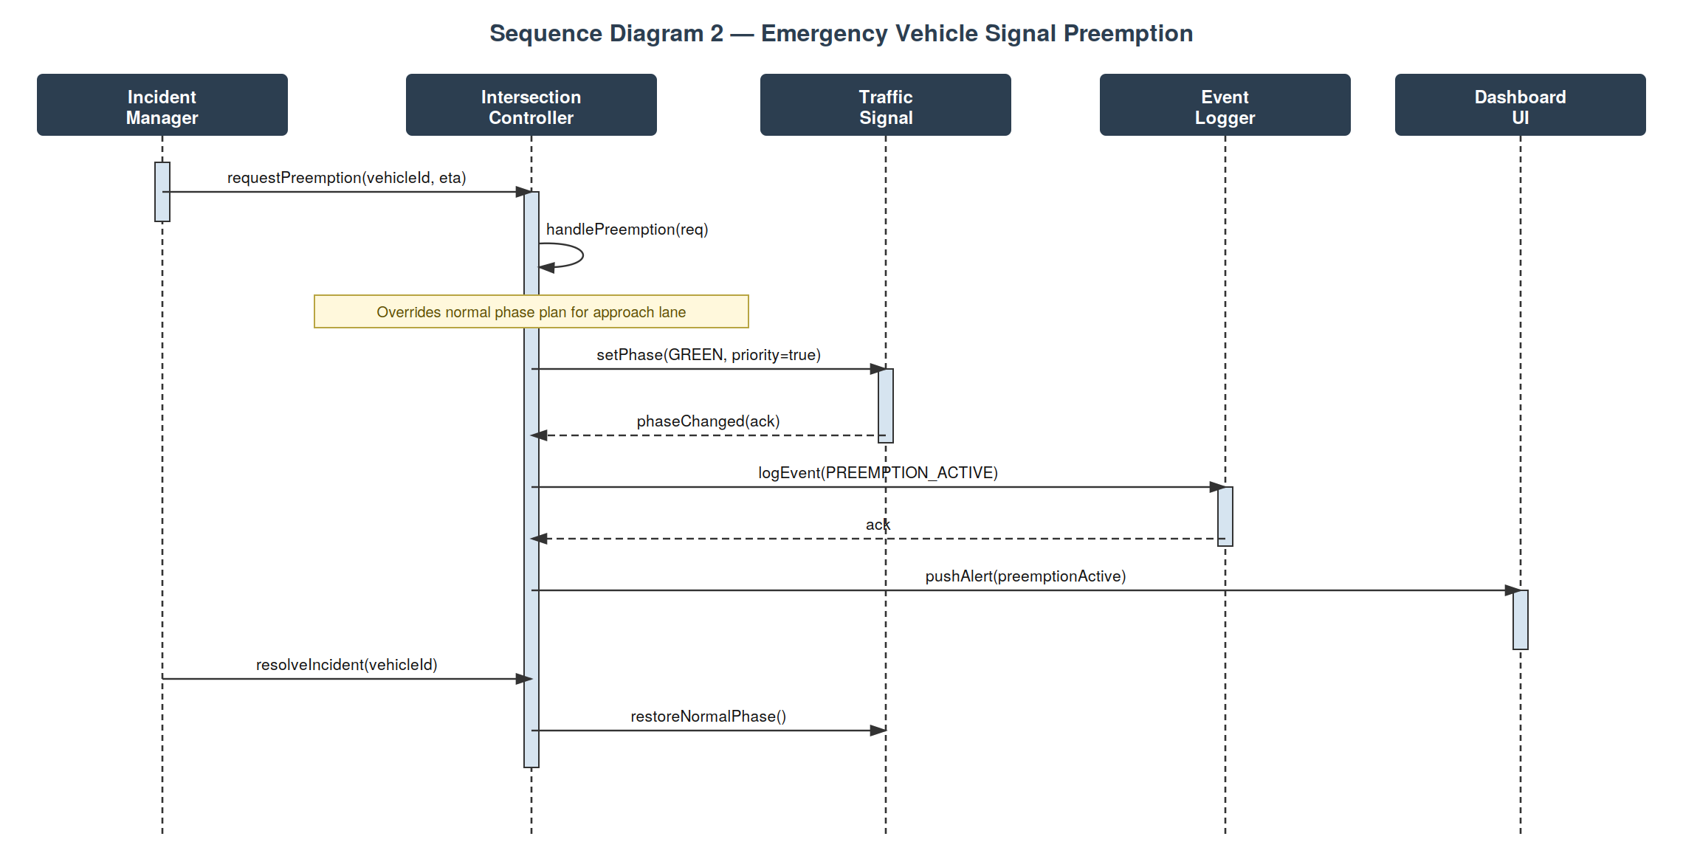
Figure 3 — Sequence Diagram 2: Emergency Vehicle Signal Preemption.

4.3 API Design
Interface definitions for the two primary externally-facing components:

Simulation Control API — Simulation Engine
- Endpoint: /simulation/start | Method: POST | Request: {topologyConfigId, tickRateMs} | Response: {status, simulationId}
- Endpoint: /simulation/stop | Method: POST | Request: {simulationId} | Response: {status}
- Errors: 400 Invalid topology config, 409 Simulation already running

Intersection State API — Intersection Controller
- Endpoint: /intersections/{id}/state | Method: GET | Response: {intersectionId, signals[], activePhase, queueLengths}
- Endpoint: /intersections/{id}/preempt | Method: POST | Request: {vehicleId, eta, priority} | Response: {status, phaseChangedAt}
- Errors: 404 Unknown intersection, 403 Unauthorized (missing operator role)

4.4 Error Handling, Logging & Monitoring
Standardized error responses are returned for all API calls with an error code and human-readable message; no sensitive configuration or credential data is written to logs. Monitoring tracks simulation tick latency, missed-tick count, preemption response time, and event-logger queue depth.

4.5 UX Design
The Dashboard UI presents a live map of simulated intersections with current signal phases and queue lengths, accessible font sizes and a high-contrast color-blind-safe palette for phase indicators, and a timeline view for replaying logged incidents and preemption events.

4.6 Open Issues & Next Steps
- Add reinforcement-learning-based adaptive phase timing as an alternative to the fixed phase-plan controller.
- Model multi-intersection coordination (green-wave / corridor timing) across adjacent controllers.
- Extend the Incident Manager to simulate accident-driven rerouting recommendations.

5. Appendices

5.1 Glossary
TMS, Intersection Controller, Phase, Preemption, ADR, TLS, STRIDE.

5.2 References
- IEEE 42010 — Systems and software engineering — Architecture description
- OWASP Top Ten / Threat Modeling guidance
- NIST SP 800-160 — Systems Security Engineering

5.3 Tools
Graphviz (UML class diagram), custom SVG rendering (sequence diagrams), draw.io, Swagger/OpenAPI.

