**Data Generation**

1. Relational Table Listing with sizes:

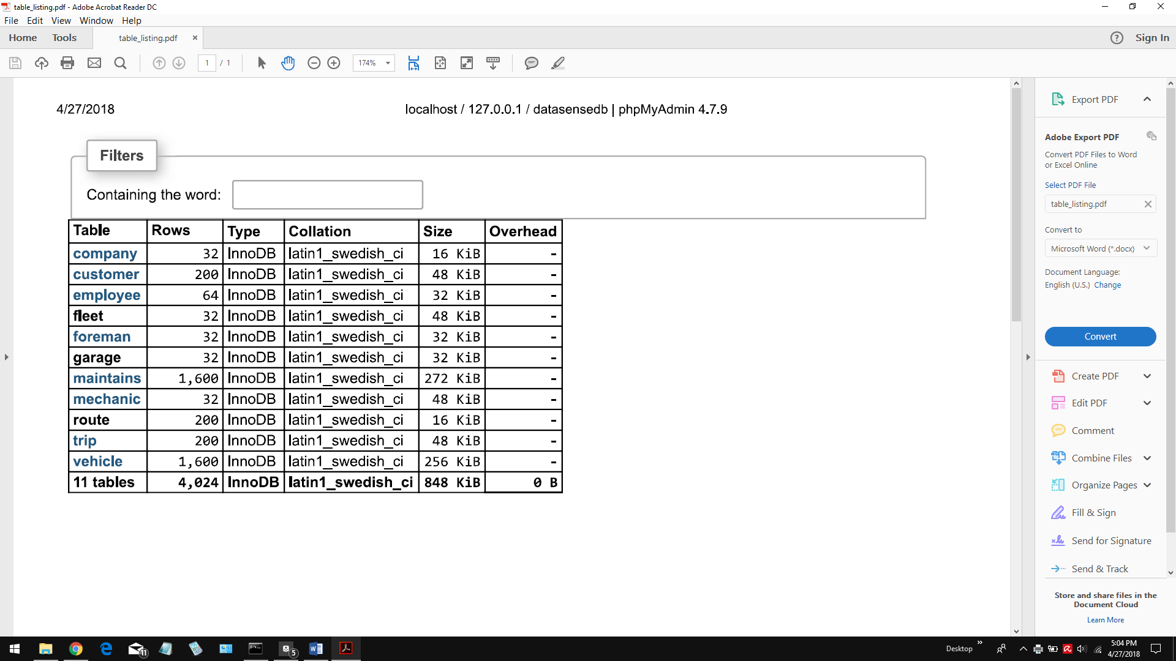

The tables COMPANY, EMPLOYEE, FLEET, FOREMAN, GARAGE, and MECHANIC all have sizes that are less than two hundred This is because having two hundred companies that provide driverless taxi services is unrealistic, especially in the *near* future. The number of employees (and the subclasses of EMPLOYEE) is less than two hundred as well, since there would only be a few employees per garage, and, in this case, was kept down to one foreman and one mechanic per garage to simplify the generation of the MAINTAINS table, and to make reading the database tuples to ensure they are valid easier.

2) The tables in the database were populated using a program written in Java. The program used a library called JDBC, found at <https://dev.mysql.com/downloads/connector/j/>, to connect and write to our database. As the program is too long and unsightly to include in a Word-formatted document, the program is attached to this project submission as a file named *DataSenseDbPopulator.java*.

*NOTE: to run this program, the JDBC library needs to be included in the classpath.*