DataSense Cohort: Entity-Relationship Dictionary

Entities:

Entity: Company

Description: A company that owns and operates autonomous Vehicles and offers taxi services using these Vehicles; each company has one or more Fleets of autonomous Vehicles

Primary Key: TaxID, CHAR(10), the tax identification number of the company

Attributes:

* Name, Varchar(32) , the name of the company
* Address, Varchar(300), the address (including state, city, and ZIP code) of the company

Entity: Customer

Description: A customer that purchases taxi services from a Company, each service issued being in the form of one Trip

Primary Key: CustomerID, CHAR(10), the unique identification number issued by a Company to each customer

Attributes:

* FirstName, Varchar(16), the first name of the Customer
* LastName, Varchar(24), the last name of the Customer
* Address, Varchar(300), the address (including state, city, and ZIP code) of the Customer
* PhoneNumber, CHAR(10), the phone number provided by the Customer

Entity: Fleet

Description: Contains a set of one or more Vehicles owned and operated by a Company; each fleet is kept and maintained in a Garage

Primary Key: FleetID, CHAR(10), the unique identification code issued to each fleet

Attributes:

* ROS, SMALLINT, the radius of service within which every Vehicle in its respective Fleet can operate

Entity: Garage

Description: A structure where each Vehicle in a Fleet is maintained and kept when not in use; a Garage has a set of Employees that perform maintenance and repairs on each car in its Fleet

Primary Key: GarageID, CHAR(10), the unique identification code assigned to the Garage

Attributes:

* Address, Varchar(300), the address (including state, city, and ZIP code) of the Garage
* VehicleCapacity, SMALLINT, the number of vehicles that a Garage can hold

Entity: Route

Description: A route from one endpoint (the origin) to another (the destination); each Route is part of a Trip and can be travelled one or more times on a Trip

Primary Key: TripID, CHAR(10), a unique identification code assigned to the Trip that the Route is associated with

Attributes:

* Endpoint1, Varchar(300), the address (including state, city, and ZIP code) representing first endpoint in the Route, which can be either an origin or a destination
* Endpoint2, Varchar(300), the address (including state, city, and ZIP code) representing second endpoint in the Route, which can be either an origin or a destination
* OriginFlag, BIT, stores the endpoint that is the origin on the current iteration over the Route (1 = Endpoint1, 2 = Endpoint2)
* DestinationFlag, BIT, stores the endpoint that is the destination on the current iteration over the Route (1 = Endpoint1, 2 = Endpoint 2)

Entity: Trip

Description: A traversal over a specified Route one or more times from one point to another; This is done in one Vehicle, and is purchased by one Customer

Primary Key: TripID, CHAR(10), a unique identification code assigned to each Trip

Attributes:

* NumberOfOccupants, SMALLINT, the number of occupants that will occupy the Vehicle assigned to the Trip
* NumberOfIterations, SMALLINT, the number of times the specified Route will be travelled
* TravelDistance, Integer, the number of miles traveled in total after all iterations over the specified Route have been completed
* TotalCost, Float, the cost of the trip after all iterations over the specified Route have been completed

Entity: Vehicle

Description: An autonomous vehicle in which one or more occupants can be transported from endpoint to endpoint; a Vehicle belongs to one Fleet and only one Fleet at a time

Primary Key: VIN, CHAR(17), the Vehicle Identification Number of the Vehicle

Attributes:

* Make, Varchar(30), the brand of the Vehicle
* Model, Varchar(30), the model of the Vehicle
* OccupantCapacity, SMALLINT, the number of occupants that can be seated inside the Vehicle

Classes:

Subclass: Foreman

Description: An Employee that supervises other Employees at a Garage

Subclass of: Employee

Attributes:

* LicenseNumber, CHAR(8), the Forman’s license identification number
* DateOfLastTraining, DATE, the date of the last training session the Foreman had

Entity: Employee

Description: An employee that works in a Garage; an Employee can only be a Foreman or a Mechanic

Primary Key: SSN, CHAR(9), the Social Security number of the Employee

Superclass of:

* Foreman
* Mechanic

Attributes:

* FirstName, Varchar(16), the first name of the Employee
* LastName, Varchar(24), the last name of the Employee
* DateOfHire, DATE, the date that the Employee was hired
* Salary, Integer, the annual salary of the Employee

Subclass: Mechanic

Description: An Employee that is employed at a Garage and performs maintenance and repairs on each Vehicle in a Fleet

Subclass of: Employee

Attributes:

* LicenseNumber, CHAR(8), the Mechanic’s mechanic license identification number
* InsuranceID, CHAR(10), the Mechanic’s liability insurance identification number

Relationships:

Relationship: Belongs

Description: Each Vehicle belongs to a certain Fleet and the Vehicle belongs to only one fleet at a time

Cardinality: 1:N

Relationship: Houses

Description: A Fleet is housed in a single Garage. The Vehicles are refueled and maintained here when they are not in transit

Cardinality: 1:N

Relationship: Maintains

Description: Mechanics perform maintenance and repairs on the Vehicles in the Garage

Cardinality: M:N

Relationship: Owns

Description: A Company owns, or possesses, a Fleet of Vehicles

Cardinality: 1:N

Relationship: Provides

Description: A Company provides the service of a Trip

Cardinality: 1:N

Relationship: Purchases

Description: A Customer purchases the taxi services from a Company in the form of one Trip

Cardinality: 1:N

Relationship: Supervises

Description: A Foreman supervises a group of Mechanics that work in the same Garage

Cardinality: 1:N

Relationship: Traverses

Description: A Trip will traverse- that is, it will travel the path of a Route

Cardinality: 1:1

Relationship: Uses

Description: A Company uses a Garage to house its Fleets

Cardinality: 1:N

Relationship: Works

Description: An Employee works at the company Garage

Cardinality: 1:N

Schema Dictionary: The DataSense Cohort

**Name:** Company

**Description:** A company that provides an Autonomous Vehicle taxi service

* **TaxID**: CHAR(10), unique tax identification number of the company. The primary key of each tuple
* **Name:** Varchar(32), name of the AV taxi company
* **Address:** Varchar(300), the address (including state, city, and ZIP code) of company

**Name:** Customer

**Description:** An individual that purchases taxi services from a Company, each service being issued in the form of one Trip

* **CustomerID:** CHAR(10), unique identification number issued by a Company to each customer. The primary key of each tuple
* **FirstName:** Varchar(16), the given name of the Customer
* **LastName:** Varchar(24), the surname of the Customer
* **Address:** Varchar(300), the address (including state, city, and ZIP code), provided by the Customer
* **PhoneNumber:** CHAR(10), the phone number provided by the Customer

**Name:** Employee

**Description:** An employee that works in a Garage; an Employee can only be a Foreman or a Mechanic

* **SSN:** CHAR(9), the Social Security number of the Employee. The primary key of each tuple.
* **Garage_ID:** CHAR(10), the unique identification code assigned to the Garage in which the employee works. Foreign key from GARAGE
* **FirstName:** Varchar(16), the given name of the Employee
* **LastName:** Varchar(24), the surname of the Employee
* **DateOfHire:** DATE, the date that the Employee was hired
* **Salary:** Integer, the annual salary of the Employee

**Name:** Fleet

**Description:** A grouping of one or more Vehicles owned and operated by a Company; each fleet is kept and maintained in a Garage

* **FleetID:** CHAR(10), the unique identification code issued to each fleet. The primary key of each tuple.
* **Company_TaxID:** CHAR(10), unique tax identification number of the company that owns the fleet. Foreign key from COMPANY.
* **Garage_ID:** CHAR(10), unique identification code assigned to the Garage that houses this fleet. Foreign key from GARAGE.
* **ROS:** SMALLINT, the radius of service within which every Vehicle in its respective Fleet can operate

**Name:** Foreman

**Description:**

* **SSN:** CHAR(9), the Social Security number of the Foreman. Foreign key from EMPLOYEE and primary key of each tuple.
* **LicenseNumber:** CHAR(8), the Forman’s license identification number
* **DateOfLastTraining:** DATE, the date of the last training session the Foreman attended

**Name:** Garage

**Description:** A structure where each Vehicle in a Fleet is maintained and kept when not in use; a Garage has a set of Employees that perform maintenance and repairs on each car in its Fleets

* **GarageID:** CHAR(10), unique identification code assigned to the Garage. The primary key of each tuple.
* **Company_TaxID:** CHAR(10), unique tax identification number of the company that runs the Garage. Foreign key from COMPANY.
* **Address:** Varchar(300), the address (including state, city, and ZIP code) of the Garage
* **VehicleCapacity:** SMALLINT, the number of vehicles that a Garage can hold

**Name:** Maintains

**Description:** Mechanics perform maintenance and repairs on the Vehicles in the Garage

* **Mech_SSN:** CHAR(9), the Social Security number of the Mechanic. Foreign key from MECHANIC, part of superkey with Vehicle_Vin, which makes up the primary key of each tuple.
* **Vehicle_Vin:** CHAR(17), the Vehicle Identification Number of the Vehicle. Foreign key from VEHICLE, part of superkey with Mech_SSN, which makes up the primary key of each tuple.

**Name:** Mechanic

**Description:** An Employee that is employed at a Garage and performs maintenance and repairs on each Vehicle in a Fleet

* **SSN:** CHAR(9), the Social Security number of the Mechanic. Foreign key from EMPLOYEE and primary key of each tuple.
* **Supervisor_SSN:** CHAR(9), the Social Security number of the Foreman that oversees this mechanic. Foreign key from FOREMAN.
* **LicenseNumber:**CHAR(8), the Forman’s license identification number
* **InsuranceID:** CHAR(10), the Mechanic’s liability insurance identification number

**Name:** Route

**Description:**

* **TripID:** CHAR(10), a unique identification code of the Trip that travelled this route. The primary key of each tuple and a foreign key from TRIP.
* **Endpoint1:** Varchar(300), the address (including state, city, and ZIP code) representing first endpoint in the Route, which can be either an origin or a destination
* **Endpoint2:** Varchar(300), the address (including state, city, and ZIP code) representing second endpoint in the Route, which can be either an origin or a destination
* **OriginFlag:** BIT, stores the endpoint that is the origin on the current iteration over the Route (0 = Endpoint1, 1 = Endpoint2)
* **DestinationFlag:** BIT, stores the endpoint that is the destination on the current iteration over the Route (0 = Endpoint1, 1 = Endpoint 2)

**Name:** Trip

**Description:** A traversal over a specified Route one or more times from one point to another; This is done in one Vehicle, and is purchased by one Customer

* **TripID:** CHAR(10), a unique identification code assigned to each Trip. The primary key of each tuple
* **Company_TaxID:** CHAR(10), unique tax identification number of the company that provided the Trip. Foreign key from COMPANY.
* **Cust_ID:** CHAR(10), unique identification number of the Customer that purchased this Trip. Foreign key from CUSTOMER
* **NumberOfOccupants:** SMALLINT, the number of occupants that will occupy the Vehicle assigned to the Trip
* **NumberOfIterations:**  SMALLINT, the number of times the specified Route will be travelled
* **TravelDistance:** Integer, the number of miles traveled in total after all iterations over the specified Route have been completed
* **TotalCost:** Float, the cost of the trip after all iterations over the specified Route have been completed

**Name:** Vehicle

**Description:** An autonomous vehicle in which one or more occupants can be transported from endpoint to endpoint; a Vehicle belongs to one Fleet and only one Fleet at a time

* **VIN:** CHAR(17), the Vehicle Identification Number of the Vehicle. The primary key of each tuple.
* **FleetID:** CHAR(10), the unique identification code issued to the Fleet to which this Vehicle is assigned. Foreign key from FLEET.
* **Make:** Varchar(30), the brand of the Vehicle
* **Model:** Varchar(30), the model of the Vehicle
* **OccupantCapacity:**  SMALLINT, the number of occupants that can be seated inside the Vehicle

DataSense ER Diagram

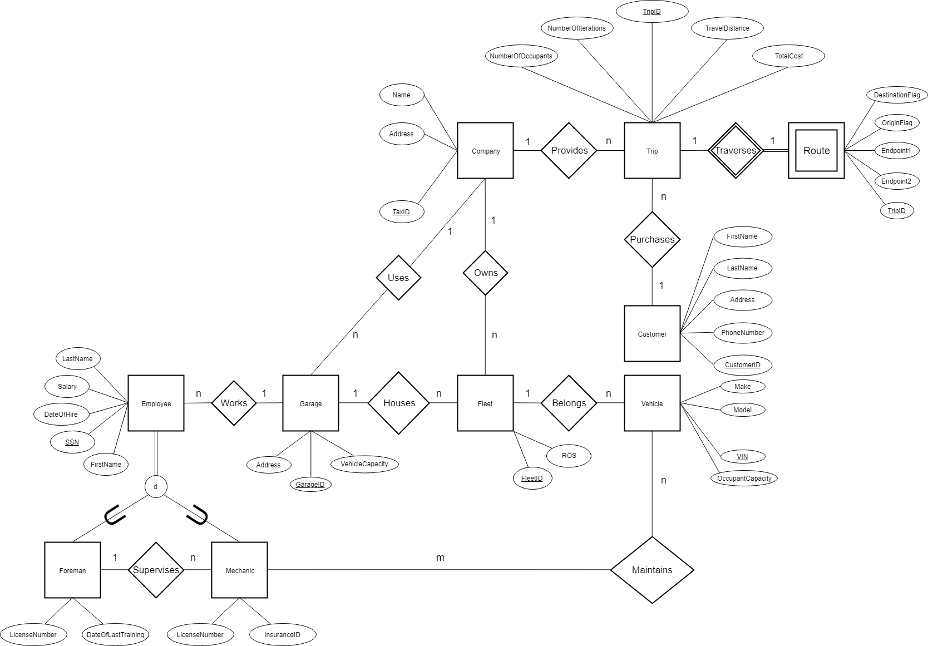

DataSense Schema Diagram

