COMP 305 - Assignment 3



Pedro Bento

Aaron Fernandes

# Table of contents

Contents

Table of contents 2

Version History 3

Detailed Game Description 4

Controls 4

Interface Sketch 4

Screen Descriptions 4

Character 4

Enemies 4

Scoring 5

Sound Index 5

Art/Multimedia Index 5

# Version History

<https://github.com/aagavin/305-3D-Game/commits/develop>

# Detailed Game Description

This is a first person shooter that takes place in on office. The office gets attacked by daleks. The player must defeat all the daleks

# Controls

The player will use the WASD keys to move the player. The mouse can be used to fire weapon and look around.

# Interface Sketch

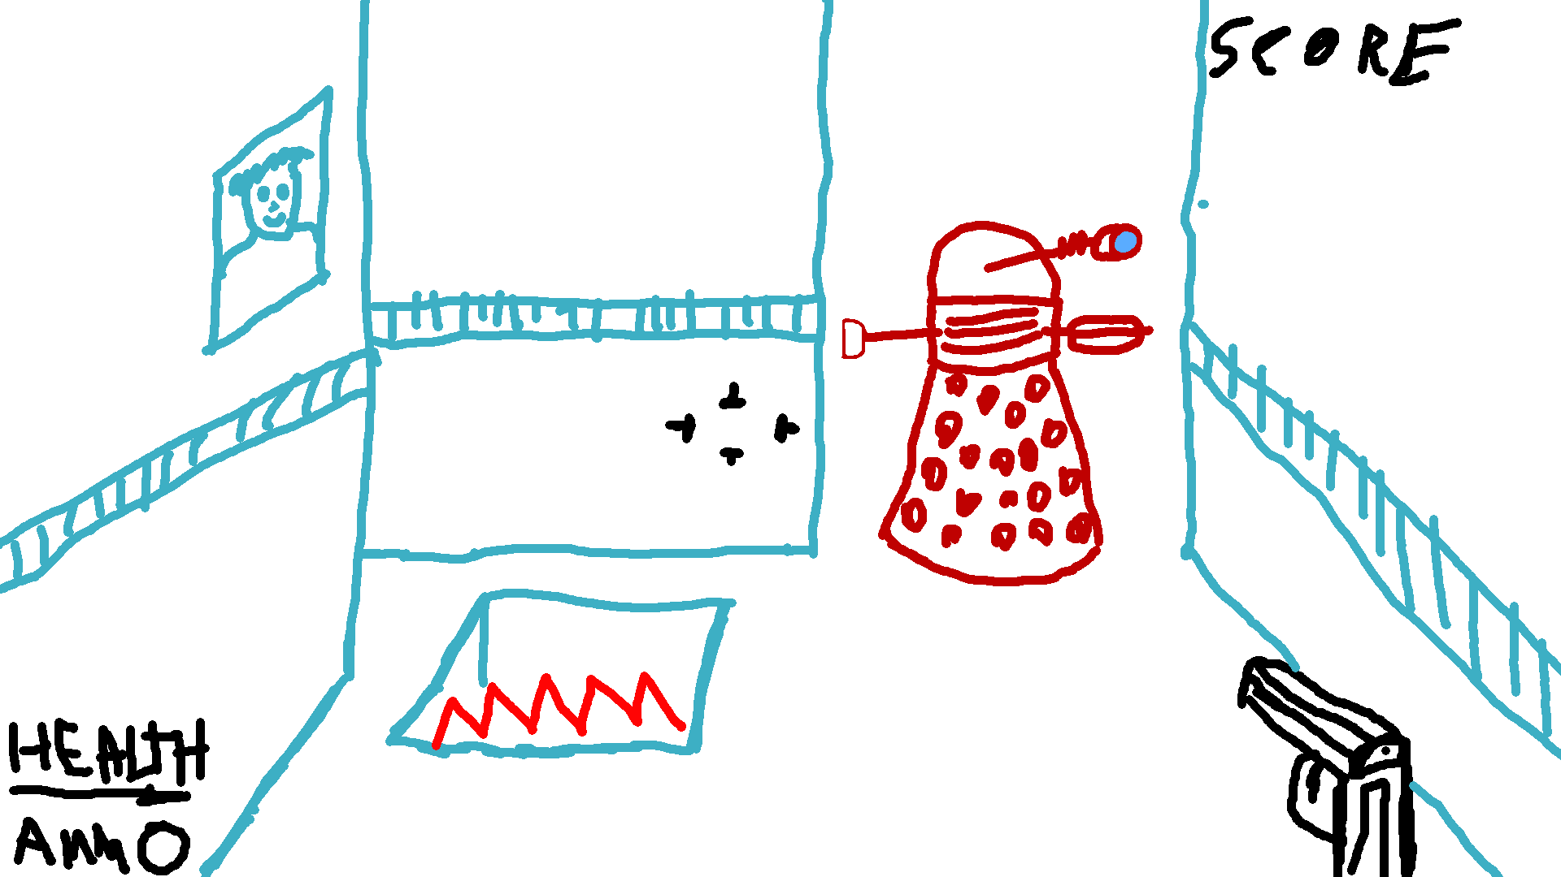

Interface Sketch

# Screen Descriptions

# Character

The Doctor has had his memory wiped so now he's an office worker. The player will use a sonic screwdriver the defeat the enemies described below.

# Enemies

Enemies include daleks that have taken over the office

# Scoring

The player needs uses a sonic screwdriver a defeat the enemies. The player gets 10 points for every enemy killed

# Sound Index

N/A

# Art/Multimedia Index

|  |  |  |  |  |
| --- | --- | --- | --- | --- |
| Name | Art | Source | License & Author | |
| Sonic screwdriver |  | http://www.blendswap.com/blends/view/52144 | Creative Commons Zero (Public Domain)  Author: "11th doctors sonic screwdriver" by *otacon* |
| Tardis |  | http://www.blendswap.com/blends/view/18597 | Creative Commons Zero (Public Domain)  Author: “Tardis” by *Alekkosinski* |
| Office Furniture |  | http://www.blendswap.com/blends/view/44775 | Creative Commons Attribution 3.0  Author: "Alcas Office Partition Wall Systems" by *exedesign* |
| Dalek |  | http://www.blendswap.com/blends/view/52144 | Creative Commons Attribution 3.0  Author: "Dalek v1.0" by *Benjee10* |