|  |  |
| --- | --- |
|  | SPARDELL |
|  |  |
| 12/5/2016 | More Fun on the inside |
|  | It started out as a headache. An everyday pain. But then there was blood. Pulled into your mind, you must destroy the source or be killed by the pain |

# Table of contents

Contents

Table of contents 1

Version history 2

Detailed Game Description 3

Controls 3

Interface Sketch 3

Level 1 3

Level 2 3

Level 3 3

Screen Descriptions 3

Game World 3

Levels 3

Characters 3

Enemies 3

Weapons 3

Scoring 4

Level 1 4

Level 2 4

Level 3 4

Sound Index 4

Art / Multimedia Index 4

# Version history

# Detailed Game Description

First Person Shooter, with an artstyle inspired by horror properties like HellRaiser and Painkiller. The player will navigate three levels with shared mechanics, but with different objectives in each one. Each level is designed differently in order to provide greater variety of challenge. The story setting up the game is that the player character awakes in what they recognize as their work office, but heavily distorted and bereft of humans, being instead populated with what they can only call demons. The player escapes the office into a parking lot, where they must find their car in order to try and escape. Finally, the player must confront an unnaturally darkened apartment building floor, grown labyrinthine and incredibly dangerous, to finally find a way out of their plight.

# Controls

Standard WASD + mouse player controls.

# Interface Sketch

## Level 1

sdf

## Level 2

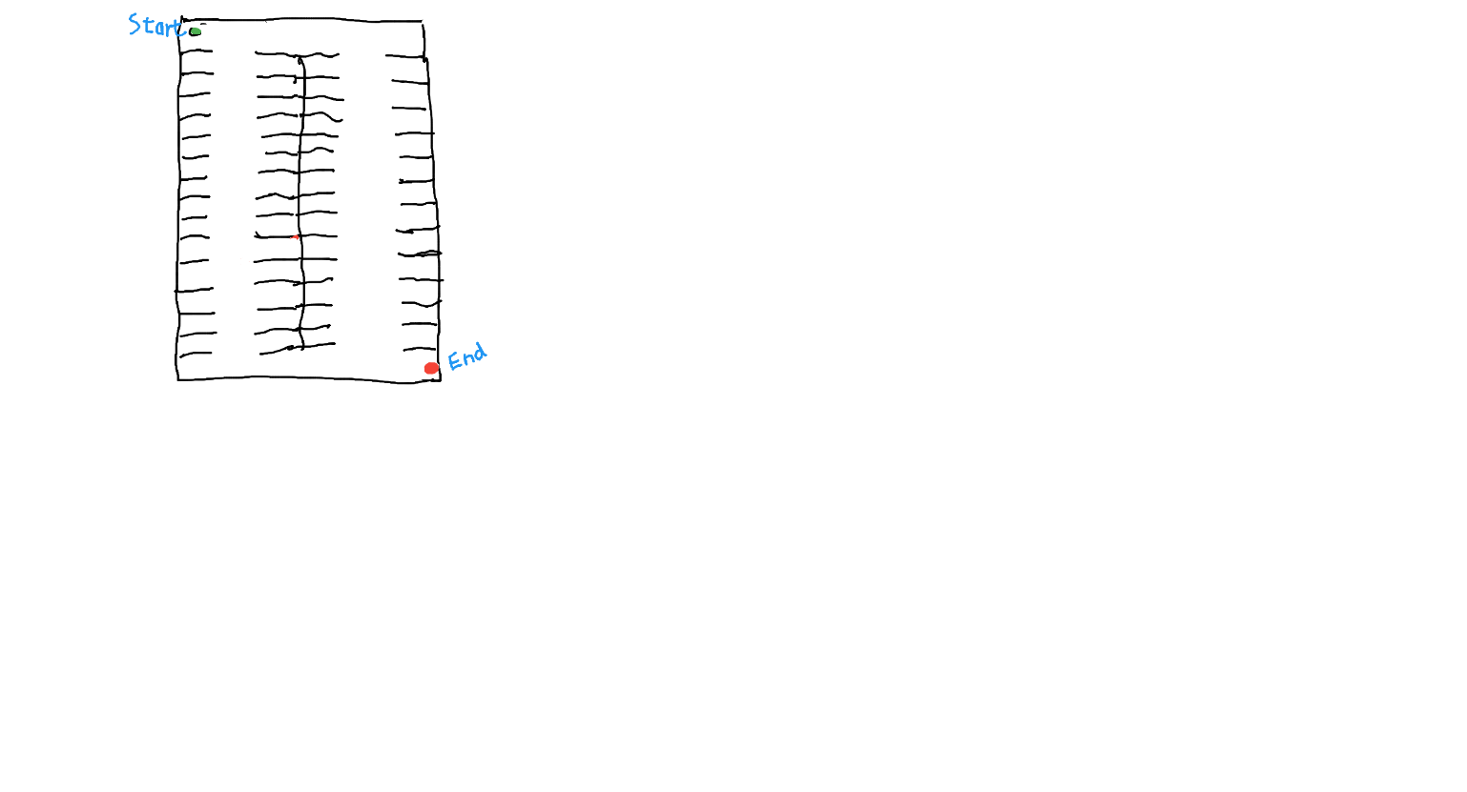

## Level 3

sdf

# Screen Descriptions

TBD

# Levels

The first level takes place in a ruined, oddly proportioned office. Second level is a long, long parking lot. Third level is a labyrinthine apartment building.

# Characters

Player character – Ageless-Faceless-Gender-Neutral-Culturally-Ambiguous-Adventure-Person

# Enemies

Demon – dark, shadowy forms with glowing red eyes, intent on nothing but the misery of their erstwhile victim.

# Weapons

Shotgun – a double-barreled shotgun that somehow does not require reloading.

Pistol – a heavy

# Scoring

## Level 1

Player gets points for enemies killed, a bonus for accuracy, a bonus for time, and a bonus for not taking damage.

## Level 2

Same as before, time bonus is much more detailed.

## Level 3

Same as Level 1, no points for kills

# Sound Index

|  |  |  |
| --- | --- | --- |
| Name | File | Source |
|  |  |  |
|  |  |  |

# Art / Multimedia Index

|  |  |  |
| --- | --- | --- |
| Name | Image | Source |
| Dementor |  |  |
|  |  |  |