Dockerized Full Stack Application
Node.js and Express frontend with a Flask backend
Project report and evidence | Aryan Amar Ghadge

Project overview
This project packages a small To-Do submission application into two Docker services. The Express frontend displays a form and forwards submitted item data to a Flask endpoint. Docker Compose builds and runs both services on one network, and the frontend can reach the backend by its Compose service name.

Project structure
Docker_aryan/
backend/ - Flask application, dependency list, and Dockerfile
frontend/ - Express application, package manifest, and Dockerfile
docker-compose.yaml - service builds, ports, health check, and network
screenshots/ - terminal and browser evidence
.gitignore - excludes local and generated files

Application behavior
The frontend is available at http://localhost:3000. It collects an item name and description, sends JSON to its /submit route, and displays the backend success or error response. Flask validates that both fields are present and returns a JSON response. The backend health endpoint is used by Compose to confirm that the service is ready.

Build and run
docker --version
Confirm Docker is available in Ubuntu on WSL.
docker compose up --build
Build both images and start the frontend and backend services.
docker compose ps
Check that both services are running and the backend health check passes.
http://localhost:3000
Open the frontend in a browser and submit a test item.

Container configuration
The frontend container uses Node.js and Express and publishes port 3000. The backend container uses Python and Flask and publishes port 5000. Compose places both services on a shared bridge network, sets BACKEND_URL to http://backend:5000, and waits for the Flask health check before starting the frontend.

Published project links
- GitHub source repository: https://github.com/aaghadge09/Docker_aryan
- Docker Hub frontend image: https://hub.docker.com/r/aaghadge09/docker_aryan-frontend
- Docker Hub backend image: https://hub.docker.com/r/aaghadge09/docker_aryan-backend

Image publishing commands
docker login -u aaghadge09
docker tag docker_aryan-frontend:latest aaghadge09/docker_aryan-frontend:latest
docker tag docker_aryan-backend:latest aaghadge09/docker_aryan-backend:latest
docker push aaghadge09/docker_aryan-frontend:latest
docker push aaghadge09/docker_aryan-backend:latest

Screenshots and evidence
The screenshots below document the project setup, browser submission, container status, and published Docker Hub images.

Docker setup and build activity
The terminal shows Docker and Compose versions, the project folder structure, and the start of the Compose image build.
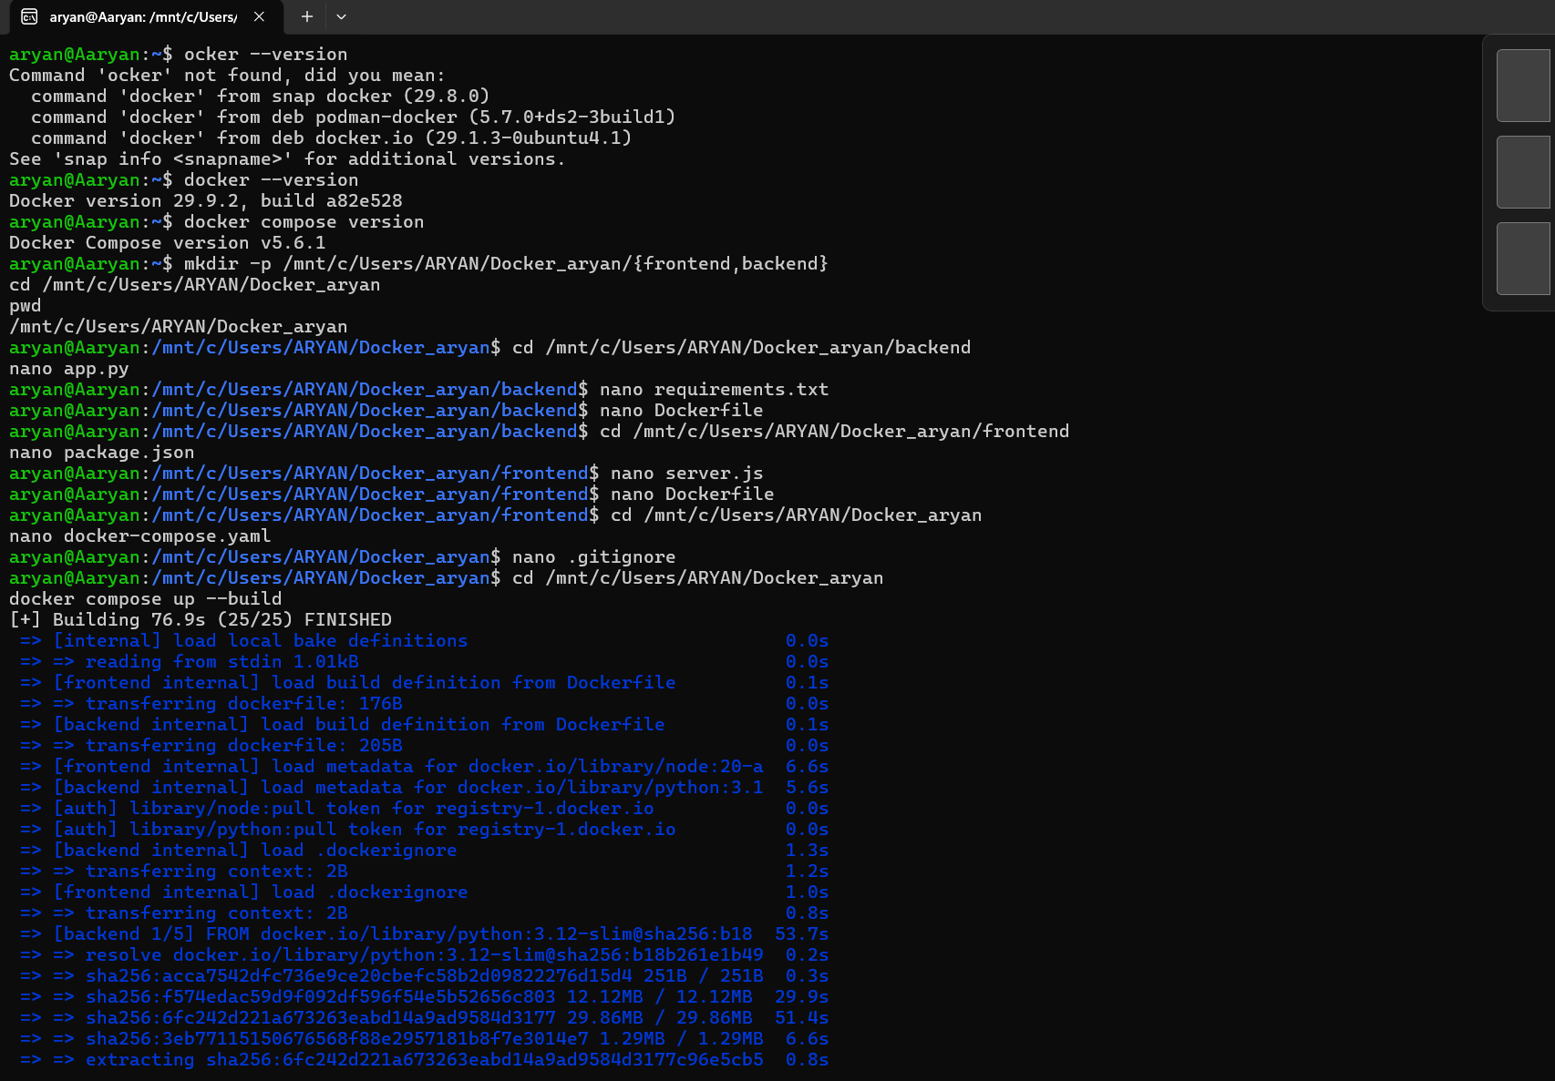

Flask backend health checks
The backend responds successfully to repeated GET /health requests, confirming that the Flask service is running.
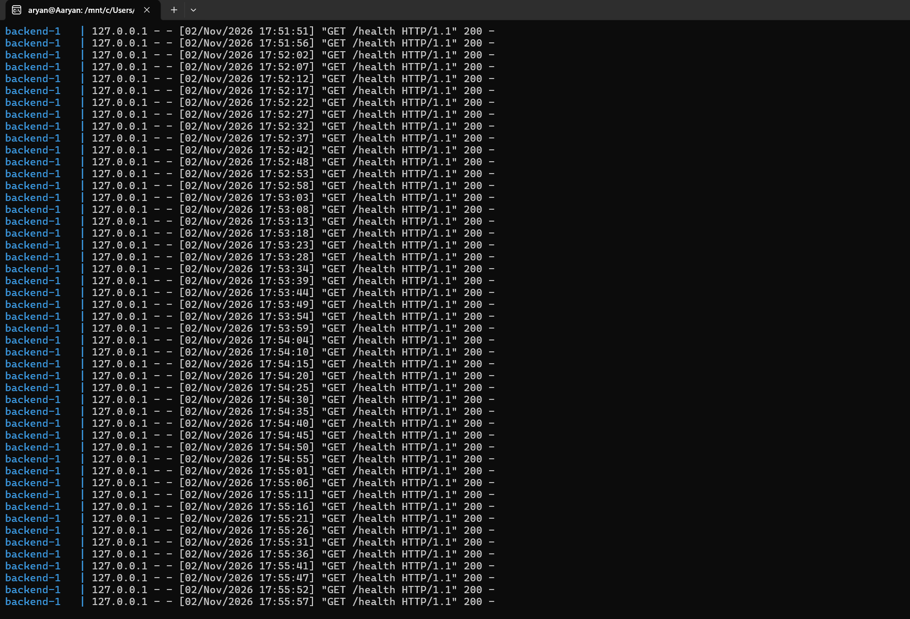

Frontend form submission
The browser shows the To-Do form and the “Data submitted successfully” response after submitting a test item.
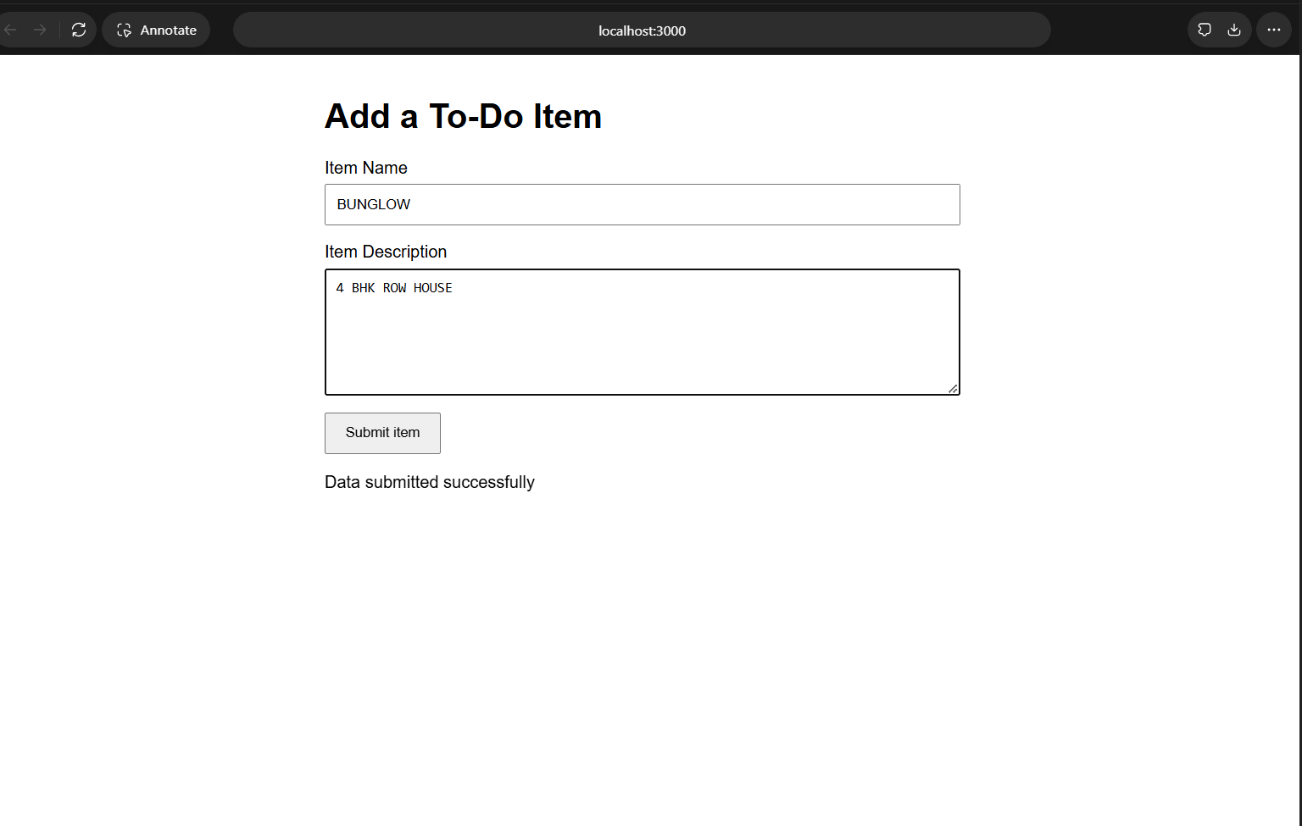

Compose service status
The Compose status output shows the frontend and backend containers running, with the backend marked healthy and ports 3000 and 5000 published.
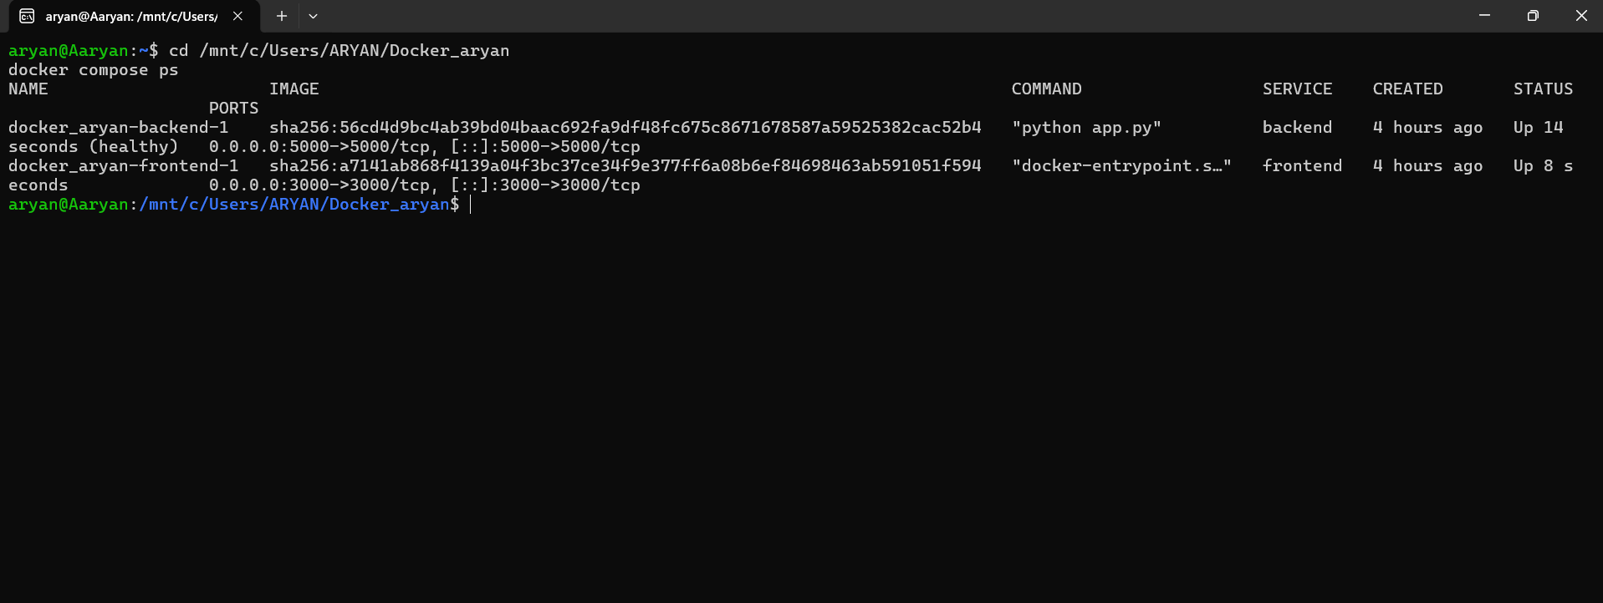

Docker Hub image repositories
Docker Hub lists the public docker_aryan-frontend and docker_aryan-backend image repositories under the aaghadge09 account.
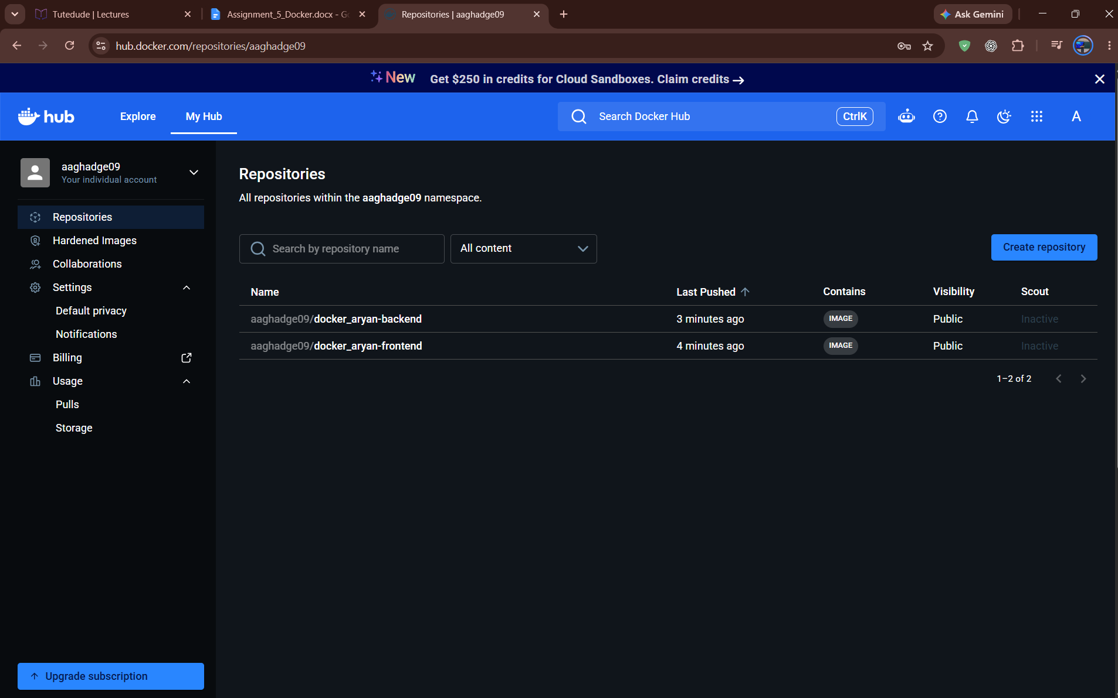

Run the project again
From Ubuntu/WSL, open the project directory and start the services with:
cd /mnt/c/Users/ARYAN/Docker_aryan
docker compose up --build
Keep the terminal open while using the application. Open http://localhost:3000 in a browser. Stop the containers with Ctrl+C in the Compose terminal.

