Short Message Service (SMS) using Visual C# 2005, Visual Basic Express
This paper describes object-oriented access to the Short Message Service (SMS). SMS is one of the GSM Data Services provided by a Network Operator. It enables you to send and receive Short Messages
The program was tested using the Nokia PC Suite and the Nokia 8250. The 8250 then functions as a modem for your PC Communications Applications, enabling you to send and receive SMS. The program should work with any phones that come with modem drivers. The latest driver (assembly ver 1.0.2221.23870 updated 30 Jan 2006) has also been tested with the Samsung SGH-E730.
Although the example is given in C#, with a little translation, you should get it working with Visual Basic Express or Visual Basic 2005
Download SMS folder EmantSMS2005.zip 28kB. Extract the entire folder to your PC

Run the SMS Demo Program
Before running the demo program, you must
- install the modem driver software that comes with your mobile phone. Read your phone manual or visit the phone manufacturer's website for installation information
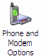
- connect your phone to the computer
- know the comm port number your phone modem is connected to. Goto the control panel and click on Modem and Phone Options
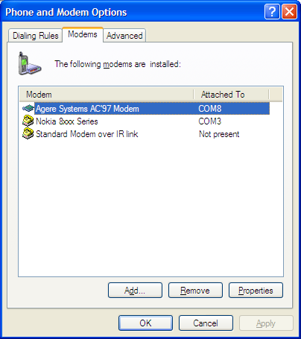
Microsoft Visual C# .NET 2005 must already be installed. Copy the entire Sms folder to your PC.
Our screenshots are taken from a Windows XP computer.

Check out your system
- From the SMS folder, browse to TestSMS\bin\Release. Run TestSMS.exe by clicking on the program.
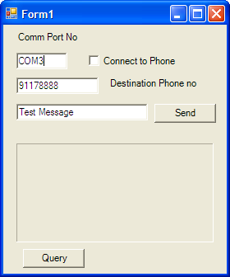
- Set the Comm Port No to the one that is indicated for your phone modem. Click on the Connect to Phone check box to connect to the phone. Your phone should reply with some status in the message box. Click on Query button and your phone should respond with its identification.
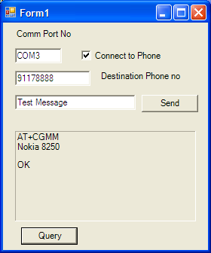
- Send a message to another phone by keying in your message and phone number and then click the Send button.
- To receive an SMS, just send a message to your phone that is connected to the computer. The message should appear in the message box.
- If you have successfully send and receive SMS, we can now analyse the C# program.

Analyse Source Code
Goto the TestSMS folder and start the IDE by clicking on the TestSMS solution.

SMS Component
The SMS component enables you to send and receive Short Messages using a GSM modem or a phone that has modem function.

Program 1.1 SMS Source Code
private void checkBox1_CheckedChanged(object sender, System.EventArgs e)
{
if (checkBox1.Checked)
sms1.Open(textBox3.Text);
else
sms1.Close();
}
private void button2_Click(object sender, System.EventArgs e)
{
sms1.Query();
}
private void button1_Click(object sender, System.EventArgs e)
{
sms1.Send(textBox1.Text, textBox2.Text);
}
private void sms1_onReceived(object sender, EventArgs e)
{
Control.CheckForIllegalCrossThreadCalls = false;
label1.Text = sms1.sresult;
}

Open method
sms1.Open(textBox3.Text);
Opens the connection to the GSM modem.
bool Open(string Portnum)
Parameters
Portnum - The comm port number the GSM modem is connected to.
Return Value
true if open is successful otherwise false

Close method
sms1.Close();
Close the GSM modem connection.
void Close()

Query method
sms1.Query();
Used to identify the GSM modem. When the GSM replies, the onReceived event occurs and the identification string is assigned to the sresult property.
void Query()

Send method
sms1.Send(textBox1.Text, textBox2.Text);
The Send method is used to send an SMS to another phone. Two strings are passed, one for the message and the other for the phone number.
void Send(string smsg, string sphone)
Parameters
smsg - message string that is sent to the destination phone
sphone - string of the phone number of the destination phone

sresult Property
The message or status from the modem is returned as a string and assigned to the sresult property.
public string sresult {get;}
Property Value
string of the message or status

onReceived Event
The event occurs when the modem receives an SMS message or reports a status or acknowledgement. The information is stored in the sresult property.
private void sms1_onReceived(object sender, EventArgs e)
{
Control.CheckForIllegalCrossThreadCalls = false;
label1.Text = sms1.sresult;
}
This CheckForIllegalCrossThreadCalls property is new in the .NET Framework version 2.0. Gets or sets a value indicating whether to catch calls on the wrong thread that access a control's Handle property. If left as default true, you will get the following runtime error.
"Cross-thread operation not valid: Control label1 accessed from a thread other than the thread it was created on."
Control.CheckForIllegalCrossThreadCalls = false;
Setting it false is a quick fix.

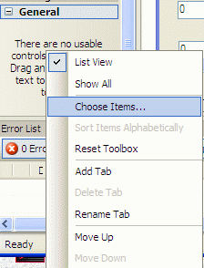
Install SMS Component
To integrate the SMS Component in Visual Studio .NET:
- Select the General tab in the Toolbox
- Right-click on the Toolbox background
- Select Choose Items...
- On the Choose Toolbox Items Dialog, select the NET Framework Components tab
- Press the Browse Button
- Locate and select the Emantsms.dll assembly in the SMS folder
- Click OK

NOKIA GSM AT COMMAND SET

Call Control

ATA Answer Command
ATD Dial Command
ATH Hang Up Call
ATL Monitor Speaker Loudness
ATM Monitor Speaker Mode
ATO Go On-Line
ATP Set Pulse Dial as Default
ATT Set Tone Dial as Default
AT+CSTA Select Type of Address
AT+CRC Cellular Result Codes

Data Card Control Commands

ATI Identification
ATS Select an S-register
ATZ Recall Stored Profile
AT&F Restore Factory Settings
AT&V View Active Configuration
AT&W Store Parameters in Given Profile
AT&Y Select Set as s Powerup Option
AT+CLCK Facility Lock Command
AT+COLP Connected Line Identification Presentation
AT+GCAP Request Complete Capabilities List
AT+GMI Request Manufacturer Identification
AT+GMM Request Model Identification
AT+GMR Request Revision Identification
AT+GSN Request Product Serial Number Identification

Phone Control Commands

AT+CBC Battery Charge
AT+CGMI Request Manufacturer Identification
AT+CGMM Request Model Identification
AT+CGMR Request Revision Identification
AT+CGSN Request Product Serial Number Identification
AT+CMEE Report Mobile Equipment Error
AT+CPAS Phone Activity Status
AT+CPBF Find Phone Book Entries
AT+CPBR Read Phone Book Entry
AT+CPBS Select Phone Book Memory Storage
AT+CPBW Write Phone Book Entry
AT+CSCS Select TE Character Set
AT+CSQ Signal Quality

Computer Data Card Interface Commands

ATE Command Echo
ATQ Result Code Suppression
ATV Define Response Format
ATX Response Range Selection
AT&C Define DCD Usage
AT&D Define DTR Usage
AT&K Select Flow Control
AT&Q Define Communications Mode Option
AT&S Define DSR Option
AT+ICF DTE-DCE Character Framing
AT+IFC DTE-DCE Local Flow Control
AT+IPR Fixed DTE Rate

Service
AT+CLIP Calling Line Identification Presentation
AT+CR Service Reporting Control
AT+DR Data Compression Reporting
AT+ILRR DTE-DCE Local Rate Reporting

Network Communication Parameter Commands

ATB Communications Standard Option
AT+CBST Select Bearer Service Type
AT+CEER Extended Error Report
AT+CRLP Radio Link Protocol
AT+DS Data Compression

Miscellaneous Commands

A/ Re-Execute Command Line
AT? Command Help
AT*C Start SMS Interpreter
AT*T Enter SMS Block Mode Protocol
AT*V Activate V.25bis Mode
AT*NOKIATEST Test Command
AT+CESP Enter SMS Block Mode Protocol

SMS Commands SMS Text Mode

AT+CSMS Select Message Service
AT+CPMS Preferred Message Storage
AT+CMGF Message Format
AT+CSCA Service Centre Address
AT+CSMP Set Text Mode Parameters
AT+CSDH Show Text Mode Parameters
AT+CSCB Select Cell Broadcast Message Types
AT+CSAS Save Settings
AT+CRES Restore Settings
AT+CNMI New Message Indications to TE
AT+CMGL List Messages
AT+CMGR Read Message
AT+CMGS Send Message
AT+CMSS Send Message from Storage
AT+CMGW Write Message to Memory
AT+CMGD Delete Message

SMS PDU Mode

AT+CMGL List Messages
AT+CMGR Read Message
AT+CMGS Send Message
AT+CMGW Write Message to Memory

