

Applewood
Gilkey Creek Rehabilitation Project

Water Quality Assessment
2010

Produced by
The Flint River Watershed Coalition

Executive Summary

During the summer and fall of 2007, a project to protect the Mott Applewood Estate from flooding and enhance water quality and wildlife habitat in Gilkey Creek was carried out in the reach encompassed by the estate. This stream rehabilitation project involved excavating a new stream bed and contouring stream banks and the flood plain to correct hydrological problems caused by channelization. A stormwater detention pond and wetland were constructed next to the creek, and rapids, dams, pools and other types of aquatic habitat were created in the new channel. Soil erosion and sedimentation control measures were carefully employed throughout construction to prevent water pollution in the creek.

Flooding was exacerbated at Applewood by upstream commercial and residential development, mostly in the City of Burton, which increased the area of upstream impervious surfaces and volume of stormwater captured by them. Upstream stormwater is rapidly directed to Gilkey Creek through enclosed storm sewers and open drains. More recent upstream development includes the use of retention basins to slow stormwater flow to prevent flooding.

In the summer and fall of 2007, an initial study of the impact of the stream rehabilitation project on water quality was done while it was under construction. Samples were collected from the creek upstream and downstream of the project, and water quality index scores were calculated from sample test results. This was done during periods of dry and wet weather to evaluate the impact of stormwater runoff and stream bank erosion during high flows on water quality. A biological survey was also done upstream and downstream of the project for assessing longer term water quality.

No substantial degradation in water quality was observed, and no correlation between rainfall amount and water quality was found.

Follow up studies were done in 2008, 2009, and 2010; and monitoring was also done within Applewood during these years.

In 2010, the water quality, as measured by chemical and physical testing, was typically good at all locations and, as measured by biological analysis, fair and good at Applewood and Kearsley Park. However, the biological analysis rating was poor and fair at Court Street.

Introduction

From May to September 2010, the Flint River Watershed Coalition monitored water quality in Gilkey Creek, both upstream and downstream of, and also within, the Mott Applewood Estate. Chemical, physical and biological methods were used to assess the impact of a stream rehabilitation project done at Applewood in 2007 for preventing flooding at the estate and improving water quality and wildlife habitat in the creek. The project involved excavating a new channel and contouring the stream banks and floodplain. Habitat was improved by creating rapids, dams, and pools and placing tree roots in the stream. A detention pond for stormwater from the estate was excavated, and a wetland for capturing and treating stormwater from a Mott Community College parking lot was created.

Sampling Locations

Samples were collected at sites upstream and downstream of the stream rehabilitation project, as well as within it.

For the chemical/physical survey, the upstream site was located at the downstream side of the bridge at the Mott Community College parking ramp next to Applewood and the downstream site was located immediately downstream of the Kearsley Park Boulevard bridge (in Kearsley Park). The site in Applewood was located south of the visitor parking lot.

For the biological survey, the upstream site was located immediately upstream of the Court Street bridge in Burroughs Park and the downstream site was located immediately downstream of the Kearsley Park Boulevard bridge (in Kearsley Park). The site in Applewood was located south of the visitor parking lot.

Sampling and Measurement Methods

Grab samples were dipped from Gilkey Creek and routinely tested for: ammonia, alkalinity, color, conductivity, dissolved solids, hardness, pH, ortho-phosphate, nitrate, suspended solids, and turbidity. Dissolved oxygen and temperature were also routinely measured insitu with a probe. A water quality index score was calculated from the test results with a method developed by the National Sanitation Foundation (NSF) and an online calculator at http://www.water-research.net/watrqualindex/index.htm.

Testing was done with the following Hach equipment and methods:

Device | Parameter | Method |  | Range
Device | Parameter | Description | # | Range
HQ30d Dissolved Oxygen Meter and LDO101 IntelliCAL Probe. | Dissolved Oxygen | Electrometric
HQ30d Dissolved Oxygen Meter and LDO101 IntelliCAL Probe. | Temperature | Electrometric
sensION1 pH Meter | pH | Electrometric |  | 0-14 S.U.
sensION5  Conductivity Meter | Conductivity | Electrometric
sensION5  Conductivity Meter | Dissolved Solids | Electrometric
DR/890 Colorimeter | Ammonia | Salicylate, Colorimetric | 8155 | 0-0.50 mg/L
DR/890 Colorimeter | Color, True & Apparent | Photometric | 8025 | 0-500 Pt/Co Units
DR/890 Colorimeter | Nitrate | Cadmium Reduction, Colorimetric | 8039 | 0-30.0 mg/L
DR/890 Colorimeter | Phosphate | Ascorbic Acid, Colorimetric | 8048 | 0-2.50 mg/L
DR/890 Colorimeter | Suspended Solids | Photometric | 8006 | 0-750 mg/L
DR/890 Colorimeter | Turbidity | Absorptometric | 8237 | 0-1000 FAU
Digital Titrator | Alkalinity, Total | Sulfuric Acid, Volumetric | 8203 | 10-4000 mg/L
Digital Titrator | Hardness, Total | EDTA, Volumetric | 8213 | 10-4000 mg/L

Sampling was done during periods of dry and wet weather, and on-line precipitation data for Flint was recorded. In addition, water velocity was measured in the creek with a Global Water FP201 Flow Probe.
Macroinvertebrate organisms were also collected from various types of habitat in Gilley Creek, which were classified according to their pollution tolerance. The relative abundance of tolerant and intolerant organisms was determined for assessing water quality.

Findings

NSF water quality scores are rated, as follows:

Score | Rating
90-100 | Excellent
70-89 | Good
50-69 | Medium
25-49 | Bad
0-24 | Very Bad

The scores ranged from 74 to 81upstream and 65 to 71 downstream, as follows:

Date | Upstream |  | Downstream
Date | Score | Rating | Score | Rating
05/28/10 | 81 | Good | 65 | Medium
06/20/10 | 74 | Good | 66 | Medium
07/11/10 | 77 | Good | 70 | Good
08/16/10 | 77 | Good | 71 | Good
Average | 77 ± 3 | Good | 68 ± 3 | Medium

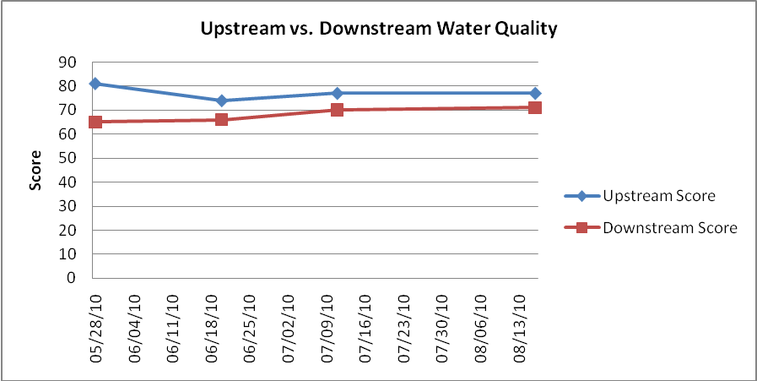

The scores ranged from 65 to 85 within Applewood, as follows:

Date | Water Quality Score | Water Quality Rating
05/23/10 | 74 | Good
06/07/10 | 79 | Good
07/13/10 | 85 | Good
08/18/10 | 69 | Medium
09/05/10 | 65 | Medium
Average | 74 ± 8 | Good

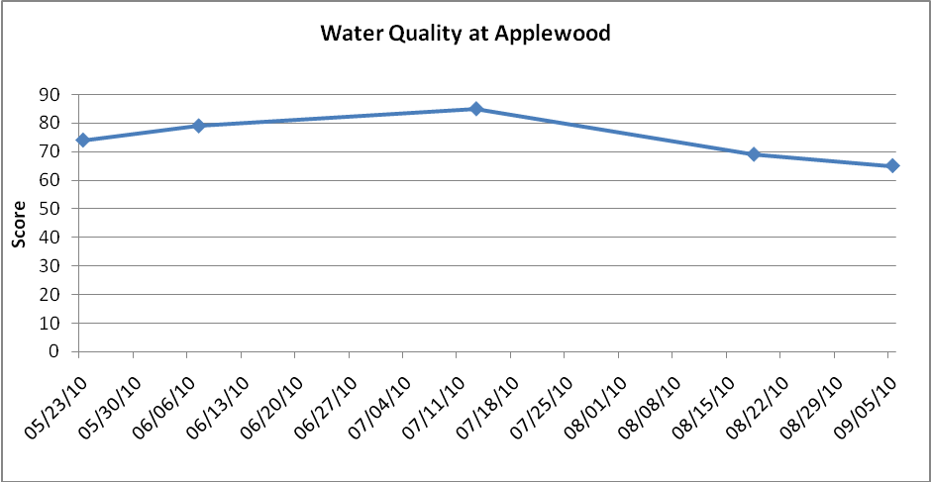

The comparative upstream and downstream turbidity and suspended solids concentrations were as follows:

Date | Turbidity |  |  | Suspended Solids
Date | Upstream | Downstream | Difference | Upstream | Downstream | Difference
Date | NTU | NTU | % | mg/L | mg/L | %
05/28/10 | 18 | 10 | -44 | 13 | 28 | 115
06/20/10 | 18 | 11 | -39 | 10 | 11 | 10
07/09/10 | 34 | 27 | -21 | 23 | 22 | -4
07/11/10 | 16 | 8 | -50 | 6 | 7 | 17
07/16/10 | 54 | 48 | -11 | 36 | 37 | 3
08/16/10 | 14 | 9 | -36 | 6 | 8 | 33
Average | 26 ± 16 | 19 ± 16 | -33 ± 15 | 16 ± 12 | 19 ± 12 | 29 ± 44

Water quality scores based on biological analyses are rated, as follows:

Score | Rating
>48 | Excellent
34-48 | Good
19-33.9 | Fair
<19 | Poor

The scores determined by biological analyses were as follows:

Court Street |  |  | Applewood |  |  | Kearsley Park
Date | Score | Rating | Date | Score | Rating | Date | Score | Rating
04/29/10 | 12.5 | Poor | 04/29/10 | 19.4 | Fair | 04/29/10 | 32.9 | Fair
10/06/10 | 29.4 | Fair | 10/27/10 | 36.2 | Good | 10/27/10 | 37.5 | Good

Discussion

The stream rehabilitation project caused no substantial degradation or improvement of downstream water quality in Gilkey Creek in Kearsley Park. However, the water quality was typically a little better upstream of the project.

On July 18th, a very high dissolved oxygen concentration was observed at the downstream location, apparently caused by excessive filamentous algal growth in the concrete flume in Kearsley Park, which is almost completely exposed to the sun. And on September 15th, a very high dissolved oxygen concentration was observed in Applewood, apparently also caused by excessive filamentous algal growth, in the new channel, which is also almost completely exposed to the sun. In both cases, gas bubbles were observed in the water and the water quality rating was only medium, due to the high dissolved oxygen concentrations. The upstream location is just downstream from a lengthy shaded stream reach extending from Burton trough Flint where such excessive dissolved oxygen concentrations have not been observed.

Sampling was done during periods of both dry and wet weather to evaluate the effect of stormwater runoff and stream bank erosion during high flows. The alkalinity and hardness measurements indicated that the creek had higher amounts of groundwater in it during low flow conditions following prolonged periods of dry weather and higher amounts of rainwater in it during high flow conditions following storms.

In addition, during high flows in the creek, turbidity and suspended solids levels increased, but dissolved solids levels decreased. Thus, the water quality scores did not significantly decrease as a result of high flow. The high level of dissolved solids in the creek during low flow typically had a strong effect (negative) on the water quality scores.

The water quality ratings were generally good at all locations. However, the lowest downstream and Applewood NSF ratings were medium. This finding tends to confirm the validity of the lower (fair and poor) ratings determined by biological analysis because the biological method tends to indicate the long-term minimum water quality level.

Appendix

