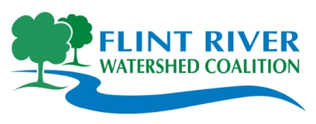
STREAM HABITAT ASSESSMENT

Stream Macroinvertebrate Datasheet

I. Stream, Team, Location Information (Please complete your specimen collection first)

Stream Name:

Location: Circle One: Monitoring Upstream -or- Downstream of road?

Collection Start Time: (AM / PM)

Date: Site ID:

County: Township:

Major Watershed: Flint River Watershed HUC Code (if known):

Latitude: (if known) Longitude: (if known)

Monitoring Team:

Name(s) of Person(s) Completing Datasheet : ________________________________________

Name(s) of Person(s) Collecting : ________________________________________

Other Team Members:

Macroinvertebrate Collection: Check the habitats that were sampled. Make sure you are sampling all habitats present. (within a 300 foot sampling reach as described in your site directions)

_____ Riffles _____ Large Rocks _____ Submerged Wood/Woody debris
_____ Overhanging Vegetation _____ Leaf Packs _____ Other/Describe Below:
_____Rooted Aquatic Plants _____ Pools
_____Runs _____ Eddies
_____ Undercut banks/Overhanging Vegetation

Did you see any: Live Crayfish? --or-- Live Clams? (Crayfish & Clams are Not Collected, just counted.)

( ) Yes - how many live crayfish? _____ ( ) No ( ) Yes - how many live clams? ______ ( ) No
-- If yes, remember to include them in the assessment at end.

Collection Finish Time: (AM / PM)

Comments: Were other wildlife present, including fish? If yes, please list what was seen and how many.

Safety First!
- Do not walk in an unstable riverbank area or wade in water too deep, or too fast flowing. Keep safety in mind when choosing measuring locations. If the stream is too deep to take measurements, an estimate will do.



II. Flow Measurement

To take a correct stream flow measurement, face upstream in a straightaway with your partner 12 feet downstream. Throw your float at least 10 feet upstream from where you stand (away from your partner). This allows the float to fully accelerate by the time it reaches you. Begin timing once it reaches you. Stop when it reaches your partner.

Flow Measurement Data
Average stream width and depth:
- Stream width is the distance from the water’s edge on one side of the stream to the other side.
- Monitors shall take three measurements of width and depth at random straight-aways along the 300 foot long sampling area, avoiding sand bars, curves, and debris.
Measurement |  | Width (feet) |  | Depth (feet) |  |  |  |  |  |  |  | Flow Measurement Data
 |  |  |  | 1/4 Way Across Stream |  | Middle of Stream |  | 3/4 Across Stream |  | Average depth |  | Time (sec) |  | Distance (feet)  (always 12 feet)
1st |  |  |  |  |  |  |  |  |  |  |  |  |  | 12 ft
2nd |  |  |  |  |  |  |  |  |  |  |  |  |  | 12 ft
3rd |  |  |  |  |  |  |  |  |  |  |  |  |  | 12 ft
Results - Office Use only | Average width: |  |  | Average depth: |  |  |  |  |  |  |  | Average Flow:
EXAMPLE: Measurement Data
Measurement |  |  | Width (ft) |  | Depth (ft) |  |  |  |  |  |  |  |  |  | Distance (feet)
 |  |  |  |  | 1 |  | 2 |  | 3 |  | 4 |  | Time (sec) |  | Distance (feet)
1 |  |  | 25 |  | 1.7 |  | 2.1 |  | 2.2 |  | 2 |  | 12.0 |  | 12
2 |  |  | 24 |  | 2.2 |  | 2.3 |  | 2.4 |  | 2.3 |  | 15.0 |  | 12
3 |  |  | 21 |  | 2.0 |  | 1.8 |  | 1.7 |  | 1.83 |  | 13.0 |  | 12

III. Bank Conditions

- Bank Angles

While doing monitoring, record the angle of the bank as indicated on the data sheet. Left/right banks are identified by looking downstream. Calculate the percentage of banks with acute (undercut), obtuse, and right angles. Right angles indicate higher erosive potential, while acute angles (<90°) improve the habitat structure of a stream.

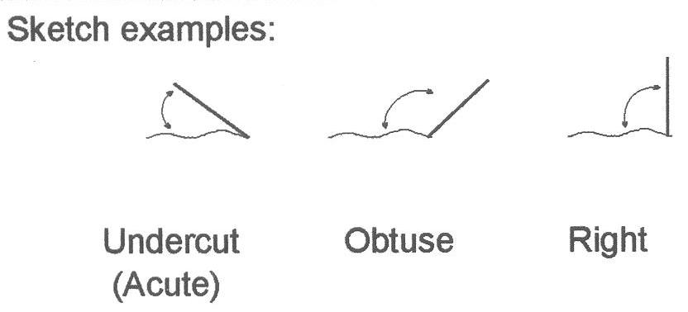
Left Bank Right Bank

Undercut (Acute) % ________ _________

Obtuse % ________ _________

Right % ________ _________

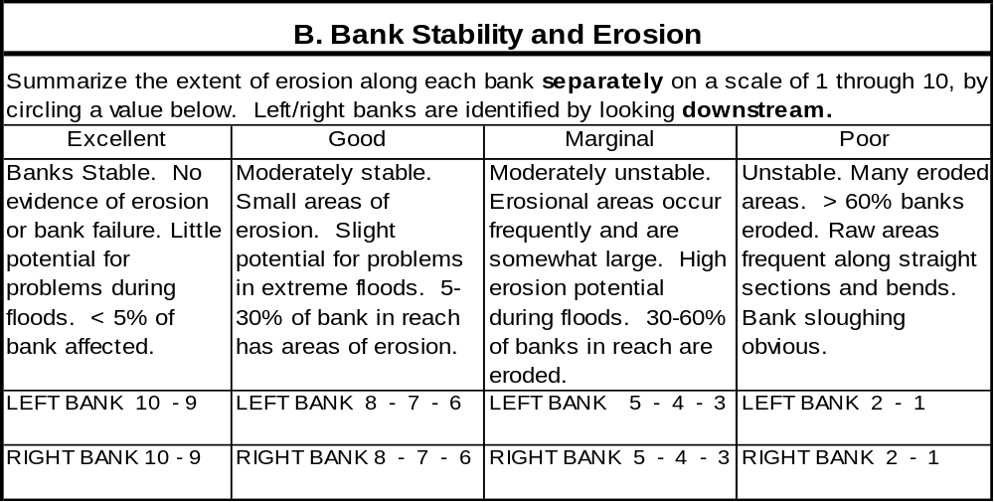

C. Riparian Zone
1. Left Bank (looking downstream)

Circle those land-use types you can see from this stream reach:

Wetlands Forest Residential Lawn Park Shrub, Old Field Agriculture

Construction Commercial Industrial Road Golf Course Highways

Other _______________________

2. Right Bank (looking downstream)

Circle those land-use types you can see from this stream reach:

Wetlands Forest Residential Lawn Park Shrub, Old Field Agriculture

Construction Commercial Industrial Road Golf Course Highways

Other _______________________

3. Summarize the size and quality of the riparian zone along each bank separately on a scale of 0 through 10 by circling a value below:
Excellent | Good | Marginal | Poor
Width of riparian zone >150 feet, dominated by vegetation, including trees, understory shrubs or wetlands; little or no vegetative disruption through grazing or mowing; almost all plants allowed to grow naturally. | Width of riparian zone 75-150 feet; human activities have impacted zone only minimally. | Width of riparian zone 10-75 feet; human activities have impacted zone a great deal. | Width of riparian zone, 10 feet; little or no riparian vegetation due to human activities.
Left bank = 10 9 | Left bank = 8 7 6 | Left bank = 5 4 3 | Left bank = 2 1 0
Right bank = 10 9 | Right bank = 8 7 6 | Right bank = 5 4 3 | Right bank = 2 1 0

IV. Stream and Riparian Habitat

D. General Information Circle one or more answer as appropriate
1 | Monitoring Event Conditions | Rain | Sunny | Windy | Other:
2 | Water Temperature (°C)
3 | Air Temperature (°C)
4 | Channel Condition (Stream shape constrained through human activity?) | Natural | Recovering | Maintained
5 | Has this stream been channelized (stream shape constrained through human activity)? | Yes,  currently | Yes, sometime in the past | No
6 | Estimate of current stream flow | Dry | Stagnant | Low | Medium |  | High
7 | Highest water mark  (In feet above the current level.) | <1 | 1-3 | 3-5 | 5-10 |  | >10
8 | Estimate of turbidity | Clear | Slightly Turbid (can barely see bottom) |  | Turbid (cannot see bottom)
9 | Is there a sheen or oil slick visible on the surface of the water? | Yes | No
10 | If yes to # 9, does the sheen break up when poked with a stick? | Yes (most likely natural) |  | No (most likely artificial)
11 | Is there foam present on the surface of the water? | Yes | No
12 | If yes to #11, does the foam feel gritty or slippery? (please circle one) | Gritty (most likely natural) |  | Slippery (most likely artificial)
13 | If the water smells, please describe:
14 | Has it rained in the last 5 days? | Yes | No | If yes, approximate the number of inches:______

E. Plant Community

Estimate the percentage of stream covered by overhanging vegetation (near the water) ____________%

Estimate the percentage of stream covered by overhanging tree canopy ____________%

Estimate the relative abundance of the following types of vegetation present using the scale below:
Scale: 0 = Absent,1 = Rare, 2 = Common, 3 = Abundant, 4= Dominant
Plants in Stream |  |  |  | Plants on Bank and in Riparian Zone
Algae on Surfaces of Rocks or Plants |  | Filamentous Algae (Streamers) |  | Shrubs |  | Trees
Macrophytes (Standing Plants) |  | Other |  | Grasses |  | Other
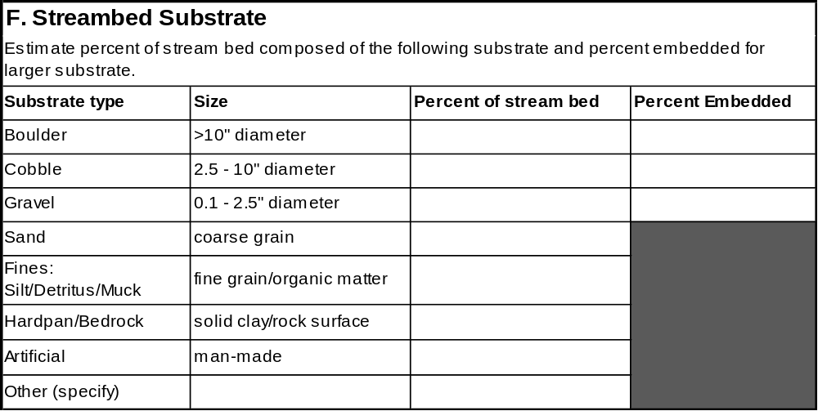

V. Sources of Degradation

Based on what you can see from this location, indicate the potential causes and level of severity of this degradation using the scale below:

Severity: S – slight (0-25%); M – moderate (26-75%); H – high (76-100%) Clarify below if necessary
Crop Related Sources | S | M | H | Signs of animals using or crossing the stream | S | M | H
Grazing Related Sources | S | M | H | On-site Wastewater Systems | S | M | H
Intensive Animal Feeding Operations | S | M | H | Silviculture (Forestry) | S | M | H
Highway/Road/Bridge Maintenance and Runoff | S | M | H | Resource Extraction (Mining) | S | M | H
Channelization | S | M | H | Recreational/Tourism Activities (general) | S | M | H
Dredging | S | M | H | - Golf Courses | S | M | H
Removal of Riparian Vegetation | S | M | H | - Recreational Boating (water releases) | S | M | H
Bank and Shoreline Erosion/ Modification/Destruction | S | M | H | - Recreational Boating (bank or shoreline erosion) | S | M | H
Flow Regulation/ Modification (Hydrology) | S | M | H | Debris in Water | S | M | H
Land Fill | S | M | H | Debris in Trees (natural sources) | S | M | H
Urban Runoff | S | M | H | Trash in trees along bank | S | M | H
Impoundment –Dam (natural or man-made) | S | M | H | Industrial Point Source | S | M | H
Construction: Highway, Road, Bridge, Culvert | S | M | H | Municipal Point Source | S | M | H
Construction: Land Development | S | M | H | Source(s) Unknown | S | M | H
Natural Sources (i.e. log jams) | S | M | H | Does a team need to come out and collect trash? | Y | N

Additional comments:

VI. Stream Map

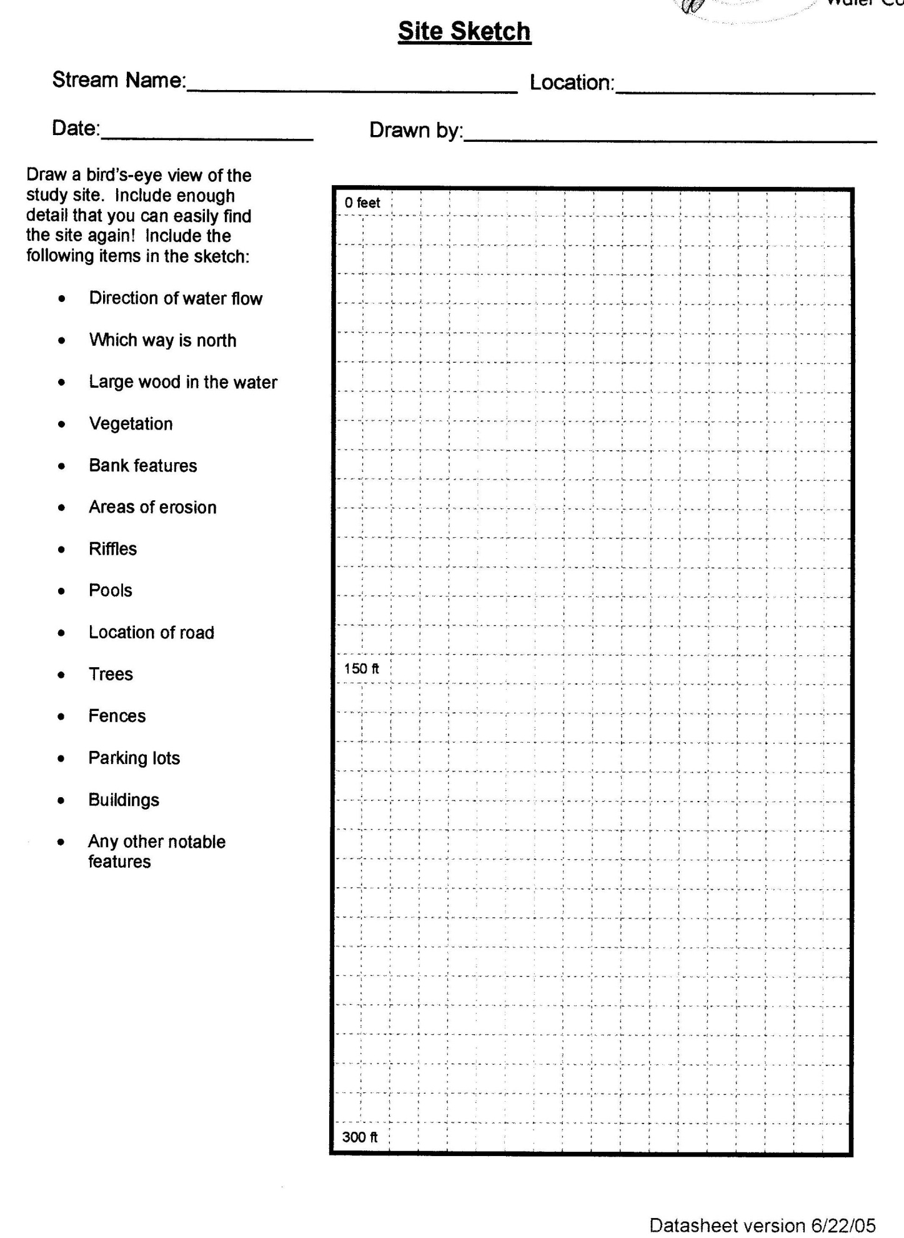
Identification and Assessment

To record the approximate numbers of live organisms collected in each taxa found in the stream reach, use letter codes: R (rare) for 1 to 10; and C (common) for 11 or more. **Do NOT count empty shells, pupae, or terrestrial macro invertebrates.

Group 1: Sensitive STREAM QUALITY SCORE
Caddisfly Larvae (Trichoptera) Group 1:
Except Net-spinning caddis (listed in Group 2)
Hellgrammites (Megaloptera) # of R's x 5.0 =
Mayfly nymphs (Ephemeroptera)
Gilled (right-handed) snails (Gastropoda) # of C's x 5.3 =
Stonefly nymphs (Plecoptera)
Water Penny (Coleoptera) Group 1 Total =
Water Snipe fly (Diptera)
Group 2: Somewhat Sensitive Group 2:
Alderfly larvae (Megaloptera) # of R's x 3.0 =
Beetle adults (Coleoptera)
Beetle larvae (Coleoptera) # of C's x 3.2 =
Flack fly larvae (Diptera)
Clams (Pelecypoda) Group 2 Total =
Crane Fly larvae (Diptera)
Crayfish (from count) (Decapoda)
Damselfly nymphs (Odonata) Group 3:
Dragonfly nymphs (Odonata)
Net-spinning caddisfly larvae # of R's x 1.1 =
(Hydropsychidae, and Trichoptera)
Scuds (Amphipoda) # of C's x 1.0 =
Sowbugs (Isopoda)
Group 3 Total =
Groups 3: Tolerant Total Stream Quality Score =
Aquatic worms (Oligochaeta) (Sum of totals for groups 1-3; round to nearest whole number)
Leeches (Hirudinea)
Midge Larvae (Diptera) Check One:
Pouch snails (Gastropoda) _____ Excellent ( > 48) _____ Fair (19 – 33)
True bugs (Hemiptera)
Other true flies (Diptera) _____ Good (34-48) _____ Poor (< 19)

Identifications Made by:
Rate your confidence in these identifications: Quite Confident Not Very Confident
5 4 3 2 1
Datasheet checked for completeness by: Datasheet Version 10/08/05
Data entered into MiCorps database by: Date:

Credits
This habitat assessment was created for the MiCorps Volunteer Stream Monitoring Program from a combination of habitat assessments from the Huron River Watershed Council, the Friends of the Rouge River, and the Michigan Department of Environmental Quality. Version 1.0, June 2009.
Revised by the Flint River Watershed Coalition, Apr. 2011

