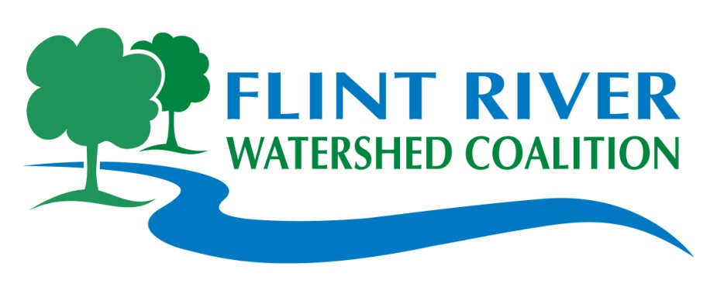

Flint River

Watershed Coalition

***We provide:***

Free T-shirts, Lunch, Water, Gloves, Rakes, &

Garbage Bags

***See Back of Flyer***

***for******Site Locations***

*Please register groups*

*of 10 people or larger*

**Unacceptable Neighborhood Items:**

* Freon (Freezers/Refrigerators)

* Air Conditioners

* Auto Parts (Tires are OK)

* Building & Demolition items:

concrete, dirt, lumber, shingles,

drywall, windows, etc.

* Fluids, Gasoline, Oil, Paint,

Transmission Fluids

*Trash mixed with grass, leaves,

brush

* Hazardous Wastes

* Paints

For Information

**Flint River Watershed**

**Call**: 810-767-6490

**Visit:** www.flintriver.org

**Email:** slossing@FlintRiver.org

**Flint River & Community Cleanup**

**May 21, 2011**



**Kid Approved!**

***Early Bird Trail Cleanup***

***Saturday, April 30,***

***Friends of the Flint River Trail***

*Location:* ***Vietnam Veteran's Memorial Park: James P. Cole Blvd., between Hamilton Ave. & Rbt. T. Longway***

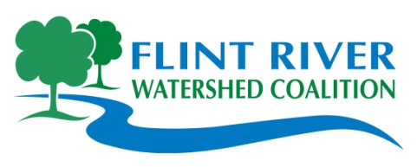

***Partnering to protect, preserve and improve the Flint River Watershed***

**9am – 12 noon**

**Come to Cleanup and stay for Lunch!**

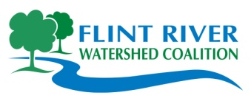

**Join Us!**

**Saturday,**

**May 21, 2011**

**9am-12noon**

**Stay for Lunch!**

**Please register**

**groups of 10**

**people or more.**

**Enjoy your Watershed!**

**Contact the Flint River Watershed:**

810-767-6490

www.FlintRiver.org

slossing@FlintRiver.org

400 N. Saginaw Street

Suite 233

Flint, MI 48502

***Flint River Watershed Coalition,***

***Partnering to***

***Protect,***

***Preserve,***

***and***

***Improve***

***The***

***Flint River Watershed!***

***Early Bird***

***Trail Cleanup:***

***Saturday, April 30th,***

***Vietnam Veteran's Memorial Park:***

***James P. Cole Blvd., between Hamilton Ave. & Rbt. T. Longway***

**Cleanup Site Locations**

**Genesee County:**

**Bendle Schools/Thread Lake, Burton: *Hosts:*** *Bendle High School, City of Burton*

**Location:** Burton: East Bristol Road, just West of S. Center Road. Park at Bendle Schools.

**Carriage Town Historic Neighborhood: *Hosts:*** *Carriage Town Historic Neighborhood*

*Assoc., City of Flint*

**Location:** Downtown Flint: 301 Lyon Street. Park in lot near Durant-Dort Carriage Town

**Flushing Riverview Park: *Hosts:*** *City of Flushing & Flushing High School*

**Location:** Flushing: 230 S. Cherry St., downtown Flushing (near the A&W Drive-In)

**Gilkey Creek/Pierce Park: *Hosts:*** *College Cultural Neighborhood Association, City of Flint, Flint Schools*

**Location:** Flint: Pierce Park Golf Course, S. of Court St., W. of Dort Hwy. Gilkey Creek

from Dort Hwy. to Court St.

**Holloway Dam Canoe Access: *Hosts:*** *Steve & Carl Hester, Genesee Co. Parks & Rec.*

**Location:** Richfield Twp.: Carr Road at the Dam, (between M15 & Henderson Roads)

**Katherine Price Unity Park: *Hosts:*** *MCC Gardening Association, City of Flint*

**Location:** Flint: off Saginaw St., N. of Pasadena between Ruth & Austin Ave. Park on Ruth

**Kearsley Park: *Hosts:*** *City of Flint, Parks and Recreation, Mott Community College*

**Location:** Flint: Kearsley Park Blvd. N. of Rbt. T. Longway, 1/4 mile East of I-475

**McKinley Park: *Hosts:*** *Resource Genesee, Youth Leadership, City of Flint*

**Location:** Flint: McKinley Center at Orville St. & Peer Avenue

**Mott Park Neighborhood: *Hosts:*** *Mott Park Neighborhood Association, City of Flint*

**Location:** Flint: Park at Mott Park, Nolen Drive & Weller Street

**Mott Park/Golf: *Hosts:*** *The Valley School*

**Location:** Flint: Park at Mott Park, Nolen Drive & Weller Street. Clean up along to

W. Ballenger Hwy.

**Vietnam Veterans Park: *Hosts:*** *Student Veterans of America, University of*

*Michigan, Flint*

**Location:** Downtown Flint: James P. Cole Blvd., between Hamilton Ave. & Rbt. T.

Longway Blvd.

**Riverbank Park: *Hosts:*** *Flint River Corridor Alliance*

**Location:** Downtown Flint: Sign in at Amphitheater at the Riverfront Residence Hall.

Parking available at the side parking lot on Garland and First Street

**Lapeer County:**

**Chatfield to Rotary Park: *Hosts:*** *Lapeer Chapter of the FRWC, Lapeer Rotary, City of Lapeer*

**Location:** Various locations. Meet at Crampton Park.

**Oakland County:**

**Ortonville Kearsley Creek: *Hosts:*** *City of Ortonville*

**Location:** Park at Brandon Schools, various locations along Kearsley Creek.