**Flint River GREEN Chemical Testing Results**

<http://bit.ly/FlintRiverGreenData>

The website above is a survey to submit your school’s/class’ 2014 GREEN water quality testing results.

This survey includes location data (latitude and longitude in Decimal Degrees) that can be found using Google Earth or an application for a smart phone. Some smartphone applications that can find location data include:

* GPS Coordinates: Albrechtsen & Co., LLC (make sure to select Decimal Degrees)

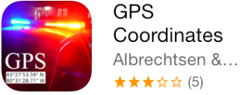

* Coordinates – Calculate and Convert a Position: myice92 (CP stands for Current Position)

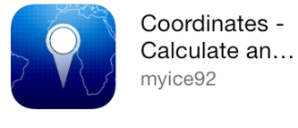

* Coordinates Locator: Sean Taylor

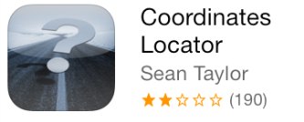

* Military Survival GPS FREE – Storeboughtmilk LLC (to change to Decimal Degrees select the gear in the upper left, under coordinates Lat/Lon is located near the bottom)

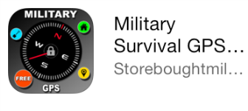

You can also find location data by using one of these computer tools:

* Google Earth
  + Placing a “Pin” in the location will give you latitude and longitude
* Google Maps
  + Turn on Satellite data and zoom into you testing location
  + Right Click on your testing site (not on a road) and select “Directions to Here”
  + The latitude and longitude will show up in the “B” location in the directions

In addition, the individual test results are asked for as well as the total WQI value. The WQI values need to be calculated separately and then entered.

Please be sure to enter your results into the online survey after your water testing, even if the results are inconclusive. We are hoping to enter these results into the Flint River GREEN portion of the watershed tour of ELUCID and students can use these results for comparison in future years.

If you have any question or trouble regarding the survey and data entry please contact Stephanie Nummer at [snummer@umflint.edu](mailto:snummer@umflint.edu) or call her at 810-767-9491.