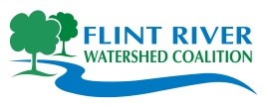

400 N. Saginaw Street, Suite 233

Flint, MI 48503

810-767-6490

[www.FlintRiver.org](http://www.FlintRiver.org)

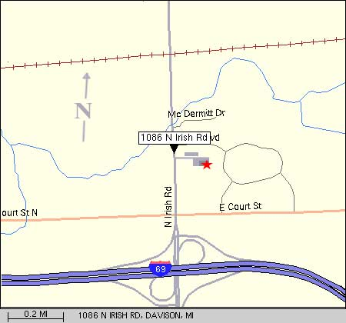**Stonegate Banquet Centre**  
1086 N. Irish Road  
Davison, MI 48423

**Flint** River

**Watershed** Coalition

**[](http://www.michiganrivernews.com/)**

**Thursday, January 26th 6-9 PM**

**Stonegate Banquet Center**

**RSVP by 12/31- $30 per person**

**1/1/12 – 1/15/12 - $35 per person**

**1/16/12 – at the door - $40 per person**

**We are honored to present**

**Andy McGlashen and Jeff Brooks Gilles**

**Co-Founders of Michigan River News**

*2012 Annual Meeting and Silent Auction*