Demand and Cancellation Analysis of VoltRide EV Ride-Hailing Services
Project Report

1. Project Overview
This project analyzes the VoltRide electric vehicle ride-hailing dataset to understand ride demand,
cancellation patterns, operational efficiency, and battery-related issues. Python was used for data cleaning and exploratory analysis,
PostgreSQL (pgAdmin) was used for SQL-based business analysis, and Power BI was used to build an interactive dashboard.

2. Dataset Summary
Dataset: VoltRide Ride Dataset
The dataset contains ride booking records with attributes such as:
• Ride ID
• City
• Pickup Zone
• Hour
• Peak Hour
• Battery Level
• Cancellation Status
• Cancellation By
• Ride Distance
• Fare
The dataset was cleaned in Python before being imported into PostgreSQL for business analysis.

3. Data Analysis using Python
Python Libraries Used:
• Pandas
• NumPy
• Matplotlib
Steps Performed:
1. Loaded the dataset using Pandas.
2. Checked data types and missing values.
3. Removed duplicate records.
4. Performed descriptive statistics.
5. Created additional columns (Hour, Peak Hour where applicable).
6. Generated exploratory visualizations for ride demand, cancellations, and battery levels.
Insert the following screenshots:
• Dataset preview (head())
• df.info()
• Missing values
• Ride demand chart
• Cancellation chart
• Battery level distribution

4. SQL Analysis (PostgreSQL)

Business Question 1
Which city–zone–hour combinations have the highest demand and cancellation rates?
SELECT
v."City",
v."Pickup_Zone",
v."Hour",
COUNT(*) AS demand,
AVG(v."Is_Cancelled") AS cancellation_rate
FROM voltride_data v
GROUP BY v."City", v."Pickup_Zone", v."Hour"
ORDER BY demand DESC
LIMIT 10;
Purpose: Identify ride demand hotspots and cancellation-prone locations. Insert pgAdmin output screenshot.
Insight: Add observations from your query results here along with the screenshot.

Business Question 2
What are the main causes of cancellations across zones?
SELECT
v."Pickup_Zone",
v."Cancellation_By",
COUNT(*) AS total_cancellations
FROM voltride_data v
WHERE v."Is_Cancelled" = 1
GROUP BY v."Pickup_Zone", v."Cancellation_By"
ORDER BY total_cancellations DESC;
Purpose: Determine whether drivers or customers are responsible for most cancellations.
Insight: Add observations from your query results here along with the screenshot.

Business Question 3
Which zones have high demand but low completion rates?
SELECT
v."Pickup_Zone",
COUNT(*) AS demand,
SUM(CASE WHEN v."Is_Cancelled" = 0 THEN 1 ELSE 0 END) AS completed_rides,
AVG(v."Is_Cancelled") AS cancellation_rate
FROM voltride_data v
GROUP BY v."Pickup_Zone"
ORDER BY cancellation_rate DESC;
Purpose: Identify inefficient operational zones.
Insight: Add observations from your query results here along with the screenshot.

Business Question 4
At which battery level bands do cancellation rates spike?
SELECT
battery_band,
COUNT(*) AS total_rides,
SUM(CASE WHEN "Is_Cancelled" = 1 THEN 1 ELSE 0 END) AS total_cancellations,
ROUND(AVG("Is_Cancelled") * 100, 2) AS cancellation_rate_pct
FROM (
SELECT *,
CASE
WHEN "Battery_Level" < 20 THEN 'Critical (0-20%)'
WHEN "Battery_Level" < 40 THEN 'Low (20-40%)'
WHEN "Battery_Level" < 60 THEN 'Medium (40-60%)'
WHEN "Battery_Level" < 80 THEN 'High (60-80%)'
ELSE 'Full (80-100%)'
END AS battery_band
FROM voltride_data
) v
GROUP BY battery_band
ORDER BY cancellation_rate_pct DESC;
Purpose: Evaluate the effect of EV battery levels on ride cancellations.
Insight: Add observations from your query results here along with the screenshot.

Business Question 5
How do peak hours impact demand and cancellations?
SELECT
v."Peak_Hour",
COUNT(*) AS demand,
AVG(v."Is_Cancelled") AS cancellation_rate
FROM voltride_data v
GROUP BY v."Peak_Hour";
Purpose: Compare ride demand and cancellation behavior during peak and non-peak hours.
Insight: Add observations from your query results here along with the screenshot.

5. Power BI Dashboard
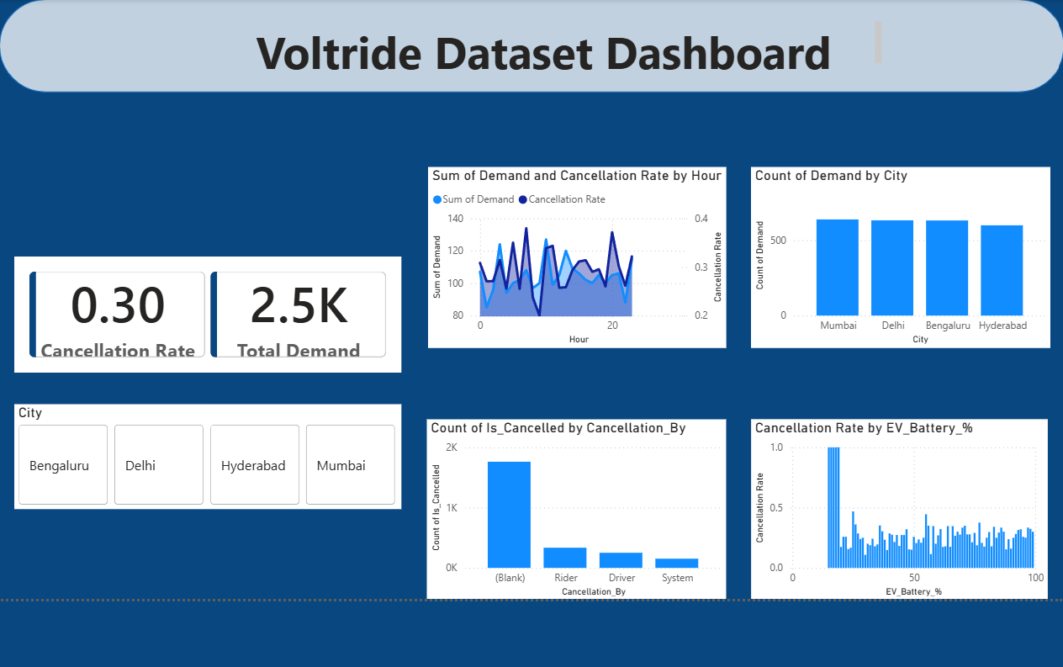
Dashboard Components:
• KPI Cards (Total Rides, Completed Rides, Cancelled Rides)
• City-wise Demand
• Pickup Zone Analysis
• Cancellation Reasons
• Battery Level Analysis
• Peak Hour Analysis
• Hourly Ride Demand
Explain how each visualization supports business decisions.

6. Business Recommendations
• Increase fleet availability in high-demand zones during peak hours.
• Improve charging schedules to reduce battery-related cancellations.
• Monitor driver cancellation behavior and introduce incentive programs.
• Allocate additional drivers to zones with consistently high demand.
• Use historical ride data for demand forecasting and dynamic fleet allocation.

7. Conclusion
The project demonstrates an end-to-end data analytics workflow using Python, PostgreSQL, and Power BI. Python enabled data cleaning and exploratory analysis, SQL answered key business questions, and Power BI transformed analytical results into an interactive dashboard. The findings can help improve fleet utilization, reduce ride cancellations, and enhance customer satisfaction.

