Academic Year: 2025-26 Name of Student: Aahana Kabdugale
Semester: V Student ID:24104169
Class / Branch: SE IT Date of Performance:12/7/26
Subject: Devops Lab Date of Submission:12/7/26
Name of Instructor: Prof. Sonal Jain

Experiment No. 1
Aim: To perform installation of Git and work on local and remote Git repositories.

Output Screen Shots:
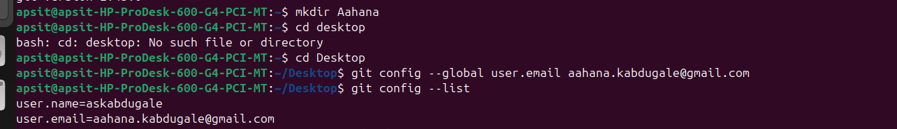
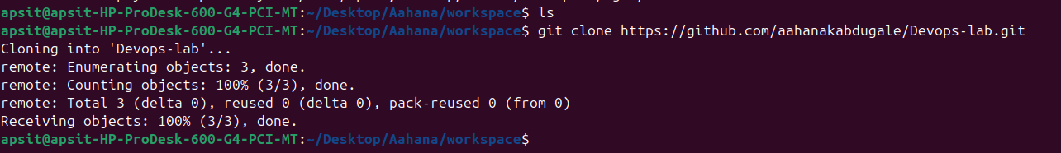

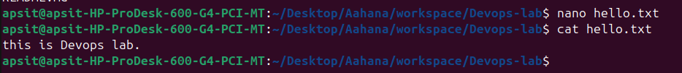
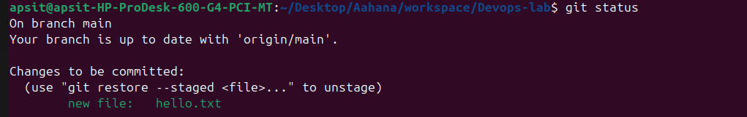

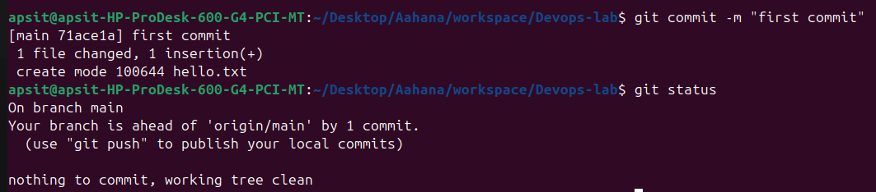

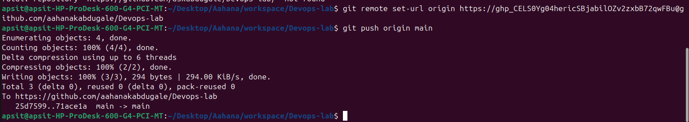
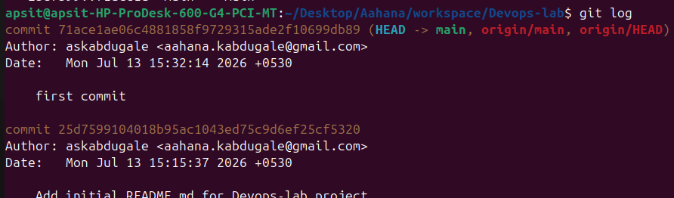

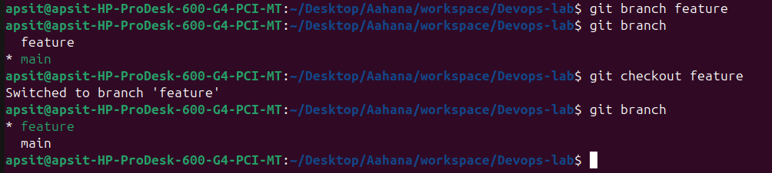
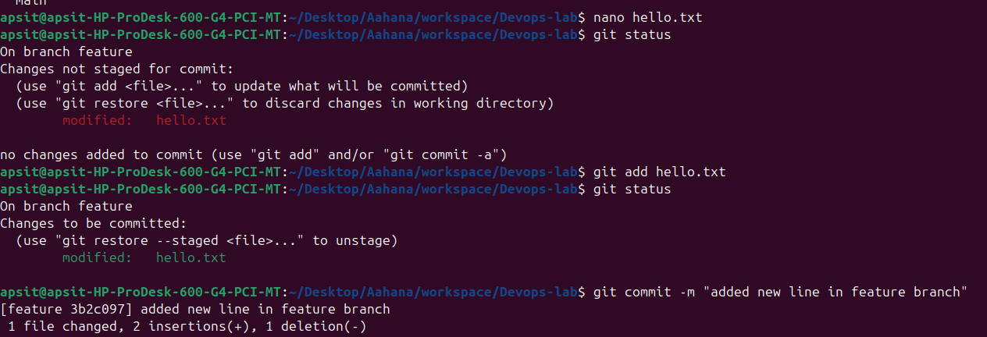
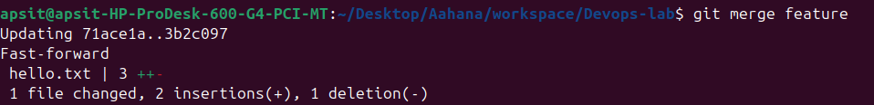

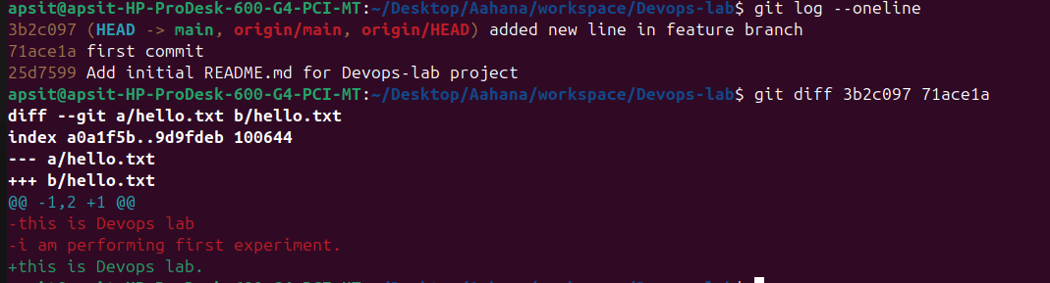
Conclusion:

