WEB Technologies 1

Assignment 1

GamePulse

Student: Aibyn Samat

Group: SE – 2438

This assignment's goal was to use HTML5 and CSS3 to create and implement a basic multi-page website. Semantic elements, page navigation, captioned images, a table, and a form had to be displayed on the website. A favicon, consistent layout across all pages, and the use of inline, internal, and external CSS were also necessary.

Inspired by portals such as IXBT, we developed GamePulse, a news and review website for mini games.  
  
News, Reviews, Schedule, and Contact are the four pages that make up the website.  
  
Creating the News and Reviews sections was my job.  
  
I added brief articles like "Zelda DLC Announced," "Starfield — Mini Review," and "Indie Trio" to the News page. These consist of internal links to reviews, supporting images, and semantic tags (, , , ).  
  
To illustrate the element, I made a ratings table and brief reviews of a few games with scores on the Reviews page. To demonstrate various CSS usage, I also used an internal CSS block and a two-column layout with floating elements.

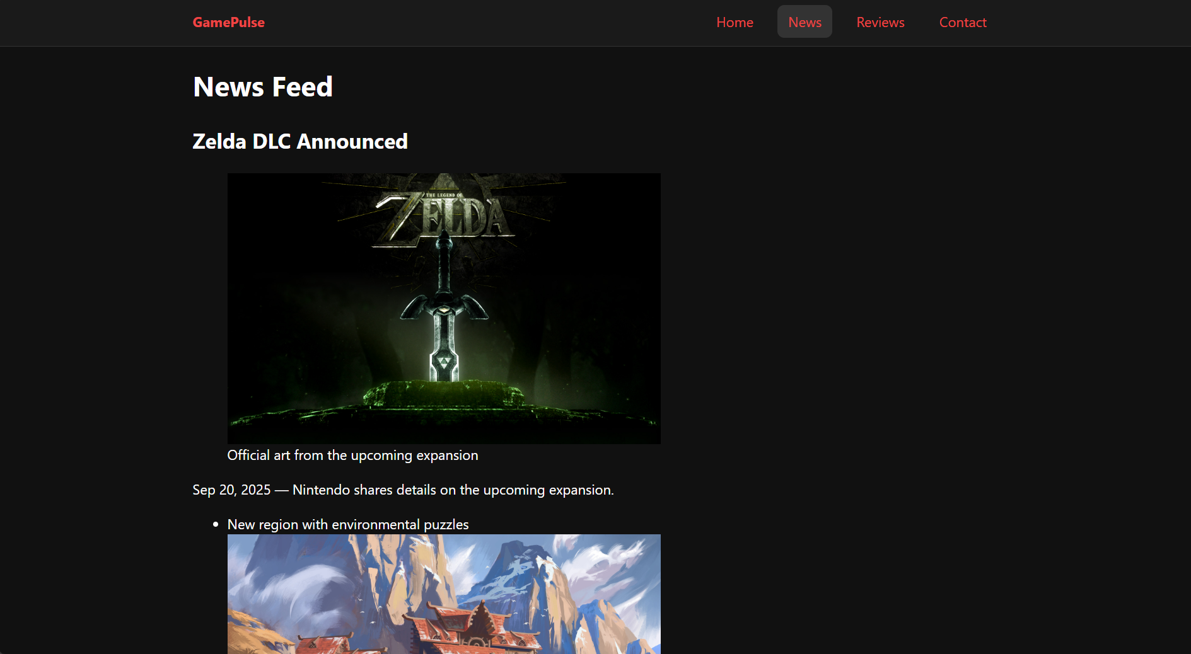

I became more aware of the value of semantic HTML for organizing content such as articles and time stamps while working on the News and Reviews pages. The news items appeared more professional with the addition of figures and captions. Although the table formatting and float-based layout made the Reviews page more difficult, I learned a lot about CSS positioning and page structure from it. If I had more time, I would make the layout completely responsive for mobile devices and include more interactivity.

**1. Assem:** Built the layout on every page, connected header and footer. Develop the design of site.

**2. Aibyn:** Implemented News and Reviews pages, including articles, figures, and ratings table.

**3.** **Farkhad:** Created the Home and Contact pages with the release table and feedback form, and helped with deployment.

|  |
| --- |
|  |