Importance of N2Hx Reaction Pathways in Modelling of NH3/H2/air Flame Chemistry
Urothiyil Aahil¹, Abe Shunnosuke¹, Matsuda Dai¹, Kitagawa Toshiaki¹ ,Ekenechukwu Chijioke Okafor¹
¹Department of Mechanical Engineering, Kyushu University
7-4-4, Motooka, Nishi-ku, Fukuoka, 819-0395, Japan
¹Student
2-16-4, Susenji, Nishi-ku, Fukuoka, 819-0395, Japan
ABSTRACT
A reduced kinetic mechanism was optimized for ${\text{NH}}_{3}$, ${\text{NH}}_{3}/{\text{CH}}_{4}$, and ${\text{NH}}_{3}/{\text{H}}_{2}$ flames to support efficient CFD modeling. 1D flame analyses showed that burning velocity underpredictions in high-hydrogen blends stem from insufficient $\text{H}$-atom generation via ${\text{NH}}_{2}+\text{NH}⇌{\text{N}}_{2}{\text{H}}_{2}+\text{H}$ and $\text{NNH}⇌{\text{N}}_{2}+\text{H}$. Updating ${\text{N}}_{2}{\text{H}}_{\text{x}}$ pathways resolved this issue, yielding accurate burning velocity predictions across all target blends.
- Introduction
Ammonia (${\text{NH}}_{3}$) is a promising carbon-free fuel, frequently blended with methane (${\text{CH}}_{4}$) or hydrogen (${\text{H}}_{2}$) to enhance reactivity in combustion systems. Combustor development for these blends relies on numerical simulations to accurately predict key phenomena, including laminar burning velocity, ignition dynamics, and pollutant emissions. Because large-scale or three-dimensional modeling using detailed kinetics incurs substantial memory and computation time costs, reliable reduced mechanisms—containing fewer species and reactions—are essential.
Numerous chemical kinetic mechanisms have been developed to model ammonia combustion; however, most are optimized for specific fuel blends and narrow operating conditions. For example, the reduced mechanism by Okafor et al. [1] was designed for ${\text{NH}}_{3}\text{/air}$ and ${\text{NH}}_{3}/{\text{CH}}_{4}\text{/air}$ flames. While it effectively predicts unstretched laminar burning velocity (${\text{S}}_{\text{L}}$) across lean-to-rich equivalence ratios for these mixtures [1–3], it significantly underpredicts ${\text{S}}_{\text{L}}$ for $\text{ec}$ flames when H₂ volume fractions exceed 0.3. Conversely, the detailed and reduced mechanisms by Gotama et al. [4] were tailored for ${\text{NH}}_{3}/{\text{H}}_{2}/\text{air}$ combustion, accurately predicting ${\text{S}}_{\text{L}}$ for high-hydrogen blends and pure ${\text{H}}_{2}/\text{air}$ flames at atmospheric pressure [4]. Similarly, the mechanism by Nakamura et al. [5] captures ${\text{S}}_{\text{L}}$ well for fuel-rich ${\text{NH}}_{3}/{\text{H}}_{2}/\text{air}$ flames ($ϕ=1.1-1.4$) [5]. Consequently, there remains a critical need for a single, comprehensive reduced mechanism capable of accurately evaluating the unstretched laminar burning velocity across a wide spectrum of ammonia blends and operating conditions
Okafor et al.’s reduced mechanism [1] under-prediction of $S_{L}$ for ${\text{NH}}_{3}/{\text{H}}_{2}/\text{air}$ flames could lie in the complex cross-coupling between ammonia and hydrogen reaction pathways. Because this reduced mechanism accurately models ${\text{NH}}_{3}/\text{air}$, ${\text{NH}}_{3}/{\text{CH}}_{4}/\text{air}$ and ${\text{H}}_{2}/\text{air}$ flames on their own, its failure at higher hydrogen fractions ($X_{{\text{H}}_{2}}>0.3$) points to missing or miscalibrated kinetic interactions specific to ${\text{NH}}_{3}/{\text{H}}_{2}$ co-combustion. At elevated hydrogen levels, the surge in key radical pools ($\text{H}$, $\text{O}$, and $\text{OH}$) alters the primary oxidation routes and radical consumption rates that dictate flame speed [4,5]. These limitations suggest that the mechanism's reaction network may need to be re-examined specifically under conditions where H₂ concentration in the fuel mixture is significant.
The primary objective of this work is to develop a robust reduced chemical kinetic mechanism capable of accurately modelling the combustion of ${\text{NH}}_{3}/air$, ${\text{NH}}_{3}/{\text{CH}}_{4}/air$, and ${\text{NH}}_{3}/{\text{H}}_{2}/air$ fuel blends across a wide range of operating conditions, building directly upon the reduced model of Okafor et al. [1]. To achieve this, the underlying reaction pathways of ${\text{NH}}_{3}/{\text{H}}_{2}/\text{air}$ flames were analysed to elucidate key kinetic interactions between ammonia and hydrogen chemistries that were underrepresented in the original mechanism.

- Numerical Procedure
In this study, the one-dimensional simulations for the unstretched laminar burning velocity, $S_{L}$, of premixed adiabatic flames were simulated using the Premixed Laminar Flame Speed Calculation Model in ANSYS Chemkin-PRO 2019 R3 and ANSYS Chemkin-PRO 2025 R2. The computation domain was set 10 cm and $S_{L}$ was calculated at the cold boundary of the computation domain. The adaptive grid settings GRAD and CURV were both set to 0.01. The ratio of H₂ in the binary fuel, $X_{H2}$, is defined in Equation (1). $X_{H2}$ was varied, while atmospheric pressure and stoichiometric equivalence ratio ($ϕ=1.0$) were maintained, to study how each reaction mechanism's $S_{L}$ predictions are affected by hydrogen addition.

 | $$X_{H2}=\frac{\left[H2\right]}{\left[NH3\right]+[H2]}$$ | (1)

The software was also used to compute rate of production of species, species concentrations and sensitivity of $S_{L}$ to rate constants of elementary reactions. The reduced chemical kinetics mechanism by Okafor et al. [1] and Gotama et al.'s [4] detailed mechanism was used in the simulations. Henceforth, for the purpose of discussion, these mechanisms shall be referred to as Okafor Reduced Mech and Gotama Mech respectively. A reduced chemical kinetic model, based on Okafor Reduced Mech [1], with 43 species and 152 reactions was developed as described in the following section. The developed mechanism will be referred to as Present Mech in this paper.

- Development of the Present Mech
The new reaction mechanism developed in this paper was based on the Okafor Reduced mechanism. Okafor Reduced Mech was selected because this mechanism has been optimized and validated for $S_{L}$ prediction of NH₃ /air and NH₃/CH₄/air flames. This is true for varying equivalence ratios, pressures and, in the case of NH₃/CH₄/air flames, varying methane concentrations. This mechanism also models the $S_{L}$ of H₂/air flames satisfactorily for most of these conditions. This mechanism under-predicts $S_{L}$ of NH₃/H₂/air flames with an error margin of $∼5$cm/s at hydrogen concentrations $X_{H2}=0.4$ as depicted in Fig. 1, a comparison of numerically simulated values and experimental measurements of burning velocity at stochiometric equivalence ratio. The mechanism's failure to predict the $S_{L}$ for this specific blend, despite accurately reproducing the individual components of NH₃/H₂/air flames, motivated the current investigation.
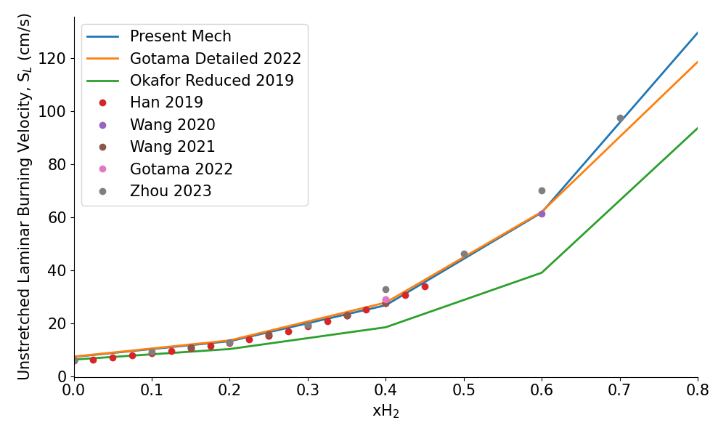
Fig. 1 Experimental and numerical laminar burning velocity of NH3/H2/air flames under stoichiometric condition at various hydrogen concentrations.

Figure 1 highlights Gotama Mech's $S_{L}$ predictions agree with experimental measurements of $S_{L}$ across all $X_{H2}$. Understanding where Gotama Mech differs from Okafor Reduced Mech should provide insights as to where the under-prediction of NH₃/H₂/air flames stems from. In addition, development of Gotama Mech focused on improving NH₃/H₂/air flame speed prediction at intermediate hydrogen concentration [4].
To understand how oxidation kinetics of each fuel in the binary fuel interact with each other, reaction pathways for each mechanism were constructed using integrated rate of production (IROP) of major species related to NH₃ and H₂ oxidation. Each IROP is calculated by integrating the rate of production, ${\dot{ω}}_{R,i}$, of specie $i$ in elementary reaction R along the length of the computational domain (10 cm) using Equation (2). The IROP, hence, characterizes the contribution of each elementary reaction to the combustion of NH₃/H₂/air fuel in each chemical kinetics model.

 | $$\int_{0}^{L}{\dot{ω_{R,i}} dx}$$ | (2)

Figures 2 (a) and (b) are reaction pathways of stoichiometric NH₃/H₂/air flame of $X_{H2}=0.5$ computed using Okafor Reduced Mech and Gotama Mech respectively. The thickness of each arrow corresponds to the magnitude of each path’s IROP. Species besides each arrow have numbers that represent the percent contribution each elementary reaction has to the corresponding path. The pathways highlighted the key differences in how the interaction of NH₃, and H₂ oxidation paths are modelled in each mechanism to inform the development of Present Mech.
Normalized sensitivity of $S_{L}$ to rate constants of elementary reactions was subsequently analysed to determine the direct dependence of the laminar burning velocity (${\text{S}}_{\text{L}}$) on individual elementary reactions. By combining these sensitivity trends with IROP analyses, the dominant reactions and critical cross-coupling pathways dictating flame speed were successfully identified. Based on these insights, targeted modifications made to Okafor Mech to model the under-represented pathways for NH₃/H₂/air flames at higher hydrogen fractions and develop the Present Mech.
Present Mech then was validated using experimental flame speed measurements from literature for ${\text{NH}}_{3}/H_{2}/\text{air}$, ${\text{NH}}_{3}/{\text{CH}}_{4}/\text{air}$ flames across lean ($ϕ=0.7$), stoichiometric and rich ($ϕ=1.4$) equivalence ratios. Present Mech’s performance at elevated pressures were evaluated too. These validation steps ensure that the developed mechanism meets the aim of this study and is compatible with various ammonia fuel blends at various operating conditions.

- Results and Discussion
Comparisons between the pathways of Okafor Reduced Mech and Gotama Mech, Fig. 2 (a) and (b) respectively, highlight interactions between NH₃ and H₂ oxidation pathways at intermediate H₂ concentrations in the binary fuel are modelled differently in the two chemical kinetics models. For instance, reactions in the reaction path ${NH}_{3}↔N_{2}H_{3}$ is modelled in Gotama Mech only. The forward reaction, the formation of N2H3, is given by;
 | $${NH}_{2}+NH=N_{2}H_{3}$$ | (R1)
and the reverse, the consumption of N2H3, is given by;

 | $${2NH}_{2}=N_{2}H_{3}+H$$ | (R2)
Gotama Mech's reaction pathway depicts the involvement of N2H3 in the control of intermediates important in ammonia oxidation pathway.
The reaction pathway $NNH→{ N}_{2}$ were distinct between Okafor Reduced Mech and Gotama Mech. Figure 1 shows that Gotama Mech exhibits an IROP approximately 2.2 times larger Okafor Reduced Mech and the pathway is primarily contributed to by the reaction;

 | $$NNH=N_{2}+H$$ | (R3)
in Gotama Mech. In Gotama Mech this pathway has become a significant contributor to H radical generation at intermediate hydrogen concentration.
Another reaction pathway, ${NH}_{2}→N_{2}H_{2}$ can also be depicted to exhibit increased IROP in Gotama Mech, approximately 3 times larger than in Okafor Reduced Mech. The reaction;

 | $${NH}_{2}+NH=N_{2}H_{2}+H$$ | (R4)
in the biggest contributor to the pathway. (R4) is a H radical generating reaction while consuming NH₂ and NH intermediates. Moreover, the increased N₂H₂ production further contributes to promoting the pathways $N_{2}H_{2}→NNH→N_{2}$ as the IROP for these pathways in Gotama Mech were approximately 2.8 times and 2.2 times that of Okafor Reduced Mech respectively. In addition, (R1) was the significant reaction in the latter pathway suggesting.

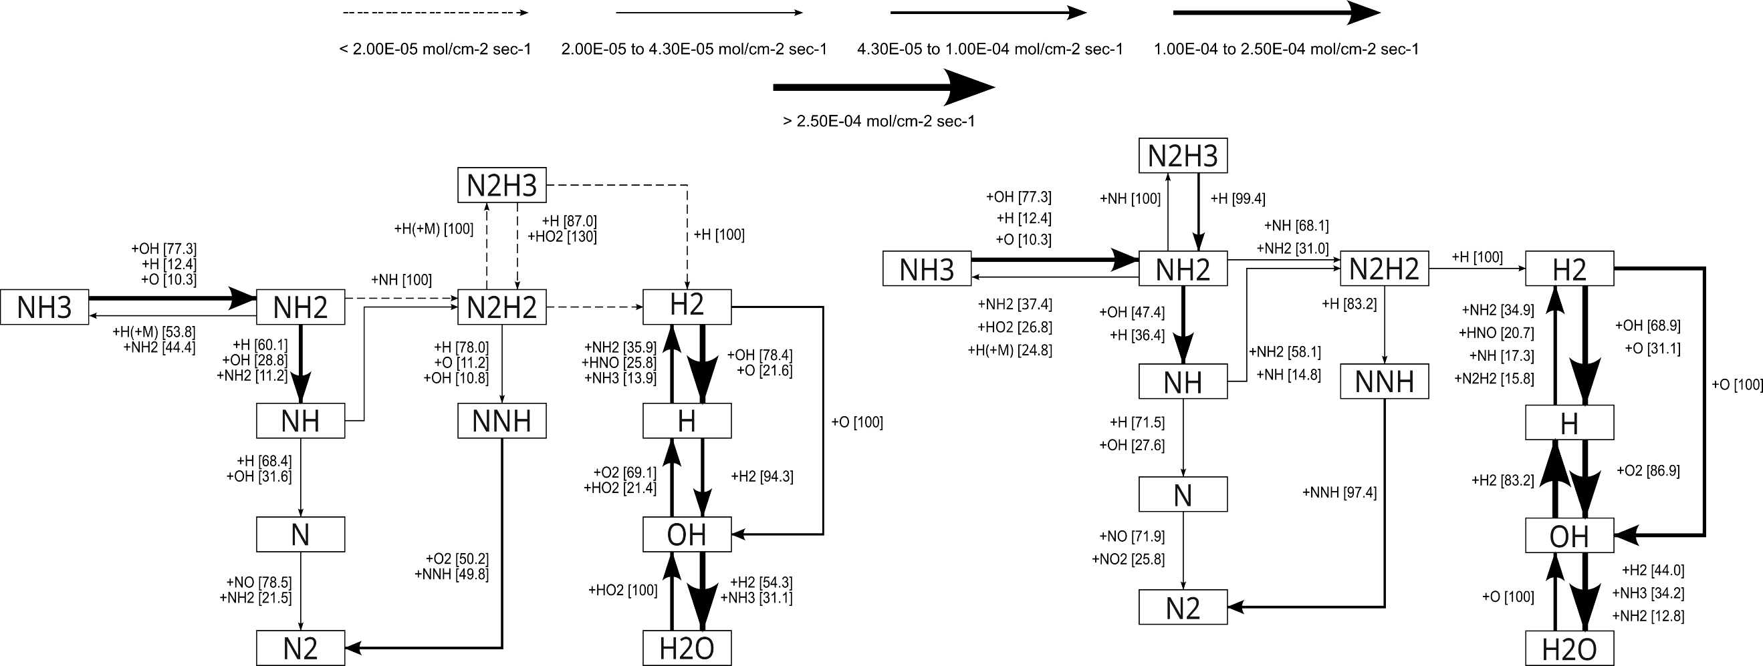
(a) Okafor Reduced Mech (b) Gotama Mech
Fig. 2 Reaction pathway of NH₃/H₂/air flame at $X_{H2}$=0.5 and equivalence ratio of 1.0 using (a) Okafor Reduced Mech and (b) Gotama Mech.
Reactions (R1) and (R2) were added to Present Mech as these reactions were established to be important for controlling NH concentration. These reactions’ roles in the combustion of ${\text{NH}}_{3}/H_{2}/\text{air}$ flames with intermediate hydrogen concentrations were also confirmed by Gotama et al. [4]. The rate constants of (R3) was updated by choosing rate constants published by Pagsberg et al. [6] as these were used by Gotama Mech. This change helped emulate Gotama Mech’s depending solely on reaction (R3) to facilitate the $NNH→N_{2}$ pathway. Glarborg et al. [7] corroborates the dominance of reaction (R3) in this pathway and confirms the significant role (R3) plays in H radical generation. Rate constants for (R4) were updated with the rate constants published by Klippenstein et al. [8] resulting in the Present Mech’s ${NH}_{2}→N_{2}H_{2}$ pathway attaining an IROP resembling Gotama Mech’s IROP for this pathway. Otomo et al. also recognizes the influence of reaction (R4) on the $S_{L}$ of ${\text{NH}}_{3}/H_{2}/\text{air}$ flames.
The normalized sensitivity of $S_{L}$ to rate constants of the elementary reactions using the Present Mech and Okafor Mech highlighted reaction (R4) playing a significant role in promoting $S_{L}$ in Present Mech while remaining insignificant in Okafor Reduced Mech. In addition, reaction (R1) only significantly inhibits $S_{L}$ in the Present Mech while remaining insignificant Okafor Reduced Mech's sensitiviy analysis. This analysis also showed other NH_{x} and N₂H_{x} related reactions being more significant with respect to $S_{L}$ in Present Mech at intermediate hydrogen concentration.
The reactions (R2), (R3) and (R4) involve N₂H_{x} species and control H radical concentrations, an important radical for promoting $S_{L}$. The increased IROP of these reactions in Present Mech implies an increase in H radical concentration, which correlates with the increased burning velocity predictions of this mechanism relative to Okafor Reduced Mech. Moreover, the formation and consumption of N₂H₃ with (R1) and (R2) respectively control NH and NH₂ concentrations. NH_{x} species are important as they interact with H and OH radicals and produce these radicals. (R4) is an example of NH_{x} species' involved in the production of an H radical. The other product of (R4), N₂H₂, is part of the pathway to form NNH which also produces H radicals via (R3). Moreover, reaction (R4)'s significant positive effect on the flame's burning velocity further supports the theory that N₂H_{x} species and their reaction pathways are important to accurately describe flame with fuel compositions of intermediate hydrogen concentration. Therefore, the Present Mech with a more accurate N₂H_{x} chemistry can predict $S_{L}$ under these conditions accurately.

- Validation
The Present Mech was validated with experimental data for $S_{L}$ of NH₃/H₂/air from the datasets consolidated by Han et al. [9]. These data sets were proven to be consistent with each other and widely used chemical kinetic mechanisms. Present Mech was validated for NH₃/CH₄/air flames also. Experimental data for NH₃/CH₄/air $S_{L}$ was compiled from three datasets: Okafor et al. (2019) [1], Han et al. (2019) [10] and Ling et al. (2026) [11]. However, experimental datasets, for both fuel blends, lacked ample $S_{L}$ measurements at elevated pressures, making validation of Present Mech for high pressure combustion difficult.
Figure 3 compares NH₃/CH₄/air predictions by the Present Mech to experimentally measured $S_{L}$ from literature at stoichiometric equivalence ratio and atmospheric pressure to depict that the $S_{L}$ predictions are satisfactory. The model also was able to validate $S_{L}$ predictions with Okafor et al. (2019)’s [1] datasets for elevated pressures and different equivalence ratios. This implies that the underlying Okafor Reduced Mech optimizations for NH₃/CH₄/air flame chemistry in Present Mech remained unaffected.
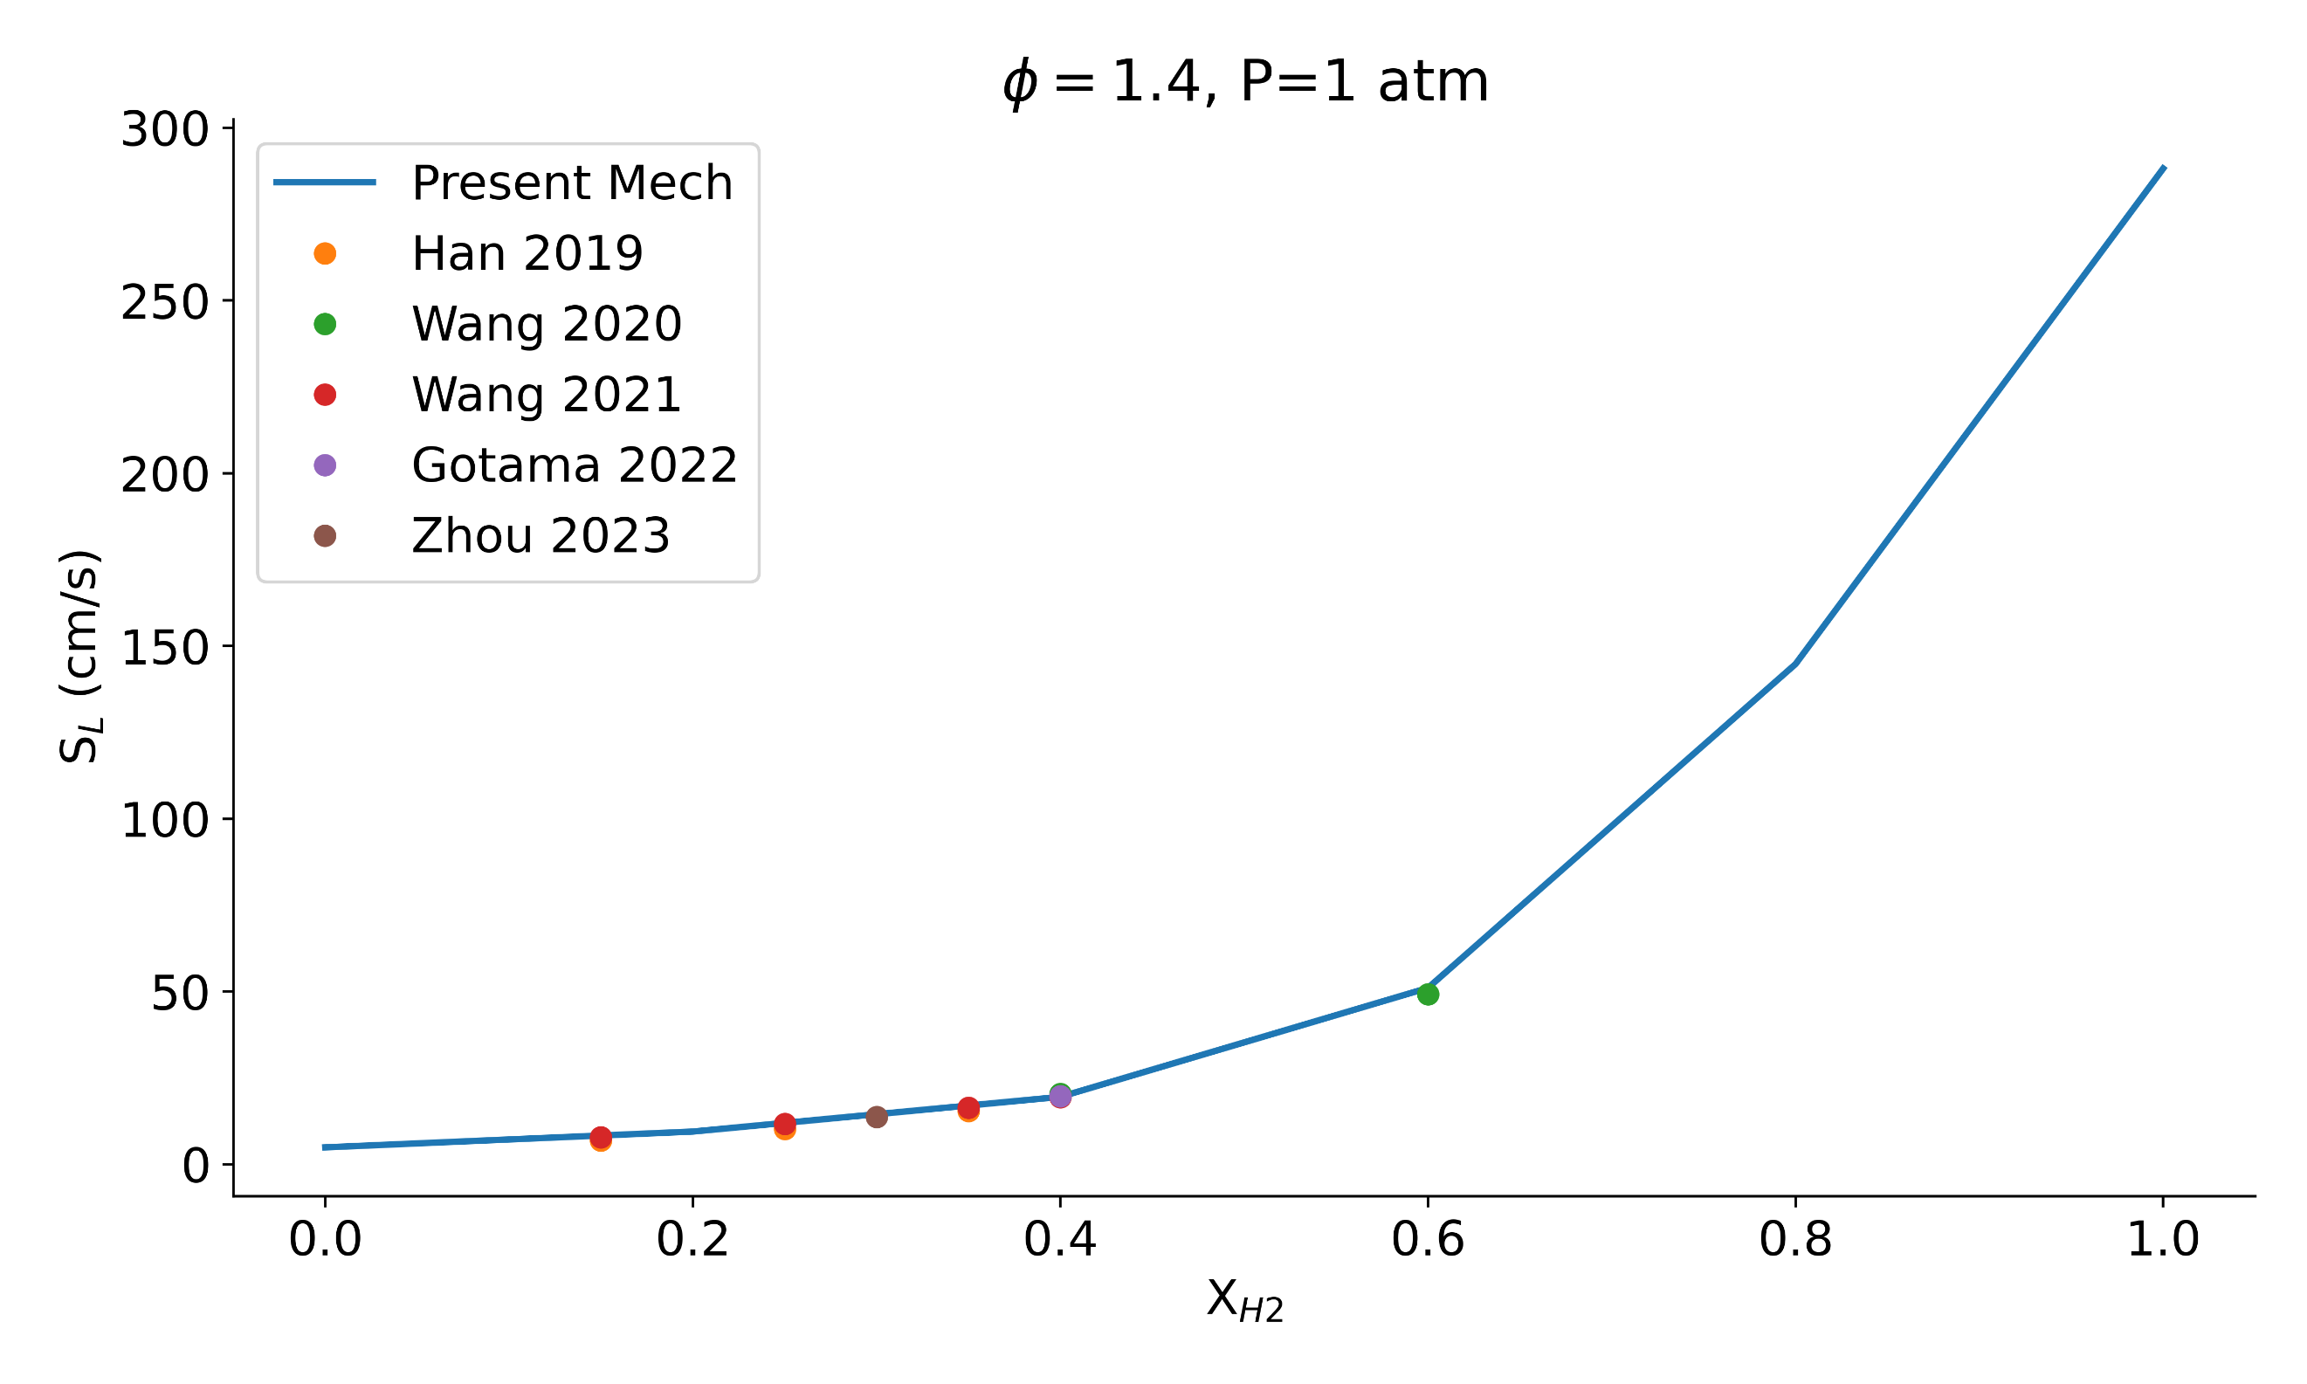
Fig. 5 Experimental and numerical laminar burning velocity of NH3/H2/air flames under lean condition ($ϕ=1.4)$ and 1 atm of pressure at various hydrogen concentrations.

Figure 4 and 5 displayed accurate modelling of NH₃/H₂/air $S_{L}$ at lean and rich equivalence ratios respectively tested for all hydrogen concentrations at atmospheric pressure. Moreover, at 3 atm of pressure, intermediate H₂ concentration ($X_{H2}=0.4, 0.6$) were validated with datasets from Wang et al. [12] while, at 5 atm of pressure, only $X_{H2}=0.4$ could be validated with the dataset from Gotama et al. [4]. This suggests that Present Mech is now capable of modelling flame speed of hydrogen enriched ammonia combustion.
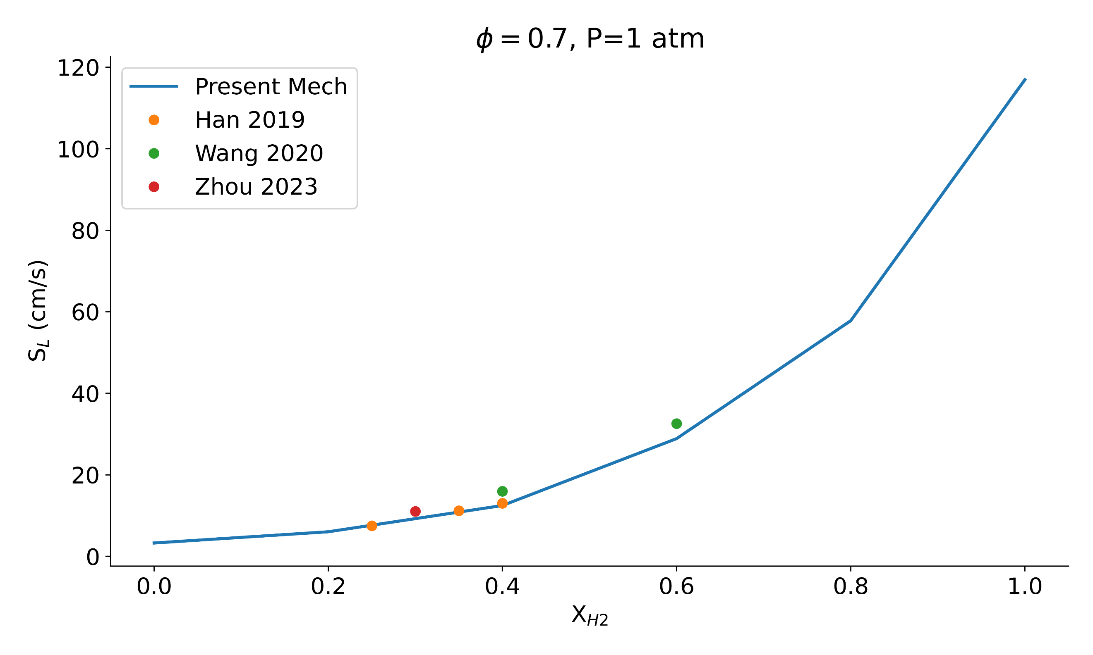
Fig. 4 Experimental and numerical laminar burning velocity of NH3/H2/air flames under lean condition ($ϕ=0.7)$ and 1 atm of pressure at various hydrogen concentrations.

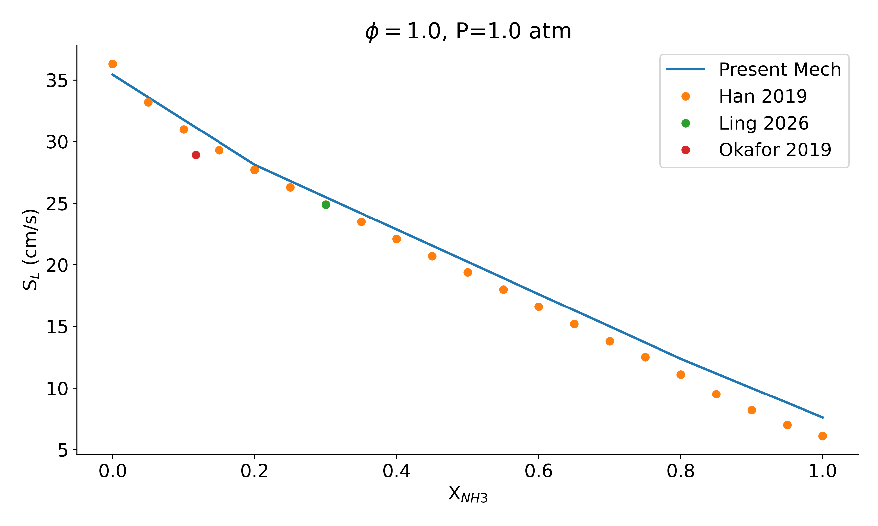
Fig. 3 Experimental and numerical laminar burning velocity of NH3/CH4/air flames under stoichiometric condition and 1 atm of pressure at various ammonia concentrations.

References
[1] E.C. Okafor, Y. Naito, S. Colson, A. Ichikawa, T. Kudo, A. Hayakawa, H. Kobayashi, Combust. Flame 204 (2019) 162–175.
[2] B. Mei, X. Zhang, S. Ma, M. Cui, H. Guo, Z. Cao, Y. Li, Combust. Flame 210 (2019) 236–246.
[3] W.S. Chai, Y. Bao, P. Jin, G. Tang, L. Zhou, Renew. Sustain. Energy Rev. 147 (2021) 111254.
[4] G.J. Gotama, A. Hayakawa, E.C. Okafor, R. Kanoshima, M. Hayashi, T. Kudo, H. Kobayashi, Combust. Flame 236 (2022) 111753.
[5] H. Nakamura, S. Hasegawa, T. Tezuka, Combust. Flame 185 (2017) 16–27.
[6] P.B. Pagsberg, J. Eriksen, H.C. Christensen, J. Phys. Chem. 83 (1979) 582–590.
[7] P. Glarborg, J.A. Miller, B. Ruscic, S.J. Klippenstein, Prog. Energy Combust. Sci. 67 (2018) 31–68.
[8] S.J. Klippenstein, L.B. Harding, B. Ruscic, R. Sivaramakrishnan, N.K. Srinivasan, M.-C. Su, J.V. Michael, J. Phys. Chem. A 113 (2009) 10241–10259.
[9] X. Han, K. Wan, T. Nagy, Combust. Flame 286 (2026) 114855.
[10] X. Han, Z. Wang, M. Costa, Z. Sun, Y. He, K. Cen, Combust. Flame 206 (2019) 214–226.
[11] Z. Ling, J. Lin, J. Li, X. Han, M. Liu, D. Yuan, Z. Wang, J. Energy Inst. 126 (2026) 102503.
[12] S. Wang, Z. Wang, A.M. Elbaz, X. Han, Y. He, M. Costa, A.A. Konnov, W.L. Roberts, Combust. Flame 221 (2020) 270–287.

