MUHAMMATH ASHIK FARHAN S,

SANTHANA KRISHNAN K

B.Tech MCT, SASTRA

SPF Forging Heat Monitoring

# Product Design

This Model consists of Sensors and Slider. Two Temperature Sensors are used to detect the Temperatures of Die and Workpiece. Both the Sensors are connected to the Guide Rod with Slider, so that its position can be adjusted according to the Die and Workpiece positions. The Sensor which is attached to sense the temperature of the Workpiece can be able to tilt in order to sense the Work piece.

## Guide Rod and Slider

The Sliders are adjusted in Guide Rod with the help of Spring Bolt Latch technique.

The Angle of Slider with Sensor for Work piece is controlled with Wing Bolts.

## Temperature Sensor

Sensors used are contactless type sensors. This sensor type is chosen because we cannot make the sensor in contact with the object of high temperature that can melt the sensor.

The above picture represents the sensors location and the design analogy

## MLX90614 - Contactless Sensor

The MLX90614 is an infrared thermometer for non-contact temperature measurements. Both the IR sensitive thermopile detector chip and the signal conditioning ASIC are integrated in the same TO-39 can. Integrated into the MLX90614 are a low noise amplifier, 17-bit ADC and powerful DSP unit thus achieving high accuracy and resolution of the thermometer.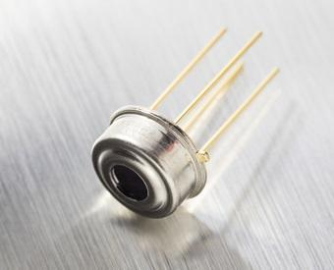

The user can configure the digital output to be pulse width modulation (PWM). As a standard, the 10-bit PWM is configured to continuously transmit the measured temperature, with an output resolution of 0.14°C.

Top features

* Small size and low cost
* Easy to integrate
* Factory calibrated in wide temperature range: -40 to 125°C for sensor temperature and -70 to 380°C for object temperature
* Available in 3V and 5V versions
* Simple adaptation for 8 to 16V applications
* Power saving mode

## Internet of Things (IoT)

The Internet of Things is the concept of connecting any device to the Internet and forming a single network in order to efficiently transfer data. The IoT is a giant network of connected things and people – all of which collect and share data about the way they are used and about the environment around them.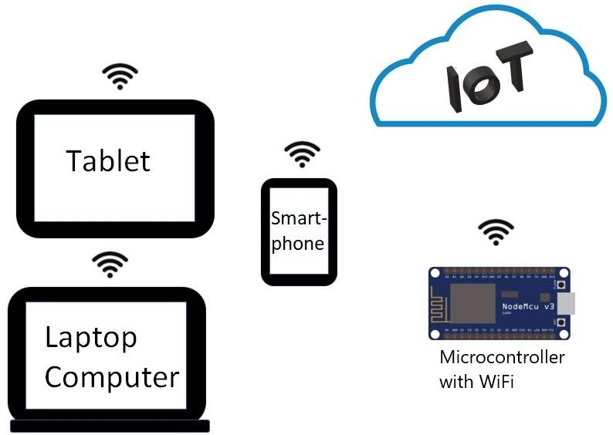

Microcontrollers can sense the Data with a sensor and then it does the required process.

With the help of IoT, the processed data will be shared to the operator/user in the form of SMS, Email and more.

Some indicators, displays and buzzers are also can be used to indicate the level of the data on the spot without any help of IoT.