**Network A, nReadoutUnits=1**

**With no feedback**

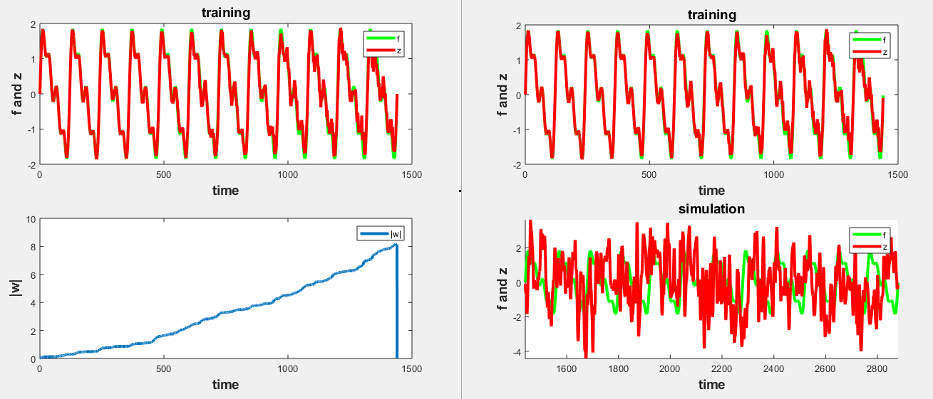

**With feedback: wf = 2.0*(rand(N,nUnitsOut)-0.5);**

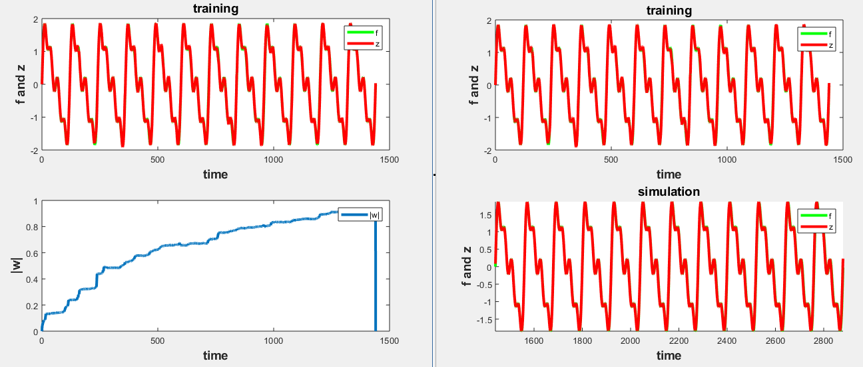

**With feedback: wf = 2.0*(rand(N,nUnitsOut)-0.5), tau=10;**

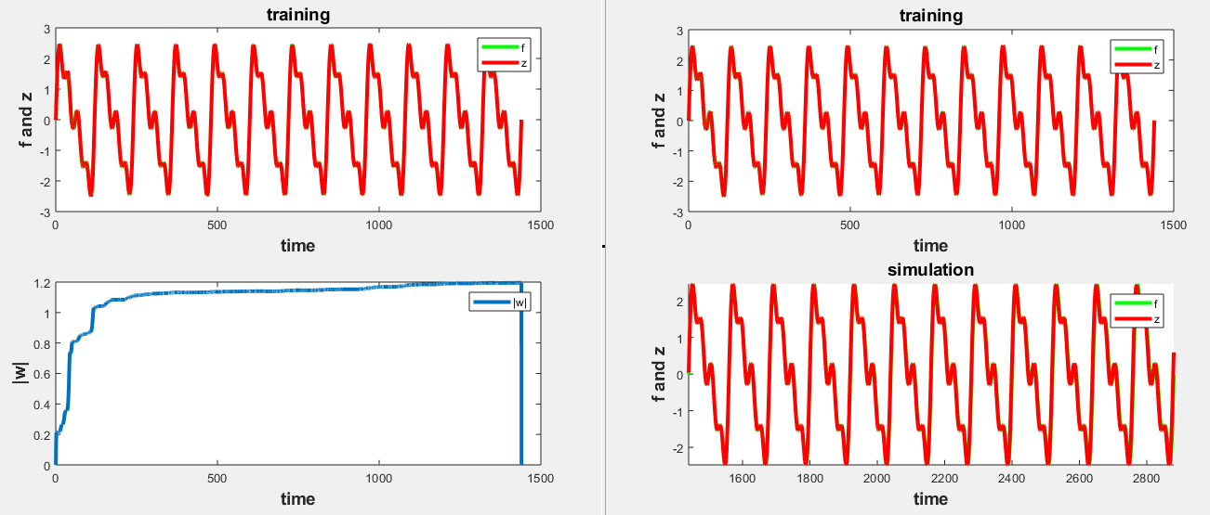

**Network A, nReadoutUnits=2**

**With feedback: wf = 2.0*(rand(N,nUnitsOut)-0.5);**

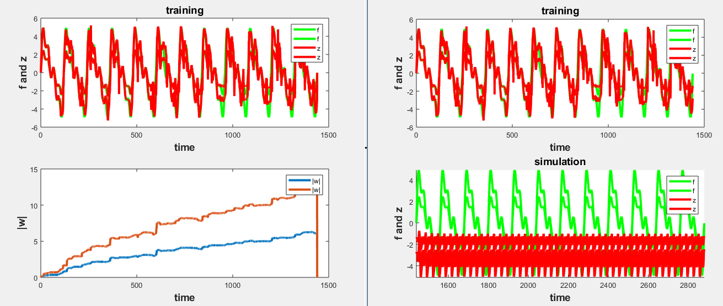

**With feedback: wf = 2.0*(rand(N,nUnitsOut)-0.5), tau=10;**

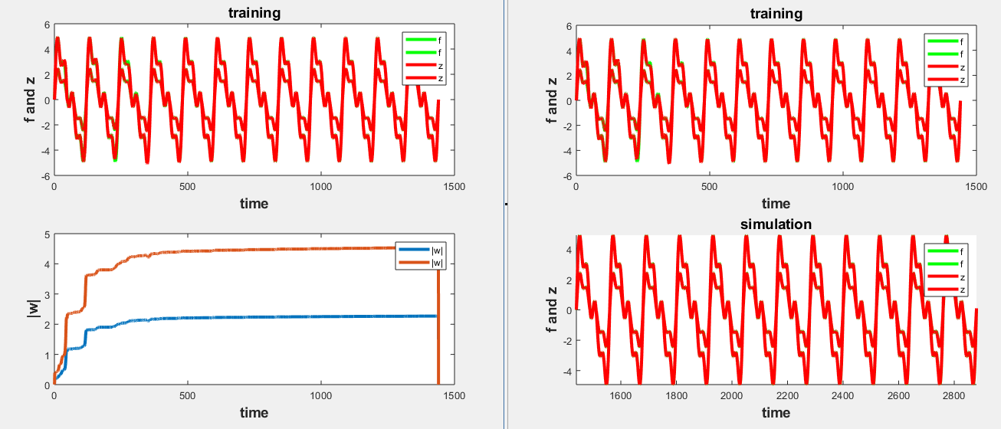

**With feedback:** wf = repmat(2.0*(rand(N,1)-0.5),1,nUnitsOut); **(attemp1)**

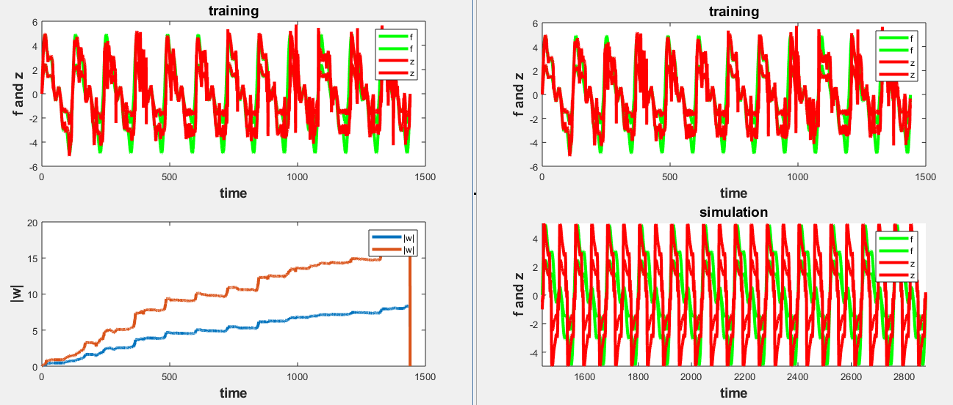

**With feedback:** wf = repmat(2.0*(rand(N,1)-0.5),1,nUnitsOut); **(attemp2)**

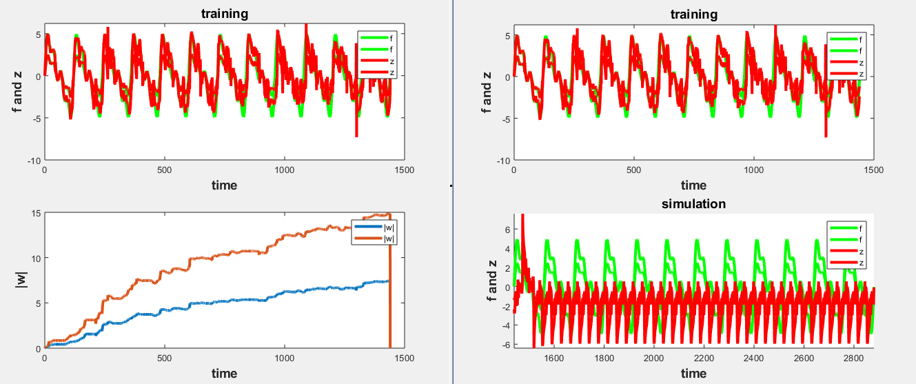

**With feedback:** wf = repmat(2.0*(rand(N,1)-0.5),1,nUnitsOut); **(attemp3)**

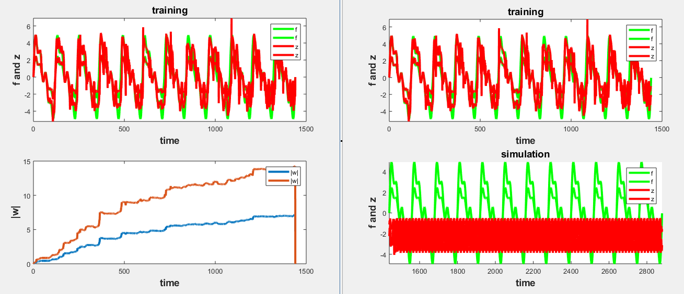

**Network A, nReadoutUnits=3**

**With feedback: wf = 2.0*(rand(N,nUnitsOut)-0.5), tau=10;**

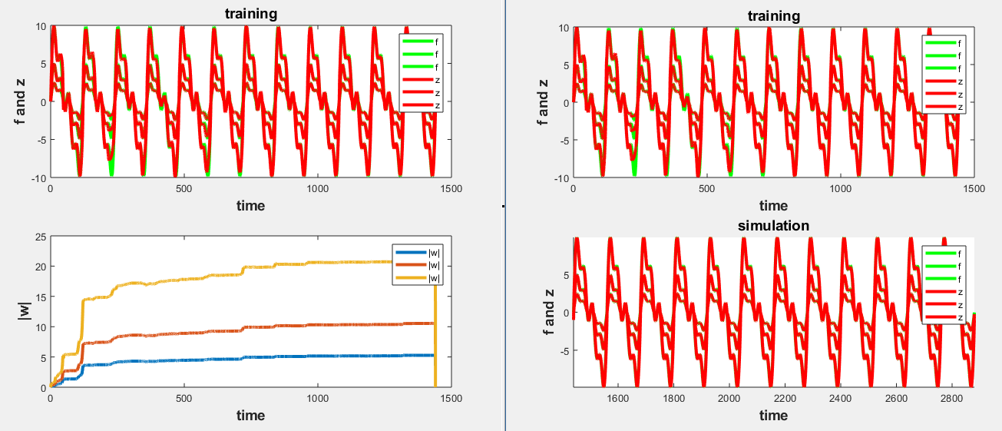

**Network A, nReadoutUnits=5**

**With feedback: wf = 2.0*(rand(N,nUnitsOut)-0.5), tau=50;**

