This document and the codes in this folder are written by Adib Ahmadzadegan, [aahmadza@purdue.edu](mailto:aahmadza@purdue.edu)

All rights reserved, please cite :

1. Ahmadzadegan, A., Ardekani, A. M., & Vlachos, P. P. (2020). Estimation of the probability density function of random displacements from images. Physical Review E, 102(3), 033305.
2. Ahmadzadegan, A., Ardekani, A., Vlachos, P. (2020). [Estimation of the Probability Density Function of Random Displacements from Images](https://doi.org/10.4231/34TJ-S109). Purdue University Research Repository. [doi:10.4231/34TJ-S109](https://doi.org/10.4231/34TJ-S109)

To run the code, open Matlab and go to the directory where the code is stored.

In the Matlab command window type :

MSD_GUI

The software will open the following window:

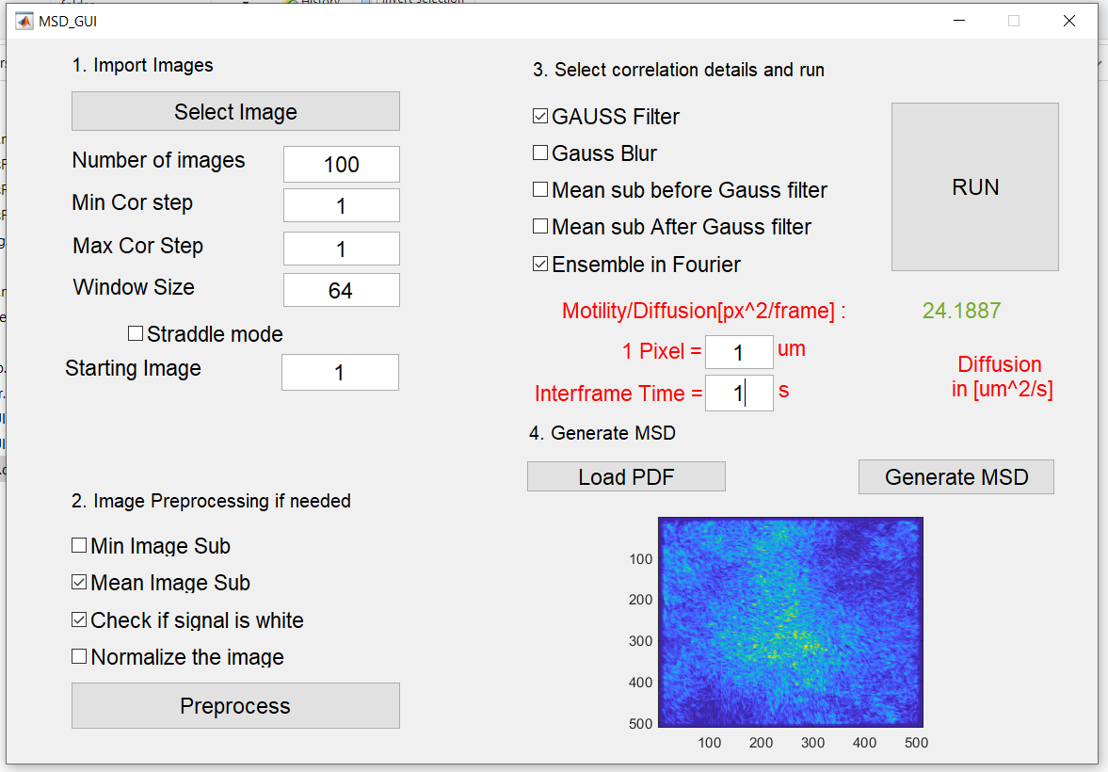

You will need to perform the steps 1,2,3 for a diffusion measurement.

In step 1) click on “select image” and select one image of your sequence of images. The type how many images you need. Set the min and max cor steps equal to help the program run faster. The min and max cor is the step size between images where at least 2 pixels displacement happens. If you are not sure always start from 1 and change to larger number if needed.

In step 2 use the default settings and click on the preprocess.

In step 3 use the default settings for diffusion measurement and input the calibration values such as pixel size and interframe time.

And run the code.

The outputs will be saved in your image folder. And the diffusion value will be shown in the GUI.